INSERT MODULE TITLE
Formative Assignment – Guidance Notes
Create a Google Account

To create your LRS you will need a Google account. If you already have a Google account you can skip these steps and go directly to ‘Creating your Learning Record Sheet’ below.

There are two ways to create a Google account.

- Create a Google account using your INSERT INSTITUTION’S NAME email address. To do this click on the following link and complete all the required fields: https://tinyurl.com/jmp8vpl

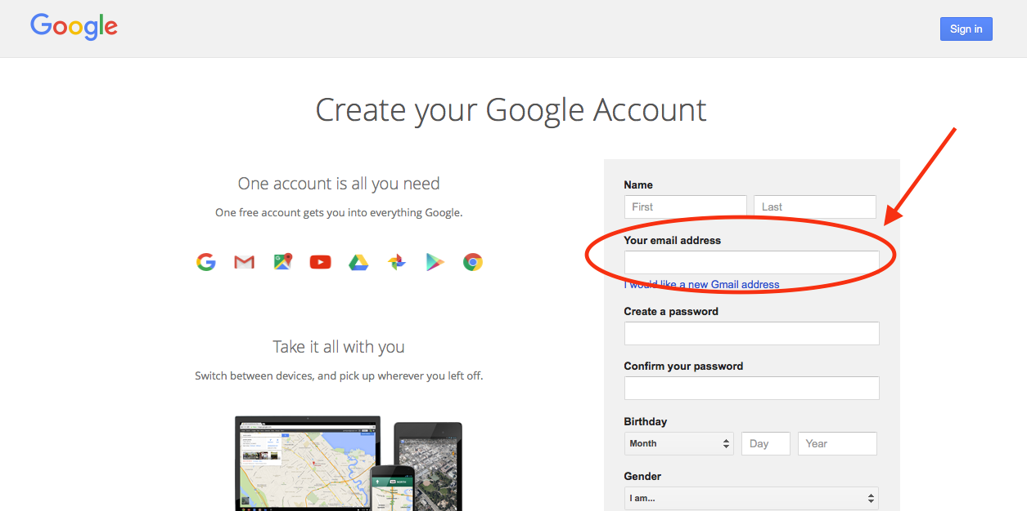
In the ‘Your email address’ box, fill in your INSERT INSTITUTION’S NAME email address.

- Create a Google account and email address. To do this click on the following link and complete all the required fields: https://tinyurl.com/jcuawgx

Creating your Learning Record Sheet

- You will receive an email from the Module Leader with a link to the template of the INSERT MODULE TITLE LRS. Click on the link. This will open the template in ‘view only’ mode.

- Click on ‘File’.

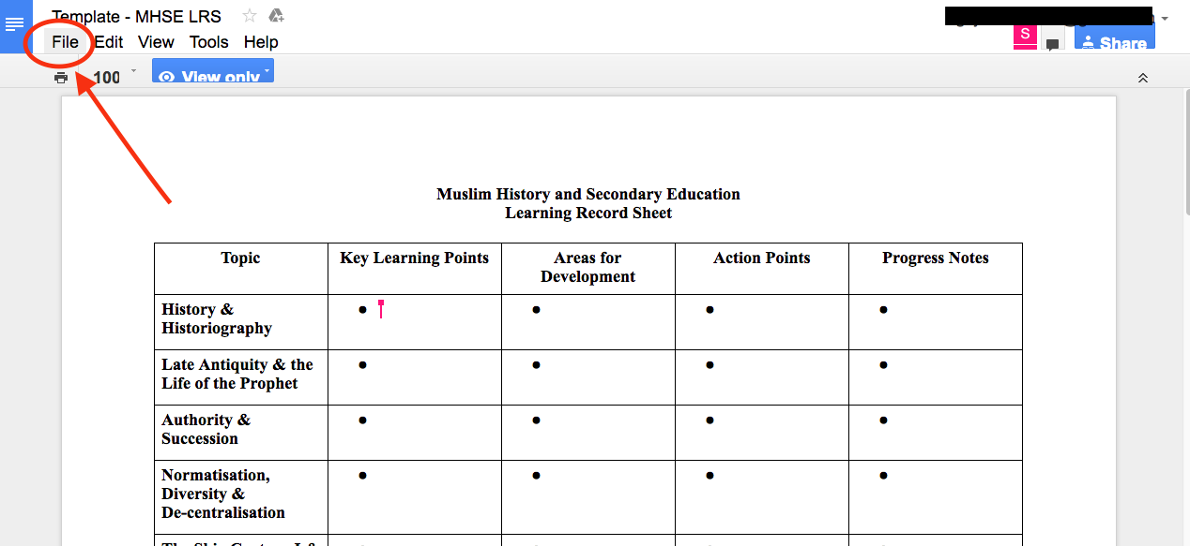

- Click on ‘Make a copy’.

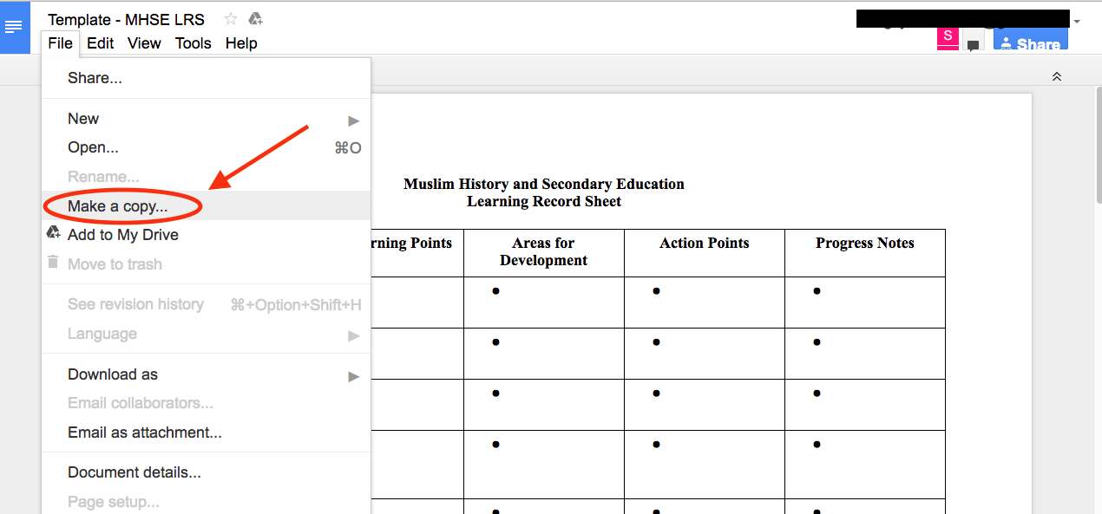

- Save the file as follows: [First Name] [Last Name] – INSERT MODULE TITLE LRS

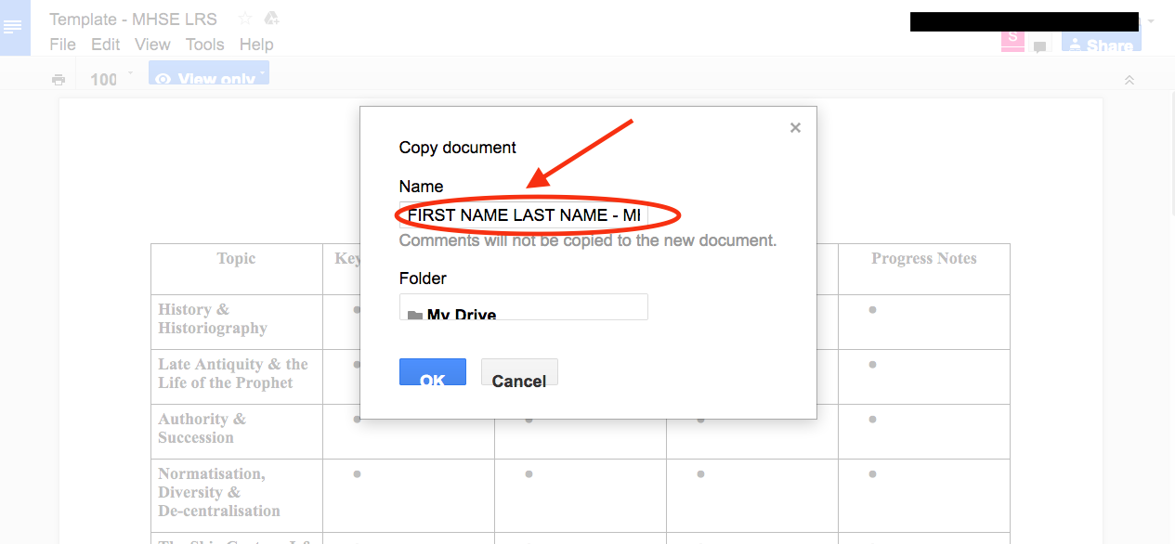

- So that I can see your LRS, you will have to share the file with me. Click on ‘Share’.

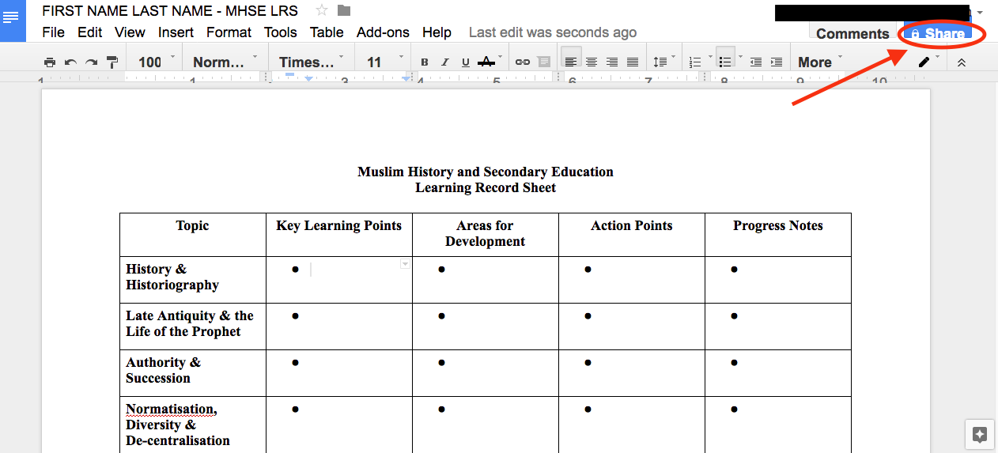

- Type in my email address – INSERT LECTURER’S EMAIL ADDRESS

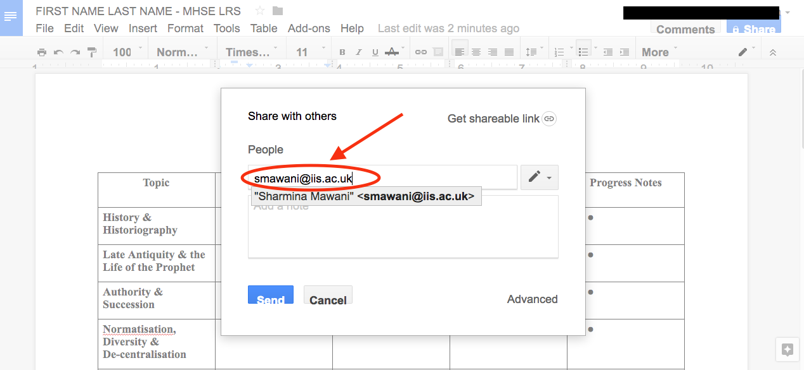

- Select ‘Can edit’ and click on ‘Send’.

