Re-evaluating multiple choice questions: online delivery and higher learning.
Andrew Williams

Multiple choice questions (MCQs) have several benefits as a form of assessment:
- Numerous questions can cover an entire module’s learning objectives.
- They can be easily performed online using VLEs (e.g. Moodle) or Uniwise platform.
- Formative MCQ tests can be provided throughout the course.
- Questions can be derived from a pre-made question bank.
- Feedback can be provided easily.
- Marking is quick and can be automated.

The move to online learning and online examinations have raised some concerns regarding quality of assessment, access and potential student collusion. The delivery of online MCQ exams should therefore take the following into account:
- MCQs are designed to be closed-book exams.
- Length of the examination needs to reflect the number of questions (e.g. 1 hour for 40-50 questions).
- Questions and answers can be randomised if necessary.
- The design of the question should incorporate higher-order learning objectives such as critical evaluation, analysis and conceptual understanding.

Traditionally MCQs have been used to test only lower-level learning such as factual knowledge. However, a well-written MCQ can also test higher-order thinking. Therefore, MCQ exams should incorporate questions that cover these high-order learning objectives, particularly level 5 and level 6 (year 2 and year 3).
Below I highlight several aspects of MCQ design that facilitate both online delivery of MCQ exams and ways to re-evaluate MCQ design to incorporative higher-order questions.

Re-evaluating MCQ design.
Below is an example of a poor multiple-choice question, which only tests very basic knowledge recall:
Which of the following bacterial products is recognised by Toll-like receptor 4?
1) LPS
2) Peptidoglycan
3) Lipoteichoic acid
4) Flagellin
5) CpG DNA
(correct answer (1))

Below is an example of a good quality MCQ:
(STEM) A patient presented to clinic with difficulty breathing. Following a laboratory investigation, the cytokine and chemokine levels were measured in the patient’s blood to provide a detailed diagnosis. The following was observed: normal levels of IFN-γ and IL-8; no IL-4 was detected; higher than normal levels of IL-5 and IL-13; higher than normal levels of IL-10; slightly increased levels of TGF-β.
(LEAD) Which disease do these measurements indicate the patient is suffering from?
a) Acute respiratory distress syndrome
b) Neutrophilic asthma
c) Eosinophilic asthma
d) Idiopathic pulmonary fibrosis
e) Acute viral infection
(Correct is (c))
The question has an extended stem, which incorporates a clinical scenario that the student is required to analyse and interpret. The stem further provides a real-world, applicable example. However, avoid giving verbal association clues in the stem, which lead the student towards the correct answer, and avoid unnecessary information that could distract the student.
The lead provides the question, which should be worded so that the student can answer the question without looking at the options first. The student then makes the final decision on which is the correct answer.
Provision of appropriate alternative/incorrect answers is also important. These need to be relevant to the question (or plausible), unambiguous and grammatically consistent. Although there is evidence that 3 possible answers are as good as 4-5, our policy is that each MCQ should have 5 (five) possible answers.
Please check for spelling or grammatical errors. Only one correct answer should be provided. Failure of either could result in an exam irregularity. Avoid negative questions, e.g. “…which of these is NOT a lung disease associated with…”.
Good MCQ design should test the student’s application of knowledge, not just knowledge recall. Depending on the level of study, the exam paper could incorporate both types of MCQ, depending on the module’s learning objectives. It is expected that level 6 (year 3 UG) or level 7 (MSc PG) MCQ exams have a higher proportion of questions that test higher-order learning.

Making the most of online delivery.
Online MCQ platforms, such as WISEflow (Uniwise), allow assessors to diversify the type of MCQ format. Examples include histological analysis, data interpretation, pathological specimens and other visual modes. Web link: https://www.uniwise.co.uk/news/ucl-to-transform-student-assessment-with-wiseflow
A simple example that incorporates knowledge application (anatomy, pathomechanisms, type of disease) and critical evaluation (interpretation of histology/pathology/data) is below:

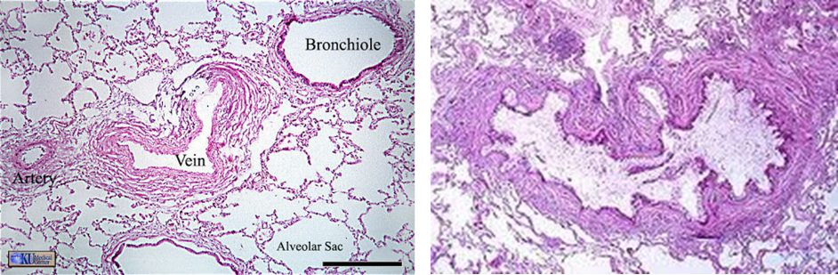
A B
(STEM) Certain fatal lung diseases are characterised by distinctive pathologies that can be evaluated post-mortem by a trained histopathologist. The histology section (A) is from an individual with no known lung disease and histology section (B) is from a deceased individual who previous suffered from a lung disease. (LEAD) The histopathology observed in section (B) is characteristic of which lung disease?
a) Idiopathic pulmonary fibrosis
b) Chronic obstructive pulmonary disease
c) Cystic fibrosis
d) Severe asthma
e) Lung cancer
(Correct answer (d))

Feedback on MCQ exams.
The debate about providing MCQ feedback mainly concerns giving student’s access to correct exam papers and questions that may be used in the LSA period or subsequent years. However, the provision of feedback, even for MCQ exams, is beneficial to the student’s learning experience and is encouraged.
There are several ways in which feedback can be given post MCQ exam, including:
- Automatically generate feedback online (immediate or delayed). This can be done for each question. For example, explaining the reasons why individual answers were correct.
- Providing face-to-face or live online feedback sessions.
- Providing solutions to problematic questions.
- Providing fully marked MCQ exam scripts, indicating correct and incorrect answers (delayed response).
- Correct answers plus the rationale (delayed).
The last option is preferable as evidence demonstrates improved outcomes in subsequent examinations when correct answers are provided alongside a more detailed rationale. A delayed response, after completion of the exam, has also been shown to be beneficial and aid student recollection and memory responses.

Useful further reading:
Gupta P, Meena P, Khan AM, Malhotra RK, Singh T. Effect of Faculty Training on Quality of Multiple-Choice Questions. Int J Appl Basic Med Res. 2020 Jul-Sep;10(3):210-214.
Tractenberg RE, Gushta MM, Mulroney SE, Weissinger PA. Multiple choice questions can be designed or revised to challenge learners' critical thinking. Adv Health Sci Educ Theory Pract. 2013 Dec;18(5):945-61.
McG Harden R, Brown RA, Biran LA, Ross WP, Wakeford RE. Multiple choice questions: to guess or not to guess. Med Educ. 1976 Jan;10(1):27-32.
Coughlin PA, Featherstone CR. How to Write a High Quality Multiple Choice Question (MCQ): A Guide for Clinicians. Eur J Vasc Endovasc Surg. 2017 Nov;54(5):654-658.

