Comparative Learning Curves of Microscope versus Exoscope-assisted Surgery:
A Preclinical Randomized Crossover Study

Zeqian Mao¹, Hugo Layard Horsfall^{2,3}, Austin Koh⁴, Danyal Z Khan^{2,3},
William Muirhead^{2,3}, Danail Stoyanov³, Hani J. Marcus^{2,3,5}

¹ Queen Square Institute of Neurology, University College London, London, UK
² Division of Neurosurgery, National Hospital for Neurology and Neurosurgery, Queen Square, London, UK
³ Wellcome/EPSRC Centre for Interventional and Surgical Sciences, University College London, London, UK
⁴ Department of Medical Physics and Biomedical Engineering, University College London, London, UK
⁵ To whom correspondence should be addressed at: h.marcus@ucl.ac.uk

Keywords: Research Protocol, Learning curves, Exoscope, ORBEYE, Microscope

- Introduction

1.1 From Operating Microscope to Exoscope
The operating microscope (OM) has revolutionized the field of surgery since its introduction to the operating room in 1920s^{1–3}. The OM provides an illuminated and highly magnified view of the operative field with a clear stereoscopic vision, allowing surgeons to perform precise manipulation of minute structures; the contemporary OMs even offer high degrees of automation and integrated advanced features, such as fluorescence, angiography, and neuronavigation⁴. However, operative challenges using the OM remain, including the bulky design, the need to frequently focus, and poor ergonomic comfort^{5,6}. For example, the OM requires surgeons to maintain an uncomfortable posture to be in proximity to the binocular eyepieces, which puts surgeons at risk of chronic pain and disorders in the long term^{6,7}.
In the last two decades, a novel “exoscope” (EX) system, consisting of an extracorporeal video telescope and connecting high-definition monitors, has been introduced as an alternative to address the limitations of the OM. The newly developed ORBEYE (OE, Olympus, Tokyo, Japan, 2017)⁸, compared to the majority of existing exoscopes, further offers high-definition and three-dimensional features^{9–11}. Without conventional eyepieces, surgeons operate while watching surgical field images on a 4K monitor using special 3D glasses, in a more comfortable natural position with their heads upright^{9,12–23}. In addition, the possibility of using 3D glasses provides an immersive surgical experience for the whole surgical team and demonstrates its potential for educational purposes since trainees can have the same view as surgeons^{15,24–26}. Another potential but powerful advantage of the EX is borne out by the current outbreak of COVID-19. Gordon et al.²⁷ and Teo et al.²⁸ reported that the exoscope system made possible many forms of personal protective equipment (PPE) in the operation room, many of which can be challenging when using the traditional OM.

1.2 Learning Curves in Surgical Practice
Despite all the advantages of innovations, the safe introduction of new technologies into surgical practice is of great importance²⁹. When a novel technique or device is introduced, surgeons will gradually gain proficiency or competence as their experience increases³⁰; this relationship between learning effort and learning outcome can be graphically represented using learning curves³¹, which has been increasingly used in medical education and training³². Improvements tend to be most rapid at first, with subsequent smaller improvements as the curve approaches a plateau^{32–34}. By shortening the inevitable learning curve, meaning an early achievement of competence, surgeons can provide state-of-the-art technologies to patients with minimized risks³⁵. In surgical education, there is great interest in techniques for minimizing the negative effects of the learning curve by focusing on proctoring efforts during the “steep part” of the learning curve³⁶.
There are four learning curve features that are modelled in previous literature: the initial skill level, the learning rate, the final skill level achieved (the learning plateau), and the duration of the learning period ^{37–39}. The shape of the learning curve is subject to the nature of a procedure, the number of cases performed, the frequency of cases performed, and individual differences⁴⁰. Learning curves have been described for numerous operative innovations; however, they are rarely quantified⁴¹. The understanding of learning curves is critical for valid assessments of new surgical techniques because surgeons may well be on different points of the learning curve⁴². It is also essential to inform surgical training and evaluate procedures in practice⁴⁰.

  - Exoscope, Learning Curves, and Present Study
Like any new technology, the EX has its own disadvantages. One obvious drawback in clinical use, reported by observational studies, is the easy obstruction of the surgical line between the surgeon and the screen^{43,44}; similarly, surgeons need to mentally filter noises perceived in peripheral vision, compared to the OM when almost the entire visual field is perceived through eyepieces. But these problems can be solved by planning optimal surgical setup in advance and paying careful attention to repositioning during operations. Another difficulty is hand-eye coordination which requires the decoupling of the surgeon’s eyes from the lens^{7,22}, which composes one main part of the learning process.
Previous comparison studies indicate the presence of the learning curve for ORBEYE, though might be minimal^{23,25,26,43,44}. In these studies, both junior and expert surgeons, who already have experience with the traditional OM in various degrees, showed improved comfort and performance using ORBEYE after performing an increasing number of surgeries using it. However, previous studies rarely compared the learning curves of microscope- and exoscope-assisted surgery in a quantitative manner and in novice surgeons who have least-established preferences.
In the present study, our goal is not only to identify the existence of the learning period, but also to estimate the learning curve features and compare them between the operating microscope (OM) and the newly developed ORBEYE (OE). Novice surgeons will be asked to perform a previously validated, preclinical microsurgical task⁴⁵ (“Stars the Limit”) using both the OM and the OE. Expert surgeons will also be recruited to perform the same task to assess its validity due to our modified scoring method, but only using the OM. An objective outcome (composite performance scores of tasks), subjective outcomes (the Raw Task Load Index⁴⁶ and a five-question survey), and modelled learning curves will be obtained and examined.

- Methods

2.1 Participants and Protocol Registration
Twelve novice surgeons and six expert surgeons will be recruited from one university hospital. Participants in the novice group will be deemed suitable for inclusion if they have no previous experience of neither microscope nor exoscope-assisted surgery (performed zero); participants will be categorized as experts if they have completed their training in neurosurgery and/or have performed more than 50 microsurgical cases^{47,48}. All participants will take a questionnaire about their previous surgical experiences (Table 1). Informed consent will be obtained from all participants. The trial protocol will be registered with the Clinical Governance Committee at the National Hospital for Neurology and Neurosurgery. The Consolidated Standards of Reporting Trials (CONSORT) statement will be used to prepare a manuscript.
Demographics
Date (complete by observer): |  | Subject ID (complete by observer):
Name: |  | Gender: F/M/prefer not to say
How many years since you started surgical training: _____ years
Approximately how many cases you have performed using operating microscope: _____ cases
Approximately how many cases you have assisted using operating microscope: _____ cases
Approximately how many cases you have performed using exoscope: _____ cases
 | If more than 0, please indicate how many cases involving ORBEYE specifically: _____ cases
Approximately how many cases you have assisted using exoscope: _____ cases
 | If more than 0, please indicate how many cases involving ORBEYE specifically: _____ cases
Table 1. Demographic questionnaire.

2.2 Optical instruments
The ORBEYE (OE, Olympus, Tokyo, Japan)⁸, a novel 4K 3D exoscope system with a 55-inch monitor, will be used as the example model of the EX. The focal length of the OE is 220 to 550 mm, with focusing and zooming controlled by hand at the scope-unit or using a footswitch. The traditional OMs, OPMI PENTERO or KINEVO 900 (Carl Zeiss Co, Oberkochen, Germany), will be used as the alternative to the OE. The PENETERO has focal length from 200 to 500 mm⁴⁹ and the KINEVO has focal length from 200 to 625 mm⁵⁰.

2.3 Procedure
A preclinical randomised crossover study design will be used to compare the operating microscope (OM) versus the exoscope (ORBEYE/OE) in a low-fidelity surgical simulation task.
All twelve novice participants will be randomly allocated using a computer-generated sequence into groups to determine the order in which the microscope- and the exoscope-assisted tasks will be performed. Permuted blocked randomisation (block size 2 and 4) will ensure that an equal number of novices begin with each instrument.
Novice participants will be asked to perform a preclinical microsurgical task -- “Stars the Limit”⁵¹. For this task, a standard star is drawn on a grape using a stencil with 5mm edge length; participants are asked to incise within the black line of the drawn star and peal the star-shaped skin off the flesh of the grape (Figure 1). Necessary instrumentations are provided including micro scissors and forceps. Novice participants will complete all tasks on the same day. No feedback on the performance will be given during the training.
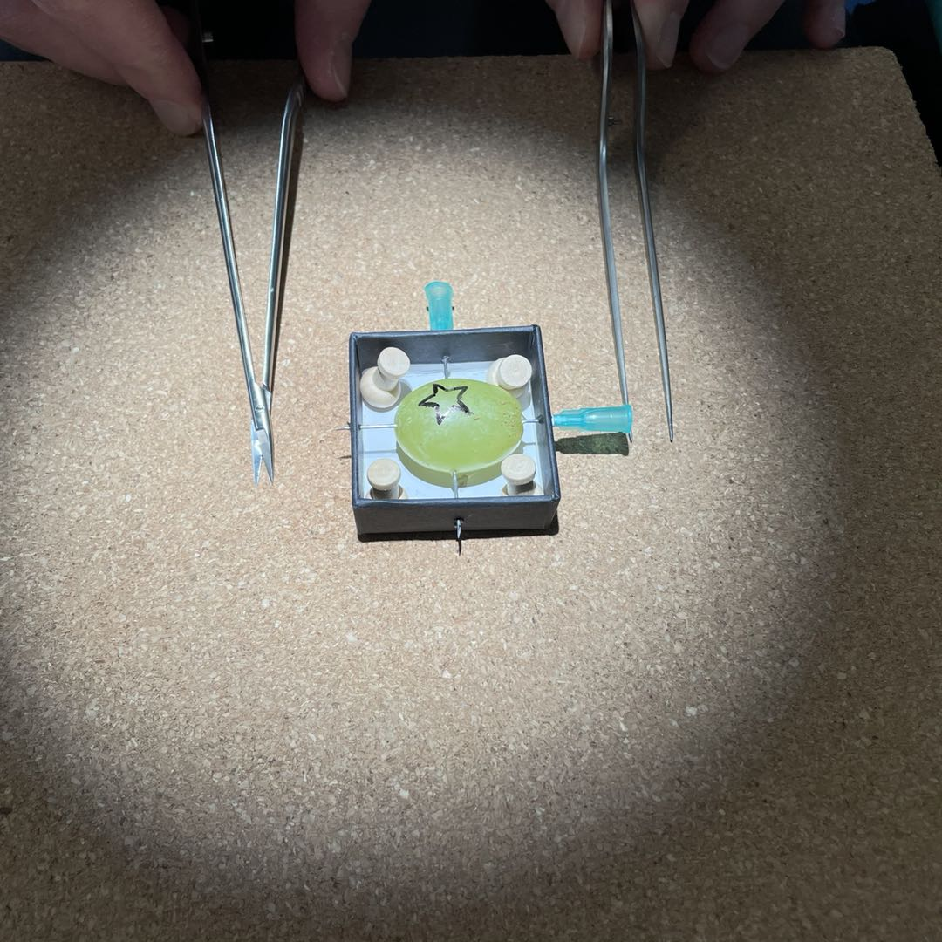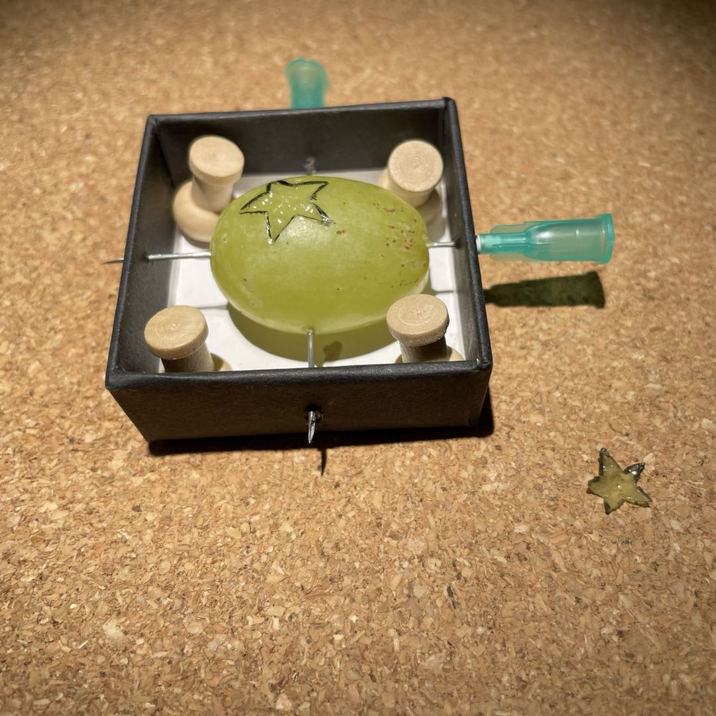
Figure 1. Microsurgical simulation task: Stars the Limit. Left: task preparation. Right: task outcome
The task is repeated 20 times under each instrument (the OM and the OE) and a 5-minute time limit is given for each repetition; if novice participants are not able to finish the task within the time limit, they will be told to stop and start the next attempt. This task simulates fine tissue dissection and requires steadiness and precise instrument handling. Before starting the actual task, participants will have 10 minutes to familiarize themselves with the goal of the task (through a briefing of scoring criteria) and both magnifying instruments. All performances will be recorded using the built-in camera of the OM or the OE; only the task area and the surgeons’ hands will be video recorded to ensure anonymity.
Since we modified the task scoring method which serves as the primary outcome (described in section 2.4.1), six expert surgeons will also be recruited to assess the validity. They will perform the same task 20 times using the OM only.

2.4 Outcomes
The primary outcome will be composite performance score (described in 2.4.1). The secondary outcomes will be perceived task workload and subjective impressions of the operating microscope (OM) and the ORBEYE (OE) (described in 2.4.2).
Summary of Outcomes
Primary outcomes | Performance | Composite performance score
Secondary outcomes | Workload | RTLX
 | Subjective impression | five-question survey
Table 2. Summary of outcomes.

2.4.1 Composite performance score
The performance will be assessed based on a five-item grading rubric (Table 3). The observer will invigilate the process and record the time to completion for each repetition. The observer will assess the grape immediately to avoid the inability to assess in the case of rapid decomposition.
Task grading rubric
Items | Description
Time to Complete | - The time to completion (seconds) is recorded, up to 5 minutes for each repetition; otherwise, will be told to stop.
Completeness of the Dissected Star | - Defined as whether an examinable, generally star-shaped skin is obtained  - 0 for failure  - 1 for success
Clean Star with No Flesh | - The dissected star needs to be clean skin without flesh attached.  - 0 points for a lot of flesh, or no star obtained  - 1 point for some flesh  - 2 points for no flesh
Edge within Limit | - Incision needs to be made within the drawn line.  - Both the dissected star and the remaining grape is examined; 1 point for the existence of the blackish on each edge.  - If no star obtained, up to 10 points, since only the main grape can be assessed.  - If star obtained, up to 20 points.
Perforation | - The number of perforations made is recorded.  - 1 point deduction for every perforation into the deep flesh.
Table 3. Task grading rubric.
The obtained raw scores of the five parameters will be combined into a composite performance score. The establishment of the scoring algorithm is adapted from the work by Schmidt et al. and Cotin et al.^{52,53}
The raw score will be notated as $z_{i}$ and adjusted to be seen as a cost function where a lower value corresponds to better performance. Specifically, the $z_{i}$ for parameters “Edge within Limit” and “Clean Star with No Flesh” will be multiplied by -1.
The standardized score will be computed according to the following equation:
$$compositescore\left(c\right)=\left(1-\frac{\sum_{i=1}^{N}{{a_{i}z}_{i}}}{\sum_{i=1}^{N}{{a_{i}×z}_{max}}}\right)×100$$
Where N is the number of parameters (N=5). $a_{i}$ and $z_{max}$ will be derived from multivariate logistic regression with cross-validation performed. To enhance readability, the standardized score will be multiplied by 100.

2.4.2 Secondary outcomes
The perceived workload will be assessed using a variation of NASA Task Load Index⁵⁴ – Raw TLX (RTLX)⁵⁵, in which the original “pairing/weighting” process is dropped but the subscales remain the same (Figure 2). There are six subscales: mental, physical and temporal demands, performance, effort, and frustration; each item is rated on a 20-point Likert scale (0=very low, 20=very high). The RTLX will be administered immediately after the completion of 20 attempts for each instrument; each novice participant and expert participant will complete the RTLX twice and once in total respectively.
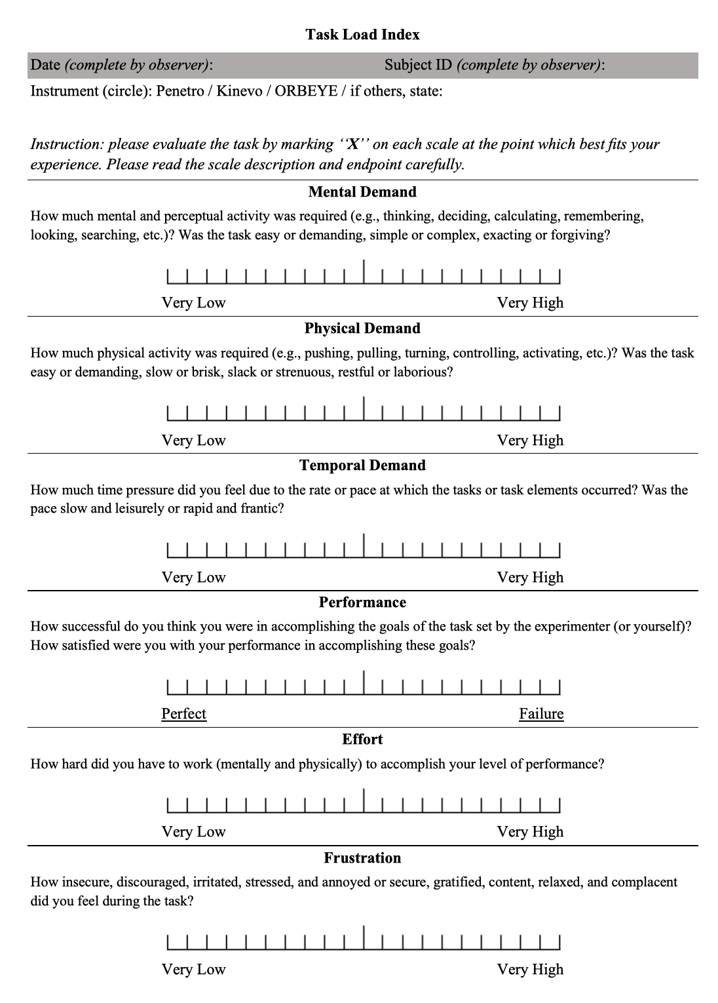
Figure 2. NASA Task Load Index⁵⁴ – Raw TLX (RTLX)
A survey about the subjective impressions will be administered after novice participants have completed the task using both instruments (Table 4). Participants will be asked about their preference between the OM and the OE in different aspects.
Subjective Impression of Operating Microscope (OM) and ORBEYE (OE)
Items | Strongly prefer OM | Prefer OM | No preference  /Similar | Prefer OE | Strongly prefer OE
1. Which one provides better visualisation?  (Consider image sharpness and brightness) | 1 | 2 | 3 | 4 | 5
2. Which one provides greater freedom of movement? | 1 | 2 | 3 | 4 | 5
3. Which one allows a more comfortable posture?  (Consider ergonomic comfort) | 1 | 2 | 3 | 4 | 5
4. Which one felt easier to perform the task with? | 1 | 2 | 3 | 4 | 5
5. Which one would you prefer to use in the future? | 1 | 2 | 3 | 4 | 5
Any other comments about the experience with two instruments (free descriptive: can related to questions above with more details or other random thoughts):

Table 4. Subjective Impressions of magnifying instruments.

2.5 Learning curve modelling
The primary outcome, composite performance score, will be used to plot learning curves for each participant since an important degree of inter-subject variability in the performance curve is expected. Curve-fitting techniques will be performed using multiple model equations from published papers: (1) inverse curve⁵⁶: $Y=a+\frac{b}{X}$. (2) exponential curve⁵⁷: $Y=a+{be}^{\left(-cX\right)}$. (3) logarithmic curve^{58,59}:$Y=aIn\left(x\right)+b$. In all equations, X represents the repetition of tasks, and Y represents the composite performance score. The quality of curve fitting will be evaluated by log-likelihood. If no above models fit the data satisfactorily, additional models will be employed and assessed. The consideration is to find a simple way to estimate learning curve features without compromising the model fitting quality.

2.6 Statistical analysis
Based on pragmatic constraints and previous similar studies, a minimum sample size of 18 (12 novices and 6 experts) is aimed with a non-inferiority margin of 20%^{47,48,60,61}. Data will be expressed as mean (standard deviation) and 95% CI. The statistical significance will be defined as p < .05.
In order to compare learning curves between subgroups based on the instrument used (the OM or the OE), curvilinear regression will be conducted after the best-fit model is selected. MATLAB Curve Fitting Toolbox (MathWorks) will be utilized to estimate the learning curve features. The differences between the groups will be tested for non-inferiority.
The NASA-RTLX contains six subscale scores and one composite score, which will be plotted and analyzed separately. For subscale scores, a 2*6 ANOVA will be applied, with the instrument (the OM or the OE) as between-subjects factors and the dimensions (MD, PD, TD, P, E, F) as within-subjects factors. For the composite score, a one-way ANOVA will be conducted. Post hoc testing with FDR correction will be conducted.
The results of the subjective impression survey will be reported. For each participant, a summed score will be calculated from the responses of all five items. Student t-test will be used to compare the groups with a different initial instrument.

- References
1. Kriss, T. C. & Kriss, V. M. History of the Operating Microscope: From Magnifying Glass to Microneurosurgery. Neurosurgery 42, 899–907 (1998).
2. Liczbik, O. et al. From magnifying glass to operative microscopy – the historical and modern role of the microscope in microsurgery. Pol. J. Pathol. 70, 14–20 (2019).
3. Yaşargi, G. A Legacy of Microneurosurgery: Memoirs, Lessons, and Axioms. Neurosurgery 45, 1025–1092 (1999).
4. Beez, T., Munoz-Bendix, C., Beseoglu, K., Steiger, H.-J. & Ahmadi, S. A. First Clinical Applications of a High-Definition Three-Dimensional Exoscope in Pediatric Neurosurgery. Cureus 10, (2018).
5. Uluç, K., Kujoth, G. C. & Başkaya, M. K. Operating microscopes: past, present, and future. Neurosurg. Focus 27, E4 (2009).
6. Catanzarite, T., Tan-Kim, J., Whitcomb, E. L. & Menefee, S. Ergonomics in Surgery: A Review. Female Pelvic Med. Reconstr. Surg. 24, 1–12 (2018).
7. Ahmad, F. I. et al. Application of the ORBEYE three‐dimensional exoscope for microsurgical procedures. Microsurgery 40, 468–472 (2020).
8. ORBEYE | Olympus America | Medical. https://medical.olympusamerica.com/products/orbeye.
9. Ricciardi, L., Mattogno, P. P., Olivi, A. & Sturiale, C. L. Exoscope Era: Next Technical and Educational Step in Microneurosurgery. World Neurosurg. 128, 371–373 (2019).
10. Ricciardi, L. et al. The Exoscope in Neurosurgery: An Innovative “Point of View”. A Systematic Review of the Technical, Surgical, and Educational Aspects. World Neurosurg. 124, 136–144 (2019).
11. Langer, D. J. et al. Advances in Intraoperative Optics: A Brief Review of Current Exoscope Platforms. Oper. Neurosurg. 19, 84–93 (2020).
12. Ebner, F. H., Marquardt, J. S., Hirt, B., Tatagiba, M. & Duffner, F. Optical requirements on magnification systems for intracranial video microsurgery. Microsurgery 31, 559–563 (2011).
13. Grammatica, A. et al. Application of a 3D 4K exoscopic system to head and neck reconstruction: a feasibility study. Eur. J. Plast. Surg. 42, 611–614 (2019).
14. Iwata, T. et al. Microsurgery “Under the Eaves” Using ORBEYE: A Case of Dural Arteriovenous Fistula of the Anterior Cranial Fossa. World Neurosurg. 138, 178–181 (2020).
15. Kanzaki, S., Takahashi, S., Toda, M., Yoshida, K. & Ogawa, K. Pros and Cons of the Exoscope for Otologic Surgery. Surg. Innov. 155335062096415 (2020) doi:10.1177/1553350620964151.
16. Khalessi, A. A. et al. First-in-Man Clinical Experience Using a High-Definition 3-Dimensional Exoscope System for Microneurosurgery. Oper. Neurosurg. 16, 717–725 (2019).
17. Langer, D. J. et al. Advances in Intraoperative Optics: A Brief Review of Current Exoscope Platforms. Oper. Neurosurg. 19, 84–93 (2020).
18. Mamelak, A. N., Danielpour, M., Black, K. L., Hagike, M. & Berci, G. A high-definition exoscope system for neurosurgery and other microsurgical disciplines: preliminary report. Surg. Innov. 15, 38–46 (2008).
19. Nossek, E. et al. Technical Aspects and Operative Nuances Using a High-Definition 3-Dimensional Exoscope for Cerebral Bypass Surgery. Oper. Neurosurg. 17, 157–163 (2019).
20. Patel, V. A. & Goyal, N. Using a 4K-3D Exoscope for Upper Airway Stimulation Surgery: Proof-of-Concept. Ann. Otol. Rhinol. Laryngol. 129, 695–698 (2020).
21. Murai, Y. et al. Preliminary Clinical Microneurosurgical Experience With the 4K3-Dimensional Microvideoscope (ORBEYE) System for Microneurological Surgery: Observation Study. Oper. Neurosurg. 16, 707–716 (2019).
22. Roethe, A. L. et al. Monitor-based exoscopic 3D4k neurosurgical interventions: a two-phase prospective-randomized clinical evaluation of a novel hybrid device. Acta Neurochir. (Wien) 162, 2949–2961 (2020).
23. Siller, S. et al. A high-definition 3D exoscope as an alternative to the operating microscope in spinal microsurgery. J. Neurosurg. Spine 33, 705–714 (2020).
24. Corcione, F. et al. Use of the ORBEYE TM Exoscope in General Surgery: The Advent of Video-Assisted Open Surgery. Surg. Innov. 155335062096534 (2020) doi:10.1177/1553350620965344.
25. Kwan, K. et al. Lessons Learned Using a High-Definition 3-Dimensional Exoscope for Spinal Surgery. Oper. Neurosurg. 16, 619–625 (2019).
26. Takahashi, S. et al. Pros and cons of using ORBEYETM for microneurosurgery. Clin. Neurol. Neurosurg. 174, 57–62 (2018).
27. Gordon, S. A., Deep, N. L. & Jethanamest, D. Exoscope and Personal Protective Equipment Use for Otologic Surgery in the Era of COVID-19. Otolaryngol. Neck Surg. 163, 179–181 (2020).
28. Teo, T. H. L., Tan, B. J.-N., Loo, W. L., Yeo, A. K. S. & Dinesh, S. K. Utility of a high-­definition 3D digital exoscope for spinal surgery during the COVID-19 pandemic. B J 1, 5 (2020).
29. Sachdeva, A. K. & Russell, T. R. Safe Introduction of New Procedures and Emerging Technologies in Surgery: Education, Credentialing, and Privileging. Surg. Clin. North Am. 87, 853–866 (2007).
30. Healey, P. & Samanta, J. When Does the ‘Learning Curve’ of Innovative Interventions Become Questionable Practice? Eur. J. Vasc. Endovasc. Surg. 36, 253–257 (2008).
31. Valsamis, E. M., Chouari, T., O’Dowd-Booth, C., Rogers, B. & Ricketts, D. Learning curves in surgery: variables, analysis and applications. Postgrad. Med. J. 94, 525–530 (2018).
32. Hopper, A. N., Jamison, M. H. & Lewis, W. G. Learning curves in surgical practice. Postgrad. Med. J. 83, 777–779 (2007).
33. Schmidt, R. A., Lee, T. D., Winstein, C., Wulf, G. & Zelaznik, H. N. Motor Control and Learning: A Behavioral Emphasis. (Human Kinetics, 2018).
34. Feldman, L. S., Cao, J., Andalib, A., Fraser, S. & Fried, G. M. A method to characterize the learning curve for performance of a fundamental laparoscopic simulator task: defining ‘learning plateau’ and ‘learning rate’. Surgery 146, 381–386 (2009).
35. Aggarwal, R. & Darzi, A. Innovation in surgical education – A driver for change. The Surgeon 9, S30–S31 (2011).
36. Sachdeva, A. K. & Russell, T. R. Safe Introduction of New Procedures and Emerging Technologies in Surgery: Education, Credentialing, and Privileging. Surg. Clin. North Am. 87, 853–866 (2007).
37. Cook, J. A., Ramsay, C. R. & Fayers, P. Using the literature to quantify the learning curve: A case study. Int. J. Technol. Assess. Health Care 23, 255–260 (2007).
38. Papachristofi, O., Jenkins, D. & Sharples, L. D. Assessment of learning curves in complex surgical interventions: a consecutive case-series study. Trials 17, 266 (2016).
39. Valsamis, E. M. et al. Modeling Learning in Surgical Practice. J. Surg. Educ. 75, 78–87 (2018).
40. Harrysson, I. J. et al. Systematic Review of Learning Curves for Minimally Invasive Abdominal Surgery: A Review of the Methodology of Data Collection, Depiction of Outcomes, and Statistical Analysis. Ann. Surg. 260, 37–45 (2014).
41. Ramsay, C. R. et al. Statistical assessment of the learning curves of health technologies. Health Technol. Assess. 5, i+iii-iv+1-89 (2001).
42. Simpson, A. H. R. W., Howie, C. R. & Norrie, J. Surgical trial design – learning curve and surgeon volume. Bone Jt. Res. 6, 194–195 (2017).
43. Vetrano, I. G. et al. High-Definition 4K 3D Exoscope (ORBEYETM) in Peripheral Nerve Sheath Tumor Surgery: A Preliminary, Explorative, Pilot Study. Oper. Neurosurg. 19, 480–488 (2020).
44. Sack, J. et al. Initial Experience Using a High-Definition 3-Dimensional Exoscope System for Microneurosurgery. Oper. Neurosurg. 14, 395–401 (2018).
45. Masud, D. et al. Microsurgery simulation training system and set up: An essential system to complement every training programme. J. Plast. Reconstr. Aesthet. Surg. 70, 893–900 (2017).
46. Hart, S. G. & Staveland, L. E. Development of NASA-TLX (Task Load Index): Results of Empirical and Theoretical Research. in Advances in Psychology vol. 52 139–183 (Elsevier, 1988).
47. Marcus, H. J. et al. Validation of martyn to simulate the keyhole supraorbital subfrontal approach. Bull. R. Coll. Surg. Engl. 96, 120–121 (2014).
48. Marcus, H. J. et al. A “Smart” Force-Limiting Instrument for Microsurgery: Laboratory and In Vivo Validation. PLOS ONE 11, e0162232 (2016).
49. OPMI PENTERO 900 - Carl Zeiss Meditec - PDF Catalogs | Technical Documentation. https://www.zeiss.com/meditec/us/products/neurosurgery/surgical-microscopes/opmi-pentero-900.html#more-information.
50. OPMI KINEVO 900 - Carl Zeiss Meditec - PDF Catalogs | Technical Documentation. https://www.zeiss.com/meditec/us/products/neurosurgery/surgical-microscopes/kinevo-900.html#intro.
51. Masud, D. et al. Microsurgery simulation training system and set up: An essential system to complement every training programme. J. Plast. Reconstr. Aesthet. Surg. 70, 893–900 (2017).
52. Schmidt, M. W. et al. The Heidelberg VR Score: development and validation of a composite score for laparoscopic virtual reality training. Surg. Endosc. 33, 2093–2103 (2019).
53. Cotin, S. et al. Metrics for Laparoscopic Skills Trainers: The Weakest Link! in Medical Image Computing and Computer-Assisted Intervention — MICCAI 2002 (eds. Dohi, T. & Kikinis, R.) 35–43 (Springer, 2002). doi:10.1007/3-540-45786-0_5.
54. Hart, S. G. & Staveland, L. E. Development of NASA-TLX (Task Load Index): Results of Empirical and Theoretical Research. in Advances in Psychology (eds. Hancock, P. A. & Meshkati, N.) vol. 52 139–183 (North-Holland, 1988).
55. Hart, S. G. Nasa-Task Load Index (NASA-TLX); 20 Years Later. Proc. Hum. Factors Ergon. Soc. Annu. Meet. 50, 904–908 (2006).
56. Feldman, L. S., Cao, J., Andalib, A., Fraser, S. & Fried, G. M. A method to characterize the learning curve for performance of a fundamental laparoscopic simulator task: Defining “learning plateau” and “learning rate”. Surgery 146, 381–386 (2009).
57. Kimura, T. & Nakano, W. Repetition of a cognitive task promotes motor learning. Hum. Mov. Sci. 66, 109–116 (2019).
58. Johnson, B., Sorokin, I., Singla, N., Roehrborn, C. & Gahan, J. C. Determining the Learning Curve for Robot-Assisted Simple Prostatectomy in Surgeons Familiar with Robotic Surgery. J. Endourol. 32, 865–870 (2018).
59. Yang, J. et al. Learning curve and clinical outcomes of percutaneous endoscopic transforaminal decompression for lumbar spinal stenosis. Int. Orthop. 44, 309–317 (2020).
60. Pafitanis, G. et al. The Exoscope versus operating microscope in microvascular surgery: A simulation non-inferiority trial. Arch. Plast. Surg. 47, 242–249 (2020).
61. Volpe, A. et al. Pilot Validation Study of the European Association of Urology Robotic Training Curriculum. Eur. Urol. 68, 292–299 (2015).

