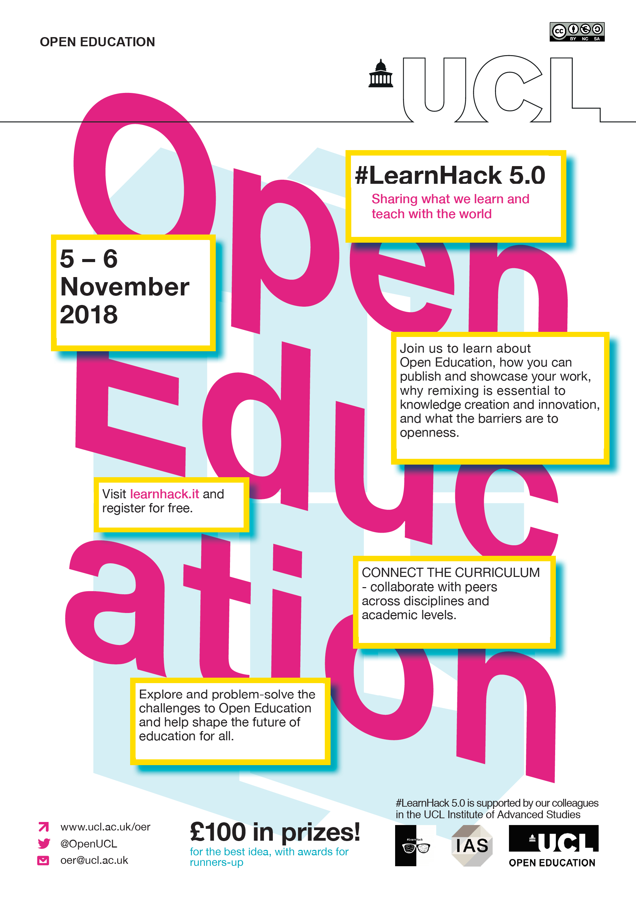

Contents

Introduction 1
General 1
Communications 1
Teams 1
Project Submissions 1
Event Schedule 2
Brief 4
Example challenges 4
Submission guidelines 6
Assessment criteria 7
Helpful information 8

Welcome to #LearnHack 5.0!

Introduction

General
#LearnHack hates waste - please reuse your cups if possible to avoid unnecessary rubbish.
Please tidy up around you and throw things in bins. Please don’t treat other participants as your cleaners.

Communications
WEB: All the info you need about the event is at http://www.learnhack.it
OTHER: Your social media hashtag is #LearnHack
PHOTOS: Under the new data protection rules you must seek permission of any person you take a photo of, especially before posting it publicly. Please be conscious of the privacy of other participants!

Teams
There will be time to form teams after the presentations at 15:30.
Please form teams of no more than 3 or 4 people (otherwise you will need to split potential prizes).
Teams need to nominate one person to document how the project progresses throughout the day. You will need to submit a summary about your event experience and project by the 16:30 deadline on Tuesday.

Project Submissions
Submission: http://ucloer.eprints-hosting.org/
At the end of DAY 1 we will set up accounts on the UCL OER repository for each group. You will be required to upload your submission to the repository before the deadline.
You can also find the link on the website.
The hard deadline is 16:30 on DAY 2. Entries are timestamped. Teams with late or no submissions will miss out on the chance of winning prizes.

Event Schedule

DAY 1 (Monday) - introductions
13:00 Registration
13:30 Welcome & Introduction to Open Education Part I
Introduction to Open Education, OER, and what UCL is doing June Hedges
Copyright, IPR, and licensing – challenges for Open Education Chris Holland
Metadata for open educational resources (OER) Leo Havemann
Quality mediation and student-generated content / Demo of the UCL OER repository, OpenEd@UCL Claudia Yogeswaran
Accessibility Sam Ahern
14:20 Break
14:40 Introduction to Open Education Part II
Using data and research as OER Daniel Van Strien
The challenges of measuring re-use and impact of OER Andrew Gray
Technical and systems requirements for managing OER Dr David Pérez-Suárez
Case studies/examples of how teaching practitioners at UCL are integrating open practices Dr Nephtali Marina-Gonzalez
15:30 Break
15:50 Networking and team formation
Overview of activities and instructions Claudia Yogeswaran/Leo Havemann
- Join teams with colleagues from across UCL (across academic levels and disciplines)
  - You can work in pre-formed teams if you prefer
- We’ll help you find people with similar interests, get started in your teams, distribute roles, start thinking about how to approach problems, etc.
18:00 Submit your team name and the title of the challenge you will hack
- What’s the group name?
- What is your group interested in?
- What are your aims, etc.?
Start working to solve your problem – until 18:30 close

DAY 2 (Tuesday) – team-working all day
10:00 Breakfast
13:00 Lunch
16:30 *** Project Deadline ***
Your project details must be submitted no later than 16:45
Break
17:00 Presentations
18:00 Awards and prizes
18:30 Tidy up and end of event

Brief

We want you to explore ideas and solutions to how Open Education (OE) practices are embedded across UCL.
Think about what you’ve learned through the talks on OE. Is there a topic you’ve found particularly interesting, or you think is worth exploring further? Do you see potential in any of the ideas discussed? Can you think of a way to make certain topics more palatable?
Talk in your groups about what issue(s) you want to address and explore ways you can tackle it. Can you think of any potential risks and how would you mitigate those?
Your challenge will likely fit into one of the following headings:
1. Advocacy
2. Support and training models
3. Tools
4. Resource creation

Example challenges
Here are some things you might want to think about – remember that these are just examples – you can think of your own, or we can help you think of others! If you have an idea for a challenge, come and speak to one of the event organisers or email oer@ucl.ac.uk – our only requirement is that it relates to a real-world Open Education issue. You don’t need to be technically-minded to explore these!

Promotional materials - videos, e.g.

Templates, guidance documents, posters, etc.
- How to make OER?
- How to turn existing teaching material/data/research into OER?
- How would you easily explain (open) licensing/copyright to someone?
- Re-use open teaching materials
- Using open resources to create lessons
- Find an open (research) data set and plan a lesson or activity around it
- Find an existing OER and re-purpose and re-publish it
- Use an OA research publication for an activity

How does Open Education tie in with other UCL initiatives, i.e. the Connected Curriculum, the Education Strategy, etc.?
- Why is it important? How would you engage peers? What would be the key messages?

Challenges for students, teaching staff, librarians, etc. on embedding OE practice into UCL
- What are the barriers to Openness?
- Why is Open Education important to librarians?
- How can the library support teaching staff to create OER?
- Why do you think OE is important for students?
- Can you suggest ways for students to get involved with, or gauge their interest in, Open Education?
- Information literacy and digital literacy is the teaching of research and study skills, which includes training on the skills which support open education and open research. What more can be done to engage students and staff with this?

System requirements for a successful Open Education/OER repository
- Research and identify system requirements for UCL’s OER repository
- What other UCL systems would UCL need to integrate/work with?
- What external systems would benefit from interoperability with the UCL OER repository
- Compare with other repositories and systems like GitHub, Open Software Framework, etc. – and consider the pros and cons of uploading OER with each

The importance of metrics in understanding and analysing the re/use and impact of OER
- What is “impact”? What are the definitions?
- Why is it important?
- How can you measure impact of an OER?
- Related issues/difficulties

Quality control
- Is it enough that teaching content meets UCL standards or should there be a peer-review process?
- How should student-generated content – examples of teaching output – be mediated?

And if you’re feeling tech-y, you could think about improving Open Education platforms and tools…
- Interoperability solutions to support discovery of OER across UCL and the Internet
- Improve discoverability and cross-repository search tools
- Build and explore network/community features (such as “likes”. visualising connections between people who engage with the OERs, etc.)
- Create usable plugins for the repository, i.e.
  - Zotero plugin to support citation
  - Push/publishing to social networks
- Create a ‘Report Maker’, so a staff member can visualise/print/export a document detailing their teaching output, its reuse and downloads, and the “impact” it makes
- Tools to measure and visualise impact, or find patterns in / analyse data

Submission guidelines

1. You need to submit your team form by 18:00 on DAY 1 to an event organiser
- What is your team name?
- Who is in your team?
- Define clearly the challenge your team will look at
You may also want to think about who in your team will be responsible for:
- Documenting how the project progresses
- Submitting the project to the UCL OER repository

2. The deadline for submission is 16:30 on DAY 2, via the UCL OER repository

- Make sure you leave plenty of time to deposit your submission!
- Instructions on how to upload content to the OER repository can be found here: https://www.ucl.ac.uk/oer/faq/deposit/deposit.pdf

Assessment criteria

A panel will judge your project based on:
- Feasibility
- Sustainability and reusability
- Accessibility
- Desirability
- Originality and creativity

They will also consider how you have:
☐ Documented your path/journey to creating your resource and what you have learned
☐ Defined your audience
☐ Detailed what parts of your output would need to be described, or what instructions you would need to sit alongside it
☐ Attributed any content you have reused
☐ Mediated the quality of your output
☐ Approached and tackled the challenge

Helpful information

Attribution If you are re/using OER and must attribute the author, the Creative Commons Wiki page details best practice for attribution. We recommend the following attributive text as a minimum citation. Note: [italicised text within square brackets] defines properties must be selected and bold text indicates where hyperlinked information is required:
Attribution[s]: [Document/image/presentation/etc.] [adapted/copied] from "[document title]" by [Author name] (UCL), which is licensed under the [CC BY-SA 4.0/etc. licence].

Licenses – Creative Commons and other open licences. A licence indicates whether OER can be copied, and/or re/used for commercial purposes, and/or modified, and/or require attribution, and/or must be shared with the same licence.
Illustrated below are examples of the different CC licences and what sharing and re/use permissions they allow.
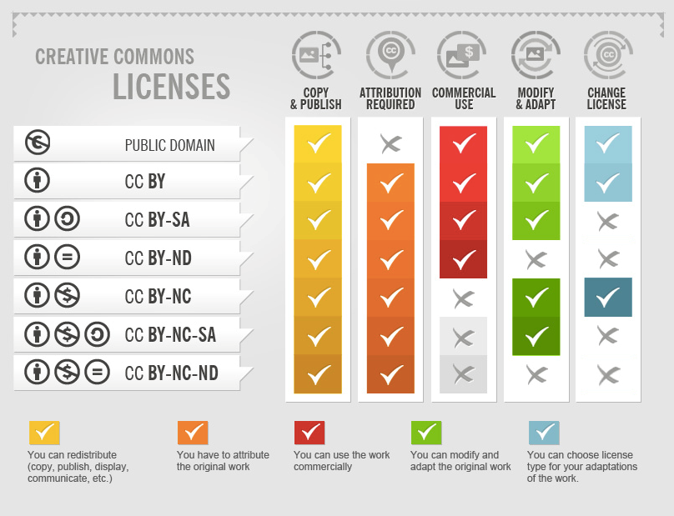
Copied image "Creative Commons licences" by Foter, which is licensed under the CC BY-SA 4.0 licence.

Metadata. In order for potential users to find resources online, and to understand the scope of a resource, it is vital to include relevant metadata. This is information about the resource, such as the author’s name, the date the resource was created, keywords, and the educational context in which the resource has previously been used.

Open educational practice (OEP) involves taking open approaches to teaching and learning. This can include, for example, thinking about licencing, third-party content, and metadata at the outset of course planning, or running skills workshops at the beginning of a module so students understand their rights regarding their educational output and how they can publish their content.

Open educational resources (OER) are digital and reusable learning/instructional objects produced through teaching and training activities. This can include recorded lectures and seminars, handouts, essays, diagrams, animations, videos, presentation slides, reading lists, and so on. They do not have to be a full course, but can be individual items created by staff to aid teaching and learning, or student-generated content which showcases teaching output. Anything that can be reused for teaching and training is an OER.

Third-party content is content that is licensed or owned by another person or organisation other than yourself. You can re/use third-party content in your OER as long as you have obtained permission to do so. Where the licence and re/use information for an OER is not explicitly stated, you must obtain clarification and permission from the creator/owner of the teaching content before you use it.

