Literacy Attainment: Historical Resources

Contents
Welcome 2
About this guide 2
Literacy Attainment 1800-1872 2
THE THREE R's; OR, BETTER LATE THAN NEVER. 2
Useful links 3
Education Reform 4
Spreading the Word 6
Shaping Education 8
Education Policy 10
The Revised Code 12
Reading Pedagogy 13
Research Project Blog 15
Thursday, 19 July 2012: Whilst I've been away.... 15
Friday, 9 December 2011: Reading the past... 16
Saturday, 3 December 2011: Some more on methodology 16
Monday, 28 November 2011: "A profusion of entangled events" 17
Saturday, 19 November 2011: Of Battledores, Hornbooks and Spelling Books 17
Friday, 11 November 2011: On blogging and telling tales 18
Wednesday, 19 October 2011: Welcome to the LADD blog 18
References 21

Welcome

About this guide
This guide provides an overview of the different kinds of resources available to track the expansion of elementary education through the voluntary sector at the start of the 19th century, the increasing involvement of the state in its funding and organisation, as well as the development of a professional knowledge base to support these activities. Over this period the resources for literacy teaching in use in schools changed, developing in tandem with the growth of the elementary sector and the specific pedagogic challenges it poses for teaching.

The guide represents a selection of the historical resources used by Professor Gemma Moss for her ESRC Fellowship on Literacy Attainment and Data Discourse.

There are links to the Library's Special Collections scattered throughout the guide as well as links to relevant resources held at Senate House, the University of London's main library. The URL link to the current live guide is found here: https://libguides.ioe.ac.uk/literacyattainment.

Literacy Attainment 1800-1872
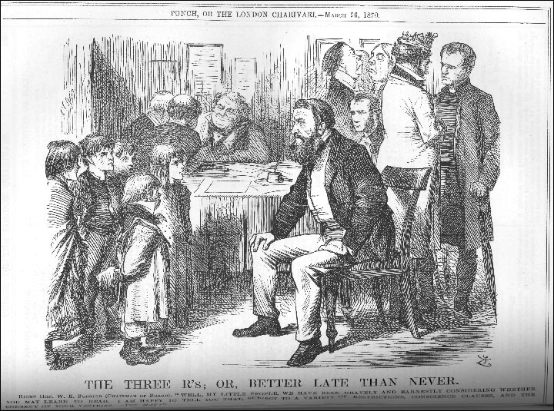
Figure 1 This cartoon was published shortly after the passage of the 1870 Education act with this caption:

THE THREE R's; OR, BETTER LATE THAN NEVER.
RIGHT HON. W.E. FORSTER (CHAIRMAN OF BOARD). "WELL, MY LITTLE PEOPLE, WE HAVE BEEN GRAVELY AND EARNESTLY CONSIDERING WHETHER YOU MAY LEARN TO READ. I AM HAPPY TO TELL YOU THAT, SUBJECT TO A VARIETY OF RESTRICTIONS, CONSCIENCE CLAUSES, AND THE CONSENT OF YOUR VESTRIES - YOU MAY!"
Punch, March 26 1870

Useful links
- Archive Collections at the Newsam Library
- History of Education in England Documents
Over 250 documents including almost all the important reports on education in England and Wales since the 1920s. Other documents include a selection of DES and HMI publications, government circulars, speeches etc. The site includes every significant education act from 1825 to 2010 and various green and white official papers.
- History of Education Seminars at the IOE
- History of Education Society Online Bibliography
- Records of the History of Education Society in the IOE Archives
- Special Collections at the Library
- Victorian Times
- Historical Official Publications at the Library Special Collections
- History Sources (free and subscribed)

Education Reform

1. The Educational Record
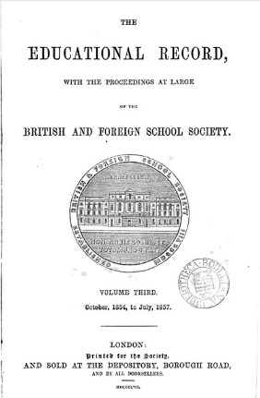
In the early 19th century, elementary schools were mainly sponsored by voluntary societies with strong religious affiliations. The British and Foreign School Society (records now at Brunel University) was the first such society to be formed by religious non-conformists and was the largest such body. They opposed the National Society's insistence on Church of England religious practice as part of elementary education, and fiercely maintained their own separate identity. Their periodical, the Educational Record, includes accounts of their annual meetings and activities. It also became a vehicle for informing teachers of current methods and advising on the best choice of resources; as well as carrying news of changing regulation of education. (See also: Quarterly Educational Magazine and Record of the Home and Colonial Society).

2. Annual Report of the National Society
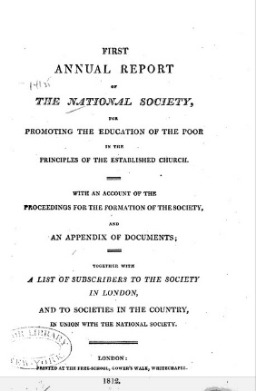
The National Society for Promoting the Education of the Poor in the Principles of the Established Church formed as a rival to the British and Foreign School Society. With its close connection to Church of England parishes it was the largest supplier of elementary school, though many depended upon the enthusiasm of local clergy for financial support. The rivalry between the various religious groupings was held to blame at the time for the difficulty in bringing successful legislation through parliament extending education nationally. The Annual Report, 1812, gives an account of the formation of the society and the activities of some of its earliest schools. (See also: The National Society's Annual Reports).

3. Practical Observations upon the Education of the People: Addressed to the Working Classes and their Employers
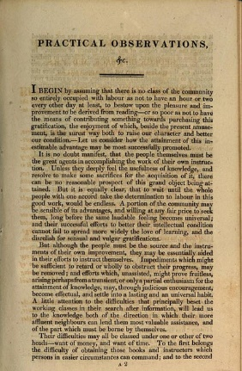
Although the religious societies were the first to undertake the planned expansion of elementary education for the working poor, whether through Sunday Schools, night classes, or elementary schools, there were other reformers who advocated that the State ought to provide and directly fund schools from the early part of the 19th century. Brougham campaigned for education in parliament and also helped establish the Society for the Diffusion of Useful Knowledge. He thought that want of money and want of time stood in the way of the working class acquiring the levels of knowledge they aspired to. The Society for the Diffusion of Useful Knowledge tried to provide cheap and easily accessible reading materials through the Penny Magazine, but its self-improvement mission did not gain it a wide or lasting circulation. (See also the works of Thomas Wyse (1791-1862), an early advocate of education reform).

4. The Social, Educational, and Religious State of the Manufacturing Districts
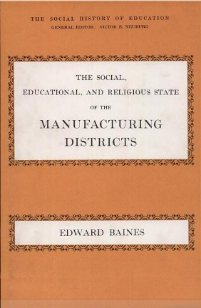
Edward Baines, a Congregationalist, collected and reported statistical data on the uses of literacy as part of his campaign against state involvement in education. He used what we might now call "unobtrusive measures" to establish literacy levels, by reporting increases in the numbers of publications as evidence of increasing literacy levels. Baines' position as a Voluntarist is hard to understand now. But in the first part of the 19th century there was widespread suspicion of the State and little belief that it would operate for the common good rather than seek to impose an unnecessary and tyrannical control over individuals. The State's support for an established church at a time when non-conformists were in the majority heightened this perception. Victor Neuburg, who oversaw the republication of this book in 1969, was a scholar with particular interests in literacy and education whose work signposts a range of primary sources from the 18th and 19th centuries. (See also Neuberg's Popular Education in the Eighteenth Century England, 1971).

5. Tracts on Popular Education
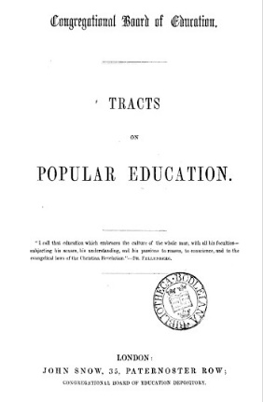
This collection of papers represents the Voluntarists perspective on popular education. A subsection of religious non-conformists, the Voluntarists, were committed to keeping popular education out of state control, a position they argued in the 1840s and 1850s before accepting the idea of state funding for education.

The most significant contributors in this volume are Edward Baines, MP and Edward Miall. Miall was a member of the Newcastle Commission whose report in 1861 led to the introduction of 'payment by results'.

Tracts on Popular Education are available at the Newsam Library and in digitised format from Google Books. See also: Crosby Hall Lectures on Education

6. Education of the Poor in England and Europe
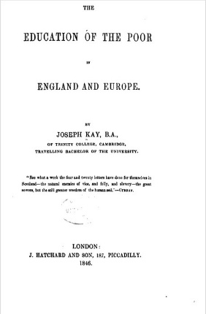
James Kay-Shuttleworth was a campaigner for the provision of education for the poor and saw this as a key element in social reform. He became the first civil servant charged with administering education as Secretary to the Committee of Council on Education. This was a sub-committee of the Privy Council which in 1839 began to grant monies to the religious societies to help support the capital costs involved in building schools. Kay-Shuttleworth devised and introduced the pupil-teacher scheme as a way of improving the monitorial system of education, and began the system of certifying teachers through examination. He resigned the post through ill health in 1849.

Spreading the Word

1. A Comparative View of the Plans of Education
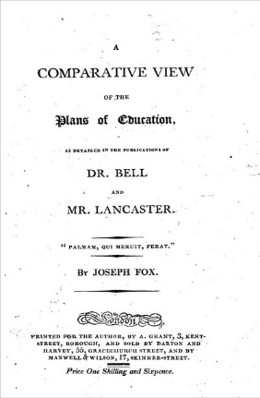
The immediate problem facing those opening schools for the working poor was how to organise such institutions, especially when large numbers of pupils attended irregularly. Most implemented the monitorial system. Promulgated separately by Dr. Bell, an Anglican, who brought the method back from Madras, and Josepeh Lancaster, a non-conformist, this system allowed the teacher to keep oversight of the work of monitors, who in turn took primary responsibility for instructing smaller groups of pupils in tasks the teacher set. The system had the advantage of making large groups manageable with a limited teaching resource. Bell and Lancaster each published their own version of the method, which were variously championed by the main religious groups. This book compares the two approaches. (See also other resources by Andrew Bell and Joseph Lancaster in the Library).

2. Manual of the System of Teaching Reading, Writing, Arithmetic and Needlework in the Elementary Schools
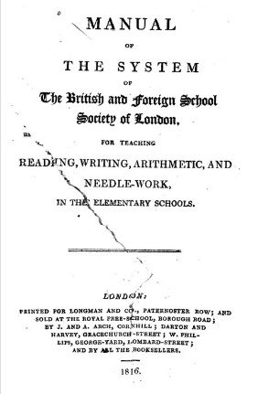
This text is a manual published by the British and Foreign Schools Society to enable its members to set up a school using the monitorial system. It gives guidance on: the appropriate size of building and its layout; the necessary equipment to purchase; how to divide the school into classes; on the organisation of the curriculum and pedagogy; on discipline and rewards; and on the duties of monitors and teachers. This edition was published in Philadelphia. Just as the original system was brought back from Asia, it was then re-exported elsewhere. An early example of policy borrowing? (See also the works of Joseph Lancaster in the Library).

3. The Village School Improved
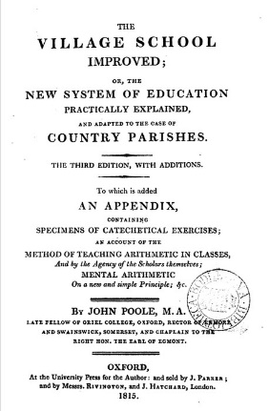
If the manuals gave an idealised version of how to organise and what to do, individuals involved in running schools also began to publish their own accounts of the problems they had encountered, and any modifications they made to the systems they had adopted. This book was written by an early adopter of the monitorial system, who recommended a series of adaptations to make it work well. Such books often give useful details of timetables and curricula. See also Sir Thomas Bernard (1750-1818) and Richard Dawes (1793-1867).

From the Manual of the System for Teaching (1817, BFSS)
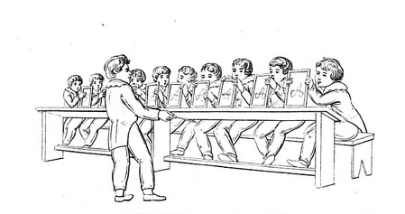
Manual of the system of teaching reading, writing, arithmetic, and needle work
(First American Edition)

4. The Training System of Education
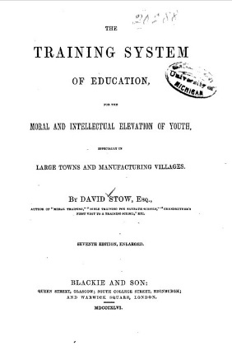
Once teacher training had become accepted as part of the attempt to improve the quality of education on offer, those involved in training teachers began to devise new methods which could enhance outcomes from education. David Stow's ideas represent an attempt to soften the amount of rote learning which had entered educational practice, and enhance the quality of interaction between pupils and the teacher. He introduced the gallery to classrooms to aid this. The system of "simultaneous instruction" which he advocated became very fashionable for a brief period, before also descending into the same problems of mechanical drudgery in implementation which dogged much 19th century practice. Infant schools seemed more open to innovation, and remained a key arena for developing new ideas about working from the child to educational practice rather than vice versa. (see also Samuel Wilderspin's (1791-1866) A system for the education of the young applied to all faculties : founded on immense experience of many thousands of children

The University of London's Senate House Library holds the Samuel Wilderspin Papers.

5. The Pupil Teacher
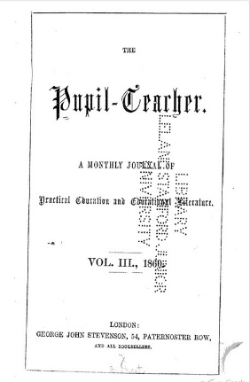
Elementary schools created a teaching profession by virtue of the numbers of staff they employed and the training they undertook. Government certificated teachers came into teaching from the working class, as distinct from those who ran proprietary schools or offered private tutoring services for a middle class clientele. Certificated teachers' training gave them a professional status, and they enjoyed much more secure employment prospects than those offering teaching services privately within working class communities. By the middle of the 19th century many journals had been established to support this new professional market. This one is explicitly aimed at helping pupil teachers with their lesson planning. Originally pupil teachers were appointed for a 5 year paid tenure in exchange for their work in the classroom and were expected to study with their teacher. Many went on to enter teacher training and became certificated teachers. See also L Fletcher (1978) The Teachers' Press in Britain, 1802-1880. The Pupil Teacher, vols. 1-6 (1857-1863) is available in the Library.

Shaping Education

1. Journal of the Royal Statistical Society
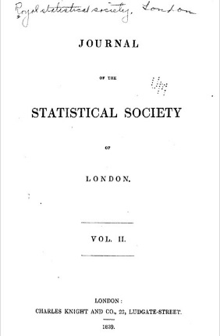
Statistical societies began to form in the 1830s. The first were locally-based and committed to collecting information that might help shape social reform through demonstrating a need, or charting the population in a local area. Statistics were originally regarded as a class of information about the public realm, not necessarily information in numerical form. Some of the earliest statistical reports on education combined quantitative with qualitative methods. They might focus on conducting enquiries door-to-door about family composition and financial resources in an attempt to identify the likely need for educational provision in a specific area. For a list of the main studies, see Phil Gardner's 1984 book The lost elementary schools of Victorian England: the people's education.

2. Transactions of the National Association for the Promotion of Social Science
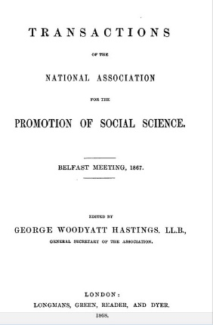
During the second half of the nineteenth century, education became a key topic for organisations and associations interested in fostering social reform and developing a knowledge base from which to act. Women fought their way into many of these associations. The National Association for the Promotion of Social Science had its heyday in the 1850s-60s, when it was particularly concerned to influence policy makers. Later it became a forum for sharing and developing a professional knowledge base about pedagogy. See Science, Reform, and Politics in Victorian Britain by Lawrence Goldman for an account of its activity.

The Transactions are also available in the Library Special Collections.

3. Reformatory schools, for the children of the perishing and dangerous classes, and for juvenile offenders
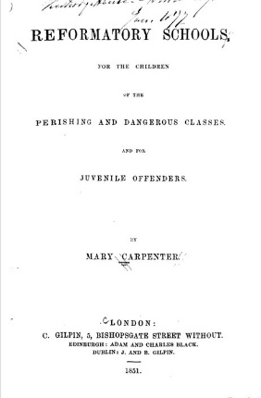
Mary Carpenter (1807-1877) was one of several women who actively campaigned for increased educational provision. She was particularly concerned with those children classed as "street arabs", whose absolute poverty meant they were excluded from ordinary schools, and those who were categorised as juvenile criminals. She established reformatory schools for the latter in her home town, Bristol, and ran a long campaign for funding for Ragged Schools to cater for the former. She presented papers at the British Association for the Advancement of Science and published in the Journal of the Statistical Society of London as part of her attempt to gain wider recognition of the needs of these children. See also Jane Martin and Joyce Goodman's Women and Eduation, 1800-1980 (Macmillan, 2004).
The item is also available in the Newsam Library.

Mary Carpenter: Some Additional Resources
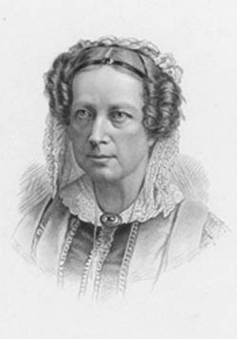
Additional resources on and by Mary Carpenter include:
Juvenile delinquency in its relation to the educational movement
Juvenile Delinquents, Their Condition and Treatment
Mary Carpenter and the children of the streets by Jo Manton
Mary Carpenter, reformatory schools and education
List of journal articles via History of Education Society
The Library's holdings are listed in the Library Catalogue.

Education Policy

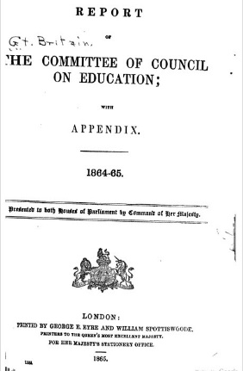
1. Minutes and Annual Reports of the Committee of Council on Education
The Committee of Council on Education was the sub-committee of the Privy Council which was set up to exercise oversight over the monies granted by parliament to the voluntary sector to support the expansion of Elementary Education. This Committee established the system of school inspection, teacher certification and the pupil teacher scheme. Much of its business was reported to parliament as minutes rather than debated. Its activities were recorded in minutes, published annually, which then became The Annual Report. Its publications can be searched online via House of Commons Parliamentary Papers (HCPP).

The Library Special Collections hold the publications of the Committee of Council on Education (1859-1900 in 45 volumes). The publication begins as Report of the Committee of Council on Education and continues as Minutes of the Committee of Council on Education. The title changes again in 1873/74 to: Report of the Committee of Council on Education (England and Wales); and until this date reports also dealt with Scotland.

2. Report of the Commissioners appointed to inquire into the State of Popular Education in England
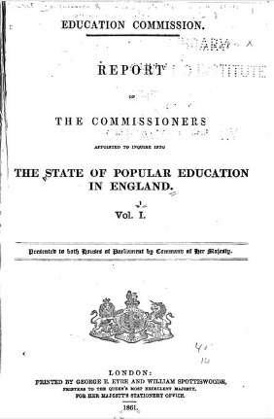
Known as the Newcastle Commission, this parliamentary inquiry was set up following successive defeats in parliament for proposals to establish a national system of education. Six Commissioners investigated the spread of education under the voluntary system with a particular emphasis on "the neglected regions", those areas where voluntary effort had not led to the founding of sufficient schools to serve the needs of the local population. The Commission also conducted a survey of opinions on the value of education and its sufficiency amongst local dignitaries. The Report highlighted the need to provide working class children with a solid grasp of reading and writing by the age of ten, arguing current practice was weak. They recommended using local taxation to fund schools on a payment by results basis. This proposal was not adopted. (See also Speech on National Education by John Russell).

3. Report from the Select Committee on Education, 1865
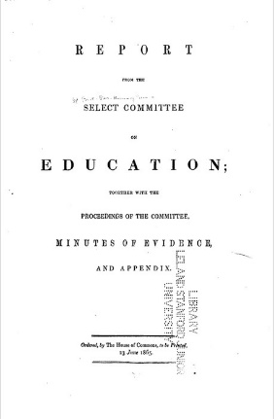
Known as the Pakington Inquiry, this Select Committee was convened under the chairmanship of Sir John Pakington, a Tory MP and campaigner for a national system of education. The Inquiry examined "the constitution of the Committee of Council on Education and the system under which the business of the Office is conducted", including the administration of grants to schools. Amongst others, the Inquiry took evidence from present and former members of the Committee of Council on Education, including Lord Granville and Robert Lowe, who were respectively President and Vice-President of the Committee during the introduction of the policy of "Payment by Results". The Committee also took evidence from Ralph Lingen, Kay Shuttleworth's successor as the Secretary of the Education Office. The evidence reveals the difficulties in administering education under the then system, and gives some insights into the priorities of those most closely involved in the task.

4. Letter to a Country Gentleman on the Education of the Lower Orders (1808)
Published in 1808 by John Weyland (1774-1854), the book mounts an economic argument against state involvement in the supply of education for those too poor to afford to pay for it themselves. The unwillingness to pay was a key element in parliamentary opposition to publicly funding a national education system in the first half of the 19th century. This book was written in response to Samuel Whitbread's unsuccessful attempt to introduce legislation to establish a system of parochial schools in England that would duplicate the system already in place in Scotland. The book was extensively reviewed in contemporary periodicals. Together they encapsulate the range of arguments over education which were voiced at the time and help explain the discursive context that slowed the introduction of a national system of education into England and Wales and maintained the voluntary sector as a key co-funder. Its author, John Weyland, was a barrister and magistrate who briefly became MP for Hindon (1830-32) and in 1811 founded the British Review, and London Critical Journal.

See also, T. Laqueur (1976) Religion and respectability: Sunday schools and working class culture 1780-1850.

The Revised Code

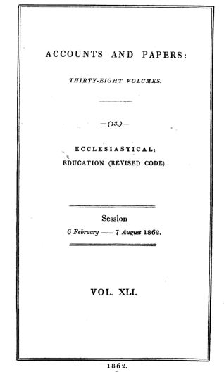
1. The Revised Code
In July 1861, just before the parliamentary recess, Robert Lowe, then Vice President of the Committee of Council on Education, laid a Revised Code before parliament. Building on a previous synthesis of all the regulations that governed schools in receipt of government grants, the Revised Code also introduced without debate a new means of paying schools: Payment by results. In the autumn, as the likely consequences of the change to the funding regime became more widely known, public opposition mounted. In Spring 1862 a series of parliamentary debates led to modifications in Lowe's original proposals. The debates in parliament can be tracked via the Hansard-Millbank digital record.

See also the resources in the Library, including the Revised Code.

2. The Memorialists
Many of those most closely involved in running schools through the voluntary sector organised petitions against the Revised Code. During the parliamentary debate the government was forced to agree to publish all the petitions, known as memorials, in the parliamentary papers. These can be found in the House of Commons Parliamentary Papers.
The Newsam Library has a collection of official documents pertaining to the Revised Code - see Library Catalogue for relevant holdings.

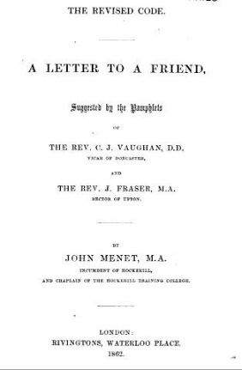
3. Pedagogy and Pamphleteering
Some of the leading educationalists of the day were opposed to Lowe's policy of "Payment by Results", on pedagogical grounds. They argued that Lowe had ignored the conditions in which most schools operated. This contribution to the debate was written by John Menet and published in pamphlet form. It is possible to find collections of these materials bound together to preserve them for future reference. The Robert Quick Memorial Collection at Senate House Library is a good source for these materials which show the range of arguments mounted at this time. Relevant resources in the Library can be found here.

Reading Pedagogy

1. A Guide to the English Tongue
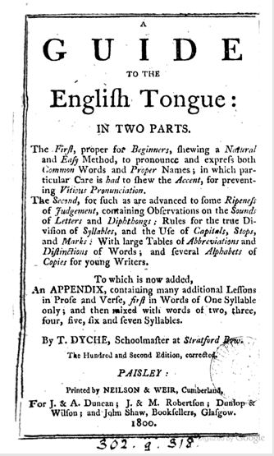
First published in 1707, this speller established the main format used to organise the first stages of learning to read in books of this type, including sub-dividing individual words into syllables. Spellers combined the introduction of vocabulary, definitions of meaning and guides to pronunciation as key elements in learning to read. The author, Thomas Dyche, dedicated the first edition to the Cripplegate Charity School and its pupils. New editions continued to be printed long after his death with the last published edition brought out in 1821. See also, Ian Michael's 1987 book The Teaching of English: from the sixteenth century to 1870.
A facsimile reprint of original ed., London : Butler, 1707 edition of the Dyche is available at the Library Special Collections.

2. The English Spelling-Book
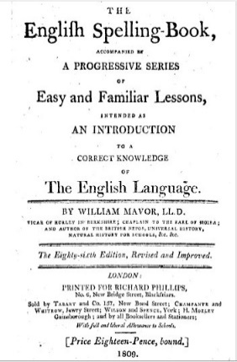
Mavor's English spelling-book was continuously re-issued during the 19th century. Like others of its kind, it acts as an all-in-one manual for learning to read, taking the user from learning the letters, through words of increasing length and complexity, to short passages to read encompassing useful information on topics such as astronomy and history. Its author, William Fordyce Mavor, had worked as a tutor and schoolmaster, and produced a range of textbooks for the emerging school market on different themes.

The Library Special Collections hold a number of editions of this book including the 446th edition published in 1840.

3. The First Book of Lessons for the Use of Schools
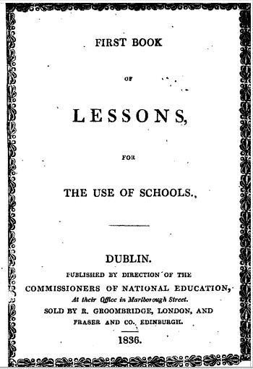
The Books of Lessons produced by the Commissioners for National Education in Ireland were the most widely used series of readers in the mid-19th century. Specially commissioned in order to avoid conflict between Protestant and Catholic communities over how reading was taught in Irish schools, passages chosen for inclusion gave "useful" advice on household and political economy, on running an allotment garden and other topics presumed to be of interest and relevance to the working poor as much as to their children. Backed by government subsidy and published at a discounted rate, the combination of price and the length of the series may well have accounted for their wide distribution. Other publishers complained that this amounted to unfair competition. See also D. Layton's 1973 book, Science for the People, for a detailed assessment of the science content of the Fifth Book of Lessons.

The Library Special Collections has the following holdings of this series:
Lessons for the use of schools. Bk. 2. Sequel no. 1 (1868)
Lessons for the use of schools. Bk. 5 (1863)
Lessons for the use of schools. Bk. 4 (1859)

4. Laurie's Graduated Series of Reading Lesson Books
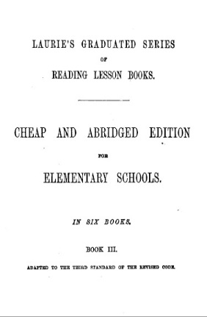
When Robert Lowe introduced the Revised Code, his intention was to ensure that all children leaving school aged ten would be able to read "a short ordinary paragraph in a newspaper or modern narrative". The Revised Code led to the production of a range of textbooks designed to help teachers achieve this objective more efficiently. This often led to a clearer articulation of the author's approach to reading pedagogy, and a more carefully constructed sequence to the way in which reading was taught. Laurie's series of reading books exemplifies this. For an account of the impact of the Revised Code on pedagogy see D. Vincent's "The Domestic and the Official Curriculum in Nineteenth Century England" in Opening the Nursery Door (1997) edited by Mary Hilton, Morag Styles and Victor Watson.

5. The Teacher's Assistant; consisting of lectures in the catechetical form
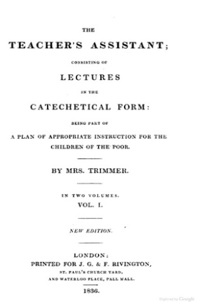
This book is one of a number produced by Mrs Trimmer to help those interested in setting up an elementary school. She offered advice on how to organise purposeful activities in class that are appropriate for the age group and skill levels of the pupils. In this case, the text is organised as a series of lessons intended to help children understand the purpose of the passages they were being asked to read. Although Mrs Trimmer was widely mocked by some of her contemporaries for her religiosity and by a later generation of educationalists for a style of rote learning that had gone out of fashion, at the time she published, the range of her texts showed a much clearer understanding of how children learn than many of her contemporaries. Many of her suggestions focused on engaging children's attention, not just lecturing them as if they were mini adults.
The Library has many of Sarah Trimmer's works, including the periodical she established, Guardian of Education which ran from 1802-1806. A full list of the holdings can be viewed on the Library Catalogue.

Mrs Sarah Trimmer

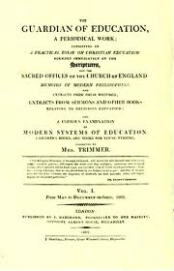
The Guardian of Education was edited by Sarah Trimmer and published from June 1802 to September 1806. The journal has advice by Mrs Trimmer on bringing up children (she was a mother of six boys and six girls herself) and was dedicated to reviewing children's literature.

The Newsam Library has many of Sarah Trimmer's works, including The Guardian of Education. A full list of the holdings can be viewed on the Library Catalogue.

Research Project Blog

http://literacyattainmentdataanddiscourse.blogspot.com/

Thursday, 19 July 2012: Whilst I've been away....
In the intervening interval I've been getting my head round numbers. This is an interesting exercise, and one that has also made very clear to me what the discipline in Disciplines is all about. The actual problem I've been wrestling with is how to make sense of the statistical data I had laboriously collected on "payment by results" from the Committee of Council on Education's Annual Reports, presented to parliament between 1862 and 1872.
The data are really in the form of accounts. They enable parliament to see what monies had been spent on education - so there is always a global sum; how much had gone to which provider - until 1870 these were all religious bodies operating either in Scotland or in England and Wales; and how much of the money had been spent on the categories of staff, buildings or equipment. From 1862 the money handed over for running costs was tied to the numbers of children attending school and whether or not they had been entered for exams, arranged as Standards I-VI. The exams tested reading, writing and arithmetic, or the three Rs, an expression which dates from this period. This is the system known as payment by results.
Dealing with the quantitative data through statistical analysis is a discipline in so far as it entails putting to one side a concern for what the numbers stand for and focusing on what the numbers themselves show. As a person inhabiting a qualitative tradition, this runs counter to most of what I know and do. Leaping over the disciplinary boundary to work in their terms means understanding the discipline built into that other tradition. That's where my ethnographic training comes in, I guess, in terms of trying to understand this other way of going about knowledge-making. It's hard work.
All Disciplines bring some issues into focus whilst dispensing with others. Quantitative traditions are neither more nor less stringent in this respect. But the rules that govern the relationships between what is in focus - only numerical data - are different. One of the things I think I've learnt from struggling with the exercise is quite how aware quantitative traditions are of the uncertainty built into the numbers; and the inherently constructed nature of the numbers that represent the data in the analysis. Precisely because they know the numbers can be used to assert many different things, the discipline of statistics has an enormous number of rules about how the numbers can be used, and what the results of the analysis can be taken for. Indeed, they recognise very clearly that the analysis creates the findings. You could argue that it's the caution in the discipline that determines the genre to the written account: the way the findings get written up with an emphasis on exactly how data reduction and then the analysis have been conducted that is seldom matched within qualitative traditions.
One further insight that flows from this is the misuse of quantitative data in public discourse. In public discourse the inherent uncertainty in the numbers is overlooked and ignored. Public discourse turns numbers into "facts". How far statistics itself is aware of what happens when their work travels in this way across the boundaries to their specialised knowledge field elsewhere is for me an interesting question.

Friday, 9 December 2011: Reading the past...
This week I've been reading my way through the parliamentary debate on payment by results. I've also been looking at large part of the public commentary on the measures, including the representations made to parliament whilst they were still being debated. One of the most striking feature of making my way through this material is how well the case is argued on both sides. Yet in a curious way they also seem to be talking past each other. Each side invokes the case it wishes to fight against, constructing a kind of shadow argument it then takes apart point by point. There is a mobilisation of tropes and rhetorical strategies that makes the other side's position look untenable. This leads to a schizophrenic reading experience as I find myself agreeing first with one side, then the other. Yet I also think this has got me closer to resolving some of the methodological issues I've been thinking about. Not by coming down on one side or another, but rather by spotting the residual and unspoken issues that seem to the rest at the heart of the debate.
In this case one of the points that seems most striking is the repeated difficulty of pinning down what people mean by "reading". I think there are two different versions in play: reading as the basic skill - the knowledge of letters and their combination into syllables and whole words which can be tested through reading aloud. And reading as the voyage through texts that happens once the basic skill has been acquired, and the kind of knowledge that can be built by browsing in this way. In the debates on payment by results these are variously invoked, with little shared understanding of who is really talking about which one, when. This confusion seems to me to run through the opposition to payment by results; but it also runs through pedagogical thinking and the resources and materials currently in place to teach reading. I find myself seeing something that those participating in the debate at the time rarely fully articulate. If I can get this written up then I may finally be doing history

Saturday, 3 December 2011: Some more on methodology
One of the best things about doing a blog is being able to write what you like as and when. I do have a plan to write about Mrs Trimmer, but at the moment I want to stick with a bit more thinking about history and methodology. I’ve been having some off-blog chat with Judith Green (See comments from Judith on the very first post below), touching on this issue, and she’s very kindly sent me a couple of papers which I aim to read this weekend. But in the meanwhile, here’s the actual methodological problem I seem to be wrestling with in the process of writing up the interaction between “payment by results” and literacy pedagogy.

When I write social science, or ethnography, I’m normally structuring what I have to say around the concepts that have evolved from the data – so somewhere lurking behind the writing is a pile of unsorted stuff, which in the process of analysis has fallen into sharp categories, which I can now define according to a relatively explicit set of principles – probably turns out that way through a combination of learning to be an ethnographer of social context from Brian Street and learning how to formalise the relations between data from Basil Bernstein. I know I get to quite tight theoretical formulations from applying Bernsteinian principles of languages of description to what I do.

But here’s the thing: historical data doesn’t seem to be amenable to being used that way. I’m beginning to see that “low-level description” has a clear function within the discipline in a way that I would reject in social science. In other words, it’s the unboundedness of historical data that matters. And when it gets wrapped up in someone else’s too tight categories, the lens distorts rather than liberates the data. This is making the act of writing very hard because – just when I think I’ve nailed something, I end up checking whether I’ve got it right, and return to the data, which however I’ve defined the data set, then tries to creep back out into more than one category. In other words, it is not the discursive unity of the past that surprises me, it’s its resistance to being pinned down. It’s more diverse and contradictory than the big narratives we’d like to tell about it allow. Positively post-structuralist in its resistance to staying in a single shape.

Monday, 28 November 2011: "A profusion of entangled events"
I've taken to this quote from Foucault. It sums up pretty much how I think about my swim through history - tangled up and confused as the past often seems to be. Here's the longer version:

"The world such as we are acquainted with it is not this ultimately simple configuration where events are reduced to accentuate their essential traits, their final meaning, or their initial and final value. On the contrary, it is a profusion of entangled events.... the true historical sense confirms our existence among countless lost events, without a landmark or a point of reference.

Historians take unusual pains to erase the elements in their work which reveal their grounding in a particular time and place, their preferences in a controversy - the unavoidable obstacles of their passion." ~ Foucault, 1994.

The quotations come from Foucault’s essay, Nietzsche, Genealogy, History. The first certainly sums up the trouble visiting the 19th century seems to be causing me. The second remains an interesting counterbalance to the silence in the literature on historical method. Certainly the major nineteenth century historiography itself increasingly seems wedded to the point at which it was created between the 1970s and 80s. More recent work takes another tack, looking at a different range of actors from another point of view. Foucault's point was not that historians could escape the dilemma of always writing from now, but rather that they should be upfront about their interests in re-working the past - whilst also allowing the past to speak back to us in its own terms. I guess that is the research dilemma I'm wrestling with.

Saturday, 19 November 2011: Of Battledores, Hornbooks and Spelling Books
This week I’ve been browsing around the net looking for examples of battledores and hornbooks. The net is a really good resource for doing this. They’re some of the earliest resources made for teaching children how to read. The hornbooks came first. They typically just have the alphabet, some simple vowel/consonant combinations and then the Lord’s Prayer. The Battledores were an eighteenth century innovation. Made out of cardboard some were highly coloured, and the alphabets were typically illustrated too, one woodblock picture for a word illustrating each letter. This site gives a good range of examples
http://mulibraries.missouri.edu/specialcollections/exhibits/childrenliterature/Horn.htm

Looking around the net for images, it turns out this is a blogging hotspot. I like the way the net gets used like this to map and share enthusiasms. I can’t quite think what the antecedent might be. There is no obvious equivalent that would facilitate this kind of display of the objects and the commentary. Except of course a book, which would have been much more expensive to produce and would once have put this kind of exercise out of most people’s hands. I can remember from my A Level course on Tudor and Elizabethan history, when we did a paper on Elizabethan architecture that style books containing ideas for design motifs were widely circulated, and influenced what and how people chose to decorate their buildings. Did they also represent a different kind of demarcation line between professional and amateur knowledge? Maybe that is part of what is in flux: changes in technologies provide different possibilities for knowledge exchange, diffusion and appropriation.

Friday, 11 November 2011: On blogging and telling tales
There seem to be three rules to blogging
1. Keep it short
2. Write often
3. Have something to say
So far I seem to be breaking the rules. Well here's my second offer, sparked off by reading an extract from Jeanette Winterson's autobiography in the Guardian Weekend Review, which set me off thinking about history.
In commenting on her first fictionalised account of her early life, Winterson said "adoption drops you into the story after it has started. It's like reading a book with the first few pages missing. It's like arriving after curtain up. The feeling that something is missing never leaves you - and it can't, and it shouldn't because something is missing. It's why I am a writer - I don't say "decided" to be, or "became". It was not an act of will or even a conscious choice. To avoid the narrow mesh of Mrs Winterson's story I had to be able to tell my own."
There is a general truth here about the stories we tell about ourselves, and the difficulty we have in disentangling them from others that run alongside or threaten to displace our own. This seems equally true of history. Reading back into the nineteenth century primary sources, I find myself stumbling over a multitude of others' stories, whose shapes I cannot fully understand, nor fully trace. Where to look to discover the start or find the end? Pulling at one thread, others unravel alongside.
I am not sure if this is a product of coming to the discipline from other traditions, or whether it is a recognised problem within history. Certainly dealing with the secondary sources intensifies the problem. Data is there, clues are scattered, but they are already tied into a particular sequence and narrative frame. How to reframe the evidence without arguing back. Does history deal with this as a methodological problem and if so how? I can't find these points directly addressed within the discipline, though the potential truth of the many different kinds of stories created are openly acknowleged. I'm intrigued to know if historians would recognise the dilemma or have a response to my questions.

Wednesday, 19 October 2011: Welcome to the LADD blog
The Literacy Attainment, Data and Discourse fellowship has been going for just over six months now. During that time I've read my way into what I now see as "my period" in history: the 1780s - 1860s. This is quite a peculiar place to have ended up, given that I am not a historian by training, and expected the LADD project to focus on a later period in the nineteenth century, the 1860s to 1890s.

So how did I get to here? Partly thanks to Michele Cohen, the historian I have been working with for the Fellowship. I had discovered and very much enjoyed her work on the variety of explanations and hypotheses that underpin public discourse on boys’ and girls’ relative educational attainment at different time periods (Cohen, 1998, 2005). Knowing that I lacked any background in history as a discipline, I asked Michele if she would provide specialist advice to the project on the study of educational attainment in its historical context, including the use of primary sources. She was written into an advisory role at the application stage.
Michele is a specialist on the long 18th century, and in our first conversation for the project she showed me some extracts from Priscilla Wakefield and Clara Reeve's writing on education (Wakefield, 1798; Reeve, 1792). These looked so different from the kind of texts I had been reading from much later in the 19th century, that they began to suggest a very different approach to understanding why public debate on education conducted in the late 19th century looked the way it did.
Most of the historical analysis of education in the 19th century focuses on the rise of a publicly funded education system which adopts the basic forms we still find: an age-related structure organised in three parts: primary, secondary, and higher education, with an entry point at 4/5 yrs, transition points at 11 and 16, and exit points now extended to roughly 18 and 22. Organisation by age is far less widely regarded as a legacy of the nineteenth century than organisation into differentiated pathways through the curriculum at 11. In particular the assumption is that the classed origins of education in the nineteenth century spills over and shapes the distinctions in curricular access written into the grammar school system, and still expressed in the sharp divide between vocational and academic routes through education that persists to this day.
The classed origins of the system in the nineteenth century are linked to the emergence of elementary education as an institutional arrangement designed for the poor. From this point of view the history of the formation of a publicly funded education system records the on-going attempt by the middle classes to constrain access to education, and maintain their own distinct class position. Attempts to thwart this and enlarge access for all on equal terms recur in the battles led by progressives and radicals which successively take place: over establishing the board schools in the nineteenth century; in opposition to the grammar school/secondary modern system in the 50s and 60s; up until the establishment of a comprehensive system of secondary education in the 1970s. This highpoint is now under attack from neo -liberal policies that seek to privatise education, fragment and exacerbate competition for scarce educational resources, and turn the clock back to a point before the State intervened for the public good. The ideological and material battle goes on.
The 18th century texts of Reeves and Wakefield complicate this story, not because of their radicalism, but rather precisely because of the nature of their conservatism. In particular, this older discourse expresses a very different view of what counts as knowledge, how it should be ordered and owned, and who is entitled to access it under what terms. To recast this argument in Bernsteinian terms, there is a different knowledge-knower relationship embedded in the discourse (Maton, 2007). This makes it possible to recognise that the (re)founding of new educational institutions during the early 19th century, their diverse forms of social organisation and curricula, the various permutations that are first tried out and then begin to settle, all represent part of a far more seismic shift in ideas, resources and social structures happening at the same time, that continues well on into the first half of the 19th century. What happens to elementary education in its organisational form - a building, a social entity, the relations it embeds and begins to cement between interested parties, the forms of knowledge it encompasses - plays out in relation to much larger shifts, one of which sees the middle class we recognise, and the professional and managerial roles they now occupy within the economy, come into being (See Hunter, 1988 for a longer exposition on this point). The middle class are not already in place, thwarting educational progress, rather they emerge alongside a more mobile working class as the economy itself re-structures through the application of new forms of knowledge to processes of production and industry. This produces a very different point of comparison between then and now. Arguably we are now witnessing something very similar at the start of the 21st century as the internet and computing power re-order working practices into new forms and challenge older ways of knowing.
Something of the high risks and high uncertainty of the late 18th century and their capacity to generate high levels of innovation in many different spheres, are now beginning to be (re)recognised and fruitfully explored in new terms across a range of academic literatures, most notably in literary and cultural studies (Goodlad, 2000; Janowitz,2004 ; Rauch, 2001); in feminist history (Cohen, 1998; Hilton, 2007; Watts, 1989) and in histories of publishing, print media and children's literature (Fyfe, 2004; Hilton, 1997; Lightman, 2000; Grenby, 2005; Myers, 1986; Ruwe, 2005; Norcia, 2010) . Much of this work is cross-disciplinary in character, and has used feminist and post-structuralist approaches to interrogate the texts they select whether in the form of poetry, children’s literature, educational texts and textbooks or polemical and religious tracts (Janowitz, 2004; Myers, 1986; Grenby, 2005; Ruwe, 2005; Cohen, 2005; Norcia, 2010; Butts and Garrett, 2006). Despite renewed interest in the history of the curriculum (Tröhler et al, 2011; Monaghan and Saul, 1987; Green and Cormack, 2008), education as a field has been at the margins rather than the centre of this conversation.
This work suggests a new set of analytic and conceptual tools through which to approach the primary sources.
The biggest challenge I've faced in the project so far has been reading my way into the nineteenth century. It's too big and too vast to make much of a dent on the available primary sources within the available time frame without being highly selective. The sampling principles that history most commonly deploys are to select a case - an individual; a site - and scope the primary sources accordingly; or to follow a story already told, reviewing the source literature and looking for new evidence. Following the latter approach would place my 19th century case - the use of statistics by the Committee of Council on Education (CCE), the funding body for education prior to the establishment of a proper Department of State - within a broader story of the history of the emergence of publicly funded state education, waged as an ideological battle for or against extending education within the parliamentary process. Approach the questions the CCE was considering from the point of view of the earlier period, leaving open how these may later resolve themselves, and the enquiry takes on a different complexion.
In particular it has meant reframing my understanding of the introduction of payment by results in 1862. In the conventional historiography this is a decisive policy event which has a pernicious effect on the future development of a publicly-funded education system, trapping elementary education for the poor into a restrictive model of the curriculum tightly focused on the three Rs, and designed to be cheap. Lowe's maxim, "If it is not cheap it shall be efficient; if it is not efficient it shall be cheap" - a phrase he used in parliamentary debate on 13th Feb 1862 - is widely used to sum up the policy. Yet this is to overlook two more crucial innovations he introduced in the Revised Code: the concept of successive "Standards" in the curriculum; and the idea of age-grouping pupils - the latter proposal was defeated in the debate, leaving schools to sub-divide students into proficiency groupings. Arguably, these two proposals have had far more far-reaching effects on schooling than did the change in the mechanism for publicly funding those schools that applied for government grants at the time. Exploring how these concepts arose, were understood, applied, and debated in contemporary sources has become a key part of this study. Such an exploration places literacy attainment firmly back in the social context of contemporary discourse, exactly as the study intended. But shifts the focus very much to the processes of curriculum change taking place at this time.
Uncertainty in the early nineteenth century over what the elementary curriculum should look like cannot be answered at this point by reference to a middle class curriculum. The terms in which the latter were defined in the late 18th century were themselves being rendered redundant as new kinds of knowledge, making greater claims for their use value, were emerging and circulating outside the confines of formal education and the classical curriculum that still dominated provision for the (male) middle class. Understanding the role elementary education played in resolving these issues means revisiting some of the existing sources, but in the light of new questions. Statistics, as an emerging discourse of "useful knowledge" in the nineteenth century, provides another light on the unsettling of the old and the formation of the new. It's strengthening and shaping as a discipline and form of enquiry within what begins to call itself the social sciences parallels the attempt to define a relevant curriculum for the new elementary schools in terms that radically re-order and revise the older forms of curricular knowledge locked into earlier models of educational provision to be found elsewhere.
The Fellowship continues to scrutinise and understand hypothesis-building within statistical approaches in the quantitative social sciences. But in its historical phase this enquiry now also focuses on a broader set of concerns rooted in the sociology of knowledge, and given new impetus by reaching back to a period before a mass education system was clearly envisaged or fully worked out.
The blog opens up this starting point for comment. Setting an ethnographer loose on historical data may be asking for trouble... I'd be interested to know how this proposition reads to those coming to this from different perspectives.
References
BUTTS, D and Garrett, P. (2006) From the dairyman's daughter to Worrals of the WAAF: the Religious Tract Society, Lutterworth Press, and children's literature. Cambridge: The Lutterworth Press.

COHEN, M. (1998) `A habit of healthy idleness`: boys’ underachievement in historical perspective. In D. Epstein et al (eds) Failing Boys: Issues in Gender and Achievement. Buckingham: Open University Press.
COHEN, M. (2005) Language and meaning in a documentary source: girls' curriculum from the late eighteenth century to the Schools Inquiry Commission, 1868, History of Education, 34:1, pp. 77-93.
FYFE, A. (2004) Science and salvation: evangelical popular science publishing in Victorian Britain. London: University of Chicago Press.
GOODLAD, L.M.E. (2000) "A Middle Class Cut into Two": Historiography and Victorian National Character ELH, Vol. 67, No. 1 , pp. 143-178.
GREEN, B. & Cormack, C. (2008) Curriculum history, ‘‘English’’ and the New Education; or, installing the empire of English?, Pedagogy, Culture & Society, 16:3, pp. 253-267.
GRENBY, M.O. (2005) “‘A Conservative Woman Doing Radical Things’: Sarah Trimmer and The Guardian of Education.” Culturing the Child, 1690–1914. Ed. Donelle Ruwe. Lanham, MD: Scarecrow Press.
HILTON, M. (2007) Women and the Shaping of the Nation's Young: Education and Public Doctrine 1750-1850, Aldershot: Ashgate Publishing.
HILTON, M., Styles, M., and Watson, V. (eds) (1997) Opening the Nursery-Door: Reading, Writing and Childhood 1600-1900. London: Routledge.

JANOWITZ, A. (2004) Women Romantic Poets: Anna Barbauld and Mary Robinson. Tavistock, Devon: Northcote House.
HUNTER, I. (1988) Culture and Government. London: Macmillan.
LIGHTMAN, B. (2000) The Story of Nature: Victorian Popularizers and Scientific Narrative Victorian Review Vol. 25:2, pp. 1-29.

MATON, K. (2007) Knowledge-knower structures in intellectual and educational fields in Christie, F. & Martin, J. (Eds.) Language, Knowledge and Pedagogy: Functional linguistic and sociological perspectives. London, Continuum, pp. 87-108.
MONAGHAN, J. and Saul, W. (1987) The Reader, the Scribe, the Thinker: A Critical Look
at Reading and Writing Instruction, in The Formation of the School Subjects: The Struggle
for Creating an American Institution, ed. Thomas S. Popkewitz New York: Falmer Press, pp. 85–122.
MYERS, M. (1986) Impeccable Governesses, Rational Dames, and Moral Mothers: Mary Wollstonecraft and the Female Tradition in Georgian Children's Books. Children's Literature - Volume 14, pp. 31-59.
NORCIA, M.A. (2010) X Marks the Spot: Women Writers Map the Empire for British Children, 1790-1895. Athens, Ohio: Ohio University Press.
RAUCH, A. (2001) Useful Knowledge: The Victorians, Morality, and the March of the Intellect. London: Duke University Press.

REEVE, Clara (1792) Plans of Education; with remarks on the systems of other writers, in a series of letters between Mrs Darnford and her friends. London, printed for T Hookham, and J. Carpenter.
RUWE, D (2005) Culturing the Child, 1690–1914. Lanham, MD: Scarecrow Press.
Tröhler, D., Popkewitz, T. S. and Labaree, D.F. (eds) (2011) Schooling and the making of citizens in the long nineteenth century: comparative visions. New York; London: Routledge, 2011.

WATTS, R. (1989) Knowledge is Power: Unitarians gender and education in the eighteenth and early nineteenth century. Gender and Education. Vol: 1 pp. 35-50.
WAKEFIELD, Priscilla. (1798) Reflections on the present condition of the female sex with suggestions for its improvement. London, printed for J. Johnson and Darnton and Harvey.

