Literacy Attainment: Historical Resources

The Revised Code

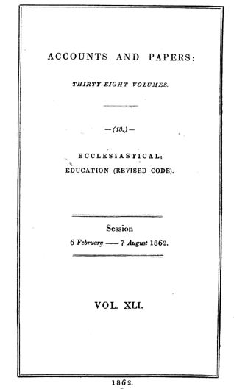
1. The Revised Code
In July 1861, just before the parliamentary recess, Robert Lowe, then Vice President of the Committee of Council on Education, laid a Revised Code before parliament. Building on a previous synthesis of all the regulations that governed schools in receipt of government grants, the Revised Code also introduced without debate a new means of paying schools: Payment by results. In the autumn, as the likely consequences of the change to the funding regime became more widely known, public opposition mounted. In Spring 1862 a series of parliamentary debates led to modifications in Lowe's original proposals. The debates in parliament can be tracked via the Hansard-Millbank digital record.

See also the resources in the Library, including the Revised Code.

2. The Memorialists
Many of those most closely involved in running schools through the voluntary sector organised petitions against the Revised Code. During the parliamentary debate the government was forced to agree to publish all the petitions, known as memorials, in the parliamentary papers. These can be found in the House of Commons Parliamentary Papers.
The Newsam Library has a collection of official documents pertaining to the Revised Code - see Library Catalogue for relevant holdings.

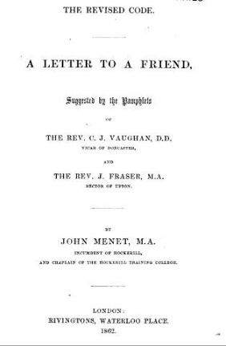
3. Pedagogy and Pamphleteering
Some of the leading educationalists of the day were opposed to Lowe's policy of "Payment by Results", on pedagogical grounds. They argued that Lowe had ignored the conditions in which most schools operated. This contribution to the debate was written by John Menet and published in pamphlet form. It is possible to find collections of these materials bound together to preserve them for future reference. The Robert Quick Memorial Collection at Senate House Library is a good source for these materials which show the range of arguments mounted at this time. Relevant resources in the Library can be found here.

