Literacy Attainment: Historical Resources

Spreading the Word

1. A Comparative View of the Plans of Education
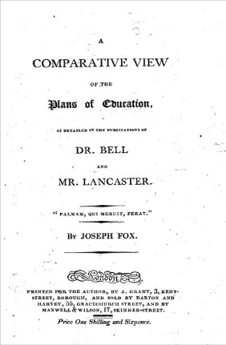
The immediate problem facing those opening schools for the working poor was how to organise such institutions, especially when large numbers of pupils attended irregularly. Most implemented the monitorial system. Promulgated separately by Dr. Bell, an Anglican, who brought the method back from Madras, and Josepeh Lancaster, a non-conformist, this system allowed the teacher to keep oversight of the work of monitors, who in turn took primary responsibility for instructing smaller groups of pupils in tasks the teacher set. The system had the advantage of making large groups manageable with a limited teaching resource. Bell and Lancaster each published their own version of the method, which were variously championed by the main religious groups. This book compares the two approaches. (See also other resources by Andrew Bell and Joseph Lancaster in the Library).

2. Manual of the System of Teaching Reading, Writing, Arithmetic and Needlework in the Elementary Schools
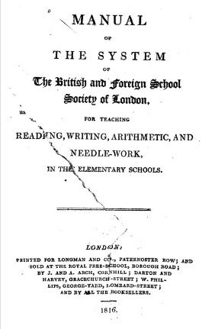
This text is a manual published by the British and Foreign Schools Society to enable its members to set up a school using the monitorial system. It gives guidance on: the appropriate size of building and its layout; the necessary equipment to purchase; how to divide the school into classes; on the organisation of the curriculum and pedagogy; on discipline and rewards; and on the duties of monitors and teachers. This edition was published in Philadelphia. Just as the original system was brought back from Asia, it was then re-exported elsewhere. An early example of policy borrowing? (See also the works of Joseph Lancaster in the Library).

3. The Village School Improved
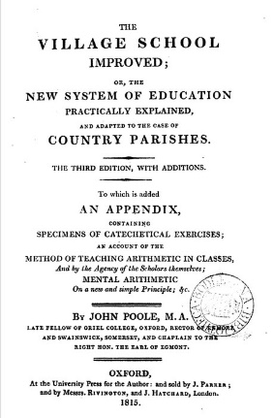
If the manuals gave an idealised version of how to organise and what to do, individuals involved in running schools also began to publish their own accounts of the problems they had encountered, and any modifications they made to the systems they had adopted. This book was written by an early adopter of the monitorial system, who recommended a series of adaptations to make it work well. Such books often give useful details of timetables and curricula. See also Sir Thomas Bernard (1750-1818) and Richard Dawes (1793-1867).

From the Manual of the System for Teaching (1817, BFSS)
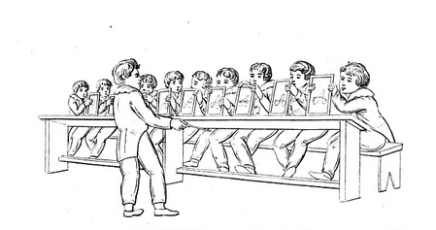
Manual of the system of teaching reading, writing, arithmetic, and needle work
(First American Edition)

4. The Training System of Education
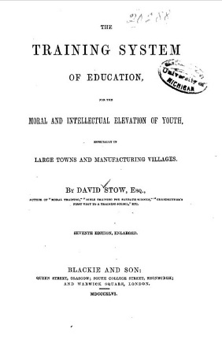
Once teacher training had become accepted as part of the attempt to improve the quality of education on offer, those involved in training teachers began to devise new methods which could enhance outcomes from education. David Stow's ideas represent an attempt to soften the amount of rote learning which had entered educational practice, and enhance the quality of interaction between pupils and the teacher. He introduced the gallery to classrooms to aid this. The system of "simultaneous instruction" which he advocated became very fashionable for a brief period, before also descending into the same problems of mechanical drudgery in implementation which dogged much 19th century practice. Infant schools seemed more open to innovation, and remained a key arena for developing new ideas about working from the child to educational practice rather than vice versa. (see also Samuel Wilderspin's (1791-1866) A system for the education of the young applied to all faculties : founded on immense experience of many thousands of children

The University of London's Senate House Library holds the Samuel Wilderspin Papers.

5. The Pupil Teacher
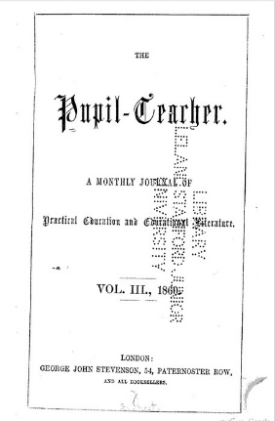
Elementary schools created a teaching profession by virtue of the numbers of staff they employed and the training they undertook. Government certificated teachers came into teaching from the working class, as distinct from those who ran proprietary schools or offered private tutoring services for a middle class clientele. Certificated teachers' training gave them a professional status, and they enjoyed much more secure employment prospects than those offering teaching services privately within working class communities. By the middle of the 19th century many journals had been established to support this new professional market. This one is explicitly aimed at helping pupil teachers with their lesson planning. Originally pupil teachers were appointed for a 5 year paid tenure in exchange for their work in the classroom and were expected to study with their teacher. Many went on to enter teacher training and became certificated teachers. See also L Fletcher (1978) The Teachers' Press in Britain, 1802-1880. The Pupil Teacher, vols. 1-6 (1857-1863) is available in the Library.

