Literacy Attainment: Historical Resources

Education Reform

1. The Educational Record
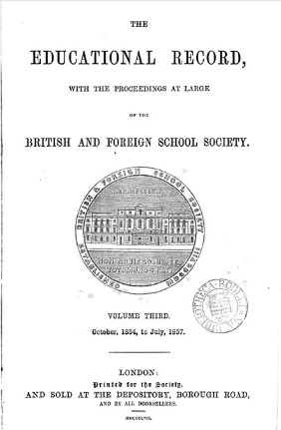
In the early 19th century, elementary schools were mainly sponsored by voluntary societies with strong religious affiliations. The British and Foreign School Society (records now at Brunel University) was the first such society to be formed by religious non-conformists and was the largest such body. They opposed the National Society's insistence on Church of England religious practice as part of elementary education, and fiercely maintained their own separate identity. Their periodical, the Educational Record, includes accounts of their annual meetings and activities. It also became a vehicle for informing teachers of current methods and advising on the best choice of resources; as well as carrying news of changing regulation of education. (See also: Quarterly Educational Magazine and Record of the Home and Colonial Society).

2. Annual Report of the National Society
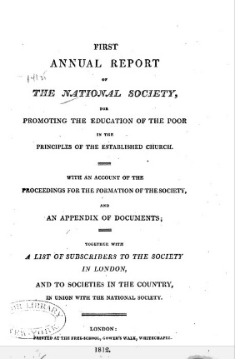
The National Society for Promoting the Education of the Poor in the Principles of the Established Church formed as a rival to the British and Foreign School Society. With its close connection to Church of England parishes it was the largest supplier of elementary school, though many depended upon the enthusiasm of local clergy for financial support. The rivalry between the various religious groupings was held to blame at the time for the difficulty in bringing successful legislation through parliament extending education nationally. The Annual Report, 1812, gives an account of the formation of the society and the activities of some of its earliest schools. (See also: The National Society's Annual Reports).

3. Practical Observations upon the Education of the People: Addressed to the Working Classes and their Employers
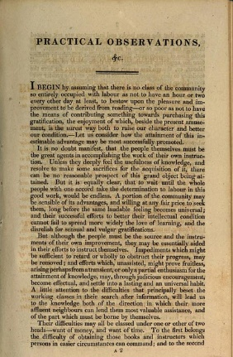
Although the religious societies were the first to undertake the planned expansion of elementary education for the working poor, whether through Sunday Schools, night classes, or elementary schools, there were other reformers who advocated that the State ought to provide and directly fund schools from the early part of the 19th century. Brougham campaigned for education in parliament and also helped establish the Society for the Diffusion of Useful Knowledge. He thought that want of money and want of time stood in the way of the working class acquiring the levels of knowledge they aspired to. The Society for the Diffusion of Useful Knowledge tried to provide cheap and easily accessible reading materials through the Penny Magazine, but its self-improvement mission did not gain it a wide or lasting circulation. (See also the works of Thomas Wyse (1791-1862), an early advocate of education reform).

4. The Social, Educational, and Religious State of the Manufacturing Districts
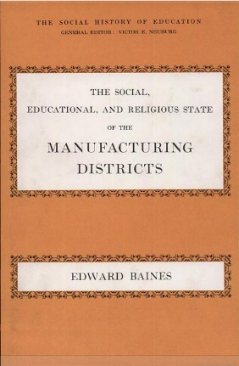
Edward Baines, a Congregationalist, collected and reported statistical data on the uses of literacy as part of his campaign against state involvement in education. He used what we might now call "unobtrusive measures" to establish literacy levels, by reporting increases in the numbers of publications as evidence of increasing literacy levels. Baines' position as a Voluntarist is hard to understand now. But in the first part of the 19th century there was widespread suspicion of the State and little belief that it would operate for the common good rather than seek to impose an unnecessary and tyrannical control over individuals. The State's support for an established church at a time when non-conformists were in the majority heightened this perception. Victor Neuburg, who oversaw the republication of this book in 1969, was a scholar with particular interests in literacy and education whose work signposts a range of primary sources from the 18th and 19th centuries. (See also Neuberg's Popular Education in the Eighteenth Century England, 1971).

5. Tracts on Popular Education
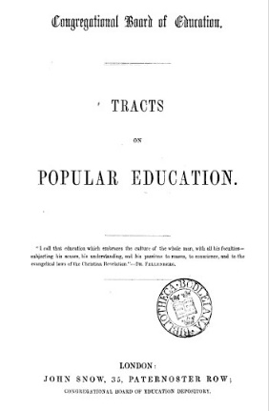
This collection of papers represents the Voluntarists perspective on popular education. A subsection of religious non-conformists, the Voluntarists, were committed to keeping popular education out of state control, a position they argued in the 1840s and 1850s before accepting the idea of state funding for education.

The most significant contributors in this volume are Edward Baines, MP and Edward Miall. Miall was a member of the Newcastle Commission whose report in 1861 led to the introduction of 'payment by results'.

Tracts on Popular Education are available at the Newsam Library and in digitised format from Google Books. See also: Crosby Hall Lectures on Education

6. Education of the Poor in England and Europe
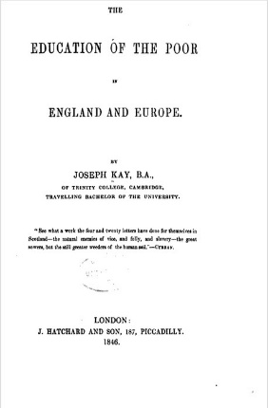
James Kay-Shuttleworth was a campaigner for the provision of education for the poor and saw this as a key element in social reform. He became the first civil servant charged with administering education as Secretary to the Committee of Council on Education. This was a sub-committee of the Privy Council which in 1839 began to grant monies to the religious societies to help support the capital costs involved in building schools. Kay-Shuttleworth devised and introduced the pupil-teacher scheme as a way of improving the monitorial system of education, and began the system of certifying teachers through examination. He resigned the post through ill health in 1849.

