Literacy Attainment: Historical Resources

Welcome

About this guide
This guide provides an overview of the different kinds of resources available to track the expansion of elementary education through the voluntary sector at the start of the 19th century, the increasing involvement of the state in its funding and organisation, as well as the development of a professional knowledge base to support these activities. Over this period the resources for literacy teaching in use in schools changed, developing in tandem with the growth of the elementary sector and the specific pedagogic challenges it poses for teaching.

The guide represents a selection of the historical resources used by Professor Gemma Moss for her ESRC Fellowship on Literacy Attainment and Data Discourse.

To see the digitised resource, click on the image of the work being discussed. There are links to the Library's Special Collections scattered throughout the guide as well as links to relevant resources held at Senate House, the University of London's main library. The URL link to the current live guide is found here: https://libguides.ioe.ac.uk/literacyattainment.

Literacy Attainment 1800-1872
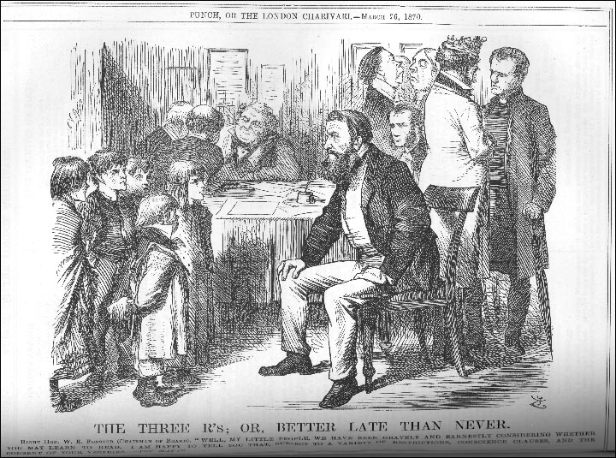
Figure 1 This cartoon was published shortly after the passage of the 1870 Education act with this caption:

THE THREE R's; OR, BETTER LATE THAN NEVER.
RIGHT HON. W.E. FORSTER (CHAIRMAN OF BOARD). "WELL, MY LITTLE PEOPLE, WE HAVE BEEN GRAVELY AND EARNESTLY CONSIDERING WHETHER YOU MAY LEARN TO READ. I AM HAPPY TO TELL YOU THAT, SUBJECT TO A VARIETY OF RESTRICTIONS, CONSCIENCE CLAUSES, AND THE CONSENT OF YOUR VESTRIES - YOU MAY!"
Punch, March 26 1870

Useful links
- Archive Collections at the Newsam Library
- History of Education in England Documents
Over 250 documents including almost all the important reports on education in England and Wales since the 1920s. Other documents include a selection of DES and HMI publications, government circulars, speeches etc. The site includes every significant education act from 1825 to 2010 and various green and white official papers.
- History of Education Seminars at the IOE
- History of Education Society Online Bibliography
- Records of the History of Education Society in the IOE Archives
- Special Collections at the Library
- Victorian Times
- Historical Official Publications at the Library Special Collections
- History Sources (free and subscribed)

