Vertebrate Diversity study pack

The following web-book contains a series of information chapters broadly outlining the diversity of living vertebrates, with a few notes on their fossil relatives. Below is a collage of specimens from UCL's Grant Museum of Zoology illustrating the wide diversity covered in this web-book – from jawless vertebrates, sharks, and ray-finned fishes, to amphibians, reptiles, and mammals.

To download this resource as a single file, see the collection page: https://open-education-repository.ucl.ac.uk/id/eprint/204

Also see the related resource Vertebrate Palaeontology and Evolution study pack here: https://open-education-repository.ucl.ac.uk/id/eprint/195

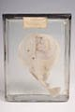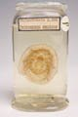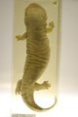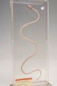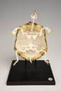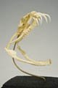
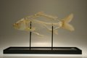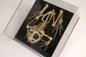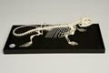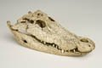
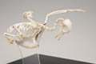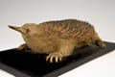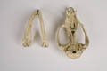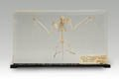
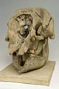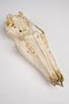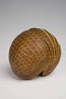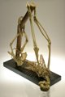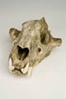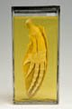

Disclaimer: 'Vertebrate Diversity' was originally designed by UCL staff as an internal teaching resource. The subsequent release of 'Vertebrate Diversity' as an OER means that any changes to the product received relative to the original content may not reflect the desires of UCL teaching staff, or the original quality of the resource.

CC BY-NC-SA 4.0 International Licence: 'Vertebrate Diversity' has been released as an open educational resource (OER) on a Creative Commons 'Attribution Non-commercial Share Alike' license. This means that once downloaded, content can be modified and improved to complement a particular course. This requires, however, that improvements are recycled back into the OER community, and full attribution is made to UCL. All content present at the time of download must be accordingly credited and, in turn, novel content must be appropriately licensed. For more information, please refer to the license deed by visiting: https://creativecommons.org/licenses/by-nc-sa/4.0/legalcode
Contents
Introduction 3
Synapsids 5
Monotremata - monotremes 5
Diversity and Lower Taxonomy 6
Distribution and Habitat 6
Conservation Status (IUCN) 6
Features 6
Marsupialia - marsupials 8
Features 9
Labelled images of an opposum skull 9
Eutherians 10
References 11
Glossary 12

Introduction

The first chapter considers the lampreys - a clade of jawless vertebrates that are thought, based on analysis of their morphology, to be the group that first diverged from the remaining vertebrate clades.

Subsequent chapters follow a structure that roughly reflects the evolutionary relationships (or phylogeny) between the higher level vertebrate groups - for example, the turtles, lizards, tuatara, crocodiles, and birds are all reptiles and, as such, their chapters are clustered together. This structure need not imply any increase in complexity or morphological "progress" as one descends through the chapters - indeed, every taxon discussed in this web-book is extant, meaning that it has some members that are still living, and are therefore also evolving under the selection pressures of their current environment. Rather, the structure reflects the greater focus of this web-book on those four-limbed vertebrates (tetrapods) whose ancestors colonised the terrestrial world in the Devonian swamps of nearly 400 million years ago - in particular the hair-covered, milk-producing mammals.

While the structure of the web-book may not always act as an accurate representation of the evolutionary history of vertebrates, the phylogenetic tree below illustrates how all the major vertebrate clades are thought to be related.

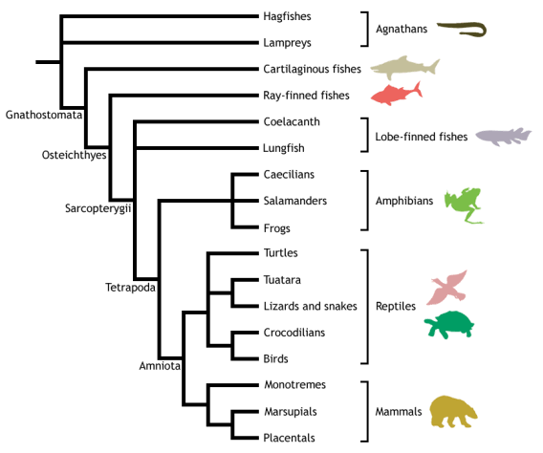

Adapted from Meyer & Zardoya (2003), this is a conservative estimate of vertebrate phylogeny, reflecting the prevailing consensus between morphological and molecular data. Conflict between morphology and molecules is manifest at the unresolved nodes, or polytomies - those nodes that are formed when greater than two branches coalesce.

For example, the most popular view of morphologists is that lampreys represent the closest living relatives of the jawed vertebrates (Gnathostomata), together forming the Vertebrata. This hypothesis excludes hagfishes from the vertebrates on the basis that they do not possess some of the derived morphological features shared by lampreys and gnathostomes - in particular, they lack a vertebral column. Instead, hagfishes are placed as the sister group to the vertebrates, together forming the Craniata (or craniates) - animals possessing a skull, or cranium. This view of craniate evolution makes the living jawless vertebrates, or agnathans, a paraphyletic group. This means that the jawless vertebrates do not form a natural (or monophyletic) grouping, as their most recent common ancestor is not unique to them - it is shared with the jawed vertebrates as well.

In contrast, molecular data tend to group the lampreys and hagfishes to the exclusion of the gnathostomes, making the living agnathans a monophyletic group termed Cyclostomi. Under the cyclostome hypothesis, it is presumed that the common ancestor of the cyclostomes and gnathostomes possessed a vertebral column, which was subsequently lost in the evolution of the hagfishes.

Despite the disparities between morphological and molecular data evident from the cladogram above, the evolutionary history of the vertebrates is fairly well resolved, with many major traditionally identified groupings persisting through recent advances in methods for phylogenetic inference and the advent of molecular systematics. Consequently, this tree should be used as a working guide while exploring the taxa described within the web-book, providing an evolutionary context that highlights the shared ancestry of the different vertebrate lineages, as well as helping to trace some of the evolutionary innovations that gave rise to the many different forms - including the origin of jaws, ossification of the endochondral skeleton, evolution of terrestrially adapted limbs, and the amniotic egg.

Synapsids

Synapsids - mammals and their extinct relatives

Sarcopterygii; Tetrapoda; Amniota; Syanpsida

The primary dichotomy within the amniotes is that between the Reptilia, or Sauropsida (see amniote groups above - turtles through to birds), and the Synapsida, thought to have diverged sometime during the Carboniferous (approx. 360 - 300 million years ago). Thus, the Synapsida is one of the two major lineages of amniotes, containing the mammals plus all extinct amniotes more closely related to mammals than to reptiles.
The following headings outline the diversity of the living representatives of the synapsids - the class Mammalia. The extant mammals are divided into three major lineages:
- Monotremata - monotremes
- Marsupialia - marsupials
- Eutheria - placental mammals

Monotremata - monotremes

Sarcopterygii; Tetrapoda; Amniota; Synapsida; Prototheria; Monotremata

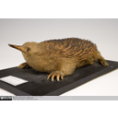  Short-beaked echidna taxidermy | 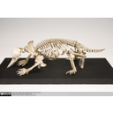  Short-beaked echidna skeleton | 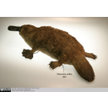  Platypus taxidermy

The order Monotremata is the only extant group within the subclass Prototheria - the oldest living taxon of theclass Mammalia. Whilst there has never been much doubt that monotremes split off from other mammal group at an early stage, due to their many ancestral reptilian characters (see below), the mid-20th-Century saw much dispute regarding the evolutionary positioning of the other two major groups of mammal - the metatherians (marsupials) and the eutherians (placental mammals) - with respect to the monotremes.

The question was whether the metatherians were the sister clade of the monotremes or of the eutherians. This proved a difficult question to answer, as much of our understanding of mammalian phylogeny has been gained through comparisons of tooth morphology, yet monotremes are toothless - a character that is certainly not ancestral.

However, much study on the ancestral amniote features of monotremes, as well as a recent complete analysis of their genome, has shown that they split off from other mammal groups around 200 million years ago, at the Triassic-Jurassic boundary. Therefore, Metatheria and Eutheria together form the clade Theria (live-bearing mammals), to the exclusion of Prototheria. The cladogram below summarises these relationships:

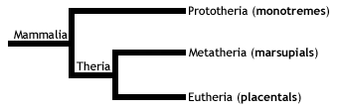

Diversity and Lower Taxonomy
The monotremes are a group of highly specialised egg-laying predatory mammals, containing the platypus and echidnas. There are only five living species of monotreme, contained within two families:
- Family Ornithorhynchidae: the platypus, a single species in a single genus, Ornithorhynchus anatinus.
- Family Tachyglossidae: the echidnas. Four species divided into two genera:
- Tachyglossus: one species of short-beaked echidna (Tachyglossus aculeatus).
- Zaglossus: three species of long-beaked echidnas. (One of these, Zaglossus attenboroughi, a species from the Papua province of the island of New Guinea named after British naturalist Sir David Attenborough, has never been seen in the wild and is only known to science through a single museum specimen from 1961! In 2007, researchers at the Zoological Society of London confirmed that Sir David's echidna is not extinct, by finding burrows and tracks made by the species)

Distribution and Habitat
Endemic to Australasia - an important point to note as it means that they represent a whole subclass of extant mammalian life in a single geographic region. While the platypus is semi-aquatic, the echidnas are all terrestrial, and their respective distributions and habitats are as follows:
- Platypus - Confined to Eastern Australia and Tasmania; freshwaters streams, rivers, and some lakes.
- Short-beaked echidna - Australia and New Guinea; most habitats, from semi-arid to alpine.
- Long-beaked echidna - New Guinea; mountainous terrain.

Conservation Status (IUCN)
- Platypus - Least Concern (LC) - However, although the platypus is common, it has a fairly narrow, specific habitat range and, consequently, is distributed in localised regions. It is therefore vulnerable to local extinction.
- Short-beaked echidna - Least Concern (LC)
- Long-beaked echidna - Critically Endangered (CR)

Features
- Males have a spur on their ankles, which bears poison in the platypus.
- Toothless - platypuses have a leathery electrosensory bill, with crushing horny plates to break through the tough exoskeleton of arthropods; echidnas have an elongate horny rostrum with a long sticky tongue for collecting insects.
- A range of mammalian characters:
  - Produce milk (lactate) from mammary glands. However, while therians have nipples, monotremes do not, and consequently the young suck milk from patches of mammary hairs - specialised areas of fur positioned around the ventral openings of the mother's mammary glands.
  - Epipubic bones - two thin rod-like bones extending anteriorly from the pubic bones of the pelvic girdle.
  - Lower jaw (mandible) made up of a single bone, the tooth-bearing dentary.
  - A middle ear formed of three bones: the incus, malleus, and stapes. While the stapes is present in the middle ear of all living tetrapods, the incus and malleus are modified bones from the typical amniote jaw joint. The jaws of non-mammalian amniotes articulate via the quadrate of the upper jaw, and the articular of the lower jaw; in mammals, the quadrate migrated to form the incus, while the articular became the malleus, leaving a jaw joint formed of the dentary articulating with the squamosal (the angular bone of the non-mammalian amniote lower jaw is used as a bony support for the eardrum in mammals). The following diagram illustrates these differences:
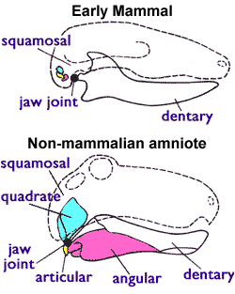

- A range of ancestral reptilian characters:
  - Egg-laying (oviparity); however, these soft-shelled eggs are short-lived, the young hatching after around ten days and being dependent on mother's milk for up to six months after.
  - Sprawling gait (although it is possible that this is a derived feature of monotremes, relating to specialisations for swimming in the platypus, and for digging in the echidnas).
  - A single common opening for the digestive, urinary, and reproductive tract, called the cloaca (the general amniote condition). In therian mammals (marsupials and placentals), there are two openings: one for the digestive system, and one for the urogenital tract.
  - Presence of the coracoid - the ventral bone of the shoulder girdle seen in all non-mammalian amniotes. This is the general amniote condition, where the humerus articulates with the shoulder girdle at the junction between the coracoid and the scapula (commonly termed the shoulder blade).
  - Not entirely homeothermic. While monotremes are - meaning that they regulate their body temperature using heat produced during endothermic metabolism - they are fairly poor at maintaining a constant body temperature during extreme enviromental conditions.

Marsupialia - marsupials

Sarcopterygii; Tetrapoda; Amniota; Synapsida;
Theria; Metatheria; Marsupialia

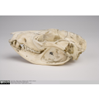  Southern oppossum skull lateral view | 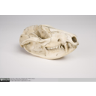  Southern oppossum skull lateral view | 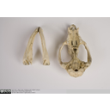  Southern opossum skull showing palate an dentary process | 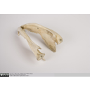  Southern opossum mandible showing in-turned dentary process

The marsupials are the sister taxon to the subclass Eutheria (placental mammals), together forming the clade Theria. Therians are then the sister clade to the monotremes, forming the group mammalia - all living mammals. The cladogram below shows these relationships:
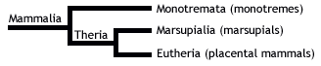
Diversity and Lower Taxonomy
The marsupials are 335 extant species across seven orders of mammals from Australasia and the Americas, which originated in the Early Cretaceous of North America.
Three of these orders are now restricted to the Americas - including opossums, shrew opossums and the charismatic Monito del Monte - while the other four are restricted to Australasia - including kangaroos, possums, marsupial moles, bandicoots, and carnivorous marsupials such as the tasmanian devil. Below is a list of these orders with their representative groups:
- Didelphimorphia - American opossums
- Paucituberculata - shrew opossums
- Microbiotheria - Monito del Monte
- Notoryctemorphia - marsupial moles
- Dasyuromorphia - Australian carnivorous marsupials
- Peramelemorphia - bandicoots and bilbies
- Diprotodontia - kangaroos, wallabies, possums, wombats, and koala

Features
- After a brief gestation in the womb with no placenta (except bandicoots), the females of certain species give birth to extremely immature young, who then develop to maturity through suckling in the mother's pouch.
- In-turned process in the dentary.
- Three premolars and four molars. (NB. This is the ancestral marsupial dentition, however, many species have actually modified this character to have a varying number of molars and premolars)
- Three premolars and four molars. (NB. This is the ancestral marsupial dentition, however, many species have actually modified this character to have a varying number of molars and premolars)
- Epipubic bones - two thin rod-like bones that extend anteriorly from the pubic bones of the pelvic girdle. These bones, although often called marsupial bones, are also seen in monotremes, and are probably an ancestral mammalian character, which was lost in the Eutheria.

Labelled images of an opposum skull
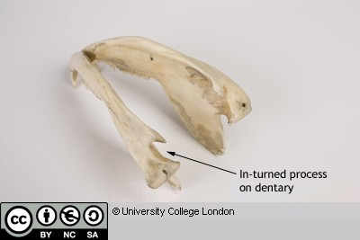

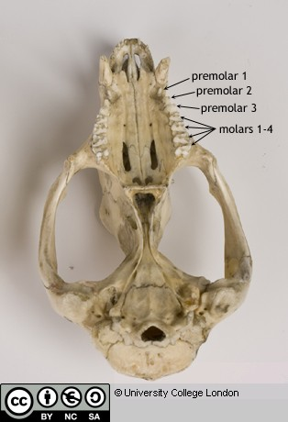
Eutherians
See 'Virtual Educational Resource for the Biosciences (VERB) - Eutherians': https://open-education-repository.ucl.ac.uk/210/

References

Marsupials
Aplin KP, Archer M (1987) Recent advances in marsupial systematics with a new syncretic classification. In: Archer M. (ed) Possums and opossums: studies in evolution. Surrey Beatty and Sons, Chipping Norton, New South Wales, pp xv–xxii
Mooney, N. and Rounsevell, D. E. 2008. Thylacine, Thylacinus cynocephalus. In: S. Van Dyck and R. Strahan (eds), The mammals of Australia. Third Edition, pp. 167-168. Reed New Holland, Sydney, Australia.

Glossary

A

akinetic
In anatomy, this refers to a low level of flexibility in a structure due to a lack of moveable joints.

amniote
Those vertebrates with an amniotic egg. The extant clades are Testudines (turtles), Diapsida (lepidosaurians, crocodilians, and birds), and Synapsida (mammals).

anapsid
Skull possessing no temporal fenestrae (NB. an- = without).
Amniotes with this skull condition form a paraphyletic group including the Parareptilia (turtles and their extinct relatives), the extinct common ancestor of all amniotes, and basal eureptiles (the extinct precursors of diapsids).
Note that the Testudines (turtles and relatives) have modified the anapsid condition through a reduction (emargination) of the posterior region of the skull.

Apatite
Calcium phosphate: the crystalline component of bone.

apomorphy
A derived or specialised character.

Appendicular skeleton
The endoskeletal element of the fins or limbs of a vertebrate, and their associated girdles (pectoral or pelvic).

Axial skeleton
All parts of the vertebrate endoskeleton except the limbs or fins and their associated girdles. That is, the cranium, visceral skeleton, notochord, vertebrae, and ribs.

B

Basal
Of, relating to, located at, or forming a base.

Bicuspid
A tooth bearing two cusps.

C

Calcified cartilage
Cartilage strengthened with a scattering of apatite crystals (calcium phosphate), as seen in Chondrichthians.

Cartilage
A tough, elastic, fibrous connective tissue composed of collagen fibres. Used as skeletal tissue in vertebrates, it is non-mineralised and is often the developmental precursor of bone.

Clade
A phylogenetic lineage comprising a common ancestor and all its descendant species.
Note that the difference between a taxon and a clade is that a clade must include all descendant species from a common ancestor, whereas a taxon need not.

cladistic
Relating to the branching sequences of phylogeny.

cladogram
A branching tree-like diagram representing the phylogenetic relationships (evolutionary history) of a lineage.

cloaca
The common opening for the reproductive, urinary, and digestive tracts, seen in all vertebrates except therian mammals (marsupials and placental mammals).

The term comes from the Latin for sewer.

Cursorial
Adapted for running.

Cusp
The biting point of a tooth.

D

Dentary
The anterior bone of the lower jaw which bears the teeth. It forms the whole of the lower jaw in mammals.

Dentine
A bone-like substance, lacking cell bodies and consisting mainly of calcium phosphate (apatite) in a fibrous matrix.

Dermal bone
A type of bone forming within the dermis - the deep layer of vertebrate skin cells below the surface layer, the epidermis.

diapsid
Skull possessing both an upper and a lower temporal fenestra (NB. di- = two).
Amniotes with this skull condition form the monophyletic clade Diapsida, which includes the lepidosaurs (lizards, snakes, and tuatara), archosaurs (crocodilians, dinosaurs, and birds), and their other extinct relatives.
Note that some diapsids, such as lizards, have lost the temporal bar separating the fenestrae to form one large window. Others, such as the Aves (birds), have merged both fenestrae with the orbit.

E

Enamel
The crystalline material covering the crown of a tooth, or certain scales.

Endopterygota
A clade of insects charachterised by their undergoing complete metamorphosis (i.e. holometabolous).
See Insect Diversity WebBook for the clades within (from Neuroptera down).

Epidermal
Pertaining to, or originating from, the epidermis - the surface layer of skin cells in vertebrates

euryapsid
Skull possessing an upper temporal fenestra only.
However, animals with this skull condition do not represent an important amniote lineage, as they are likely to be a polyphyletic group, originating a least twice within the Diapsida. Euryapsids include the plesiosaurs and ichthyosaurs - Mesozoic marine reptiles.

extant
Not extinct.

F

fossorial
Specialised for burrowing.

furcula
The fused clavicle bones of a bird, also known as the wishbone.

H

Hemimetabolous
Refers to a type of insect development that is categorised by three distinct, progressive life stages: egg, nymph, imago (adult). Changes are gradual, with no pupal stage.
Some hemimetabolous insects include grasshoppers, cicadas, cockroaches, termites, earwigs, and dragonflies.
Also termed incomplete metamorphosis.

Holometabolous
Refers to a type of insect development that is categorised by four distinct, progressive life stages: embryo, larva, pupa, imago (adult).
Seen exlusively in the Endopterygota, which includes beetles, butterflies, wasps, bees, ants, and others.
Also termed complete metamorphosis.

Horny
Consisting of horn - a tough material composed mainly of keratin.

I

ilium
In tetrapods, the dorsal section of the pelvis, which articulates with one or more sacral vertebrae.

K

Kinetic
In anatomy, referring to a high level of flexibility afforded by numerous moveable joints.

L

Lymph heart
Muscular dilation in a lymph vessel, which pumps lymph (fluid containing white blood cells called lymphocytes important in immune response) around the body of some lungfishes, amphibians and reptiles.

M

Metacone
In mammals, the metacone is the distobuccal (rear-most and cheek side) cusp of an upper molar tooth.

monophyletic
Having a single evolutionary origin. A taxon is monophyletic if it contains all the descendants of a common ancestor.

For example, mammals are a monophyletic group, as all species descended from the first known mammal are considered mammals.

See paraphyletic and polyphyletic for alternative terms.

Myrmecophagy
Feeding behaviour categorised by an exclusive (or near exclusive) diet of ants ant termites.

O

Orbit
The bony socket of the eye.

Osteosclerosis
An increase in the density of bone.

P

Pachyostosis
A thickening of the bone, often associated with a reduction in the volume of marrow tissue contained within.

Paracone
In mammals, the paracone is the mesiobuccal (front-most and cheek side) cusp of an upper molar tooth.

Paraphyletic
A taxon including a common ancestor and some but not all of its descendants.
For example, the class Reptilia is paraphyletic, as it does not include birds, who are considered a separate class: Aves. However, birds evolved from theropod dinosaurs, and are therefore reptiles themselves. Similarly, all tetrapods are, evolutionarily speaking, lobe-finned fish.
Importantly, reptiles can be made monophyletic through the addition of birds to the taxon.
See monophyletic and polyphyletic for alternative terms.

Pectoral girdle
In vertebrates, the skeletal structure that provides support for the fore limbs or fins.

Pelvic girdle
In vertebrates, the skeletal structure that provides support for the hind limbs or fins, which also fuses with the sacral vertebrae.

phylogeny
The evolutionary history of organismal lineages as they develop through time.

plesiomorphy
An ancestral character.

polyphyletic
Referring to a group that does not contain the common ancestor of all the taxa within. Therefore, this is not a true taxonomic group, but is often a term used to categorise organisms with a similar ecology, such as insectivorious mammals, or marine mammals.
It is also used when the evolutionary origin of a group, such as snakes, is unsure, and characteristic species within may have originated separately.

Protocone
In mammals, the protocone is the mesiolingual cusp of an upper molar tooth.

Pulp cavity
The space within a tooth, or a dentine scale, occupied by blood vessels and nerves.

S

symplesiomorphy
A character that is shared between groups but was inherited from an ancestor prior to the last common ancestor.
These are characters that - at the level at which they are referred to as symplesiomorphies - are not used to form cladistic groupings, or clades.

synapomorphy
A derived or specialised character that is shared between two or more groups, and was inherited from the common ancestor in which it originated.
These are the characters that morphological systematists use to support the existence of particular clades, forming the basis of the field of cladistics.

synapsid
Skull possessing a lower temporal fenestra only.
Amniotes with this skull condition form the monophyletic clade Synapsida, which includes the mammals and their extinct ancestors, the non-mammalian reptile-like synapsids.
Note that in the Mammalia, the lower temporal fenestra has merged with the orbit.

T

taxon
A group of organisms sharing a common ancestry.
Note that the difference between a taxon and a clade is that a clade must include all descendant species from a common ancestor, whereas a taxon need not.
Pl. taxa.

temporal fenestra
An opening in the temporal region of the skull seen in amniotes, providing a flat edge for the attachment of strong lower jaw closing muscles to the skull.
Amniotes show four skull types, based on the position and number of these temporal fenestrae, two of which define two major lineages of the amniotes. The skull types and associated groups are as follows:
1) Synapsid - Skull possessing a lower temporal fenestra only. Amniotes with this skull condition form the monophyletic clade Synapsida, which includes the mammals and their extinct ancestors, the mammal-like reptiles. Note that in the Mammalia, the lower temporal fenestra has merged with the orbit.
2) Diapsid - Skull possessing both an upper and a lower temporal fenestra (NB. di- = two). Amniotes with this skull condition form the monophyletic clade Diapsida, which includes the lepidosaurs (lizards, snakes, and tuatara), archosaurs (crocodilians, dinosaurs, and birds), and their other extinct relatives. Note that some groups within the Diapsida, such as lizards, have lost the temporal bar separating the fenestrae to form one large window. Others, such as the Aves (birds), have merged both fenestrae with the orbit.
3) Anapsid - Skull possessing no temporal fenestrae (NB. an- = without). Amniotes with this skull condition form a paraphyletic group including the Parareptilia (turtles and their extinct relatives), the extinct common ancestor of all amniotes, and basal eureptiles (the extinct precursors of diapsids). Note that the Testudines (turtles and relatives) have modified the anapsid condition through a reduction (emargination) of the posteriorregion of the skull.
4) Euryapsid - Skull possessing an upper temporal fenestra only. However, animals with this skull condition do not represent an importantamniote lineage, as they are likely to be a polyphyletic group, originating a least twice within the Diapsida. Euryapsids include the plesiosaurs and ichthyosaurs - Mesozoic marine reptiles.

V

vertebrae
From anterior to posterior:
Cervical vertebrae: Facilitate the mobility of the head. The first two, the atlas and the axis are highly specialised, the former articulating with the occipital region of the skull.
Thoracic vertebrae: Articulate with the ribs that fuse with the sternum.
Lumbar vertebrae: Generally larger, with small ribs not attached to the sternum, which support the posterior musculature.
Sacral vertebrae: Fused to the pelvic girdle, allowing the transfer of force from the appendicular skeleton (limbs) during locomotion.
Caudal vertebrae: Small and less specialised, forming the tail.

Vertebrate anatomical directions and axes
The image below illustrates the terms used for anatomical directions and axes in vertebrates.
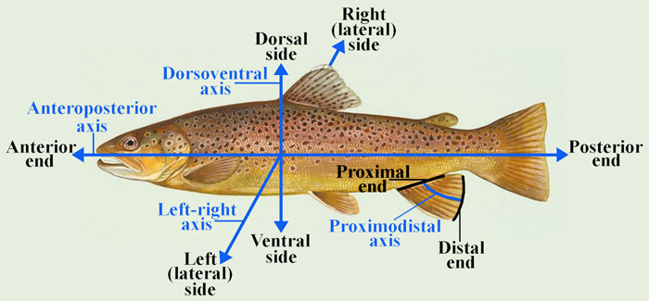

Vestigial
Occurring as a structure that, once functional (whether during development or in earlier evolutionary forms), is now reduced or degenerate. An example is the vestigial pelvic girdle seen in many snakes, including the boas and pythons, which bears no function.

Z

Zygapophysis
Articular process of a vertebra that articulates with the corresponding process of an adjacent vertebra.
Plural = zygapophyses

