Vertebrate Diversity study pack

The following web-book contains a series of information chapters broadly outlining the diversity of living vertebrates, with a few notes on their fossil relatives. Below is a collage of specimens from UCL's Grant Museum of Zoology illustrating the wide diversity covered in this web-book – from jawless vertebrates, sharks, and ray-finned fishes, to amphibians, reptiles, and mammals.

To download this resource as a single file, see the collection page: https://open-education-repository.ucl.ac.uk/id/eprint/204

Also see the related resource Vertebrate Palaeontology and Evolution study pack here: https://open-education-repository.ucl.ac.uk/id/eprint/195

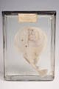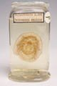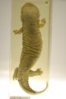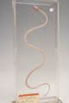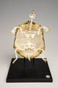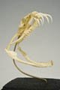
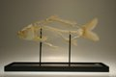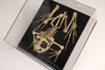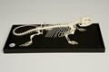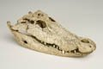
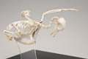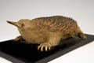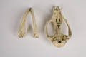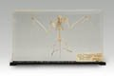
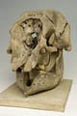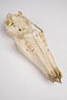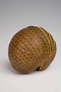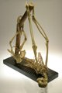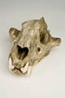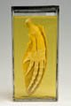

Disclaimer: 'Vertebrate Diversity' was originally designed by UCL staff as an internal teaching resource. The subsequent release of 'Vertebrate Diversity' as an OER means that any changes to the product received relative to the original content may not reflect the desires of UCL teaching staff, or the original quality of the resource.

CC BY-NC-SA 4.0 International Licence: 'Vertebrate Diversity' has been released as an open educational resource (OER) on a Creative Commons 'Attribution Non-commercial Share Alike' license. This means that once downloaded, content can be modified and improved to complement a particular course. This requires, however, that improvements are recycled back into the OER community, and full attribution is made to UCL. All content present at the time of download must be accordingly credited and, in turn, novel content must be appropriately licensed. For more information, please refer to the license deed by visiting: https://creativecommons.org/licenses/by-nc-sa/4.0/legalcode
Contents
Introduction 3
Rhynchocephalians 5
Diversity and Lower Taxonomy 5
Conservation Status (IUCN) 6
Uniting features (synapomorphies) of the Rhychocephalia 6
Fossil taxa and rhynchocephalian phylogeny 6
Clevosaurs 7
Pleurosaurs 7
Sapheosaurs 7
Sphenodontines 7
Eilenodontines 7
References 7
Glossary 8

Introduction

The first chapter considers the lampreys - a clade of jawless vertebrates that are thought, based on analysis of their morphology, to be the group that first diverged from the remaining vertebrate clades.

Subsequent chapters follow a structure that roughly reflects the evolutionary relationships (or phylogeny) between the higher level vertebrate groups - for example, the turtles, lizards, tuatara, crocodiles, and birds are all reptiles and, as such, their chapters are clustered together. This structure need not imply any increase in complexity or morphological "progress" as one descends through the chapters - indeed, every taxon discussed in this web-book is extant, meaning that it has some members that are still living, and are therefore also evolving under the selection pressures of their current environment. Rather, the structure reflects the greater focus of this web-book on those four-limbed vertebrates (tetrapods) whose ancestors colonised the terrestrial world in the Devonian swamps of nearly 400 million years ago - in particular the hair-covered, milk-producing mammals.

While the structure of the web-book may not always act as an accurate representation of the evolutionary history of vertebrates, the phylogenetic tree below illustrates how all the major vertebrate clades are thought to be related.

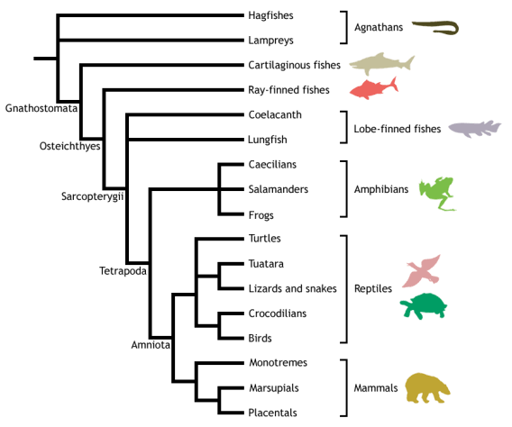

Adapted from Meyer & Zardoya (2003), this is a conservative estimate of vertebrate phylogeny, reflecting the prevailing consensus between morphological and molecular data. Conflict between morphology and molecules is manifest at the unresolved nodes, or polytomies - those nodes that are formed when greater than two branches coalesce.

For example, the most popular view of morphologists is that lampreys represent the closest living relatives of the jawed vertebrates (Gnathostomata), together forming the Vertebrata. This hypothesis excludes hagfishes from the vertebrates on the basis that they do not possess some of the derived morphological features shared by lampreys and gnathostomes - in particular, they lack a vertebral column. Instead, hagfishes are placed as the sister group to the vertebrates, together forming the Craniata (or craniates) - animals possessing a skull, or cranium. This view of craniate evolution makes the living jawless vertebrates, or agnathans, a paraphyletic group. This means that the jawless vertebrates do not form a natural (or monophyletic) grouping, as their most recent common ancestor is not unique to them - it is shared with the jawed vertebrates as well.

In contrast, molecular data tend to group the lampreys and hagfishes to the exclusion of the gnathostomes, making the living agnathans a monophyletic group termed Cyclostomi. Under the cyclostome hypothesis, it is presumed that the common ancestor of the cyclostomes and gnathostomes possessed a vertebral column, which was subsequently lost in the evolution of the hagfishes.

Despite the disparities between morphological and molecular data evident from the cladogram above, the evolutionary history of the vertebrates is fairly well resolved, with many major traditionally identified groupings persisting through recent advances in methods for phylogenetic inference and the advent of molecular systematics. Consequently, this tree should be used as a working guide while exploring the taxa described within the web-book, providing an evolutionary context that highlights the shared ancestry of the different vertebrate lineages, as well as helping to trace some of the evolutionary innovations that gave rise to the many different forms - including the origin of jaws, ossification of the endochondral skeleton, evolution of terrestrially adapted limbs, and the amniotic egg.

Rhynchocephalians

Rhynchocephalia - tuatara

Vertebrata; Gnathostomata; Osteichthyes; Sarcopterygii; Tetrapoda; Amniota; Sauropsida;
Reptilia; Diapsida; Sauria; Lepidosauromorpha; Lepidosauria; Rhynchocephalia

The Rhynchocephalia is the sister group to the Squamata (lizards and their relatives), united in the monophyletic clade Lepidosauria by the following synapomorphies:
- Derived skin structure with shedding mechanisms. Epidermis is periodically lost and replaced in a cyclic switch between the production of α-keratin and β-keratin.
- An opening, or window, in the pelvis called the thyroid fenestra.
- Paired male hemipenes - intromittent organs used to deliver sperm to the female during copulation. They are held hidden within eversible pouches in a transverse cloacal slit. Note this is well defined in squamates but only rudimentary in male tuatara (the only extant rhynchocephalian).
- The possession of fracture planes within tail vertebrae, allowing caudal autotomy - the ability to self-amputate the tail. This is used as a defensive escape mechanism.
- Extra centres of ossification in the epiphyses of the limb bones.
- Knee joint in which the fibula fits into a lateral recess on the femur. This is unique within tetrapods.
- Sexual segment of the kidney.
- Specialised foot and ankle structure, including:
  - Fused astralago-calcaneun and enlarged fourth distal tarsal - combined, these two features produce a specialised mesotarsal joint that aids in movement over rough terrain.
  - Hooked fifth metatarsal - this acts in a manner analagous to a rudimentary mammalian heel.
Lepidosauria is defined as encompassing the last common ancestor of Rhynchocephalia and Squamata, plus all its descendants. Lepidosauromorpha contains lepidosaurs and stem-lepidosaurs known from fossils (e.g.Kuehneosaurus). If only extant taxa are considered then Lepidosauria is the sister group to the Archosauria (crocodilians, dinosaurs, birds, and possibly turtles). Lepidosauromorpha and Archosauromorpha (Archosaurs plus now extinct stem-Archosaurs) are sometimes together referred to as Sauria. A larger more inclusive grouping, Diapsida, contains Lepidosauromorpha and Archosauromorpha along with various fossil taxa (such as Petrolacosaurus and plesiosaurs). Diapsida is in turn nested within Sauropsida (equal to a monophyletic definition of Reptilia as used by some authors) which contains additional fossil taxa such as procolophonids and captorhinids.

Diversity and Lower Taxonomy
The Rhynchocephalia is now represented by just a single extant genus, Sphenodon, comprising two species, S. punctatus and S. guntheri (the status of which is questioned). In its nativeNew Zealand, Sphenodon is known as the tuatara - derived from a Māori term meaning "peaks on the back".

This apparently minimal diversity has led many authors to suggest that the Rhynchocephalia is a conservative and relatively unchanged group with uniform morphology; however, there are a number of fossil taxa known that demonstrate variation in body shape, skull structure and tooth morphology.
Distribution and Habitat
Although globally distributed in the Mesozoic, the living representatives of the Rhynchocephalia (Sphenodon) are now restricted to the terrestrial habitat of New Zealand's offshore islands.
- Sphenodon punctatus (Northern + Cook Strait tuatara) - present on 33 islands.
- Sphenodon guntheri (Brothers Island tuatara) - present on only three islands.

Conservation Status (IUCN)
- Sphenodon punctatus (Northern + Cook Strait tuatara) - Least Concern (LC) - not updated since 1996
- Sphenodon guntheri (Brothers Island tuatara) - Vulnerable (Vu) - not updated since 1996

Uniting features (synapomorphies) of the Rhychocephalia
- Enlarged palatine tooth row - allowing the application of three-point bending to food items. This is a unique feature amongst amniotes.
- Acrodont dentition - teeth fused to the crest of the jaw bone, with no sockets. These teeth are not usually replaced and tend to be added to the back of the jaw bone as it grows.
- Posterior extension of the dentary.

Fossil taxa and rhynchocephalian phylogeny
Thought to have originated in the Early Triassic (~250-240 mya), rhychocephalians achieved global distribution in the Early Mesozoic, and were a major part of faunal assemblages for a large proportion of this era. In addition to the phylogenetically basal-most taxa, such asGephryosaurus, there are 5 distinct, apparently monophyletic lineages of derived rhynchocephalians: the clevosaurs, pleurosaurs, sapheosaurs, sphenodontines, and eilenodontines. These groups - whose phylogenetic interrelationships are uncertain - are all extinct, except the sphenodontines, which include the extant Sphenodon. The phylogenetic tree below illustrates rhynchocephalian interrelationships based on Jones (Journal of Morphology, 2008):

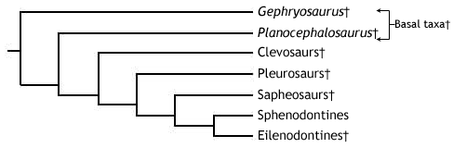

"Basal taxa" - known from the Triassic through to the Early Jurassic, this is a paraphyletic assemblage, consisting of taxa that originated early in the rhyncocephalian lineage - includingGephryosaurus, Diphydontosaurus, and Planocephalosaurus. The "basal taxa" possess many relatively simple maxillary and dentary teeth, with a conical form suitable for piercing small, invertebrate prey. The dentition perhaps demonstrates transition from an ancestral state, as they are pleuro-acrodont (in the ancestral pleurodont condition, teeth are set into the inner sides of the jaw bones). All other rhychocephalians have a fully acrodont dentition, and some of the more derived forms discussed below show a trend towards fewer, stouter teeth, that are more resilient to loading and bending forces, thus suitable for seizing larger prey. The shape of the jaw joint indicates that some sliding movement of the lower jaw could occur during food processing.

Clevosaurs - a group of carnivorous ryhnchocephalians known from the Mid Triassic to the Early Jurassic. Clevosaurs possess a highly specialised dentition, with a blade-like morphology that were used in conjunction with a precise vertical (orthal) cutting action like that of a pair of scissors. With this dentition and a skull size of 20-40+ mm, they were able to seize large invertebrates and probably even some small vertebrates.

Pleurosaurs - one of the two groups of aquatic rhynchocephalians - the other being the sapheosaurs. This aquatic habit is thought to have evolved independently in the two lineages. The pleurosaurs, known from the Early Mid to the Late Jurassic, possess a flattened, elongate skull (60-80mm), trunk and tail specialised for their aquatic mode of life, and have a dentition similar to that of the clevosaurs.

Sapheosaurs- the second group of aquatic rhynchocephalians - known only from around the Jurassic-Cretaceous boundary (~206 mya). The sapheosaur fossil record is poorly known and little is known about their specialisations. The dentition has been described as blade-like and may resemble that of the clevosaurs or pleurosaurs.

Sphenodontines- known from the Early Jurassic onwards, this is the group that includes the extant genus, Sphenodon. The sphenodontines possess only a single enlarged palatine tooth row, running parallel to the maxillary teeth. Each maxillary and palatine tooth bears a posterior flange. The teeth on the dentary are conical with an anteriorly placed apex. Following wear they bear two small anterior flanges or “shoulders”. When the jaws close the lower jaw slides forward (protraction) to allow a shearing action analogous to that of a steak knife. This is termed a propalinal, or more specifically prooral, jaw action. This allows members of this group to process tougher, more complex prey, such as arthropods and small vertebrates but in a different way to clevosaurs and pleurosaurs.

Eilenodontines - a group of highly specialised rhynchocephalians, that may form the sister group to the sphenodontines. Known from the Late Jurassic to the Mid Late Cretaceous, the eilenodontines were the largest group of rhynchocephalians, with skull sizes reaching between 80-150mm and robust jaws. The dentition of the eilenodontines is in many ways like that of the sphenodontines - they have similar maxillary teeth, have a single enlarged palatal tooth row parallel to the maxillary teeth, and utilise some kind of propalinal jaw action. However, the dentary teeth are wider, with a thickened layer of enamel. When worn (which they usually are) each tooth possesses a flat wear facet bounded by sharp enamel edges. These resemble the teeth of mammalian herbivores and are therefore considered suitable for processing plant material, and thus indicate an herbivorous diet for the group.

References
Jones, MEH. 2008. Skull shape and feeding strategy in Sphenodon and other Rhynchocephalia (Diapsida: Lepidosauria). Journal of Morphology 269: 945-966.
Evans, SE. 2003. At the feet of the dinosaurs: the early history and radiation of lizards. Biological Reviews 78: 513-551.

Glossary

A

akinetic
In anatomy, this refers to a low level of flexibility in a structure due to a lack of moveable joints.

amniote
Those vertebrates with an amniotic egg. The extant clades are Testudines (turtles), Diapsida (lepidosaurians, crocodilians, and birds), and Synapsida (mammals).

anapsid
Skull possessing no temporal fenestrae (NB. an- = without).
Amniotes with this skull condition form a paraphyletic group including the Parareptilia (turtles and their extinct relatives), the extinct common ancestor of all amniotes, and basal eureptiles (the extinct precursors of diapsids).
Note that the Testudines (turtles and relatives) have modified the anapsid condition through a reduction (emargination) of the posterior region of the skull.

Apatite
Calcium phosphate: the crystalline component of bone.

apomorphy
A derived or specialised character.

Appendicular skeleton
The endoskeletal element of the fins or limbs of a vertebrate, and their associated girdles (pectoral or pelvic).

Axial skeleton
All parts of the vertebrate endoskeleton except the limbs or fins and their associated girdles. That is, the cranium, visceral skeleton, notochord, vertebrae, and ribs.

B

Basal
Of, relating to, located at, or forming a base.

Bicuspid
A tooth bearing two cusps.

C

Calcified cartilage
Cartilage strengthened with a scattering of apatite crystals (calcium phosphate), as seen in Chondrichthians.

Cartilage
A tough, elastic, fibrous connective tissue composed of collagen fibres. Used as skeletal tissue in vertebrates, it is non-mineralised and is often the developmental precursor of bone.

Clade
A phylogenetic lineage comprising a common ancestor and all its descendant species.
Note that the difference between a taxon and a clade is that a clade must include all descendant species from a common ancestor, whereas a taxon need not.

cladistic
Relating to the branching sequences of phylogeny.

cladogram
A branching tree-like diagram representing the phylogenetic relationships (evolutionary history) of a lineage.

cloaca
The common opening for the reproductive, urinary, and digestive tracts, seen in all vertebrates except therian mammals (marsupials and placental mammals).

The term comes from the Latin for sewer.

Cursorial
Adapted for running.

Cusp
The biting point of a tooth.

D

Dentary
The anterior bone of the lower jaw which bears the teeth. It forms the whole of the lower jaw in mammals.

Dentine
A bone-like substance, lacking cell bodies and consisting mainly of calcium phosphate (apatite) in a fibrous matrix.

Dermal bone
A type of bone forming within the dermis - the deep layer of vertebrate skin cells below the surface layer, the epidermis.

diapsid
Skull possessing both an upper and a lower temporal fenestra (NB. di- = two).
Amniotes with this skull condition form the monophyletic clade Diapsida, which includes the lepidosaurs (lizards, snakes, and tuatara), archosaurs (crocodilians, dinosaurs, and birds), and their other extinct relatives.
Note that some diapsids, such as lizards, have lost the temporal bar separating the fenestrae to form one large window. Others, such as the Aves (birds), have merged both fenestrae with the orbit.

E

Enamel
The crystalline material covering the crown of a tooth, or certain scales.

Endopterygota
A clade of insects charachterised by their undergoing complete metamorphosis (i.e. holometabolous).
See Insect Diversity WebBook for the clades within (from Neuroptera down).

Epidermal
Pertaining to, or originating from, the epidermis - the surface layer of skin cells in vertebrates

euryapsid
Skull possessing an upper temporal fenestra only.
However, animals with this skull condition do not represent an important amniote lineage, as they are likely to be a polyphyletic group, originating a least twice within the Diapsida. Euryapsids include the plesiosaurs and ichthyosaurs - Mesozoic marine reptiles.

extant
Not extinct.

F

fossorial
Specialised for burrowing.

furcula
The fused clavicle bones of a bird, also known as the wishbone.

H

Hemimetabolous
Refers to a type of insect development that is categorised by three distinct, progressive life stages: egg, nymph, imago (adult). Changes are gradual, with no pupal stage.
Some hemimetabolous insects include grasshoppers, cicadas, cockroaches, termites, earwigs, and dragonflies.
Also termed incomplete metamorphosis.

Holometabolous
Refers to a type of insect development that is categorised by four distinct, progressive life stages: embryo, larva, pupa, imago (adult).
Seen exlusively in the Endopterygota, which includes beetles, butterflies, wasps, bees, ants, and others.
Also termed complete metamorphosis.

Horny
Consisting of horn - a tough material composed mainly of keratin.

I

ilium
In tetrapods, the dorsal section of the pelvis, which articulates with one or more sacral vertebrae.

K

Kinetic
In anatomy, referring to a high level of flexibility afforded by numerous moveable joints.

L

Lymph heart
Muscular dilation in a lymph vessel, which pumps lymph (fluid containing white blood cells called lymphocytes important in immune response) around the body of some lungfishes, amphibians and reptiles.

M

Metacone
In mammals, the metacone is the distobuccal (rear-most and cheek side) cusp of an upper molar tooth.

monophyletic
Having a single evolutionary origin. A taxon is monophyletic if it contains all the descendants of a common ancestor.

For example, mammals are a monophyletic group, as all species descended from the first known mammal are considered mammals.

See paraphyletic and polyphyletic for alternative terms.

Myrmecophagy
Feeding behaviour categorised by an exclusive (or near exclusive) diet of ants ant termites.

O

Orbit
The bony socket of the eye.

Osteosclerosis
An increase in the density of bone.

P

Pachyostosis
A thickening of the bone, often associated with a reduction in the volume of marrow tissue contained within.

Paracone
In mammals, the paracone is the mesiobuccal (front-most and cheek side) cusp of an upper molar tooth.

Paraphyletic
A taxon including a common ancestor and some but not all of its descendants.
For example, the class Reptilia is paraphyletic, as it does not include birds, who are considered a separate class: Aves. However, birds evolved from theropod dinosaurs, and are therefore reptiles themselves. Similarly, all tetrapods are, evolutionarily speaking, lobe-finned fish.
Importantly, reptiles can be made monophyletic through the addition of birds to the taxon.
See monophyletic and polyphyletic for alternative terms.

Pectoral girdle
In vertebrates, the skeletal structure that provides support for the fore limbs or fins.

Pelvic girdle
In vertebrates, the skeletal structure that provides support for the hind limbs or fins, which also fuses with the sacral vertebrae.

phylogeny
The evolutionary history of organismal lineages as they develop through time.

plesiomorphy
An ancestral character.

polyphyletic
Referring to a group that does not contain the common ancestor of all the taxa within. Therefore, this is not a true taxonomic group, but is often a term used to categorise organisms with a similar ecology, such as insectivorious mammals, or marine mammals.
It is also used when the evolutionary origin of a group, such as snakes, is unsure, and characteristic species within may have originated separately.

Protocone
In mammals, the protocone is the mesiolingual cusp of an upper molar tooth.

Pulp cavity
The space within a tooth, or a dentine scale, occupied by blood vessels and nerves.

S

symplesiomorphy
A character that is shared between groups but was inherited from an ancestor prior to the last common ancestor.
These are characters that - at the level at which they are referred to as symplesiomorphies - are not used to form cladistic groupings, or clades.

synapomorphy
A derived or specialised character that is shared between two or more groups, and was inherited from the common ancestor in which it originated.
These are the characters that morphological systematists use to support the existence of particular clades, forming the basis of the field of cladistics.

synapsid
Skull possessing a lower temporal fenestra only.
Amniotes with this skull condition form the monophyletic clade Synapsida, which includes the mammals and their extinct ancestors, the non-mammalian reptile-like synapsids.
Note that in the Mammalia, the lower temporal fenestra has merged with the orbit.

T

taxon
A group of organisms sharing a common ancestry.
Note that the difference between a taxon and a clade is that a clade must include all descendant species from a common ancestor, whereas a taxon need not.
Pl. taxa.

temporal fenestra
An opening in the temporal region of the skull seen in amniotes, providing a flat edge for the attachment of strong lower jaw closing muscles to the skull.
Amniotes show four skull types, based on the position and number of these temporal fenestrae, two of which define two major lineages of the amniotes. The skull types and associated groups are as follows:
1) Synapsid - Skull possessing a lower temporal fenestra only. Amniotes with this skull condition form the monophyletic clade Synapsida, which includes the mammals and their extinct ancestors, the mammal-like reptiles. Note that in the Mammalia, the lower temporal fenestra has merged with the orbit.
2) Diapsid - Skull possessing both an upper and a lower temporal fenestra (NB. di- = two). Amniotes with this skull condition form the monophyletic clade Diapsida, which includes the lepidosaurs (lizards, snakes, and tuatara), archosaurs (crocodilians, dinosaurs, and birds), and their other extinct relatives. Note that some groups within the Diapsida, such as lizards, have lost the temporal bar separating the fenestrae to form one large window. Others, such as the Aves (birds), have merged both fenestrae with the orbit.
3) Anapsid - Skull possessing no temporal fenestrae (NB. an- = without). Amniotes with this skull condition form a paraphyletic group including the Parareptilia (turtles and their extinct relatives), the extinct common ancestor of all amniotes, and basal eureptiles (the extinct precursors of diapsids). Note that the Testudines (turtles and relatives) have modified the anapsid condition through a reduction (emargination) of the posteriorregion of the skull.
4) Euryapsid - Skull possessing an upper temporal fenestra only. However, animals with this skull condition do not represent an importantamniote lineage, as they are likely to be a polyphyletic group, originating a least twice within the Diapsida. Euryapsids include the plesiosaurs and ichthyosaurs - Mesozoic marine reptiles.

V

vertebrae
From anterior to posterior:
Cervical vertebrae: Facilitate the mobility of the head. The first two, the atlas and the axis are highly specialised, the former articulating with the occipital region of the skull.
Thoracic vertebrae: Articulate with the ribs that fuse with the sternum.
Lumbar vertebrae: Generally larger, with small ribs not attached to the sternum, which support the posterior musculature.
Sacral vertebrae: Fused to the pelvic girdle, allowing the transfer of force from the appendicular skeleton (limbs) during locomotion.
Caudal vertebrae: Small and less specialised, forming the tail.

Vertebrate anatomical directions and axes
The image below illustrates the terms used for anatomical directions and axes in vertebrates.
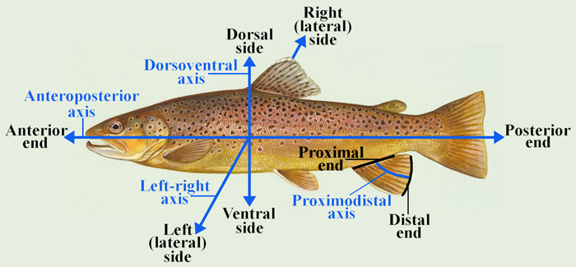

Vestigial
Occurring as a structure that, once functional (whether during development or in earlier evolutionary forms), is now reduced or degenerate. An example is the vestigial pelvic girdle seen in many snakes, including the boas and pythons, which bears no function.

Z

Zygapophysis
Articular process of a vertebra that articulates with the corresponding process of an adjacent vertebra.
Plural = zygapophyses

