Vertebrate Diversity study pack

The following web-book contains a series of information chapters broadly outlining the diversity of living vertebrates, with a few notes on their fossil relatives. Below is a collage of specimens from UCL's Grant Museum of Zoology illustrating the wide diversity covered in this web-book – from jawless vertebrates, sharks, and ray-finned fishes, to amphibians, reptiles, and mammals.

To download this resource as a single file, see the collection page: https://open-education-repository.ucl.ac.uk/id/eprint/204

Also see the related resource Vertebrate Palaeontology and Evolution study pack here: https://open-education-repository.ucl.ac.uk/id/eprint/195

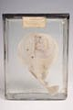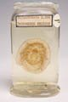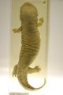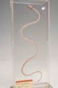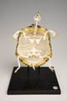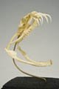
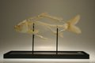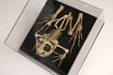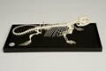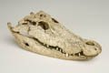
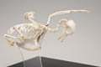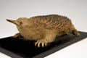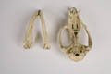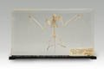
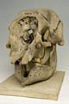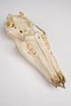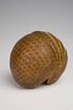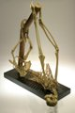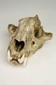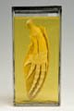

Disclaimer: 'Vertebrate Diversity' was originally designed by UCL staff as an internal teaching resource. The subsequent release of 'Vertebrate Diversity' as an OER means that any changes to the product received relative to the original content may not reflect the desires of UCL teaching staff, or the original quality of the resource.

CC BY-NC-SA 4.0 International Licence: 'Vertebrate Diversity' has been released as an open educational resource (OER) on a Creative Commons 'Attribution Non-commercial Share Alike' license. This means that once downloaded, content can be modified and improved to complement a particular course. This requires, however, that improvements are recycled back into the OER community, and full attribution is made to UCL. All content present at the time of download must be accordingly credited and, in turn, novel content must be appropriately licensed. For more information, please refer to the license deed by visiting: https://creativecommons.org/licenses/by-nc-sa/4.0/legalcode
Contents
Introduction 5
Lobe-finned Fishes 7
Diversity and Lower Taxonomy 7
Distribution and Habitat 8
Features 8
References 9
Glossary 10

Introduction

The first chapter considers the lampreys - a clade of jawless vertebrates that are thought, based on analysis of their morphology, to be the group that first diverged from the remaining vertebrate clades.

Subsequent chapters follow a structure that roughly reflects the evolutionary relationships (or phylogeny) between the higher level vertebrate groups - for example, the turtles, lizards, tuatara, crocodiles, and birds are all reptiles and, as such, their chapters are clustered together. This structure need not imply any increase in complexity or morphological "progress" as one descends through the chapters - indeed, every taxon discussed in this web-book is extant, meaning that it has some members that are still living, and are therefore also evolving under the selection pressures of their current environment. Rather, the structure reflects the greater focus of this web-book on those four-limbed vertebrates (tetrapods) whose ancestors colonised the terrestrial world in the Devonian swamps of nearly 400 million years ago - in particular the hair-covered, milk-producing mammals.

While the structure of the web-book may not always act as an accurate representation of the evolutionary history of vertebrates, the phylogenetic tree below illustrates how all the major vertebrate clades are thought to be related.

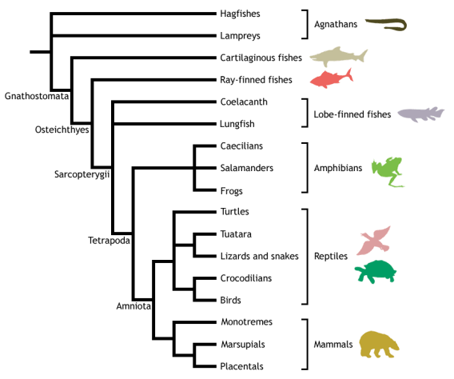

Adapted from Meyer & Zardoya (2003), this is a conservative estimate of vertebrate phylogeny, reflecting the prevailing consensus between morphological and molecular data. Conflict between morphology and molecules is manifest at the unresolved nodes, or polytomies - those nodes that are formed when greater than two branches coalesce.

For example, the most popular view of morphologists is that lampreys represent the closest living relatives of the jawed vertebrates (Gnathostomata), together forming the Vertebrata. This hypothesis excludes hagfishes from the vertebrates on the basis that they do not possess some of the derived morphological features shared by lampreys and gnathostomes - in particular, they lack a vertebral column. Instead, hagfishes are placed as the sister group to the vertebrates, together forming the Craniata (or craniates) - animals possessing a skull, or cranium. This view of craniate evolution makes the living jawless vertebrates, or agnathans, a paraphyletic group. This means that the jawless vertebrates do not form a natural (or monophyletic) grouping, as their most recent common ancestor is not unique to them - it is shared with the jawed vertebrates as well.

In contrast, molecular data tend to group the lampreys and hagfishes to the exclusion of the gnathostomes, making the living agnathans a monophyletic group termed Cyclostomi. Under the cyclostome hypothesis, it is presumed that the common ancestor of the cyclostomes and gnathostomes possessed a vertebral column, which was subsequently lost in the evolution of the hagfishes.

Despite the disparities between morphological and molecular data evident from the cladogram above, the evolutionary history of the vertebrates is fairly well resolved, with many major traditionally identified groupings persisting through recent advances in methods for phylogenetic inference and the advent of molecular systematics. Consequently, this tree should be used as a working guide while exploring the taxa described within the web-book, providing an evolutionary context that highlights the shared ancestry of the different vertebrate lineages, as well as helping to trace some of the evolutionary innovations that gave rise to the many different forms - including the origin of jaws, ossification of the endochondral skeleton, evolution of terrestrially adapted limbs, and the amniotic egg.

Lobe-finned Fishes

Sarcopterygii - lobe-finned fishes

Vertebrata; Gnathostomata; Osteichthyes; Sarcopterygii

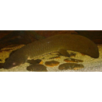  Queensland lungfish (Neoceratodus forsteri) | 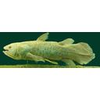  West Indian Ocean Coelacanth (Latimeria chalumnae)

Diversity and Lower Taxonomy
The Sarcopterygii, or lobe-finned fishes, is a clade containing the coelacanths, lungfishes, tetrapods, and their fossil relatives, including the osteolepiformes and panderichthyids. They are the sister group to the ray-finned fishes (Actinopterygii), together forming the bony fishes (Osteichthyes).
Sarcopterygians are characterised by their fleshy pectoral and pelvic (paired) fins that articulate with the pectoral (shoulder) and pelvic (hip) girdles via a single bone. This is apparent in the coelacanths and lungfishes, which are more intuitively fish-like. These lobe-fins gave rise to the paired limbs of tetrapods, with the single bones representing the humerus (forelimb) and femur (hindlimb).
The once-diverse coelacanths (Actinistia) are now represented by just two species in a single genus -Latimeria chalumnae and L. menadoensis.
The lungfishes (Dipnoi) are also a small relict of a once-diverse assemblage, with only six extant species in three genera - Protopterus (4x species), Lepidosiren paradoxa, and Neoceratodus forsteri.
The palaeontological record makes clear that the terrestrial verterbates evolved from lobe-finned fishes nearly 400 million years ago during the Devonian, and are therefore members of the Sarcopterygii. The only terrestrial vertebrates still living today are the tetrapods, which originated around 350 million years ago and are defined as that group which comprises the common ancestor of the living amphibians and amniotes plus all its descendants. The vertebrate conquest of the land was a major evolutionary transition that required many morphological and physiological changes away from a fish-like form, and has given rise to around 21100 living species and probably many more extinct forms. As such, the extant tetrapods are considered in depth in the following ZooMoodle webpages.
While some molecular data have proposed a sister group relationship between lungfishes and coelacanths to the exclusion of tetrapods (e.g., nuclear 28S rRNA gene; Zardoya & Meyer 1996), and certain studies have been unable to statistically reject the placement of the coelacanths as the closest living relative of the tetrapods (Zardoya & Meyer 1997a, Zardoya et al. 1998), most morphological, palaeontological, and molecular evidence (e.g., combined mitochondrial protein coding genes) supports the lungfishes as the closest living relatives to the tetrapods, to the exclusion of the Actinistia (Meyer & Zardoya, 2003). This is further supported by a unique deletion in the gene encoding RAG2 that is uniquely shared between tetrapods and lungfishes (Venkatesh et al. 2001). This prevailing view is depicted in the following phylogeny:

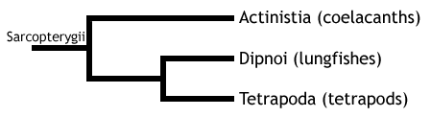

Distribution and Habitat
Fossils of Coelacanths have been discovered on every continent, evidence of their previous distribution (Helfman et al., 2009). But modern coelacanths have a limited geographic distribution. Previously thought extinct, Latimeria chalumnae has been indentified since 1938 in the waters of the West Indo Pacific Ocean near the Comoros Island and eastern coast of southern Africa (Bone et Moore, 2008). Latimeria menadoensis has been sighted only in Sulawesi, Indonesia since its discovery in 1999 (Pouyaud et al., 1999). Coelacanths live in the benthic zone, between 200 - 300m along steep underwater slopes and shelves. (Helfman et al., 2009). They aggregate in submarine caves during the day and emerge to feed during the night (Boine and Moore, 2005).

The Dipnoi have a wider distribution - Central and South Africa (Protopterus), Amazon and Paron riverbasins of South America (Lepidosiren), and Queensland, Australia (Neoceratodus) (Bone and Moore, 2005; Helfman et al. 2009). They inhabit freshwater streams, rivers and swamps. During drought, Protopterus and Lepidosiren will burrow into the earth, breath intermittently with their lung and can remain in this state of torpidity for months to avoid desiccation (Helfman et al, 2009).Neoceratodus is unable to estivate and lives only in deep rivers where there is no risk of drought.
Conservation Status (IUCN)
Latimeria chalumnae is classified by the IUCN as critically endangered. Latimeria menadoensis isvulnerable, but there have only ever been three sighting of this species so it is difficult to ascertain populations levels (IUCN, 2008). Both species are often by-catch of deep sea trawlers and shark nets. Low fecundity and slow growth rates put the Coelacanths at risk of extinction and even small depletions in population size can take decades to recover.

The Dipnoi are not considered at risk of extinction because of their wide distribution. But they do face anthropogenic threats such as habitat loss and degradation - contruction of dams impedes flooding, the spread of agriculture is reducing wetland habitats and both practices produce harmful pollution (IUCN, 2008).

Features
- Muscular paired fleshy fins
- Fins attached the pelvic and pectoral girdle by single basal bone.
- Teeth coated with enamel.

References

Lobe-finned Fishes
Bone, Q., Moore, R., (2008) The Biology of Fishes. Taylor and Francis Group.pp25-33
Gene S. Helfman, Bruce B. Collette, Douglas E. Facey, Brian W. Bowen, (2009) The diversity of fishes: biology, evolution, and ecology. Blackwell, 2009, p 348.
IUCN 2010. IUCN Red List of Threatened Species. Version 2010.3. <http://www.iucnredlist.org>. Downloaded on 15 September 2010.
Takezaki, N., F. Figueroa, Z. Zaleska-Rutczynska, N. Takahata, and J. Klein. 2004. The phylogenetic relationship of tetrapod, coelacanth, and lungfish revealed by the sequences of forty four nuclear genes. Mol. Biol. Evol. 21:1512–1524.

Glossary

A

akinetic
In anatomy, this refers to a low level of flexibility in a structure due to a lack of moveable joints.

amniote
Those vertebrates with an amniotic egg. The extant clades are Testudines (turtles), Diapsida (lepidosaurians, crocodilians, and birds), and Synapsida (mammals).

anapsid
Skull possessing no temporal fenestrae (NB. an- = without).
Amniotes with this skull condition form a paraphyletic group including the Parareptilia (turtles and their extinct relatives), the extinct common ancestor of all amniotes, and basal eureptiles (the extinct precursors of diapsids).
Note that the Testudines (turtles and relatives) have modified the anapsid condition through a reduction (emargination) of the posterior region of the skull.

Apatite
Calcium phosphate: the crystalline component of bone.

apomorphy
A derived or specialised character.

Appendicular skeleton
The endoskeletal element of the fins or limbs of a vertebrate, and their associated girdles (pectoral or pelvic).

Axial skeleton
All parts of the vertebrate endoskeleton except the limbs or fins and their associated girdles. That is, the cranium, visceral skeleton, notochord, vertebrae, and ribs.

B

Basal
Of, relating to, located at, or forming a base.

Bicuspid
A tooth bearing two cusps.

C

Calcified cartilage
Cartilage strengthened with a scattering of apatite crystals (calcium phosphate), as seen in Chondrichthians.

Cartilage
A tough, elastic, fibrous connective tissue composed of collagen fibres. Used as skeletal tissue in vertebrates, it is non-mineralised and is often the developmental precursor of bone.

Clade
A phylogenetic lineage comprising a common ancestor and all its descendant species.
Note that the difference between a taxon and a clade is that a clade must include all descendant species from a common ancestor, whereas a taxon need not.

cladistic
Relating to the branching sequences of phylogeny.

cladogram
A branching tree-like diagram representing the phylogenetic relationships (evolutionary history) of a lineage.

cloaca
The common opening for the reproductive, urinary, and digestive tracts, seen in all vertebrates except therian mammals (marsupials and placental mammals).

The term comes from the Latin for sewer.

Cursorial
Adapted for running.

Cusp
The biting point of a tooth.

D

Dentary
The anterior bone of the lower jaw which bears the teeth. It forms the whole of the lower jaw in mammals.

Dentine
A bone-like substance, lacking cell bodies and consisting mainly of calcium phosphate (apatite) in a fibrous matrix.

Dermal bone
A type of bone forming within the dermis - the deep layer of vertebrate skin cells below the surface layer, the epidermis.

diapsid
Skull possessing both an upper and a lower temporal fenestra (NB. di- = two).
Amniotes with this skull condition form the monophyletic clade Diapsida, which includes the lepidosaurs (lizards, snakes, and tuatara), archosaurs (crocodilians, dinosaurs, and birds), and their other extinct relatives.
Note that some diapsids, such as lizards, have lost the temporal bar separating the fenestrae to form one large window. Others, such as the Aves (birds), have merged both fenestrae with the orbit.

E

Enamel
The crystalline material covering the crown of a tooth, or certain scales.

Endopterygota
A clade of insects charachterised by their undergoing complete metamorphosis (i.e. holometabolous).
See Insect Diversity WebBook for the clades within (from Neuroptera down).

Epidermal
Pertaining to, or originating from, the epidermis - the surface layer of skin cells in vertebrates

euryapsid
Skull possessing an upper temporal fenestra only.
However, animals with this skull condition do not represent an important amniote lineage, as they are likely to be a polyphyletic group, originating a least twice within the Diapsida. Euryapsids include the plesiosaurs and ichthyosaurs - Mesozoic marine reptiles.

extant
Not extinct.

F

fossorial
Specialised for burrowing.

furcula
The fused clavicle bones of a bird, also known as the wishbone.

H

Hemimetabolous
Refers to a type of insect development that is categorised by three distinct, progressive life stages: egg, nymph, imago (adult). Changes are gradual, with no pupal stage.
Some hemimetabolous insects include grasshoppers, cicadas, cockroaches, termites, earwigs, and dragonflies.
Also termed incomplete metamorphosis.

Holometabolous
Refers to a type of insect development that is categorised by four distinct, progressive life stages: embryo, larva, pupa, imago (adult).
Seen exlusively in the Endopterygota, which includes beetles, butterflies, wasps, bees, ants, and others.
Also termed complete metamorphosis.

Horny
Consisting of horn - a tough material composed mainly of keratin.

I

ilium
In tetrapods, the dorsal section of the pelvis, which articulates with one or more sacral vertebrae.

K

Kinetic
In anatomy, referring to a high level of flexibility afforded by numerous moveable joints.

L

Lymph heart
Muscular dilation in a lymph vessel, which pumps lymph (fluid containing white blood cells called lymphocytes important in immune response) around the body of some lungfishes, amphibians and reptiles.

M

Metacone
In mammals, the metacone is the distobuccal (rear-most and cheek side) cusp of an upper molar tooth.

monophyletic
Having a single evolutionary origin. A taxon is monophyletic if it contains all the descendants of a common ancestor.

For example, mammals are a monophyletic group, as all species descended from the first known mammal are considered mammals.

See paraphyletic and polyphyletic for alternative terms.

Myrmecophagy
Feeding behaviour categorised by an exclusive (or near exclusive) diet of ants ant termites.

O

Orbit
The bony socket of the eye.

Osteosclerosis
An increase in the density of bone.

P

Pachyostosis
A thickening of the bone, often associated with a reduction in the volume of marrow tissue contained within.

Paracone
In mammals, the paracone is the mesiobuccal (front-most and cheek side) cusp of an upper molar tooth.

Paraphyletic
A taxon including a common ancestor and some but not all of its descendants.
For example, the class Reptilia is paraphyletic, as it does not include birds, who are considered a separate class: Aves. However, birds evolved from theropod dinosaurs, and are therefore reptiles themselves. Similarly, all tetrapods are, evolutionarily speaking, lobe-finned fish.
Importantly, reptiles can be made monophyletic through the addition of birds to the taxon.
See monophyletic and polyphyletic for alternative terms.

Pectoral girdle
In vertebrates, the skeletal structure that provides support for the fore limbs or fins.

Pelvic girdle
In vertebrates, the skeletal structure that provides support for the hind limbs or fins, which also fuses with the sacral vertebrae.

phylogeny
The evolutionary history of organismal lineages as they develop through time.

plesiomorphy
An ancestral character.

polyphyletic
Referring to a group that does not contain the common ancestor of all the taxa within. Therefore, this is not a true taxonomic group, but is often a term used to categorise organisms with a similar ecology, such as insectivorious mammals, or marine mammals.
It is also used when the evolutionary origin of a group, such as snakes, is unsure, and characteristic species within may have originated separately.

Protocone
In mammals, the protocone is the mesiolingual cusp of an upper molar tooth.

Pulp cavity
The space within a tooth, or a dentine scale, occupied by blood vessels and nerves.

S

symplesiomorphy
A character that is shared between groups but was inherited from an ancestor prior to the last common ancestor.
These are characters that - at the level at which they are referred to as symplesiomorphies - are not used to form cladistic groupings, or clades.

synapomorphy
A derived or specialised character that is shared between two or more groups, and was inherited from the common ancestor in which it originated.
These are the characters that morphological systematists use to support the existence of particular clades, forming the basis of the field of cladistics.

synapsid
Skull possessing a lower temporal fenestra only.
Amniotes with this skull condition form the monophyletic clade Synapsida, which includes the mammals and their extinct ancestors, the non-mammalian reptile-like synapsids.
Note that in the Mammalia, the lower temporal fenestra has merged with the orbit.

T

taxon
A group of organisms sharing a common ancestry.
Note that the difference between a taxon and a clade is that a clade must include all descendant species from a common ancestor, whereas a taxon need not.
Pl. taxa.

temporal fenestra
An opening in the temporal region of the skull seen in amniotes, providing a flat edge for the attachment of strong lower jaw closing muscles to the skull.
Amniotes show four skull types, based on the position and number of these temporal fenestrae, two of which define two major lineages of the amniotes. The skull types and associated groups are as follows:
1) Synapsid - Skull possessing a lower temporal fenestra only. Amniotes with this skull condition form the monophyletic clade Synapsida, which includes the mammals and their extinct ancestors, the mammal-like reptiles. Note that in the Mammalia, the lower temporal fenestra has merged with the orbit.
2) Diapsid - Skull possessing both an upper and a lower temporal fenestra (NB. di- = two). Amniotes with this skull condition form the monophyletic clade Diapsida, which includes the lepidosaurs (lizards, snakes, and tuatara), archosaurs (crocodilians, dinosaurs, and birds), and their other extinct relatives. Note that some groups within the Diapsida, such as lizards, have lost the temporal bar separating the fenestrae to form one large window. Others, such as the Aves (birds), have merged both fenestrae with the orbit.
3) Anapsid - Skull possessing no temporal fenestrae (NB. an- = without). Amniotes with this skull condition form a paraphyletic group including the Parareptilia (turtles and their extinct relatives), the extinct common ancestor of all amniotes, and basal eureptiles (the extinct precursors of diapsids). Note that the Testudines (turtles and relatives) have modified the anapsid condition through a reduction (emargination) of the posteriorregion of the skull.
4) Euryapsid - Skull possessing an upper temporal fenestra only. However, animals with this skull condition do not represent an importantamniote lineage, as they are likely to be a polyphyletic group, originating a least twice within the Diapsida. Euryapsids include the plesiosaurs and ichthyosaurs - Mesozoic marine reptiles.

V

vertebrae
From anterior to posterior:
Cervical vertebrae: Facilitate the mobility of the head. The first two, the atlas and the axis are highly specialised, the former articulating with the occipital region of the skull.
Thoracic vertebrae: Articulate with the ribs that fuse with the sternum.
Lumbar vertebrae: Generally larger, with small ribs not attached to the sternum, which support the posterior musculature.
Sacral vertebrae: Fused to the pelvic girdle, allowing the transfer of force from the appendicular skeleton (limbs) during locomotion.
Caudal vertebrae: Small and less specialised, forming the tail.

Vertebrate anatomical directions and axes
The image below illustrates the terms used for anatomical directions and axes in vertebrates.
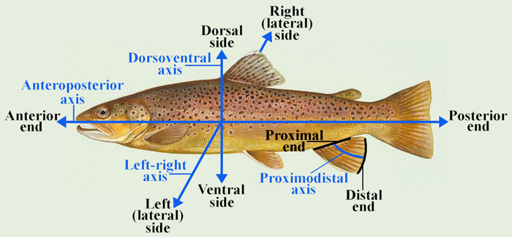

Vestigial
Occurring as a structure that, once functional (whether during development or in earlier evolutionary forms), is now reduced or degenerate. An example is the vestigial pelvic girdle seen in many snakes, including the boas and pythons, which bears no function.

Z

Zygapophysis
Articular process of a vertebra that articulates with the corresponding process of an adjacent vertebra.
Plural = zygapophyses

