Vertebrate Diversity study pack

The following web-book contains a series of information chapters broadly outlining the diversity of living vertebrates, with a few notes on their fossil relatives. Below is a collage of specimens from UCL's Grant Museum of Zoology illustrating the wide diversity covered in this web-book – from jawless vertebrates, sharks, and ray-finned fishes, to amphibians, reptiles, and mammals.

To download this resource as a single file, see the collection page: https://open-education-repository.ucl.ac.uk/id/eprint/204

Also see the related resource Vertebrate Palaeontology and Evolution study pack here: https://open-education-repository.ucl.ac.uk/id/eprint/195

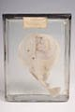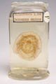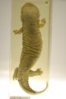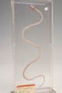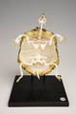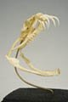
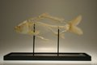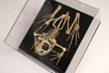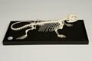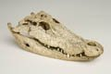
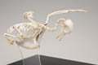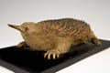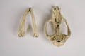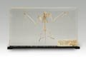
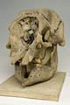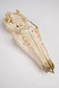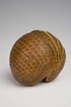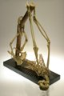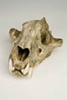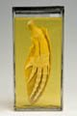

Disclaimer: 'Vertebrate Diversity' was originally designed by UCL staff as an internal teaching resource. The subsequent release of 'Vertebrate Diversity' as an OER means that any changes to the product received relative to the original content may not reflect the desires of UCL teaching staff, or the original quality of the resource.

CC BY-NC-SA 4.0 International Licence: 'Vertebrate Diversity' has been released as an open educational resource (OER) on a Creative Commons 'Attribution Non-commercial Share Alike' license. This means that once downloaded, content can be modified and improved to complement a particular course. This requires, however, that improvements are recycled back into the OER community, and full attribution is made to UCL. All content present at the time of download must be accordingly credited and, in turn, novel content must be appropriately licensed. For more information, please refer to the license deed by visiting: https://creativecommons.org/licenses/by-nc-sa/4.0/legalcode
Contents
Introduction 7
Lamphreys 9
Diversity and Lower Taxonomy 9
Distribution and Habitat 10
Conservation Status (IUCN) 10
Features 10
Chondrichthyes 11
Diversity and Lower Taxonomy 11
Distribution and Habitat 15
Loss of habitat 16
Features 16
Ray-finned Fishes 17
Diversity and Lower Taxonomy 17
Distribution and Habitat 19
Features 19
Labelled image of a typical ray-finned fish skeleton 21
Lobe-finned Fishes 22
Diversity and Lower Taxonomy 22
Distribution and Habitat 23
Features 23
Amphibians 24
Gymnophiona - caecilians 24
Diversity and Lower Taxonomy 24
Distribution and Habitat 25
Conservation Status (IUCN) 25
Features 25
Caudata - salamanders 26
Distribution and Habitat 26
Anura - frogs and toads 27
Features 27
Turtles 28
Diversity and Lower Taxonomy 28
Distribution and Habitat 28
Conservation Status (IUCN) 29
Features 29
Rhynchocephalians 30
Diversity and Lower Taxonomy 30
Conservation Status (IUCN) 31
Uniting features (synapomorphies) of the Rhychocephalia 31
Fossil taxa and rhynchocephalian phylogeny 31
Clevosaurs 32
Pleurosaurs 32
Sapheosaurs 32
Sphenodontines 32
Eilenodontines 32
References 32
Squamata 33
Synapomorphies of the Squamata 33
Phylogenetic relationships of the Squamata 33
Dibamidae - blind lizards 36
Diversity and Lower Taxonomy 36
Distribution and Habitat 36
Conservation Status (IUCN) 36
Features 37
Gekkota - geckoes and pygopodids 37
Diversity and Lower Taxonomy 37
Description 38
Distribution and Habitat 38
Conservation Status (IUCN) 39
Scincomorpha - skinks, wall lizards, and relatives 39
Diversity and Lower Taxonomy 39
Amphisbaenia - worm lizards 39
Description 41
Distribution and Habitat 42
Conservation Status (IUCN) 42
Synapomorphies of the Amphisbaenia and its families (sensu Kearney 2003) 42
Anguimoprpha - monitor lizards, glass lizards, and relatives 43
Iguania - iguanas, chamaeleons, and agamids 43
Conservation Status (IUCN) 46
Serpentes - snakes 47
Crocodilians 49
Diversity and Lower Taxonomy 49
Distribution and Habitat 49
Features 49
Birds 51
Diversity and Lower Taxonomy 51
Features 52
Synapsids 53
Monotremata - monotremes 53
Diversity and Lower Taxonomy 54
Distribution and Habitat 54
Conservation Status (IUCN) 54
Features 54
Marsupialia - marsupials 56
Features 57
Labelled images of an opposum skull 57
Eutherians 58
References 59
Glossary 60

Introduction

The first chapter considers the lampreys - a clade of jawless vertebrates that are thought, based on analysis of their morphology, to be the group that first diverged from the remaining vertebrate clades.

Subsequent chapters follow a structure that roughly reflects the evolutionary relationships (or phylogeny) between the higher level vertebrate groups - for example, the turtles, lizards, tuatara, crocodiles, and birds are all reptiles and, as such, their chapters are clustered together. This structure need not imply any increase in complexity or morphological "progress" as one descends through the chapters - indeed, every taxon discussed in this web-book is extant, meaning that it has some members that are still living, and are therefore also evolving under the selection pressures of their current environment. Rather, the structure reflects the greater focus of this web-book on those four-limbed vertebrates (tetrapods) whose ancestors colonised the terrestrial world in the Devonian swamps of nearly 400 million years ago - in particular the hair-covered, milk-producing mammals.

While the structure of the web-book may not always act as an accurate representation of the evolutionary history of vertebrates, the phylogenetic tree below illustrates how all the major vertebrate clades are thought to be related.

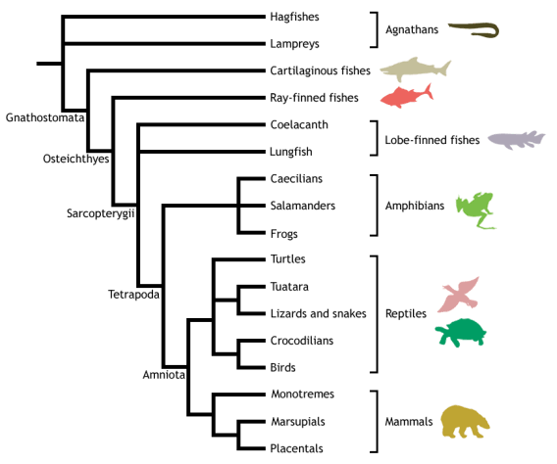

Adapted from Meyer & Zardoya (2003), this is a conservative estimate of vertebrate phylogeny, reflecting the prevailing consensus between morphological and molecular data. Conflict between morphology and molecules is manifest at the unresolved nodes, or polytomies - those nodes that are formed when greater than two branches coalesce.

For example, the most popular view of morphologists is that lampreys represent the closest living relatives of the jawed vertebrates (Gnathostomata), together forming the Vertebrata. This hypothesis excludes hagfishes from the vertebrates on the basis that they do not possess some of the derived morphological features shared by lampreys and gnathostomes - in particular, they lack a vertebral column. Instead, hagfishes are placed as the sister group to the vertebrates, together forming the Craniata (or craniates) - animals possessing a skull, or cranium. This view of craniate evolution makes the living jawless vertebrates, or agnathans, a paraphyletic group. This means that the jawless vertebrates do not form a natural (or monophyletic) grouping, as their most recent common ancestor is not unique to them - it is shared with the jawed vertebrates as well.

In contrast, molecular data tend to group the lampreys and hagfishes to the exclusion of the gnathostomes, making the living agnathans a monophyletic group termed Cyclostomi. Under the cyclostome hypothesis, it is presumed that the common ancestor of the cyclostomes and gnathostomes possessed a vertebral column, which was subsequently lost in the evolution of the hagfishes.

Despite the disparities between morphological and molecular data evident from the cladogram above, the evolutionary history of the vertebrates is fairly well resolved, with many major traditionally identified groupings persisting through recent advances in methods for phylogenetic inference and the advent of molecular systematics. Consequently, this tree should be used as a working guide while exploring the taxa described within the web-book, providing an evolutionary context that highlights the shared ancestry of the different vertebrate lineages, as well as helping to trace some of the evolutionary innovations that gave rise to the many different forms - including the origin of jaws, ossification of the endochondral skeleton, evolution of terrestrially adapted limbs, and the amniotic egg.

Lamphreys

Petromyzontiformes - lampreys

Vertebrata; Petromyzontiformes

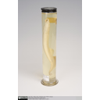  Lamprey | 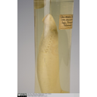  Lamprey Gill Slits | 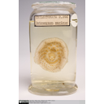  Lamprey Mouthparts

The Petromyzontiformes, or lampreys, were once grouped in a taxon called Agnatha (jawless fishes), which also contained the other extant group of jawless fishes, the hagfishes (Hyperotreti). The Agnatha traditionally formed one of the two major sister lineages of vertebrates, the other being the Gnathostomata (jawed vertebrates). Below is a cladogram showing the old view of basal vertebrate phylogeny:

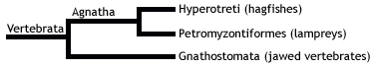
However, it has since been discovered that lampreys are more closely related to jawed vertebrates than are hagfishes, and thus Agnatha is a paraphyletic group. In fact, hagfishes are no longer considered vertebrates in the strict sense, as they do not possess vertebral elements surrounding the dorsal nerve cord - evolutionary precursors to the vertebral column seen in well-known vertebrates. Instead, they are classified as an outgroup to the Vertebrata, collectively forming the monophyletic Craniata. Craniates are defined by the presence of a well-defined head region, with a cranium that encases a brain and paired sensory organs, and includes the last common ancestor of vertebrates and hagfishes plus all its descendents.

Lampreys and jawed vertebrates are therefore considered the two extant clades forming the Vertebrata in its strict sense. The cladogram below illustrates these phylogenetic relationships
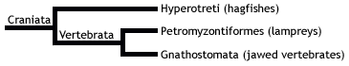

Diversity and Lower Taxonomy
The order Petromyzontiformes comprises a single family, Petromyzontidae, containing 40 extant species of lamprey across ten genera: Petromyzon, Caspiomyzon, Geotria, Mordacia,Eudontomyzon, Tetrapleurodon, Entosphenus, Lethenteron, and Lampetra.

Distribution and Habitat
Lampreys are distributed amphitropically (in temperate regions north and south of the tropics). Only two genera (Geotria and Mordacia) are present in the Southern Hemisphere, with the remaining eight in the Northern Hemisphere.
Lampreys inhabit either freshwater or marine environments in all temperate regions except those of Africa. All species live in freshwater during their larval stage and also spawn and die in river habitats. Some species are anadromous, migrating to coastal seas when mature and only returning to reproduce. Lamprey larvae have a low tolerance for high water temperature, hence they are not found in tropical regions.

Conservation Status (IUCN)
The IUCN Red List has assessment entries for only 18 of the 40 species of lamprey. Of these, the majority (10 species) are listed as Least Concern (LC). While one species, the Ukrainian migratory lamprey (Eudontomyzon sp. nov. 'migratory'), was confirmed extinct in 2008, another species, the Greek Brook lamprey (Eudontomyzon hellenicus), is Critically Endangered (CR). Two species are considered Near Threatened (NT) and one is Vulnerable (VU), while the remaining species are Data Deficient (DD).

Features
- Lack a bony skeleton and jaws (bones may have been secondarily lost, as there is evidence to suggest that their ancestors possessed a bony skeleton).
- No paired fins (pectoral, pelvic), but do have unpaired fins: dorsal and caudal (tail) fin.
- Presence of horny teeth, which they use as a "rasping tongue" to suck on to prey, and pierce the flesh to draw blood.
- Rows of paired gill openings; water flows in and out of the gills in a tidal flow - while most fish breathe by drawing water into the mouth, past the gills, and out through the gill slits in a one-way flow of water, lampreys cannot use their mouths for ventilation as they are attached to prey!

Chondrichthyes

Chondrichthyes - cartilaginous fishes

Vertebrata; Gnathostomata; Chondrichthyes

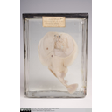  Torpedo ray - dorsal view | 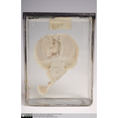  Torpedo ray - ventral view showing toothplate | 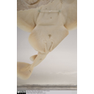  Torpedo ray - ventral close-up showing pelvic claspers

Diversity and Lower Taxonomy
The class Chondrichthyes comprises almost 1050 extant species ofcartilaginous fishes, encompassing skates, sharks, rays, andchimaeras. The class contains 12 orders which are divided between 2 monophyletic subclasses, the Elasmobranchii (sharks, rays and skates) and Holocephali (chimaeras). With the Holocephali now represented by only ~40 living species of chimaera in the single order Chimaeriformes, the vast majority of extant chondrichthians are elasmobranchs, and are divided between 11 orders. Although traditional classifications separated the elasmobranchs into two groups, the sharks and the batoids (rays and skates), Campagno (1973, 1977) recognised four distinct groupings on the basis of phenetics (overall similarity), and identified these as the four elasmobranch superorders as follows:

- Subclass Elasmobranchii (sharks, rays and skates)
  - Superorder Batoidea (over 500 species of rays and skates):
    - Order Rajiformes (common rays and skates)
    - Order Pristiformes (Sawfish)
    - Order Torpediniformes (electric rays)
  - Superorder Squalomorphii:
    - Order Hexanchiformes: containing 5 extant species within 2 families, the Hexanchidae(cow shark) and Chlamydoselachidae (frilled shark), distinguished by their additional gill slits (either six or seven).
    - Order Squaliformes: containing 80 species divided into 3 families: Echinorhinidae(Bramble Sharks), Squalidae (Dogfish sharks) and Oxynotidae (Roughsharks).
    - Order Pristiophoriformes: containing 5 species within a single family,Pristiophoridae(sawsharks).
  - Superorder Squatinomorphii:
    - Order Squatiniformes: containing 13 species in 1 family, Squatinidae (Angel sharks).
  - Superorder Galeomorphii:
    - Order Heterodontiformes: 8 species in 1 family, Heterodontidae (bullsharks).
    - Order Orectolobiformes: 7 families are found within this order: Brachaeluridae (blind catsharks and blind sharks), Ginglymostomatidae (nurse sharks), Hemiscylliidae(bamboo sharks and longtailed carpetsharks), Orectolobidae (wobbegongs),Parascyllidae (collared carpetsharks), Rhincodontidae and Stegostomatidae(zebra sharks).
    - Order Carcharhiniformes: this is the largest order containing approximately 200 species within 8 families: Carcharhinidae (requiem sharks), Hemigaleidae (weasel sharks),Leptochariidae(barbeled houndsharks), Proscylliidae (finback catsharks), Pseudotriakidae(false cat sharks),Scyliorhinidae (cat sharks), Sphyrnidae (bonnethead sharks, hammerhead sharks, and scoophead sharks), Triakidae (houndsharks, smooth-hounds, topes, and whiskery sharks).
    - Order Lamniformes: known as mackerel sharks, this order contains 7 families and 16 species:Alopiidae (thresher sharks), Cetorhinidae (basking sharks), Lamnidae (mackerel sharks, porbeagles, and white sharks), Megachasmidae (megamouth sharks),Mitsukurinidae (goblin sharks), Odontaspididae (goblin sharks, sand sharks, and sand tiger sharks) and Pseudocarchariidae (crocodile sharks)
- Subclass Holocephali (chimaeras)
  - Order Chimaeriformes: 40 species in 6 genera and three families, Callorhinchidae,Chimaeridae and Rhinochimaeridae.

Following this view of chondrichthian classification, Maisey (1980) adopted a more phylogenetic approach, identifying a potential shared derived morphological charcater between the squalomorph and squatinomorph sharks - an orbital process in the eye socket protruding from the upper-jaw cartilage. This synapomorphy was used to unite these two superorders in a group termed the "orbitostylic" sharks, to the exclusion of the galeomorphs and batoids. Further, the galeomporphs were proposed as the sister group to the orbitostylic sharks, resulting in a return to the traditional view that sharks and batoids represent separate natural groupings (see cladogram below).

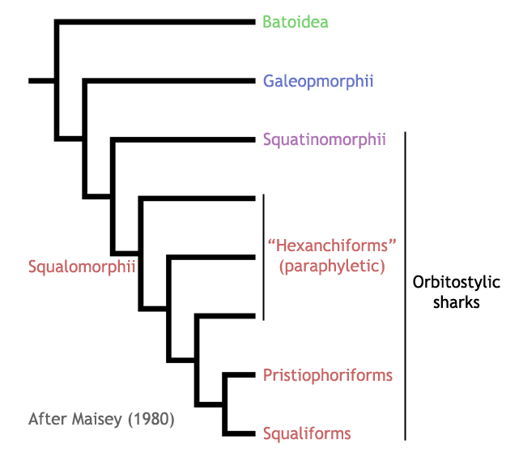
This view was strongly contested in the following decade, with many morphological phylogenetic studies (Shirai, 1992, 1996; de Carvalho, 1996) gathering support for the hypnosqualean hypothesis, which states that batoids (rays and skates) are in fact derived sharks, grouped with the Pristiophoriformes and Squatinomorphii in the clade "Hypnosqualea" (see cladogram below). The remaining squalomorph orders (Squaliformes and Hexanchiformes) then grouped (whether as a clade or grade) nearest to the Hypnosqualea, to form the "Squalea", which formed the sister group to the remaining elasmobranchs - the monophyletic Galeomorphii. In addition to the controversial proposal that sharks are in fact paraphyletic with respect to rays and skates, these studies were significant in that they began to identify the fragility of the superorder Squalomorphii as a natural grouping, in these instances containing both the batoids and the squatinomorphs. This, over time, has led to the breakdown of the Squatinomorphii as a distinct elasmobranch superorder, with its single order (Squatiniformes) being redefined as an order within a newly defined Squalomorphii (containing its original three orders plus Squatiniformes).

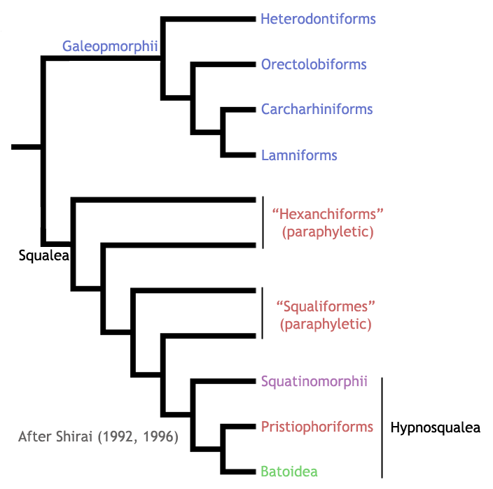

Since the turn of the millenium, a wealth of molecular studies starting with Douady et al (2003) have brought about a new view of elasmobranch phylogeny that strongly and consistently rejects the hypnosqualean hypothesis, and returns to the classically held view that sharks form a monophyletic group, the Selachimorpha, which is sister to the rays and skates (Batoidea). Within Selachimorphi, there has been repeated support for the monophyly of the new Squalomorphii containing squatiniform sharks (Douady et al, 2003; Winchell et al, 2004; Naylor et al, 2005; Mallatt et al, 2007; Heinicke et al, 2009; Vélez-Zuazo & Agnarsson, 2011). Note that this newly defined Squalomorphii is equivalent in terms of membership to the orbitostylic sharks. The phylogenetic positions of the remaining four orders (galeomorph sharks) have, in contrast, been less consistent. While some studies have recovered amonophyletic Galeomorphii (Heinicke et al, 2009; Vélez-Zuazo & Agnarsson, 2011), others have placed the Heterodontiformes as the closest living relative to the Squalomorphii (Winchell et al, 2004; Mallatt et al, 2007). Most molecular studies have, nonetheless, recovered the remaining galeomorph orders (Orectolobiformes, Carcharhiniformes, and Lamniformes) as a monophyletic grouping (see Douady et al, 2003 for exception), although the interelationships between these groups is still a matter of debate. The two cladograms below show recent conflicting views on the phylogeny of Selachimorpha based on DNA sequence data.

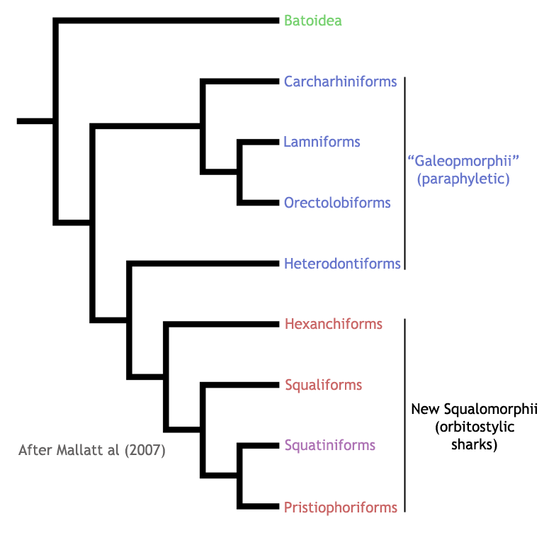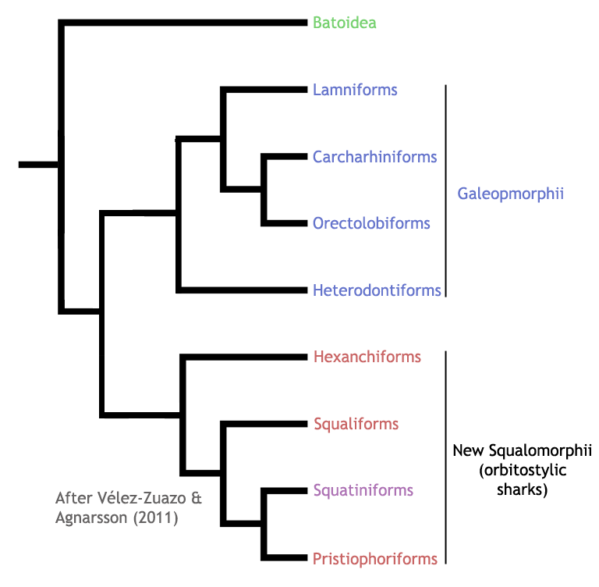

Distribution and Habitat
Most chondrichthyans are marine species. Only 5% (approximately 45 species) are restricted to freshwater, such as the giant freshwater stingray, Himantura chaophraya (Fowler et al., 2005; Helfman et al., 2009). Others enter estuaries and freshwater sporadically, often to breed.
Members of the Chondrichthyes can be found in nearly all aquatic ecosystems and depths, except the most extreme conditions. But most species are restricted to and specialised for a particular oceanic zone. For example, the skates (members of Rajidae) and angel sharks (Squatinidae) are benthic species. The Lamnidae (white sharks) are pelagic, but in the upper depths only (Fowler et al., 2005). Approximately 50% of species inhabit the continental slopes, up to 200m, and 35% occupy depths between 200 - 2000m (Helfman, 2009). Only 5% of species, mainly the large pelagic ones, inhabit the open ocean. For example, the mantarays (Myliobatiformes) make annual migrations, while the great white shark (Carcharodon carcharias) has been known to travel between South Africa and Australia (Fowler et al., 2005).

The elasmobranchs occcupy the widest range of habitats - even the icy waters of the Arctic and Antarctic Ocean. But their physiology cannot withstand the most extreme conditions such as high salinity or the oxygen deficient depths that some teleosts have become specialised to endure. Therefore most sharks do not inhabit very deep water, although some species have been sighted at depths up to 4000m (Helfman et al., 2009). The Holocephali are found only in temperate waters up to 2000m, and prefer the cooler depths below 80m (Fowler et al, 2005; Helfman et al., 2009).
Conservation Status (IUCN)
The 2008 IUCN Red List categorised 17% of chondrichthyan species (181/1044) as threatened with extinction. The majority of these are in the lowest risk category (Vulnerable), but 42 species are Endangered, and 25 are placed within the highest risk category (Critically Endangered). The Squatiniformes (angelsharks) are the chondrichthyan order at greatest risk, with over half (12/22) of its species considered threatened with extinction (3x Critically Endangered, 5x Endangered, and 4x Vulnerable). Seven of the remaining ten species are Data Deficient, and so may themselves also be under threat.

Chondrichthyes are an ancient and successful clade, having survived 400 million years of changing environments. Yet human presence and intervention has put them at risk. The life history of Chondrichthyes marks them as vulnerable to extinction. As a K-selection species, they give birth to only a few young after a long gestation, which grow slowly and reach sexual maturity late (Fowler et al., 2005). Although their rate of survival is usually high, if populations become rapidly depleted, recovery can be difficult and lengthy.

The primary threat to sharks, rays, and chimaeras is fishing (Fowler et al. 2005). Commercial demand for shark meat and fins is high and fisheries are unmanaged, pushing population levels to dangerously low numbers. Many species are also often killed as by-catch from bottom trawlers.

Loss of habitat is also a significant threat, and those species which inhabit regions closest to human activity are at most risk from habitat degradation and pollution. Estuaries, whose shallow waters provide invaluable nurseries for chondrichthyans are being destroyed or polluted. Similarly, certain freshwater systems are becoming increasingly degraded by pollution, making them inhospitable to indigenous species.

Features
- Skeletons formed of calcified cartilage - no bone.
- Covered in placoid scales - a structure like teeth, with a dentine crown coated in an enamel-like material, a vascularised pulp cavity, and a bony base. They are sometimes referred to as denticles.
- True teeth, which are shed and replaced regularly in modern species.
- The males of all but the oldest fossil species have a pelvic clasper, used in courtship and mating. It is formed of the pelvic meta-pterygium - the basal cartilage of the pelvic fin.

Ray-finned Fishes

Actinopterygii - ray-finned fishes

Vertebrata; Gnathostomata; Osteichthyes; Actinopterygii

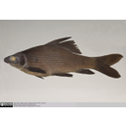  Lateral view of Black Labeo (Carp) in spirit | 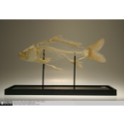  Carp skeleton | 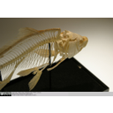  Carp skeleton | 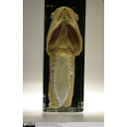  Fish swim bladder in spirit

The actinopterygians, or ray-finned fish, are one of the two major clades of bony fish (Osteichthyes), the other being the lobe-finned fish, or Sarcopterygians. The Chondrichthyes (cartilaginous fish) are the extant sister clade of the Osteichthyes. Below is a cladogram to show these relationships:

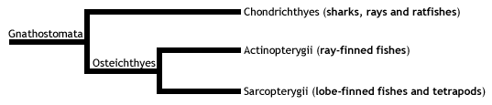

Diversity and Lower Taxonomy
- The subclass Actinopterygii comprises some 27,000 species of ray-finned bony fishes, making it the largest radiation of any vertebrate group. As a result, covering the whole group in detail would be extremely complex and, more importantly, hugely baffling! Therefore, the information below aims to highlight the key groups of ray-finned fish in an evolutionary context, explaining how each clade is divided and related.
- Actinopterygians can be divided into two distinct groups: basal actinopterygians and neopterygians (most extant fishes). The basal actinopterygians comprise two closely related small taxa, the more primitive Polypteriformes (containing a single family of bichirs), and the Chondrostei (containing two families, the sturgeons and the paddlefishes). The following cladogram illustrates these relationships:
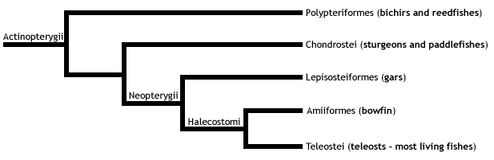

- Living neopterygians can then be split into three groups (see cladogram above), the first two of which are considered primitive neopterygians:
- The gars, forming a single family in the order Lepisosteiformes. These are medium- to large-sized (ranging from 1 - 4 metres long) predatory fishes with elongate bodies and jaws, long needle-like teeth, and thick armoured scales.
- The bowfin, Amia calva, the single living species forming the Order Amiiformes. The bowfin ranges in length from 0.5 - 1 metre, and is characterised by its long dorsal fin extending across most of the length of the body.
- The teleosts, the largest radiation of vertebrate life, exhibiting huge diversity in more than 20,000 species of ray-finned fishes across 40 orders.
- The clade Teleostei contains four main subgroups, shown in the cladogram below. The highly derived Euteleostei is the largest of the teleosts groups, with around 17,000 species in 375 families. This group shows tremendous diversity, and includes both the largest (the ocean sunfish, reaching up to 3.6 m in length) and the smallest (Paedocypris, a genus of the carp family with females as small as 7.9 mm) extant bony fish species.

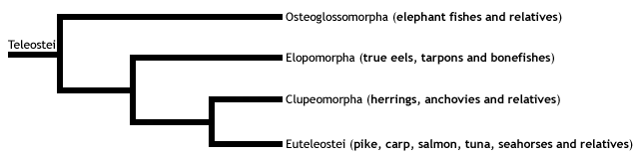

- The Euteleostei comprises three groups:

- Order Esociformes - a small group containing pikes and mudminnows.
- Division Ostariophysi - a large group including carps, catfishes, minnows, piranhas, and relatives. These 6,500 species form approximately 80 percent of all living freshwater fish species.
- Division Neognathi - contains two groups, the Order Salmoniformes (salmon, trout and smelts), and theSubdivision Neoteleostei. The neoteleosts are divided into four groups: three basal groups containing many deep-sea fishes (including the bioluminous lanternfishes), and a single group of highly advanced fishes - the acanthomorphs, or spiny-rayed teleosts (acanth is Ancient Greek for thorn). Spiny teleosts then fall into two groups, the Paracanthopterygii (1200 species of cods, haddocks and anglerfishes) and the Acanthopterygii, a huge clade containing around 12,000 extant species, which dominate the vast majority of the world's open ocean and shallow marine environments. Within this clade is theAtherinomorpha (guppies, killifishes and relatives), and the Percomorpha - by far the most diverse group of fish, containing over one-third of all ray-finned fish species, and exhibiting a fascinating array of body forms - including perches, seahorses, flatfishes, pufferfishes, and tunas

Distribution and Habitat
As one would expect from their massive diversity, there are certain species of ray-finned fishes present in waters worldwide. However, some clades are much smaller than others, and consequently have much narrower distributions. It would be a huge task to highlight the distribution of all actinopterygian species, or even families, and so the following is a list of the geographical distributions and aquatic environments of the evolutionarily key groups outlined above:
- Polypteriformes (bichirs and reedfishes) - Africa; freshwater.
- Chondrostei (sturgeons and paddlefish) - Northern Hemisphere; coastal and freshwater.
- Lepisosteiformes (gars) - North and Central America and Cuba; fresh and brackish water.
- Amiiformes (bowfin) - North America; freshwater.
- Osteoglossomorpha (elephant fishes and relatives) - Worldwide; mostly tropical freshwater.
- Elopomorpha (true eels and relatives) - Worldwide; mostly marine.
- Clupeomorpha (herrings, anchovies, and relatives) - Worldwide; mostly marine.
- Esociformes (pikes and mudminnows) - North America, Western Europe and Northern Eurasia; freshwater.
- Ostariophysi (carps, catfishes, piranhas, and relatives) - Worldwide; mostly freshwater.
- Salmoniformes (slamons, trouts, and relatives) - Temperate Northern and Southern hemisphere; freshwater.
- Paracanthopterygii (cods, haddocks, and anglerfishes) - Northern hemisphere; marine and freshwater.
- Atherinomorpha (guppies, killifishes, and relatives) - Worldwide; surface-dwelling; freshwater and marine.
- Percomorpha (perches, seahorses, tunas, and relatives) - Worldwide; mostly marine.

Features
- The skeleton of the paired fins is formed from many small bones, called fin rays, in a fan-like arrangement, which are supported at the bases of the fins by parallel rows of bones called radials. All living actinopterygians except bichirs and reedfishes (Order Polypteryformes) also have branching rays in unpaired fins.

- Modified the ancestral fish character of a breathing lung into a swim bladder to aid and adjust buoyancy. Although it is easy to assume that lungs are an adaptation unique to terrestrial vertebrates (tetrapods), it is likely that lungs evolved in early armoured fishes called placoderms in the seas of the Silurian and Devonian around 415 million years ago, and are therefore a shared ancestral character of all bony fishes, including their tetrapod descendents. The swim bladder is a smooth-walled (i.e., non-alveolar) modified lung that is virtually impermeable to gas. Therefore, gas can be gulped - or indeed transferred from the bloodstream in many more derived teleosts - into the swimbladder of ray-finned fishes to reduce the overall density of the body, and afford neutral buoyancy. This allows fish to remain stationary in the water column, and thus waste less energy. As the pressure of the water column on the body changes with depth, actinopterygians must regulate the volume of air in their swim bladders to remain neutrally buoyant. Some ray-finned fishes, such as the gars of North and Central America and Cuba, are secondary air-breathers, who have evolved an alveolar lung to survive in their low-oxygen environment.

- Single dorsal fin. Some fishes, such as salmons and catfishes, have an additional fin positioned just posterior of the dorsal fin, called the adipose fin, which is small, soft and fleshy.

- Ancestrally, ray-finned fishes were covered in tough rhomboidal ganoid scales, formed of a thick layer of spongy bone, covered with dentine, followed by ganoine (a substance derived from enamel - the material that covers human teeth). However, the more derived fish groups have modified the structure of their scales to increase flexibility and reduce weight, in order to improve locomotory efficiency - allowing individuals to become more advanced predators, as well as more evasive prey. Living species within the teleost clade have reduced scales that are circular, flexible, thin, and overlapping craniocaudally - cycloid scales. One group, the spiny-rayed teleosts (Order Acanthomorpha), have further modified their scales to a form termed ctenoid (cten is Ancient Greek for comb), which bear comb-like spines on the posterior edge.

- While many basal actinopterygians possess a primitive heterocercal tail - one in which the fin lobes are different in length (asymmetrical) - there is increasing symmetry towards the teleost group, with teleosts themselves possessing a homocercal tail, which is completely symmetrical in appearance (the images clearly show this in a species of carp).

- The jaws of ray-finned fish have undergone many modifications through their evolution. Early forms had simple snapping jaws with weak jaw-closing muscles, which were used to grab prey. The neopterygians then lost the connection between the cheek bones and the posterior of the upper jaw (maxilla). This caused the maxilla to be rotated forwards and to the side when the jaws were opened, increasing the volume of the oral cavity to create a suction effect, drawing prey items into the mouth. Further skeletal jaw modifications, alongside flaps of skin around the maxilla then allowed teleosts to have a highly protruding tube-like mouth, whose fully circular opening produced a stronger and highly directional suction force into the oral cavity, which also retained prey on jaw closure. These adaptations to increase suction were crucial in the evolution of ray-finned fishes as active predators, as lunging towards prey items in water actually acts to push them away by forcing a flow of water towards them.

Labelled image of a typical ray-finned fish skeleton
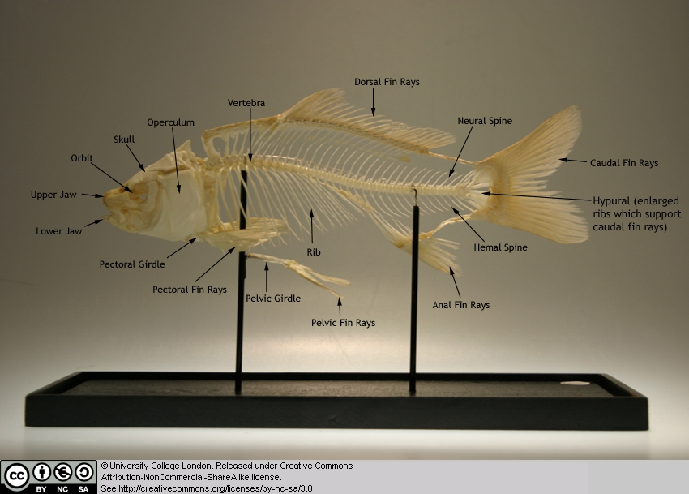

Lobe-finned Fishes

Sarcopterygii - lobe-finned fishes

Vertebrata; Gnathostomata; Osteichthyes; Sarcopterygii

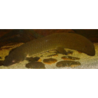  Queensland lungfish (Neoceratodus forsteri) | 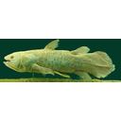  West Indian Ocean Coelacanth (Latimeria chalumnae)

Diversity and Lower Taxonomy
The Sarcopterygii, or lobe-finned fishes, is a clade containing the coelacanths, lungfishes, tetrapods, and their fossil relatives, including the osteolepiformes and panderichthyids. They are the sister group to the ray-finned fishes (Actinopterygii), together forming the bony fishes (Osteichthyes).
Sarcopterygians are characterised by their fleshy pectoral and pelvic (paired) fins that articulate with the pectoral (shoulder) and pelvic (hip) girdles via a single bone. This is apparent in the coelacanths and lungfishes, which are more intuitively fish-like. These lobe-fins gave rise to the paired limbs of tetrapods, with the single bones representing the humerus (forelimb) and femur (hindlimb).
The once-diverse coelacanths (Actinistia) are now represented by just two species in a single genus -Latimeria chalumnae and L. menadoensis.
The lungfishes (Dipnoi) are also a small relict of a once-diverse assemblage, with only six extant species in three genera - Protopterus (4x species), Lepidosiren paradoxa, and Neoceratodus forsteri.
The palaeontological record makes clear that the terrestrial verterbates evolved from lobe-finned fishes nearly 400 million years ago during the Devonian, and are therefore members of the Sarcopterygii. The only terrestrial vertebrates still living today are the tetrapods, which originated around 350 million years ago and are defined as that group which comprises the common ancestor of the living amphibians and amniotes plus all its descendants. The vertebrate conquest of the land was a major evolutionary transition that required many morphological and physiological changes away from a fish-like form, and has given rise to around 21100 living species and probably many more extinct forms. As such, the extant tetrapods are considered in depth in the following ZooMoodle webpages.
While some molecular data have proposed a sister group relationship between lungfishes and coelacanths to the exclusion of tetrapods (e.g., nuclear 28S rRNA gene; Zardoya & Meyer 1996), and certain studies have been unable to statistically reject the placement of the coelacanths as the closest living relative of the tetrapods (Zardoya & Meyer 1997a, Zardoya et al. 1998), most morphological, palaeontological, and molecular evidence (e.g., combined mitochondrial protein coding genes) supports the lungfishes as the closest living relatives to the tetrapods, to the exclusion of the Actinistia (Meyer & Zardoya, 2003). This is further supported by a unique deletion in the gene encoding RAG2 that is uniquely shared between tetrapods and lungfishes (Venkatesh et al. 2001). This prevailing view is depicted in the following phylogeny:

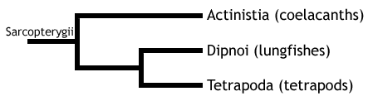

Distribution and Habitat
Fossils of Coelacanths have been discovered on every continent, evidence of their previous distribution (Helfman et al., 2009). But modern coelacanths have a limited geographic distribution. Previously thought extinct, Latimeria chalumnae has been indentified since 1938 in the waters of the West Indo Pacific Ocean near the Comoros Island and eastern coast of southern Africa (Bone et Moore, 2008). Latimeria menadoensis has been sighted only in Sulawesi, Indonesia since its discovery in 1999 (Pouyaud et al., 1999). Coelacanths live in the benthic zone, between 200 - 300m along steep underwater slopes and shelves. (Helfman et al., 2009). They aggregate in submarine caves during the day and emerge to feed during the night (Boine and Moore, 2005).

The Dipnoi have a wider distribution - Central and South Africa (Protopterus), Amazon and Paron riverbasins of South America (Lepidosiren), and Queensland, Australia (Neoceratodus) (Bone and Moore, 2005; Helfman et al. 2009). They inhabit freshwater streams, rivers and swamps. During drought, Protopterus and Lepidosiren will burrow into the earth, breath intermittently with their lung and can remain in this state of torpidity for months to avoid desiccation (Helfman et al, 2009).Neoceratodus is unable to estivate and lives only in deep rivers where there is no risk of drought.
Conservation Status (IUCN)
Latimeria chalumnae is classified by the IUCN as critically endangered. Latimeria menadoensis isvulnerable, but there have only ever been three sighting of this species so it is difficult to ascertain populations levels (IUCN, 2008). Both species are often by-catch of deep sea trawlers and shark nets. Low fecundity and slow growth rates put the Coelacanths at risk of extinction and even small depletions in population size can take decades to recover.

The Dipnoi are not considered at risk of extinction because of their wide distribution. But they do face anthropogenic threats such as habitat loss and degradation - contruction of dams impedes flooding, the spread of agriculture is reducing wetland habitats and both practices produce harmful pollution (IUCN, 2008).

Features
- Muscular paired fleshy fins
- Fins attached the pelvic and pectoral girdle by single basal bone.
- Teeth coated with enamel.

Amphibians

Lissamphibia - frogs, salamanders, and caecilians

Vertebrata; Gnathostomata; Osteichthyes;
Sarcopterygii; Tetrapoda; Lissamphibia

The following three headings outline the diversity of three living orders of amphibians - Gymnophiona (caecilians), Urodela (salamanders and newts), and Anura (frogs and toads).

Gymnophiona - caecilians

Vertebrata; Gnathostomata; Osteichthyes; Sarcopterygii; Tetrapoda; Lissamphibia; Gymnophiona

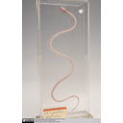  Caecilian skeleton - whole body view showing limblessness and elongate trunk | 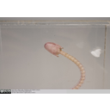  Caecilian skeleton - dorsal view of skull, showing compound structure and reduced orbits | 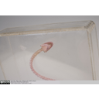  Caecilian skeleton - ventral view showing compound structure of the skull and lower jaw

The caecilians are a group of limbless, burrowing amphibians, which superficially resemble earthworms or some limbless lizards (snakes, amphisbaenians). Together, caecilians form the order Gymnophiona - one of the three extant amphibian orders, along with Anura (frogs and toads) and Caudata (newts and salamanders).

Diversity and Lower Taxonomy
The Gymnophiona currently comprises 183 extant species of caecilian. Until recently, these were grouped between the following six families: Caecilidae, Ichthyophiidae, Rhinatrematidae, Scolecomorphidae, Typhlonectidae, and Uraeotyphlidae. However, in 2006, Frost et al. revised amphibian phylogeny, proposing that only three of the previous six caecilian familial groupings - Caecilidae, Ichthyophiidae, and Rhinatrematidae - represented distinct families. The remaining three groupings are now thought to be embedded within these three major lineages, with caecilian taxonomy as follows:

- Caecilidae - 123 species
  - 21 genera including 104 species
  - Scolecomorphinae (6 species in 2 genera)
  - Typhlonectinae (13 species in 5 genera)
- Ichthyophiidae - 50 species in 3 genera (including the genus Uraeotyphlus)
- Rhinatrematidae - 10 species in 2 genera

Distribution and Habitat
Most caecilians inhabit moist tropical and subtropical regions of South and Central America, South and Southeast Asia, and Sub-Saharan Africa. A single species inhabits Trinidad & Tobago.
Almost all caecilians are terrestrial, but they are elusive as they spend the majority of their lives underground. They burrow primarily in forests, but also in grassland, savanna, shrubland, and wetlands.

Members of the suborder Typhlonectinae are known as aquatic caecilians, and inhabit freshwater systems. At least four typhlonectin species are exclusively aquatic.

Conservation Status (IUCN)
Of the 172 species of caecilian present on the IUCN Red List, over 66% (114 species) are lacking enough data to have their extinction threat assessed (Data Deficient).
For the 58 species for which there is sufficient data for assessment, 52 are considered of Least Concern. The remaining 6 species are threatened with extinction, with four Vulnerable, one Endangered (Grandisonia brevis), and one Critically Endangered (Boulengerula niedeni).

Features
- No appendicular skeleton - they are completely limbless and have no shoulder girdle, but there is a kink in the spine where the pelvic girdle once was.
- 95-285 presacral vertebrae (those anterior to the sacral vertebrae, which once fused with the pelvic girdle).
- Compound, akinetic skull formed of joined plates of bone - this is an excellent and typical adaptation for a fossorial animal (also seen in burrowing lizards, and burrowing mammals, such as the golden moles), allowing the head to be used like a spade to dig, push, and pack earth when burrowing in underground tunnels.
- Reduced eyes.
- 200+ lymph hearts situated intersegmentally under the skin.

Caudata - salamanders

Vertebrata; Gnathostomata; Osteichthyes; Sarcopterygii; Tetrapoda; Lissamphibia; Caudata

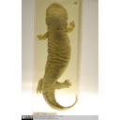  Japanese giant salamander in spirit - dorsal view showing elongate body, short limbs, and laterally compressed swimming tail | 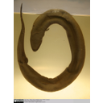  Salamander in spirit - dorsal view showing elongate body, short limbs, and laterally compressed swimming tail | 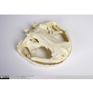  Skull of a Chinese giant salamander - showing broad, flattened skull, and large orbits | 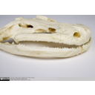  Skull of a Chinese giant salamander - showing flattened skull, and bicuspid teeth on both mandibles

Distribution and Habitat
Salamanders are almost entirely confined to the holarctic - the ecozone including the habitats of the northern continents, as well as a small part of North Africa north of the Sahara. This means that no species of salamander is native to sub-Saharan Africa or the Australian continent. Approximately 30 species inhabit South America - all being members of the family Plethodontidae.
The majority of salamanders are restricted to North and Central America (367 species), variously inhabiting terrestrial and freshwater systems in temperate or tropical forests.
Conservation Status (IUCN)
Of the 552 species of salamander that are listed on the IUCN Red List, two species - the Yunnan Lake newt, Cynops wolterstorffi, and Ainsworth's salamander, Plethodon ainsworthi - are now considered extinct, after not being recorded since between 1964 and 1979.
A further 58 species are listed as Data Deficient, meaning that current population level data is either absent or insufficient to make species-level assessments.
A huge 55% of the remaining species (270/492) are considered threatened with extinction, with 92 species listed as Vulnerable, 101 Endangered, and 77 Critically Endangered. The remaining species are at lower risk, either listed as Least Concern (160) or Near Threatened (62).
Features
- Elongate body, usually with four short limbs and a laterally flattened tail for swimming.
- Broad, flattened skull, with large orbits.
- Bicuspid teeth on both the upper and lower jaw.
- The rib-bearers (the elements of the vertebrae that articulate with the ribs) are bicipital (have two prongs).

Anura - frogs and toads

Vertebrata; Gnathostomata; Osteichthyes; Sarcopterygii; Tetrapoda; Lissamphibia; Anura

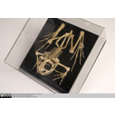  Frog skeleton - dorsal view showing specialised morphology for jumping | 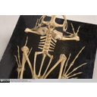  Frog skeleton - dorsal view showing urostyle and short, stiff vetebral column

Features
- A skeleton that is highly modified for jumping (although many forms have altered these features to specialise in other lifestyles, such as an aquatic or burrowing one):
  - Elongate hind limbs, including the ankle bones (tarsals) and foot bones (metatarsals and phalanges).
  - A urostyle: a rod-like fusion of the sacral vertebrae, running in parallel with the extended iliac blades of the pelvis, resulting in a strong, shock absorbing pelvic basket.
  - Short, stiff vertebral column (9 or less vertebrae proper) and no ribs. This helps to stiffen the trunk, providing a solid path for the transmission of thrust from the limbs when jumping, as well as maintaining posture.
- Short and flat head.
- No teeth on the dentary.
- Fused radius and ulna to form a compound radio-ulna.

Turtles

Testudines - turtles

Vertebrata; Gnathostomata; Osteichthyes; Sarcopterygii; Tetrapoda;
Amniota; Sauropsida; Parareptilia (formerly Anapsida); Testudines

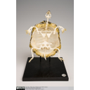  Testudine skeleton | 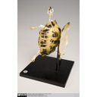  Testudine skeleton | 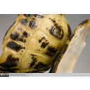  Testudine skeleton

Diversity and Lower Taxonomy
The order testudines is a monophyletic clade containing 260 species of extant turtles, terrapins and tortoises in 13 families. Tortoises include just a single family (Testudinidae), which is phylogenetically embedded within the turtles. Turtles are therefore the paraphyletic group comprising the remaining 12 families (they are paraphyletic as their last common ancestor is shared with that of tortoises).
Extant testudines are divided into two clades, the Cryptodira (meaning "hidden neck") and the Pleurodira (meaning "side neck"), categorised by a difference in the articulation of the cervical vertebrae. The Pleurodira, containing the 3 families of side-necked turtles, can fold their necks medio-laterally, while cryptodires - the remaining families, including the tortoises - fold their necks dorso-ventrally.

Distribution and Habitat
Testudines species are terrestrial, aquatic or semi-aquatic and occupy many different habitats within these systems, from the open ocean to freshwater rivers, tropical rainforests and deserts (Pough et al., 2009).

The distribution of Pleurodires is restricted to the Southern Hemisphere (South America, Australia, New Guinea) where all species are either aquatic or semi-aquatic.

The Crpytodires, on the other hand, can be found in both the Northern and parts of the Southern hemisphere (South America and Africa) (Pough et al., 2009), and may be terrestrial (e.g., Hermann's tortoise, Testudo hermanni), freshwater (e.g., European pond turtle, Emys orbicualris), or marine (e.g., leatherback sea turtle, Dermochelys coriacea).

Testudines are predominantly found in tropical and temperate regions, although it is believed the migratory route of some leatherbacks may pass close to the Arctic Circle (Sherrill-Mix, 2008). The Testudinidae (tortoises, or land turtles) are most speciose in Sub-Saharan Africa, but the greatest diversity of all turtles is found in South America - specifically, in the Rio Negro region of the Amazon basin (Buhlman et al., 2009).

Conservation Status (IUCN)
In the 2008 IUCN Red List, 63% (132 species) of Testudines are categorised as threatened with extinction, and 6 species are listed as extinct, including Cylindraspis indica, C. inepta, C. peltastes, C. vosmaeri, and Pelusios seychellensis (Bonin et al., 2006).

Historically, this ancient group have always been prized and captured for their meat, shell and skin. Today, many species are threatened with extinction from over-exploitation, with illegal trade taking place unregulated (Buhlman et al., 2009). Turtles are commercially valuable, particularly in China, as a delicacy and medicine. Significant numbers are also killed as by-catch. Habitat loss and degradation, particularly of nesting sites, is a major threat (Buhlman et al., 2009), and pollution of freshwater and marine ecosystems as well as climate change are growing problems (Bonin et al., 2006).

Testudines have a very slow growth rate, reach sexual maturity late and, although they produce a high number of offspring, their initial rate of survival is low. This life history means populations are vulnerable to extinction as any depletion in numbers can have long lasting or irreparable effects (Pough et al., 2009).

Features
- The skull has no temporal fenestrae (openings in the skull near the temples) - the anapsid condition - unlike all other extant amniotes - mammals have one (synapsid), and other reptiles have two (diapsid).
- The trunk is surrounded by a two layered shell - carapace (dorsal) and plastron (ventral) - composed largely of dermal bone (fused with the ribs and vertebrae in the carapace). The carapace is also covered with an epidermal component - a layer of broad, horny scales called scutes. Note in the photographs the plastron has been removed and attached to the carapace to allow the skeleton to be seen.
- The limb girdles are uniquely incorporated into the rib cage. This is due to the fact that they are housed within the carapace, which is derived partly from the rib bones and thoracic vertebrae.
- They have evolved a horny beak instead of teeth.

Rhynchocephalians

Rhynchocephalia - tuatara

Vertebrata; Gnathostomata; Osteichthyes; Sarcopterygii; Tetrapoda; Amniota; Sauropsida;
Reptilia; Diapsida; Sauria; Lepidosauromorpha; Lepidosauria; Rhynchocephalia

The Rhynchocephalia is the sister group to the Squamata (lizards and their relatives), united in the monophyletic clade Lepidosauria by the following synapomorphies:
- Derived skin structure with shedding mechanisms. Epidermis is periodically lost and replaced in a cyclic switch between the production of α-keratin and β-keratin.
- An opening, or window, in the pelvis called the thyroid fenestra.
- Paired male hemipenes - intromittent organs used to deliver sperm to the female during copulation. They are held hidden within eversible pouches in a transverse cloacal slit. Note this is well defined in squamates but only rudimentary in male tuatara (the only extant rhynchocephalian).
- The possession of fracture planes within tail vertebrae, allowing caudal autotomy - the ability to self-amputate the tail. This is used as a defensive escape mechanism.
- Extra centres of ossification in the epiphyses of the limb bones.
- Knee joint in which the fibula fits into a lateral recess on the femur. This is unique within tetrapods.
- Sexual segment of the kidney.
- Specialised foot and ankle structure, including:
  - Fused astralago-calcaneun and enlarged fourth distal tarsal - combined, these two features produce a specialised mesotarsal joint that aids in movement over rough terrain.
  - Hooked fifth metatarsal - this acts in a manner analagous to a rudimentary mammalian heel.
Lepidosauria is defined as encompassing the last common ancestor of Rhynchocephalia and Squamata, plus all its descendants. Lepidosauromorpha contains lepidosaurs and stem-lepidosaurs known from fossils (e.g.Kuehneosaurus). If only extant taxa are considered then Lepidosauria is the sister group to the Archosauria (crocodilians, dinosaurs, birds, and possibly turtles). Lepidosauromorpha and Archosauromorpha (Archosaurs plus now extinct stem-Archosaurs) are sometimes together referred to as Sauria. A larger more inclusive grouping, Diapsida, contains Lepidosauromorpha and Archosauromorpha along with various fossil taxa (such as Petrolacosaurus and plesiosaurs). Diapsida is in turn nested within Sauropsida (equal to a monophyletic definition of Reptilia as used by some authors) which contains additional fossil taxa such as procolophonids and captorhinids.

Diversity and Lower Taxonomy
The Rhynchocephalia is now represented by just a single extant genus, Sphenodon, comprising two species, S. punctatus and S. guntheri (the status of which is questioned). In its nativeNew Zealand, Sphenodon is known as the tuatara - derived from a Māori term meaning "peaks on the back".

This apparently minimal diversity has led many authors to suggest that the Rhynchocephalia is a conservative and relatively unchanged group with uniform morphology; however, there are a number of fossil taxa known that demonstrate variation in body shape, skull structure and tooth morphology.
Distribution and Habitat
Although globally distributed in the Mesozoic, the living representatives of the Rhynchocephalia (Sphenodon) are now restricted to the terrestrial habitat of New Zealand's offshore islands.
- Sphenodon punctatus (Northern + Cook Strait tuatara) - present on 33 islands.
- Sphenodon guntheri (Brothers Island tuatara) - present on only three islands.

Conservation Status (IUCN)
- Sphenodon punctatus (Northern + Cook Strait tuatara) - Least Concern (LC) - not updated since 1996
- Sphenodon guntheri (Brothers Island tuatara) - Vulnerable (Vu) - not updated since 1996

Uniting features (synapomorphies) of the Rhychocephalia
- Enlarged palatine tooth row - allowing the application of three-point bending to food items. This is a unique feature amongst amniotes.
- Acrodont dentition - teeth fused to the crest of the jaw bone, with no sockets. These teeth are not usually replaced and tend to be added to the back of the jaw bone as it grows.
- Posterior extension of the dentary.

Fossil taxa and rhynchocephalian phylogeny
Thought to have originated in the Early Triassic (~250-240 mya), rhychocephalians achieved global distribution in the Early Mesozoic, and were a major part of faunal assemblages for a large proportion of this era. In addition to the phylogenetically basal-most taxa, such asGephryosaurus, there are 5 distinct, apparently monophyletic lineages of derived rhynchocephalians: the clevosaurs, pleurosaurs, sapheosaurs, sphenodontines, and eilenodontines. These groups - whose phylogenetic interrelationships are uncertain - are all extinct, except the sphenodontines, which include the extant Sphenodon. The phylogenetic tree below illustrates rhynchocephalian interrelationships based on Jones (Journal of Morphology, 2008):

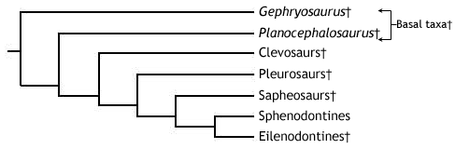

"Basal taxa" - known from the Triassic through to the Early Jurassic, this is a paraphyletic assemblage, consisting of taxa that originated early in the rhyncocephalian lineage - includingGephryosaurus, Diphydontosaurus, and Planocephalosaurus. The "basal taxa" possess many relatively simple maxillary and dentary teeth, with a conical form suitable for piercing small, invertebrate prey. The dentition perhaps demonstrates transition from an ancestral state, as they are pleuro-acrodont (in the ancestral pleurodont condition, teeth are set into the inner sides of the jaw bones). All other rhychocephalians have a fully acrodont dentition, and some of the more derived forms discussed below show a trend towards fewer, stouter teeth, that are more resilient to loading and bending forces, thus suitable for seizing larger prey. The shape of the jaw joint indicates that some sliding movement of the lower jaw could occur during food processing.

Clevosaurs - a group of carnivorous ryhnchocephalians known from the Mid Triassic to the Early Jurassic. Clevosaurs possess a highly specialised dentition, with a blade-like morphology that were used in conjunction with a precise vertical (orthal) cutting action like that of a pair of scissors. With this dentition and a skull size of 20-40+ mm, they were able to seize large invertebrates and probably even some small vertebrates.

Pleurosaurs - one of the two groups of aquatic rhynchocephalians - the other being the sapheosaurs. This aquatic habit is thought to have evolved independently in the two lineages. The pleurosaurs, known from the Early Mid to the Late Jurassic, possess a flattened, elongate skull (60-80mm), trunk and tail specialised for their aquatic mode of life, and have a dentition similar to that of the clevosaurs.

Sapheosaurs- the second group of aquatic rhynchocephalians - known only from around the Jurassic-Cretaceous boundary (~206 mya). The sapheosaur fossil record is poorly known and little is known about their specialisations. The dentition has been described as blade-like and may resemble that of the clevosaurs or pleurosaurs.

Sphenodontines- known from the Early Jurassic onwards, this is the group that includes the extant genus, Sphenodon. The sphenodontines possess only a single enlarged palatine tooth row, running parallel to the maxillary teeth. Each maxillary and palatine tooth bears a posterior flange. The teeth on the dentary are conical with an anteriorly placed apex. Following wear they bear two small anterior flanges or “shoulders”. When the jaws close the lower jaw slides forward (protraction) to allow a shearing action analogous to that of a steak knife. This is termed a propalinal, or more specifically prooral, jaw action. This allows members of this group to process tougher, more complex prey, such as arthropods and small vertebrates but in a different way to clevosaurs and pleurosaurs.

Eilenodontines - a group of highly specialised rhynchocephalians, that may form the sister group to the sphenodontines. Known from the Late Jurassic to the Mid Late Cretaceous, the eilenodontines were the largest group of rhynchocephalians, with skull sizes reaching between 80-150mm and robust jaws. The dentition of the eilenodontines is in many ways like that of the sphenodontines - they have similar maxillary teeth, have a single enlarged palatal tooth row parallel to the maxillary teeth, and utilise some kind of propalinal jaw action. However, the dentary teeth are wider, with a thickened layer of enamel. When worn (which they usually are) each tooth possesses a flat wear facet bounded by sharp enamel edges. These resemble the teeth of mammalian herbivores and are therefore considered suitable for processing plant material, and thus indicate an herbivorous diet for the group.

References
Jones, MEH. 2008. Skull shape and feeding strategy in Sphenodon and other Rhynchocephalia (Diapsida: Lepidosauria). Journal of Morphology 269: 945-966.
Evans, SE. 2003. At the feet of the dinosaurs: the early history and radiation of lizards. Biological Reviews 78: 513-551.

Squamata

Squamata - lizards and snakes

Vertebrata; Gnathostomata; Osteichthyes; Sarcopterygii; Tetrapoda; Amniota; Sauropsida;
Reptilia; Diapsida; Sauria; Lepidosauromorpha; Lepidosauria; Squamata

Squamates are a highly successful and familiar group of reptilies including lizards (e.g. gekkotans, skinks, chamaeleons), snakes, and amphisbaenians. With over 7000 species, they are present on every continent except Antarctica, and have invaded marine environments (e.g. sea snakes, mosasaurs), as well as diversifying into many different specialised terrestrial forms, including burrowers (e.g. amphisbaenians), gliders (e.g. Draco), bipedal runners (e.g. Basiliscus), climbers (e.g. chameleons), and active predators (e.g. Varanus).

In addition to the plesiomorphic reptilian condition of egg-laying (oviparity), some groups give birth to live young (viviparity). More surprisingly, at least eight groups contain a species with only female members, reproducing by a process called parthenogenesis - the development of unfertilised eggs into functional (female) offspring.
Squamates range in size from approximately 3 cm (pygmy chamaeleons, e.g. Brookesia minima) to several metres (e.g. komodo dragon, anaconda, extinct marine mosasaurs). Limblessness is common in squamates (incluing snakes, amphisbaenians, dibamids, and members of each major lizard group), and is thought to have evolved as many as five times independently. For more information on squamate diversity, please visit the squamate subgroup headings visible in the table of contents.
The Squamata is the sister group to the Rhynchocephalia (the Tuatara and extinct relatives), sharing a common ancestor around 250 million years ago at the start of the Mesozoic. Together, they form the monophyletic Lepidosauria. For lepidosaurian synapomorphies and phylogeny, see the information on the rhynchocephalian chapter.

Synapomorphies of the Squamata
- Cranial kinesis - a high degree of flexibility between the bones of the back of the skull, allowing relative movements between them.
- Paired hemipenes (present in all lepidosaurs) are fully eversible.
- Pleurodont dentition - teeth set into the side of the inner surfaces of the jaws, and periodically replaced.
- Loss of gastralia (ventral belly ribs).
- Double-hooked fifth metatarsal, functionally analagous to the mammalian heel.
- Further complexity to the mesotarsal joint (in comparison to non-squamate lepidosaurs).

Phylogenetic relationships of the Squamata
Researchers in squamate phylogeny have yet to reach a consensus on the evolutionary affinities of the group's different lineages. Traditionally, the crown-group Squamata was divided into Lacertilia (lizards and amphisbaenians) and Ophidia (snakes). Modern cladistic analysis, however, has demonstrated that both snakes and amphisbaenians can be grouped with certain lizards to the exclusion of other lizard groups (e.g. Estes et al. 1988), and thus the term 'lizard' is not a natural grouping (i.e. not monophyletic). Therefore, formal terms like Lacertilia should be avoided, as they are phylogenetically misleading. The term lizard can be used informally to indicate any squamate that is not a snake or amphisbaenian.
Studies based on cladistic analysis of the morphological characteristics of both extant and fossil taxa assert that the primary split in the crown-group Squamata was between the Iguania and the Scleroglossa around 206 million years ago, at the Triassic-Jurassic boundary. The Iguania contains the familiar iguanas and chamaeleons, as well as the agamids, and its monophyly is well supported. For more information see the Iguania chapter.

The first major phylogenetic analysis of the Squamata (Estes et al. 1988) defined three major scleroglossan clades - Gekkota, Anguimorpha, and Scincomorpha. The phylogeny of Squamata as proposed by Estes et al. (1998) is illustrated in the cladogram below (note the colour-coding of proposed clades, for comparison with conflicting theories below):
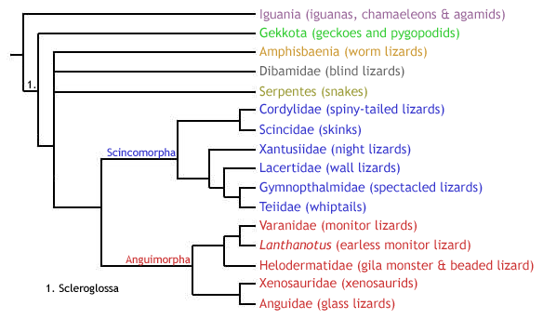
While the monophyly of Gekkota and Anguimorpha is usually supported by morphological studies, the monophyly of the Scincomorpha is not always reconciled (e.g. Lee et al.1998), and the interrelationships of these clades has been difficult to resolve. In addition to the three principle lineages, there are three other groups of limbless scleroglossans that have been difficult to place into the phylogeny (see cladogram above). These are the snakes (Serpentes), amphisbaenians (Amphisbaenia), and dibamids (Dibamidae). Snakes are usually placed within the anguimorphs (e.g. Lee et al. 1998), although their origins are a major subject of scientific dispute. Amphisbaenians and dibamids are, however, something of a phylogenetic mystery. Often grouped as a clade (Amphisbaenia + Dibamidae), some authors place them as sister to the Gekkota (e.g. Lee et al. 1998), while others suggest a close affinity with snakes (e.g. Rieppel & Zaher 2000).
Lee et al. (1998) suggested that the apparent grouping of these three problematic taxa as a clade within the anguimorphs seen in many phylogenetic studies is a misleading result, as it is almost exclusively supported by specialisations for a burrowing mode of life, such as cranial consolidation, loss of limbs and elongation of the body, which are known to convergently evolve in other tetrapods (e.g. caecilians). They argue that the addition of fossil taxa is crucial to understanding the evolutionary transition of these groups to leglessness, in order to detect any convergence, or homoplasy. Indeed, their inclusion of certain fossil taxa (namely the large marine mosasauroids, the basal snake Pachyrhachis, and the limbed amphisbaenian-like Sineoamphisbaenia) produced an amphisbaenian-dibamid clade as sister group to the Gekkota, away from snakes and anguimorphs. Snakes, however, remained as anguimorphs, forming the clade Pythonomorpha with the large marine mosasaurs of the Cretaceous, which is then sister group to the monitor lizards (family Varanidae) in the Varanoidea.
In addition, Lee et al. (1998) questioned the monophyly of the Scincomorpha, defined by (Estes et al. 1988). First, they proposed that scincids and cordylids are more closely related to anguimorphs than to other "scincomorphs". Second, they placed the xantusiids in a new clade, Nyctisaura, as sister group to the Gekkota-Amphisbaenia-Dibamida clade. The remaining "scincomorphs" persisted in the clade Lacertiformes.
The phylogeny of squamates proposed by Lee et al. (1998) is shown below (note the polyphyly of Scincomorpha, as well as the positions of Serpentes, Amphisbaenia, and Dibamidae, and the addition of mosasaurs):
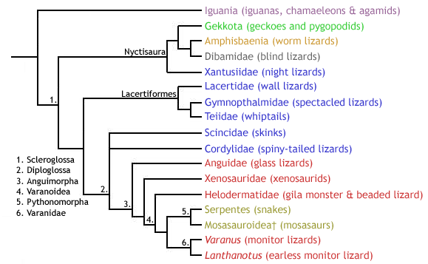
More recently, the monophyly of the Scleroglossa has been questioned by researchers studying squamate DNA sequence data. For example, Townsend et al.(2004), who compared around 4600 DNA base pairs in 69 squamate species, placed the Iguania as well-nested within a consequently paraphyletic Scleroglossa - contrary to the usual Iguania-Scleroglossa dichotomy. Instead, they proposed that geckoes (plus relatives) and dibamids were the first squamate groups to diverge. The monophyly of the traditional Anguimorpha was supported, although it did not include snakes, and refuted the monophyly of Xenosauridae by proposing separate origins for the genera Xenosaurus and Shinisaurus. Again, the monophyly of Scincomorpha was refuted, albeit in a different manner (see below) to that proposed by Lee et al. (1998). Amphisbaenians were placed in yet another position, this time embedded within the Lacertiformes as sister group to the family Lacertidae. The authors showed that amphisbaenians share almost identical multicodon deletions in a gene called c-mos with members of a particular lacertid genus (Gallotia). This provided additional support to their sequence comparison results that demonstrated that dibamids are not closely related to snakes or dibamids, but to lacertids. Finally, the relationships between Anguimorpha, Lacertiformes, Serpentes, and Iguania were not resolved. The cladogram below illustrates the squamate molecular phylogeny sensuTownsend et al. (2004):

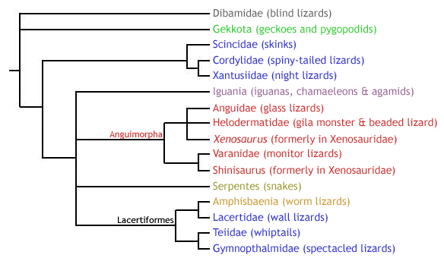

Dibamidae - blind lizards

Lepidosauria; Squamata; Dibamidae

The dibamids (or blind lizards) are a group of small, limbless lizards whose phylogenetic affinities have long been disputed. To learn more about their place in squamate phylogeny, please return to the Squamata heading.

Diversity and Lower Taxonomy
There are 10 species of dibamid, divided between two genera: Dibamus and Anelytropsis. The former contains all but one species.

Distribution and Habitat
- Dibamus spp. - inhabit the rainforests of southeast Asia (including Indonesia and the Philippines) and Western New Guinea.
- Anelytropsis papillosus - present only in Mexico, inhabiting dense forest, pine-oak forest, semi-arid deciduous brush, or open shrubland.
All dibamids are fossorial, burrowing in soil or under rocks or felled logs on the forest floor.

Conservation Status (IUCN)
No members of the genus Dibamus have been issued a conservation status by the IUCN. Anelytropsis papillosus is listed as Least Concern (LC).

Features
- Limbless - although males have small, vestigial hind limbs; these are flap-like and used to grasp females during mating.
- Vestigial eyes covered by a scale.
- Lack external ear openings.
- Cranial consolidation - rigidly fused skull - an adaptation for a burrowing mode of life

Gekkota - geckoes and pygopodids

Lepidosauria; Squamata; Gekkota

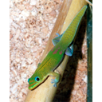  Gold dust day gecko (Phelsuma l. laticauda) | 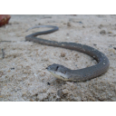  Common Scaly-Foot (Pygopus lepidopodus)

The Gekkota is a monophyletic clade containing the familiar geckoes, as well as the pygopodids - a group of limbless lizards commonly referred to as Australasian legless lizards. To learn more about their place in squamate phylogeny, please return to the Squamata heading.
Diversity and Lower Taxonomy
Traditionally (e.g. Estes et al. 1988), the geckoes and pygopodids have been divided into two distinct families, as follows:
- Family Gekkonidae (geckoes) - comprising approximately 1180 species of gecko divided between five subfamilies.
  - Subfamily Gekkoninae - containing 75 genera.
  - Subfamily Teratoscincinae - containing a single genus, Teratoscincus.
  - Subfamily Diplodactylinae - containing 18 genera.
  - Subfamily Eublepharinae - containing 5 genera.
  - Subfamily Aeluroscalabotinae - containing one genus, Aeluroscalabotes.
- Family Pygopodidae - 39 species of pygopodid divided between seven genera in two subfamilies.
  - Subfamily Pygopodinae - conatining 23 species divided between 3 genera.
  - Subfamily Lialisinae - containing 16 species in 4 genera.

This Gekkonidae-Pygopodidae dichotomy proposed the monophyly of the two groups, and Gekkota was therefore defined as encompassing the last common ancestor of these two families, plus all its descendents. Both morphological (e.g. Kluge 1987) and molecular (e.g. Saint et al. 1998) phylogenetic studies have, however, demonstrated that Pygopodidae is nested within Gekkonidae, more closely related to the diplodactylines (subfamily Diplodactylinae) than to other gekkotans. Under these conditions, the term Gekkonidae becomes phylogenetically redundant, as if Pygopodidae is excluded from its definition, then Gekkonidae is paraphyletic, and if Pygopodidae is included, then Gekkonidae becomes equivalent to the higher Gekkota (including geckoes and pygopodids).

Nonetheless, Gekkotan interrelationships are by no means fully resolved, and not all researchers agree with a nested position for Pygopodidae. More recently, a molecular study conducted by Jonniaux & Kumazawa (2008) proposed that the subfamilies Eublepharinae and Aeluroscalabotinae form a distinct family, Eublepharidae, that is siter to Gekonidae (containing the three remaining traditional gekkonid genera), and in turn this clade is sister to Pygopodidae. This molecular-based grouping is interesting as it corroborates certain morphological differences between these groups (see Descriptions section below).

Description
It is useful to describe the appearance and morphology of geckoes and pygopodids separately, as they are clearly distinct. Bear in mind, however, that it is possible that the pygopodids evolved within the geckoes. If this is the case, then pygopodids are in fact geckoes themselves, and may have secondarily lost many gekkotan features in favour of specialisation for a burrowing mode of life. Consequently, the term 'gecko' below refers to an informal (i.e., not phylogenetic) grouping meaning 'any non-pygopodid gekkotan'.

Geckoes are a familiar group of often strikingly coloured small to average-sized lizards, ranging from 30 mm (Sphaerodactylus ariasae) to 350 mm (e.g. Rhacodactylus leachianus, Gekko gecko), with a tail that is similar in length to the snout-vent length (s-v; distance between the snout and the cloacal opening, or vent, at the base of the tail). Most are nocturnal (these species have vertically slitted pupils), but some genera are diurnal (with rounded pupils, e.g. Phelsuma), and a few even show both diurnal and nocturnal activity. The majority are insectivorous, but some will eat small reptiles, and some larger species have been known to consume small rodents. They are oviparous, with the exception of members of the following three live-bearing genera: Hoplodactylus, Naultinus and Rhacodactylus.

Geckoes can be divided into two main forms: those with moveable eyelids (the eublepharines & aeleuroscalabotines, corresponding to the potential family Eublepharidae, as above), and those with fixed eyelids (the gekkonines, teratoscincines, and diplodactylines, corresponding to the remaining members of the traditional family Gekkonidae). Within the latter grouping, there is a further division based on the presence (arboreal species) or absence (usually terrestrial species) of adhesive toe pads - a specialisation for arboreal locomotion. These pads consist of a set of overlapping expanded scales on the base of the toes, possessing millions of microscopic hair-like protrusions (called setae), each of which branches into hundreds of 200 nm wide tips (called spatulae). This microstructure acts as an extremely strong adhesive (each hair can resist 200 µN of force), allowing these geckoes to walk up smooth vertical surfaces, and even upsidedown. In fact, these hairs are so sticky that a gecko can hang from a ceiling by just a single toepad, and a single hair (seta) could lift an ant!

Pygopodids are a small group of average sized (7-25 cm s-v) limbless lizards, feeding mainly on insects and some lizards. They are slender and elongate, with no traces of pectoral skeleton. The pelvic girdle is, however, still present in part, and the hindlimbs persist as vestigial scaly flaps. The majority of pygopodids are diurnal, but Paradelma orientalis, as well as subsepecies of Pygopus nigriceps are nocturnal. Like most geckoes, they are oviparous.

Distribution and Habitat
Geckoes are distributed worldwide, and are most speciose in the tropics, subtropics, and deserts. They are either terrestrial or arboreal.
Pygopodids are found in Australia, with Lialis also present in Indonesia. While two genera, Aprasia and Ophidiocephalus, are burrowing, the majority inhabit grass and litter.

Conservation Status (IUCN)
Geckoes - Of the 91 species of gecko listed in the IUCN Red List, the majority (52 species) have been assessed as Least Concern (LC). Two species (Lepidoblepharis montecanoensis and Phelsuma antanosy) are Critically Endangered (CR), while four are Endangered (EN), ten are Vulnerable (VU), and eleven are Near Threatened (NT). The remainder (10 species) are Data Deficient (DD).
Pygopodids - the conservation status of seven pygopodid species has been assessed by the IUCN. All but one are Vulnerable (VU), and the other is Near Threatened (NT).

Synapomorphies of the Gekkota
- Upper temporal bar absent.
- Incomplete post-orbital bar.
- Absence of the lacrimal - the anterior-most bone in the medial wall of the orbit.

Scincomorpha - skinks, wall lizards, and relatives

Lepidosauria; Squamata; Scincomorpha

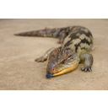  Blotched Blue-tongued Skink (Tiliqua nigrolutea) | 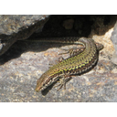  Common wall lizard (Podarcis muralis)

Diversity and Lower Taxonomy
Traditionally, the Scincomorpha consisted of the following six families:
- Scincidae (skinks) - the most speciose lizard family, with approximately 1200 species.
- Cordylidae (spiny-tailed lizards)
- Xantusiidae (night lizards) - 29 species of diurnal, viviparous lizards across three genera: Cricosaura (monospecific; subfamily Cricosaurinae), Lepidophyma (18 species; subfamily Xantusiinae), and Xantusia (10 species; subfamily Xantusiinae).
- Lacertidae (wall lizards) - 32 genera.
- Gymnophthalmidae (spectacled lizards)
- Teiidae (whiptails)

While the Lacertidae, Gymnophthalmidae, and Teiidae have remained closely affiliated in the monophyletic clade Lacertiformes (as shown on the Squamata chapter), the remaining three groups are often placed away from the Lacertiformes.

Amphisbaenia - worm lizards

Lepidosauria; Squamata; Amphisbaenia

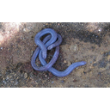
Iberian Worm Lizard (Blanus cinereus)

The Amphisbaenia are a poorly known group of limbless burrowing squamates, called amphisbaenians, or worm lizards. While the monophyly of Amphisbaenia is well supported, their affinities to other squamate groups remain unresolved. For more information regarding the position of the Amphisbaenia in squamate phylogeny, please refer to the Squamata heading.
Diversity and Lower Taxonomy
There are approximately 169 species of amphisbaenian, contained within 24 well-established genera. The position of these genera at the family-level, however, has been the subject of scientific debate.
In 2003, Kearney performed a comprehensive morphological cladistic analysis of the Amphisbaenia, and proposed the following five families (including one new family, Blanidae, previously placed in Amphisbaenidae):
- Bipedidae - conaining three species in the single genus Bipes. These are the only amphisbaenians to have forelimbs.
- Blanidae - containing four species in the genus Blanus.
- Amphisbaenidae - containing 153 species divided between 13 genera. The most speciose genus is Amphisbaena (69 species).
- Trogonophidae - containing six species in four genera.
- Rhineuridae - containing the monospecific Rhineura floridana.

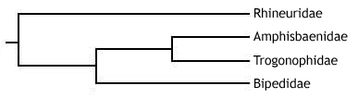
The family status of the four remaining genera - Aulura, Dalophia, Leposternon, and Monopeltis - was not resolved, but they were placed in the superfamily Rhineuroidea with the family Rhineuridae. These are united by the possession of a shovel-like skull shape, amongst other characteristics (see below).
See below for the synapomorphies of these clades.
Since Kearney's (2003) phylogeny, molecular studies have demonstrated a different evolutionary history for the Amphisbaenia. In 2004, Macey et al. analysed the full mitochodrial genomes of 12 amphisbaenian species in four families (Blanidae was not recognised in this study, and no Blanusspecies were used) - a total of 5797 parsimony informative sites. They found that the family Rhineuridae was the first to split from other extant amphisbaenians, followed by the family Bipedidae - a reversal of the relationships proposed by Kearney (2003). Both, however, agreed on the nested position and monophyly of the Amphisbaenoidea - the clade formed of the sister families Amphisbaenidae and Trogonophidae. The cladogram below illustrates Macey et al.'s results:
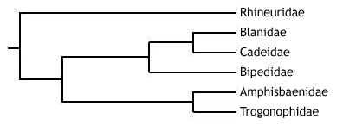
An even more recent study (Vidal et al. 2007) proposed, using molecular and biogeographic evidence, that the Cuban genus Cadea should be removed from the family Amphisbaenidae, and placed in its own new family, Cadeidae, as sister group to Blanidae. The Blanidae-Cadeidae clade was sister to the Bipedidae, together forming the sister group to the Amphisbaenoidea. Like Macey et al. (2004), Rhineuridae was the first family to diverge.
Description
Amphisbaenians are highly specialised for a fossorial (burrowing) mode of life. Almost all are completely limbless, except the three species of the Mexican genus Bipes, which have small, well-developed forelimbs. All are elongate, ranging in size from around 10 to 70 cm, with a long trunk region and short tail (the musculature required for burrowing is present in the trunk).
They have an extremely distinctive skin, consisting of conspicuous rings of scales, called annuli, which encircle the trunk. Only loosely connected to the main trunk, this specialised integument forms a tube in which the animal can move forwards and backwards. This is key to the ability of amphisbaenians to burrow. An amphisbaenian can use longitudinal muscular contractions between each annulus to bunch up the skin in order to anchor a part of the body in the soil. Trunk muscles can then be used to move the body forward within the integumentary tube. The front can then be anchored whilst the posterior integument is brought forward, after which the cycle can restart, allowing the amphisbaenian to advance.
Amphisbaenians are headfirst burrowers, and so the skull is highly modified for digging. While all have a rigid, compact skull, there are three main amphisbaenian skull types, which are functionally related to the way in which they burrow:

- "Shovel-headed" (e.g. Rhineura and Leposternon) - dorsoventrally flattened snout, with a sharp craniofacial angle. Amphisbaenians with this skull form dig by forcing the head forwards and slightly downwards, and then lifting the head dorsally to pack the soil onto the top of the tunnel. The sides of the tunnel are smoothed with the pectoral musculature.
- "Spade-headed" (trogonophids) - again a dorsoventrally flattened snout, with a strong craniofacial angle. The burrowing method, is however, quite distinct. Trogonophids use the sharp sides of their head (called lateralcanthi) to shave off soil from the front of the tunnel in an oscillatory motion. Soil is pushed and packed using the sides of the head and the body.
- "Keel-headed" (e.g. Anops and Mesobaenia) - laterally compressed head. These amphisbaenians dig by ramming the head forwards, and then push and pack soil rearwards by forcing the head alternately left and right.
- "Round-headed" or "bullet-headed" (the majority of amphisbaenians, e.g. Amphisbaenia, Blanus, Cadea,Zygaspis) - dig by using the head as a simple battering ram, followed by pushing the head in different directions to pack soil.

While the majority of amphisbaenians have a similar appearance, close to that described above, some are more distinct, and warrant further description. As already noted, members of the family Bipedidae (genus Bipes) have functional forelimbs. These are used for the initial surface excavation of a tunnel, and the first digit possesses extra phalanges to increase the efficiency of this digging process.
The trogonophids (family Trogonophidae) also have some features that make them distinct. First, they have a triangular cross-section, as opposed to cylindrical. Second, they have an acrodont dentition, in contrast to the pleurodont dentition of other amphisbaenians. Third, they do not exhibit caudal autotomy (the ability to self-amputate the tail). Finally, they are "spade-headed" and exhibit a unique burrowing behaviour (see above).
Distribution and Habitat
While the majority of amphisbaenians are located in Africa and South America (members of Amphisbaenidae, Blanidae, and Trogonophidae), others are present in Florida (Rhineura floridana), Cuba (Cadea spp.), the Carribean (members of Amphisbaenidae), Mexico (Bipedidae), the Middle East (members of Trogonophidae), and the Mediterranean region (members of Blanidae).
All amphisbaenians burrow in soil or dry, loose sand.
Conservation Status (IUCN)
Only nine species of amphisbaenian are present on the IUCN Red List. All of these are listed as Least Concern (LC), and have been assessed since at least 2006.
Synapomorphies of the Amphisbaenia and its families (sensu Kearney 2003)
- Amphisbaenia:
- High degree of cranial consolidation.
- Brain completely surrounded by frontal bone (anteriorly) and enlarged, azygous orbitosphenoid plate (ventrally).
- Presence of annuli - ring-like arrangement of scales.
- Enlarged median tooth in the premaxillary bone of the upper jaw. This tooth fits into a groove between the two lower teeth, forming an efficient 'nipper' that can take a chunk of flesh from its prey.
- Modified extracolumellar system of the ear, sensitive to low frequency sounds - improving subterranean hearing.
- Absence of the epipterygoid.
- Right lung reduced in size or lost (in contrast to other limbless squamates, which show reduction of the left lung).

- Family Bipedia only:
- Presence of (functional) forelimbs, with anteriorly shifted pectoral girdle.
- Fused fronto-parietal complex.
- Digit I exhibits polyphalangy (the presence of extra phalanges).

- Family Blanidae only:
- Reduced clavicles.
- Anteriorly truncated nasals.

- Family Amphisbaenidae only:
- Absence of squamosal.
- Absence of the sternum.

- Family Trogonophidae only:
- Acrodont dentition.
- Absence of caudal autotomy - no fracture planes to self-amputate.
- Strong craniofacial angle.
- Enlarged sternal plate.
- Short tail.

- Family Rhineuridae only:
- Anterior edge of the snout is squared-off.
- External naris opens ventrally.
- Pterygoid vomer contact.
- Absence of posterodorsal rib processes.

Anguimoprpha - monitor lizards, glass lizards, and relatives

Lepidosauria; Squamata; Anguimorpha

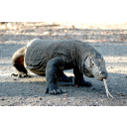  Komodo dragon (Varanus Komodoensis) | 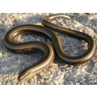  Slow-worm (Anguis fragilis)

Iguania - iguanas, chamaeleons, and agamids

Lepidosauria; Squamata; Iguania

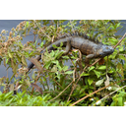  Green Iguana (Iguana iguana) | 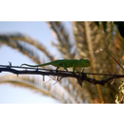  Common Chameleon (Chamaeleo chamaeleon) | 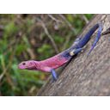  Mwanza flat-headed agama (Agama mwanzae)

To learn more about their place in squamate phylogeny, please return to the Squamata heading.
Diversity and Lower Taxonomy
Like most other squamate groups, the taxonomy of the over 1550 species-rich Iguania has long been a topic of dispute. An early classification of the Iguania by Charles Camp in 1923 defined three families:
- Iguanidae - Approximately 956 species of iguanas, anoles, horned lizards, collared lizards, and relatives.
- Chamaeleonidae - Approximately 178 species of chamaeleon.
- Agamidae - Approximately 416 species of agamid, such as the gliding Draco, and the thorny devil Moloch horridus.

This simple classification remained for over 50 years, but there became a strong need to readdress these relationships in a phylogenetic framework, i.e. one that uses cladistics to understand evolutionary history by identifying monophyletic groups, or clades. This led Etheridge and de Queiros (1988) to examine the contents of the family Iguanidae and, through analysis of morphological characteristics, identify eight major groups within. These were the subfamilies Corytophaninae (helmet lizards), Crotaphytinae (collared lizards),Hoplocercinae (dwarf and spiny tail iguanas), Iguaninae (iguanas), Oplurinae (Madagascan iguanas), Phrynosomatinae (spiny lizards, horned lizards, and relatives), Polychrotinae (anoles), andTropidurinae (neotropical ground lizards).
After further study, however, Frost and Etheridge (1989) failed to find sufficient support for the monophyly of Iguanidae, and so proposed to raise the eight subfamilies to family status (all had the same name but with a -dae suffix rather than a -nae suffix). While some authors still use this taxonomy, many refute it. For example, Macey et al. (1997) found strong support for the monophyly of the traditional Iguanidae using a combined morphological and DNA sequence analysis, and proposed that the families promoted by Frost and Etheridge (1989) be returned to their initial statuses as subfamilies of Iguanidae. This was corroborated by more comprehensive combined analyses by Schulteet al. (1998, 2003), who also brought into question the monophyly of two of the subfamilies of the Iguanidae, the Tropidurinae and Polychrotinae. The monophyly of all the remaining subfamilies was strongly supported, although the phylogenetic interrelationships between these subfamilies failed to be reconciled.
The sister group to the Iguanidae is the monophyletic Acrodonta (Estes et al. 1998). This contains the remaining iguanians: the chamaeleons and agamids. Within the Acrodonta, studies such as Maceyet al. (1997, 2000) have found little statistical support for the monophyly of the traditional family Agamidae. That is, some agamids may be more closely related to the chamaeleons than to other agamids. Nonetheless, it is useful to use the term Agamidae in the meantime, as what is termed ametataxon - a traditionally recognised group whose monophyly is statistically uncertain. Macey et al. (2000) defined six agamid subfamilies:
- Agaminae - the African-West Asian clade of agamids, containing 6 genera, including Agama.
- Amphibolurinae - the clade comprising the Chinese water dragon, Physignathus cocincinus, plus all Australian or New Guinean agamids, in 14 genera.
- Draconinae - the South Asian clade of agamids, containing 14 genera, including the gliding Draco.
- Hydrosaurinae - the sailfin lizards, Hydrosaurus.
- Leiolepidinae - the butterfly lizards, Leiolepis.
- Uromastycinae - the spiny-tailed lizard, Uromastyx.

The following cladogram illustrates the evolutionary history of these taxa, as proposed by Macey et al. (2000). While the monophyly of the subfamilies was well supported, among the group phylogenetic relationships and the monophyly of Agamidae shown in the diagram received little statistical support.

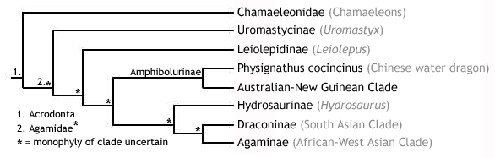
The chamaeleons, on the other hand, remain in the monophyletic clade Chamaeleonidae. This family is divided into two subfamilies, Brookesiinae (containing three genera, including Brookesia) andChamaeleoninae (containing 6 genera, including Chamaeleo).
Description
The iguanids. Living agamids are a highly diverse group of average to large-sized lizards with a wide range of specialisations. As a result, it would be difficult to describe the appearance of a "typical" agamid. For example, members of the South Asian arboreal genus Draco (subfamily Draconinae) have evolved extremely elongate, protruding ribs, which stretch the skin out into two wing-like patagial membranes, allowing individuals to perform extensive glides between trees (recorded as far as 60 m, with only a 10 m descent). Some groups possess modified spiny scales, which may cover the body (as in the Australian thorny devil, Moloch horridus) or the tail (as in members of the genus Uromastyx), while another group, the Southeast Asian sailfin lizards (Hydrosaurus), possess a laterally compressed dorsal extension of the tail, making them proficient swimmers.
Most agamids are diurnal, feeding mainly on insects and other small prey. A few, e.g. Uromastyx, are partly herbivorous. They are all oviparous, except for members of the genus Phrynocephalus, which give birth to live young (viviparous).
The chamaeleons are a familiar and charismatic group of lizards, with a large suite of unique physical characteristics making them extremely distinct. Ranging in size from around 2.5 cm (e.g. Brookesia spp.) to over 50 cm (e.g. Furcifer oustaleti), they are probably most famous for their ability to change colour - made possible by the presence of specialised chromatophores (cells containing pigment that reflect light) in the skin - which is often used in social signalling. The body of a chamaeleon is laterally compressed, and the head often bears many horns and ridges. These features are likely to play a role in sexual selection, as males are usually considerably more ornamented than females.
Chamaeleons are highly specialised for arboreal life. Not only do they have a strong grasping prehensile tail, but their feet are zygodactylus - meaning that two digits face forwards and two face rearwards, allowing a firm grip on a branch. In addition, they have an extremely long, rapidly protractable tongue, with which insect prey can be seized efficiently from a distance often as far away as the length of their own body. This kind of accuracy is afforded by the positioning of their eyes, which are bulbous and protruding, allowing the two fields of vision to overlap and result in stereopsis(depth perception). The eyes can also be moved independently. The tip of the tongue is highly muscular and covered in mucus, forming a suction cup that is extremely difficult for prey to escape.
Distribution and Habitat
- Iguanids
- Agamids are distributed throughout Asia, Oceania, Africa, and Europe. Thus, they are a strictly Old World group. Inhabiting areas from desert to tropical rainforest, they are mostly terrestrial, although some groups, e.g. Draco, are abrboreal.
- Chamaeleons are mainly found in Africa and Madagascar, but a few species occur in Southern Europe, the Middle East, and Asia. Like agamids, chamaeleons are an Old World group. They are, for the most part, an arboreal group, again inhabiting regions as diverse as desert to tropical rainforest.

Conservation Status (IUCN)
There are 223 species of iguanid present on the IUCN Red List. Almost 25% of these are recognised as either Critically Endangered (CR; 5%), Endangered (EN; 7%), or Vulnerable (VU; 12%). Thankfully, the majority (55%) are considered Least Concern (LC). The remainder are either Near Threatened (NT; 4%) or Data Deficient (DD; 17%).
Only 13 of the 416 species of agamid are present on the Red List. Of these, 2 are Critically Endangered (CR), whilst 2 are Endangered (EN), and 3 are Vulnerable (VU). Of the remaining 6 species, 2 are Data Deficient (DD), and the rest are Lower Risk (LR) - either Near Threatened (NT) or Least concern (LC).
There are 9 species of chamaeleon on the Red List. Smith's dwarf chamaeleon, Bradypodion taeniabronchum, is the only Critically Endangered (CR) species. Of the rest, 2 are Endangered (EN), 4 are Vulnerable (VU), and 2 are Near Threatened (NT).
Synapomorphies of the Iguania and Acrodonta
- Iguania:
  - Postfrontal either reduced or absent.
  - Anteroventral margin of the orbit formed by the jugal.
  - Ridges near the orbital margin.
  - Frontal shelf underlying the nasal.
  - Pineal foramen located on the frontoparietal suture or within frontals.
  - Articular separate from prearticular and surangular.
  - A contact between the jugal and squamosal along the upper temporal arch.
- Acrodonta
  - Acrodont dentition.
  - No replacement teeth.
  - Postfrontal absent.
  - Contact between palatines across the entire midline.
  - No intravertebral fracture planes for caudal autotomy.
  - No depression on ventral surface of the pterygoid.
  - Unique mitochondrial gene order, involving the rearrangement of two tRNA genes - a molecular synapomorphy.

Serpentes - snakes

Lepidosauria; Squamata; Serpentes

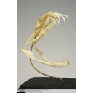  Lateral view of Gaboon Viper skull | 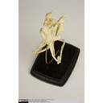  Dorsal view of Gaboon Viper skull | 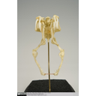  Front view of Gaboon Viper skull

The Serpentes, commonly known as snakes, are a familiar and well defined group, whose monophyly has strong support from a suite of both morphological and molecular characteristics (see below). Their position within the squamates, however, has proved extremely difficult to resolve. For more information regarding higher level squamate phylogeny, please refer to the Squamata heading.

Diversity and Lower Taxonomy
Extant snakes are divided into two well-supported monophyletic sister groups: the Scolecophidia and the Alethinophidia.

Description
- Scolephidians are a poorly known group of snakes that are small, fossorial, and worm-like.
- Alethinophidians, however, are the more familiar group, possessing what would generally be considered a snake-like body. They are generally larger and less fossorial.

Features
- Limbless, but many retain traces of a pectoral girdle. Members of some of the more primitive families, such as the boas and pythons (contained within the superfamily Booidea), show external traces in the form of vestigial hind limbs, called anal spurs, which flank the cloacal opening and are now only used for clasping during courtship.
- Well-developed chemosensation, with forked tongue.
- Highly kinetic skull with eight points of rotation, allowing large prey to be swallowed whole. Each side of the skull can move independently.
- Many elements of the skull reduced or lost, facilitating the evolution of kinesis.
- The two sides of the mandible are loosely connected with cartilage at the rostral midline (in other jawed vertebrates, the two sides of the mandible are strongly fused to form the mandibular symphysis).
- Recurved teeth, preventing the escape of seized prey victims.
- No external ear openings.

Crocodilians

Crocodylia - crocodiles, alligators, and gharials

Sarcopterygii; Tetrapoda; Amniota; Sauropsida; Reptilia; Diapsida; Archosauria; Crocodylia

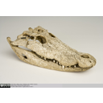  Lateral view of Crocodilian skull | 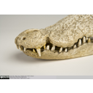  Close up of Crocodilian snout | 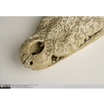  Dorsal view of Crocodilian snout | 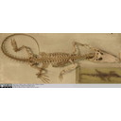  Crocodile skeleton

Diversity and Lower Taxonomy
The 22 living members of the order Crocodylia are divided into three families:
- Gavialidae - containing a single species, the gharial.
- Crocodylidae - the crocodiles, comprising 14 species in 3 genera.
- Alligatoridae - 7 species of alligators and caimans in 4 genera.

Distribution and Habitat
- Species present on every continent except Europe and Antarctica.

Features
- The presence of a secondary palate, which acts to separate the oral cavity into two defined chambers:
- The nasal passage, travelling from the nostrils to the internal nares at the back of the throat, for breathing.
- The mouth, from the mouth opening to the oesophagus, for the mastication of food.

This is an archosaurian derived feature (which convergently evolved in mammals) that allows crocodylians to inhale and exhale solely through their nostrils, and thus eat and breathe simultaneously - a feature usually only seen in endotherms.

- Nostrils at the tip of a long snout, connected to the internal nares via the nasal passage created by the secondary palate. This feature acts like a snorkel, meaning crocodylians can lead a semi-aquatic lifestyle - the mouth can be fully submerged yet have no effect on air passing through the nasal passage.
- Semi-erect gait: they can pull their bodies upwards, straightening their legs slightly, resulting in a stance halfway between that of a horse and a lizard. This allows more efficient locomotion, as each stride acts more in the direction of travel and can therefore be longer, compared with the semicircular arc of a lizard's sprawling stride. A semi-erect gait also clears the trunk further from the ground, affording increasingly efficient breathing by permitting greater expansion of the lung cavity, as well as a more even compression of the lungs during each stride.

HINT: You will find that the evolution of locomotory efficiency often goes hand in hand with the evolution of respiratory efficiency - this coevolution is due to the fact that without the ability of an animal to gain enough oxygen to meet the energetic demands of a fast moving body, adaptations for locomotory efficiency and performance become redundant, as they are physiologically too advanced.

- The presence of two openings in the skull and lower jaw: the antorbital fenestra and mandibular foramen, respectively. These are both defining characters, or synapomorphies, of the archosaurs, which includes crocodylians, dinosaurs, and birds. The antorbital fenestra can be located on the snout between the orbit and the nostril, while the mandibular foramen can be seen as a small hole in the lower jaw.
- Laterally flattened, serrated teeth.
- Crocodiles can be discriminated from alligators by differences in the shape of their mandibles, specifically the positioning of the large fourth tooth in the lower jaw:
  - In crocodiles, this tooth sits outside the upper jaw when the mouth is closed (notice the recess in the exterior of the upper jaw).
  - In alligators, it is contained within the oral cavity, slotting into a complimentary groove in the palate of the upper jaw. Therefore, all the teeth of an alligator's upper jaw bite outside those of the lower jaw.

Birds

Aves - birds

Sarcopterygii; Tetrapoda; Amniota; Sauropsida; Reptilia; Diapsida
Archosauria; Dinosauria; Saurischia; Theropoda; Aves

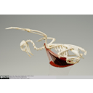  Lateral view of a Pigeon Skeleton | 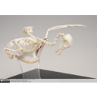  Pigeon Skeleton | 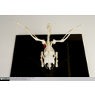  Posterio-dorsal view of a Pigeon Skeleton | 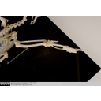  Close-up of the Wing Bones of a Pigeon

Birds evolved from a group of small theropod dinosaurs in the Middle-Late Jurassic.

Diversity and Lower Taxonomy
The class Aves, containing around 10,000 extant species of bird, can be divided into two clades:
- Palaeognathae: Includes the tinamous - 47 species in one family within a single order - and the ratites (flightless birds), containing 5 families - the ostriches, kiwis, rheas, emu and cassowaries. Although previously thought to be separate groups, it has recently been shown that the tinamous are actually embedded within the ratites, thus ratites as they have been traditionally considered are a paraphyletic group, as their most recent common ancestor is shared with the tinamous. The proposed phylogenetic tree for palaeognathans is shown below:

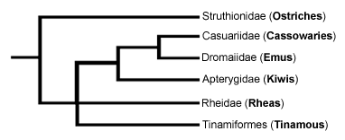

- Neognathae: With nearly 10,000 species, this clade contains the remaining living modern birds. It splits early to form two taxa, the Galloanserae (ducks, fowl and their relatives), and the Neoaves.
- The superorder Neoaves contains 26 orders, including many well-known groups such as parrots, woodpeckers, penguins, flamingoes, owls, raptors and vultures, kingfishers, and the largest, most diverse and recognised group - the passerine, or perching, birds.
- With around 5,300 species, the monophyletic order Passeriformes makes up over half of all bird species, including the most popular and studied of all birds, the songbirds (Oscines), which are characterised by a complex voicebox used in mate attraction, as well as territory defence. You probably hear these sounds outside your bedroom window every morning, as songbirds include many common species such as robins, blackbirds, magpies, finches and swallows.
- The phylogenetic relationships of the Neoaves is a hotly debated topic, with many studies currently in progress. In 2008, Neoaves underwent a major upheaval and reshuffle, based on genetic studies from Hackett et al. (2008) and Ericson et al. (2006), placing many groups in dramatically different phylogenetic positions. For example, the birds of prey, traditionally grouped together in an order called Falconiformes, has been split into two separate orders - the new Falconiformes, including only the single family of true falcons, and the Accipitriformes, containing all other birds of prey, including hawks, eagles and vultures. Phylogenetically, the new Falconiformes have been relocated to become the sister clade of the parrots and the passerines, far away from the Accipitriformes (whose full evolutionary relationships remain somewhat cloudy).

Features
- Feathers, which are specialised structures modified from reptilian scales, for insulation, display, camouflage and flight.
- The insulation from these feathers allowed birds (and perhaps their dinosaurian ancestors) to become endotherms - allowing them to raise their internal body temperature by retaining the heat energy generated as a by-product of metabolism - a feature they share with mammals.
- Wings, formed of the humerus, radius, ulna, wrist and three digits (of these, the first and third are greatly reduced).
- The first digit forms the alula, a specialised wing slit, which acts to reduce drag when flying by keeping air close to the wing.
- Fused clavicles, forming the furcula (wishbone).
- Large keeled sternum (breastbone), for the attachment of powerful flight muscles. This keel is greatly reduced in most flightless birds, such as ratites.
- No teeth; replaced by a horny beak.
- Caudal vertebrae are reduced and fused to form the pygostyle, which supports the tail feathers.
- Sacral vertebrae fused to form a synsacrum, which connects with a broad, elongated pelvic girdle and ossified thoracic vertebrae. These features, combined with the pygostyle, form a rigid trunk - an important adaptation for flight stability.
- Fused tibia and uppermost tarsals (ankle bones) to form the tibiotarsus - what we call the drumstick. The fibula is reduced and spike-like.
- Tarsometatarsus, formed by the fusion of the outermost tarsals with the metatarsals (toe bones).
- Reversed hallux (big toe) on feet, specialised for perching.
- In most birds, many bones, such as the sternum, pectoral girdle and humeri, are hollow and air-filled, or pneumatic. These air spaces have two functions:
  - They acts to balance out the overall body weight to keep it relatively light for flight, as the bones of the hind limbs are usually solid and heavy to position the centre of gravity on the legs for perching/standing.
  - They aid in respiration, by acting as a space to contain air sacs involved in the one-way (as opposed to tidal) flow of air through a bird's faveolar lungs.

Synapsids

Synapsids - mammals and their extinct relatives

Sarcopterygii; Tetrapoda; Amniota; Syanpsida

The primary dichotomy within the amniotes is that between the Reptilia, or Sauropsida (see amniote groups above - turtles through to birds), and the Synapsida, thought to have diverged sometime during the Carboniferous (approx. 360 - 300 million years ago). Thus, the Synapsida is one of the two major lineages of amniotes, containing the mammals plus all extinct amniotes more closely related to mammals than to reptiles.
The following headings outline the diversity of the living representatives of the synapsids - the class Mammalia. The extant mammals are divided into three major lineages:
- Monotremata - monotremes
- Marsupialia - marsupials
- Eutheria - placental mammals

Monotremata - monotremes

Sarcopterygii; Tetrapoda; Amniota; Synapsida; Prototheria; Monotremata

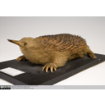  Short-beaked echidna taxidermy | 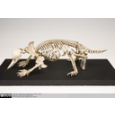  Short-beaked echidna skeleton | 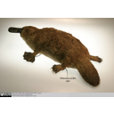  Platypus taxidermy

The order Monotremata is the only extant group within the subclass Prototheria - the oldest living taxon of theclass Mammalia. Whilst there has never been much doubt that monotremes split off from other mammal group at an early stage, due to their many ancestral reptilian characters (see below), the mid-20th-Century saw much dispute regarding the evolutionary positioning of the other two major groups of mammal - the metatherians (marsupials) and the eutherians (placental mammals) - with respect to the monotremes.

The question was whether the metatherians were the sister clade of the monotremes or of the eutherians. This proved a difficult question to answer, as much of our understanding of mammalian phylogeny has been gained through comparisons of tooth morphology, yet monotremes are toothless - a character that is certainly not ancestral.

However, much study on the ancestral amniote features of monotremes, as well as a recent complete analysis of their genome, has shown that they split off from other mammal groups around 200 million years ago, at the Triassic-Jurassic boundary. Therefore, Metatheria and Eutheria together form the clade Theria (live-bearing mammals), to the exclusion of Prototheria. The cladogram below summarises these relationships:

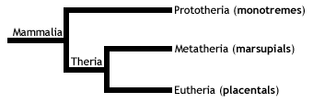

Diversity and Lower Taxonomy
The monotremes are a group of highly specialised egg-laying predatory mammals, containing the platypus and echidnas. There are only five living species of monotreme, contained within two families:
- Family Ornithorhynchidae: the platypus, a single species in a single genus, Ornithorhynchus anatinus.
- Family Tachyglossidae: the echidnas. Four species divided into two genera:
- Tachyglossus: one species of short-beaked echidna (Tachyglossus aculeatus).
- Zaglossus: three species of long-beaked echidnas. (One of these, Zaglossus attenboroughi, a species from the Papua province of the island of New Guinea named after British naturalist Sir David Attenborough, has never been seen in the wild and is only known to science through a single museum specimen from 1961! In 2007, researchers at the Zoological Society of London confirmed that Sir David's echidna is not extinct, by finding burrows and tracks made by the species)

Distribution and Habitat
Endemic to Australasia - an important point to note as it means that they represent a whole subclass of extant mammalian life in a single geographic region. While the platypus is semi-aquatic, the echidnas are all terrestrial, and their respective distributions and habitats are as follows:
- Platypus - Confined to Eastern Australia and Tasmania; freshwaters streams, rivers, and some lakes.
- Short-beaked echidna - Australia and New Guinea; most habitats, from semi-arid to alpine.
- Long-beaked echidna - New Guinea; mountainous terrain.

Conservation Status (IUCN)
- Platypus - Least Concern (LC) - However, although the platypus is common, it has a fairly narrow, specific habitat range and, consequently, is distributed in localised regions. It is therefore vulnerable to local extinction.
- Short-beaked echidna - Least Concern (LC)
- Long-beaked echidna - Critically Endangered (CR)

Features
- Males have a spur on their ankles, which bears poison in the platypus.
- Toothless - platypuses have a leathery electrosensory bill, with crushing horny plates to break through the tough exoskeleton of arthropods; echidnas have an elongate horny rostrum with a long sticky tongue for collecting insects.
- A range of mammalian characters:
  - Produce milk (lactate) from mammary glands. However, while therians have nipples, monotremes do not, and consequently the young suck milk from patches of mammary hairs - specialised areas of fur positioned around the ventral openings of the mother's mammary glands.
  - Epipubic bones - two thin rod-like bones extending anteriorly from the pubic bones of the pelvic girdle.
  - Lower jaw (mandible) made up of a single bone, the tooth-bearing dentary.
  - A middle ear formed of three bones: the incus, malleus, and stapes. While the stapes is present in the middle ear of all living tetrapods, the incus and malleus are modified bones from the typical amniote jaw joint. The jaws of non-mammalian amniotes articulate via the quadrate of the upper jaw, and the articular of the lower jaw; in mammals, the quadrate migrated to form the incus, while the articular became the malleus, leaving a jaw joint formed of the dentary articulating with the squamosal (the angular bone of the non-mammalian amniote lower jaw is used as a bony support for the eardrum in mammals). The following diagram illustrates these differences:
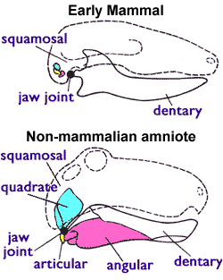

- A range of ancestral reptilian characters:
  - Egg-laying (oviparity); however, these soft-shelled eggs are short-lived, the young hatching after around ten days and being dependent on mother's milk for up to six months after.
  - Sprawling gait (although it is possible that this is a derived feature of monotremes, relating to specialisations for swimming in the platypus, and for digging in the echidnas).
  - A single common opening for the digestive, urinary, and reproductive tract, called the cloaca (the general amniote condition). In therian mammals (marsupials and placentals), there are two openings: one for the digestive system, and one for the urogenital tract.
  - Presence of the coracoid - the ventral bone of the shoulder girdle seen in all non-mammalian amniotes. This is the general amniote condition, where the humerus articulates with the shoulder girdle at the junction between the coracoid and the scapula (commonly termed the shoulder blade).
  - Not entirely homeothermic. While monotremes are - meaning that they regulate their body temperature using heat produced during endothermic metabolism - they are fairly poor at maintaining a constant body temperature during extreme enviromental conditions.

Marsupialia - marsupials

Sarcopterygii; Tetrapoda; Amniota; Synapsida;
Theria; Metatheria; Marsupialia

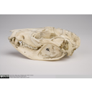  Southern oppossum skull lateral view | 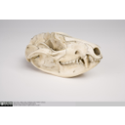  Southern oppossum skull lateral view | 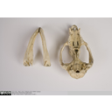  Southern opossum skull showing palate an dentary process | 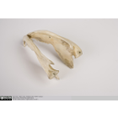  Southern opossum mandible showing in-turned dentary process

The marsupials are the sister taxon to the subclass Eutheria (placental mammals), together forming the clade Theria. Therians are then the sister clade to the monotremes, forming the group mammalia - all living mammals. The cladogram below shows these relationships:
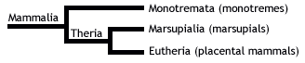
Diversity and Lower Taxonomy
The marsupials are 335 extant species across seven orders of mammals from Australasia and the Americas, which originated in the Early Cretaceous of North America.
Three of these orders are now restricted to the Americas - including opossums, shrew opossums and the charismatic Monito del Monte - while the other four are restricted to Australasia - including kangaroos, possums, marsupial moles, bandicoots, and carnivorous marsupials such as the tasmanian devil. Below is a list of these orders with their representative groups:
- Didelphimorphia - American opossums
- Paucituberculata - shrew opossums
- Microbiotheria - Monito del Monte
- Notoryctemorphia - marsupial moles
- Dasyuromorphia - Australian carnivorous marsupials
- Peramelemorphia - bandicoots and bilbies
- Diprotodontia - kangaroos, wallabies, possums, wombats, and koala

Features
- After a brief gestation in the womb with no placenta (except bandicoots), the females of certain species give birth to extremely immature young, who then develop to maturity through suckling in the mother's pouch.
- In-turned process in the dentary.
- Three premolars and four molars. (NB. This is the ancestral marsupial dentition, however, many species have actually modified this character to have a varying number of molars and premolars)
- Three premolars and four molars. (NB. This is the ancestral marsupial dentition, however, many species have actually modified this character to have a varying number of molars and premolars)
- Epipubic bones - two thin rod-like bones that extend anteriorly from the pubic bones of the pelvic girdle. These bones, although often called marsupial bones, are also seen in monotremes, and are probably an ancestral mammalian character, which was lost in the Eutheria.

Labelled images of an opposum skull
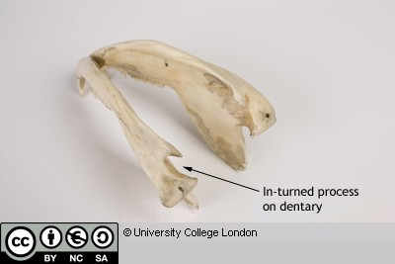

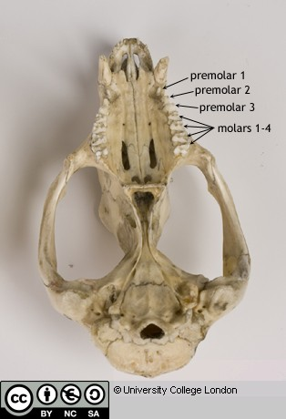
Eutherians
See 'Virtual Educational Resource for the Biosciences (VERB) - Eutherians': https://open-education-repository.ucl.ac.uk/210/

References

Chondrichthyes
Bonfil R, Meyer M, Scholl MC, Johnson R, O'Brien S, et al. Transoceanic migration, spatial dynamics, and population linkages of white sharks. Science. 2005;310:100–103.
Camhi, M., Fowler, S.L., Musick, J.A., Bräutigam, A. and Fordham, S.V. (1998) Sharks and their Relatives – Ecology and Conservation. IUCN/SSC Shark Specialist Group. IUCN, Gland, Switzerland and Cambridge, UK. iv + 39 pp.
Fowler, S.L., Cavanagh, R.D., Camhi, M., Burgess, G.H., Cailliet, G.M., Fordham, S.V., Simpfendorfer, C.A. and Musick, J.A. (comp. and ed.). 2005. Sharks, Rays and Chimaeras: The Status of the Chondrichthyan Fishes. Status Survey. IUCN/SSC Shark Specialist Group. IUCN, Gland, Switzerland and Cambridge, UK. x + 461 pp.
Gene S. Helfman, Bruce B. Collette, Douglas E. Facey, Brian W. Bowen, (2009) The diversity of fishes: biology, evolution, and ecology. Blackwell, 2009, pp 205-214.
IUCN 2010. IUCN Red List of Threatened Species. Version 2010.3. <http://www.iucnredlist.org>. Downloaded on 15 September 2010.

Lobe-finned Fishes
Bone, Q., Moore, R., (2008) The Biology of Fishes. Taylor and Francis Group.pp25-33
Gene S. Helfman, Bruce B. Collette, Douglas E. Facey, Brian W. Bowen, (2009) The diversity of fishes: biology, evolution, and ecology. Blackwell, 2009, p 348.
IUCN 2010. IUCN Red List of Threatened Species. Version 2010.3. <http://www.iucnredlist.org>. Downloaded on 15 September 2010.
Takezaki, N., F. Figueroa, Z. Zaleska-Rutczynska, N. Takahata, and J. Klein. 2004. The phylogenetic relationship of tetrapod, coelacanth, and lungfish revealed by the sequences of forty four nuclear genes. Mol. Biol. Evol. 21:1512–1524.

Turtles
Bonin, F, Devaux B, Alain Dupre. 2006 Turtles of the World. The John Hopkins University Press.
Buhlmann, K. A., T. S. B. Akre, J. B. Iverson, D. Karapatakis, R. A. Mittermeier, A. Georges, A. G. J. Rhodin, P. P. van Dijk, and J. W. Gibbons. 2009. A global analysis of tortoise and freshwater turtle distributions with identification of priority conservation areas. Chelonian Conservation and Biology 8:116–149.
IUCN 2010. IUCN Red List of Threatened Species. Version 2010.3. <http://www.iucnredlist.org>. Downloaded on 16 September 2010.
Pough, F, Janis, C, Heiser, J., 2009, Vertebrate Life, 8th ed. Pearson International.
Sherrill-Mix, S. A., James, M. C., and Myers, R. A. (2008). Migration cues and timing in leatherback sea turtles. Behav. Ecol. 19, 231–236.

Marsupials
Aplin KP, Archer M (1987) Recent advances in marsupial systematics with a new syncretic classification. In: Archer M. (ed) Possums and opossums: studies in evolution. Surrey Beatty and Sons, Chipping Norton, New South Wales, pp xv–xxii
Mooney, N. and Rounsevell, D. E. 2008. Thylacine, Thylacinus cynocephalus. In: S. Van Dyck and R. Strahan (eds), The mammals of Australia. Third Edition, pp. 167-168. Reed New Holland, Sydney, Australia.

Glossary

A

akinetic
In anatomy, this refers to a low level of flexibility in a structure due to a lack of moveable joints.

amniote
Those vertebrates with an amniotic egg. The extant clades are Testudines (turtles), Diapsida (lepidosaurians, crocodilians, and birds), and Synapsida (mammals).

anapsid
Skull possessing no temporal fenestrae (NB. an- = without).
Amniotes with this skull condition form a paraphyletic group including the Parareptilia (turtles and their extinct relatives), the extinct common ancestor of all amniotes, and basal eureptiles (the extinct precursors of diapsids).
Note that the Testudines (turtles and relatives) have modified the anapsid condition through a reduction (emargination) of the posterior region of the skull.

Apatite
Calcium phosphate: the crystalline component of bone.

apomorphy
A derived or specialised character.

Appendicular skeleton
The endoskeletal element of the fins or limbs of a vertebrate, and their associated girdles (pectoral or pelvic).

Axial skeleton
All parts of the vertebrate endoskeleton except the limbs or fins and their associated girdles. That is, the cranium, visceral skeleton, notochord, vertebrae, and ribs.

B

Basal
Of, relating to, located at, or forming a base.

Bicuspid
A tooth bearing two cusps.

C

Calcified cartilage
Cartilage strengthened with a scattering of apatite crystals (calcium phosphate), as seen in Chondrichthians.

Cartilage
A tough, elastic, fibrous connective tissue composed of collagen fibres. Used as skeletal tissue in vertebrates, it is non-mineralised and is often the developmental precursor of bone.

Clade
A phylogenetic lineage comprising a common ancestor and all its descendant species.
Note that the difference between a taxon and a clade is that a clade must include all descendant species from a common ancestor, whereas a taxon need not.

cladistic
Relating to the branching sequences of phylogeny.

cladogram
A branching tree-like diagram representing the phylogenetic relationships (evolutionary history) of a lineage.

cloaca
The common opening for the reproductive, urinary, and digestive tracts, seen in all vertebrates except therian mammals (marsupials and placental mammals).

The term comes from the Latin for sewer.

Cursorial
Adapted for running.

Cusp
The biting point of a tooth.

D

Dentary
The anterior bone of the lower jaw which bears the teeth. It forms the whole of the lower jaw in mammals.

Dentine
A bone-like substance, lacking cell bodies and consisting mainly of calcium phosphate (apatite) in a fibrous matrix.

Dermal bone
A type of bone forming within the dermis - the deep layer of vertebrate skin cells below the surface layer, the epidermis.

diapsid
Skull possessing both an upper and a lower temporal fenestra (NB. di- = two).
Amniotes with this skull condition form the monophyletic clade Diapsida, which includes the lepidosaurs (lizards, snakes, and tuatara), archosaurs (crocodilians, dinosaurs, and birds), and their other extinct relatives.
Note that some diapsids, such as lizards, have lost the temporal bar separating the fenestrae to form one large window. Others, such as the Aves (birds), have merged both fenestrae with the orbit.

E

Enamel
The crystalline material covering the crown of a tooth, or certain scales.

Endopterygota
A clade of insects charachterised by their undergoing complete metamorphosis (i.e. holometabolous).
See Insect Diversity WebBook for the clades within (from Neuroptera down).

Epidermal
Pertaining to, or originating from, the epidermis - the surface layer of skin cells in vertebrates

euryapsid
Skull possessing an upper temporal fenestra only.
However, animals with this skull condition do not represent an important amniote lineage, as they are likely to be a polyphyletic group, originating a least twice within the Diapsida. Euryapsids include the plesiosaurs and ichthyosaurs - Mesozoic marine reptiles.

extant
Not extinct.

F

fossorial
Specialised for burrowing.

furcula
The fused clavicle bones of a bird, also known as the wishbone.

H

Hemimetabolous
Refers to a type of insect development that is categorised by three distinct, progressive life stages: egg, nymph, imago (adult). Changes are gradual, with no pupal stage.
Some hemimetabolous insects include grasshoppers, cicadas, cockroaches, termites, earwigs, and dragonflies.
Also termed incomplete metamorphosis.

Holometabolous
Refers to a type of insect development that is categorised by four distinct, progressive life stages: embryo, larva, pupa, imago (adult).
Seen exlusively in the Endopterygota, which includes beetles, butterflies, wasps, bees, ants, and others.
Also termed complete metamorphosis.

Horny
Consisting of horn - a tough material composed mainly of keratin.

I

ilium
In tetrapods, the dorsal section of the pelvis, which articulates with one or more sacral vertebrae.

K

Kinetic
In anatomy, referring to a high level of flexibility afforded by numerous moveable joints.

L

Lymph heart
Muscular dilation in a lymph vessel, which pumps lymph (fluid containing white blood cells called lymphocytes important in immune response) around the body of some lungfishes, amphibians and reptiles.

M

Metacone
In mammals, the metacone is the distobuccal (rear-most and cheek side) cusp of an upper molar tooth.

monophyletic
Having a single evolutionary origin. A taxon is monophyletic if it contains all the descendants of a common ancestor.

For example, mammals are a monophyletic group, as all species descended from the first known mammal are considered mammals.

See paraphyletic and polyphyletic for alternative terms.

Myrmecophagy
Feeding behaviour categorised by an exclusive (or near exclusive) diet of ants ant termites.

O

Orbit
The bony socket of the eye.

Osteosclerosis
An increase in the density of bone.

P

Pachyostosis
A thickening of the bone, often associated with a reduction in the volume of marrow tissue contained within.

Paracone
In mammals, the paracone is the mesiobuccal (front-most and cheek side) cusp of an upper molar tooth.

Paraphyletic
A taxon including a common ancestor and some but not all of its descendants.
For example, the class Reptilia is paraphyletic, as it does not include birds, who are considered a separate class: Aves. However, birds evolved from theropod dinosaurs, and are therefore reptiles themselves. Similarly, all tetrapods are, evolutionarily speaking, lobe-finned fish.
Importantly, reptiles can be made monophyletic through the addition of birds to the taxon.
See monophyletic and polyphyletic for alternative terms.

Pectoral girdle
In vertebrates, the skeletal structure that provides support for the fore limbs or fins.

Pelvic girdle
In vertebrates, the skeletal structure that provides support for the hind limbs or fins, which also fuses with the sacral vertebrae.

phylogeny
The evolutionary history of organismal lineages as they develop through time.

plesiomorphy
An ancestral character.

polyphyletic
Referring to a group that does not contain the common ancestor of all the taxa within. Therefore, this is not a true taxonomic group, but is often a term used to categorise organisms with a similar ecology, such as insectivorious mammals, or marine mammals.
It is also used when the evolutionary origin of a group, such as snakes, is unsure, and characteristic species within may have originated separately.

Protocone
In mammals, the protocone is the mesiolingual cusp of an upper molar tooth.

Pulp cavity
The space within a tooth, or a dentine scale, occupied by blood vessels and nerves.

S

symplesiomorphy
A character that is shared between groups but was inherited from an ancestor prior to the last common ancestor.
These are characters that - at the level at which they are referred to as symplesiomorphies - are not used to form cladistic groupings, or clades.

synapomorphy
A derived or specialised character that is shared between two or more groups, and was inherited from the common ancestor in which it originated.
These are the characters that morphological systematists use to support the existence of particular clades, forming the basis of the field of cladistics.

synapsid
Skull possessing a lower temporal fenestra only.
Amniotes with this skull condition form the monophyletic clade Synapsida, which includes the mammals and their extinct ancestors, the non-mammalian reptile-like synapsids.
Note that in the Mammalia, the lower temporal fenestra has merged with the orbit.

T

taxon
A group of organisms sharing a common ancestry.
Note that the difference between a taxon and a clade is that a clade must include all descendant species from a common ancestor, whereas a taxon need not.
Pl. taxa.

temporal fenestra
An opening in the temporal region of the skull seen in amniotes, providing a flat edge for the attachment of strong lower jaw closing muscles to the skull.
Amniotes show four skull types, based on the position and number of these temporal fenestrae, two of which define two major lineages of the amniotes. The skull types and associated groups are as follows:
1) Synapsid - Skull possessing a lower temporal fenestra only. Amniotes with this skull condition form the monophyletic clade Synapsida, which includes the mammals and their extinct ancestors, the mammal-like reptiles. Note that in the Mammalia, the lower temporal fenestra has merged with the orbit.
2) Diapsid - Skull possessing both an upper and a lower temporal fenestra (NB. di- = two). Amniotes with this skull condition form the monophyletic clade Diapsida, which includes the lepidosaurs (lizards, snakes, and tuatara), archosaurs (crocodilians, dinosaurs, and birds), and their other extinct relatives. Note that some groups within the Diapsida, such as lizards, have lost the temporal bar separating the fenestrae to form one large window. Others, such as the Aves (birds), have merged both fenestrae with the orbit.
3) Anapsid - Skull possessing no temporal fenestrae (NB. an- = without). Amniotes with this skull condition form a paraphyletic group including the Parareptilia (turtles and their extinct relatives), the extinct common ancestor of all amniotes, and basal eureptiles (the extinct precursors of diapsids). Note that the Testudines (turtles and relatives) have modified the anapsid condition through a reduction (emargination) of the posteriorregion of the skull.
4) Euryapsid - Skull possessing an upper temporal fenestra only. However, animals with this skull condition do not represent an importantamniote lineage, as they are likely to be a polyphyletic group, originating a least twice within the Diapsida. Euryapsids include the plesiosaurs and ichthyosaurs - Mesozoic marine reptiles.

V

vertebrae
From anterior to posterior:
Cervical vertebrae: Facilitate the mobility of the head. The first two, the atlas and the axis are highly specialised, the former articulating with the occipital region of the skull.
Thoracic vertebrae: Articulate with the ribs that fuse with the sternum.
Lumbar vertebrae: Generally larger, with small ribs not attached to the sternum, which support the posterior musculature.
Sacral vertebrae: Fused to the pelvic girdle, allowing the transfer of force from the appendicular skeleton (limbs) during locomotion.
Caudal vertebrae: Small and less specialised, forming the tail.

Vertebrate anatomical directions and axes
The image below illustrates the terms used for anatomical directions and axes in vertebrates.
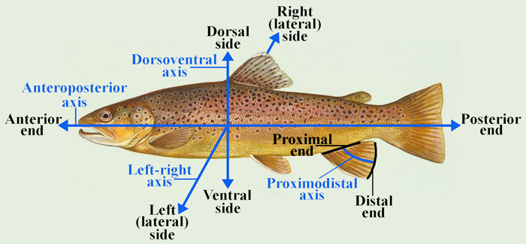

Vestigial
Occurring as a structure that, once functional (whether during development or in earlier evolutionary forms), is now reduced or degenerate. An example is the vestigial pelvic girdle seen in many snakes, including the boas and pythons, which bears no function.

Z

Zygapophysis
Articular process of a vertebra that articulates with the corresponding process of an adjacent vertebra.
Plural = zygapophyses

