Vertebrate Palaeontology and Evolution study pack

This resource is designed to familiarise you with the structure, diversity and evolutionary history of vertebrates through analysing images of specimens held at UCL’s Grant Museum of Zoology. It contains seven chapters: an introduction to vertebrate diversity, Fishes, the fish-tetrapod transition, Amphibians and Amniotes, Lepidosaurs and Chelonians, Archosaurs, and Birds and flight. All images have accompanying text, including information about the specimen plus hints about what to look for and the questions to consider when analysing the images. Please note that this resource does not look at mammals in detail – instead, this fascinating group are given a more thorough treatment in another Object Based Learning for Higher Education (OBL4HE) resource entitled ‘Vertebrate Diversity’ and the Virtual Educational Resource for the Biosciences (VERB) resource ‘Eutherians’.

- Verb Diversity: https://open-education-repository.ucl.ac.uk/id/eprint/204
- Eutherians (VERB): https://open-education-repository.ucl.ac.uk/id/eprint/210

Scalebars are provided throughout (except for models). Please note that there are two different scale bars used, one with 1cm divisions and one with 0.5cm divisions.

Multiple images of specimens are provided to try to illustrate the various anatomical features. However, please note that the limitations of photography (especially for specimens in cases or bottles) means that some distortion may occur or parts may be concealed or generally hard to determine.

To download this resource in its entirety, see the resource's collection page: https://open-education-repository.ucl.ac.uk/195/

Disclaimer: 'Vertebrate Palaeontology and Evolution' was originally designed by UCL staff as an internal teaching resource. The subsequent release of 'Vertebrate Palaeontology and Evolution' as an OER means that any changes to the product received relative to the original content may not reflect the desires of UCL teaching staff, or the original quality of the resource.

CC BY-NC-SA 4.0 International Licence: 'Vertebrate Palaeontology and Evolution' has been released as an open educational resource (OER) on a Creative Commons 'Attribution Non-commercial Share Alike' license. This means that once downloaded, content can be modified and improved to complement a particular course. This requires, however, that improvements are recycled back into the OER community, and full attribution is made to UCL. All content present at the time of download must be accordingly credited and, in turn, novel content must be appropriately licensed. For more information, please refer to the license deed by visiting: https://creativecommons.org/licenses/by-nc-sa/4.0/legalcode

Chapter 7: Birds and flight

This chapter will look at the anatomy of birds, especially with regard to the structure of their skulls and locomotor systems. Some non-birds are also included for revision and comparison.

Contents
Chapter 7: Birds and flight 2
7.1 Noctule bat 5
7.2 Archaeopteryx 7
7.3 Rhea 9
7.4 Fulmaris glacialis (the Fulmar) 12
7.5 Penguin (species unknown) 16
7.6 Gallus 21
7.7 Other taxa 22
Glossary 23

7.1 Noctule bat

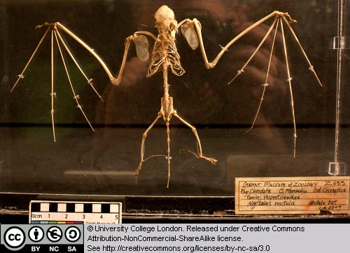

This is the skeleton of a bat. Look at the skeleton support for the wing membranes and compare it with the system used by birds and pterosaurs.

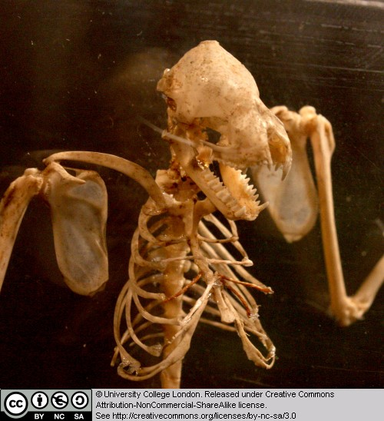

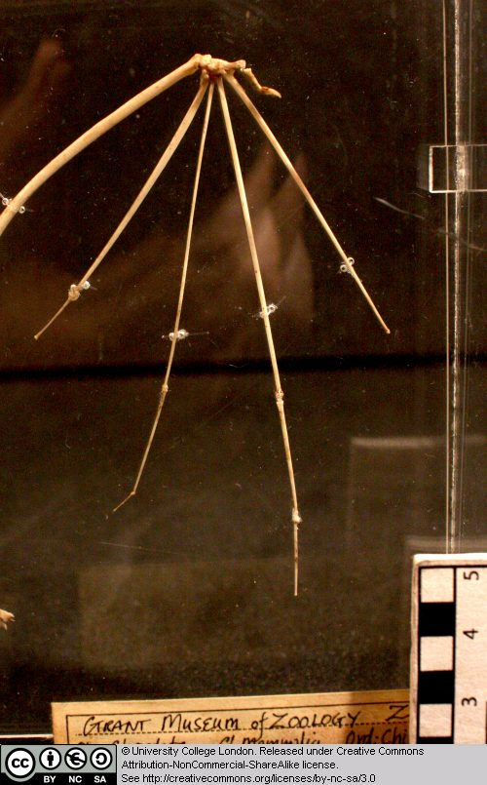

7.2 Archaeopteryx

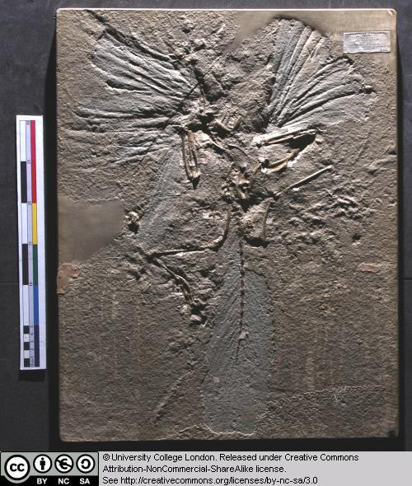

This is a cast of the London Archaeopteryx specimen. Look at the feathers – which parts of the animal do they cover? Examine the wing feathers – are they symmetrical or asymmetrical?

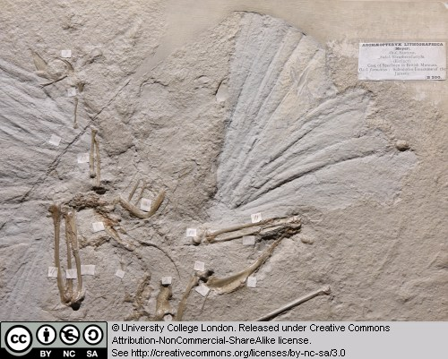

Compare the anatomy of Archaeopteryx with that of Compsognathus and the modern birds. What differences and similarities can you detect?

There are now ten specimens of Archaeopteryx known and occaionally new specimens come to light. Some of the previous ones can be seen here, here, and here.

7.3 Rhea

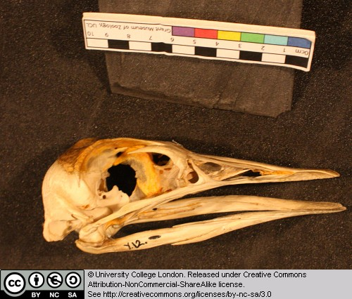

The Rhea is a large flightless bid from South America. Examine the light construction of the skull and beak region.

Try to identify as many of the openings in the skull as you can. Note the enlarged braincase – birds have large brains compared to their reptilian ancestors.

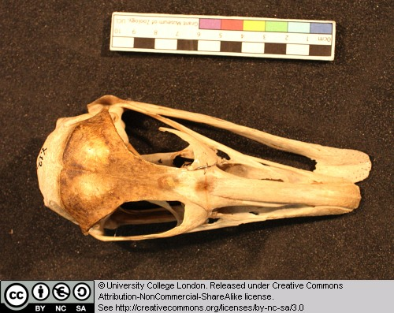

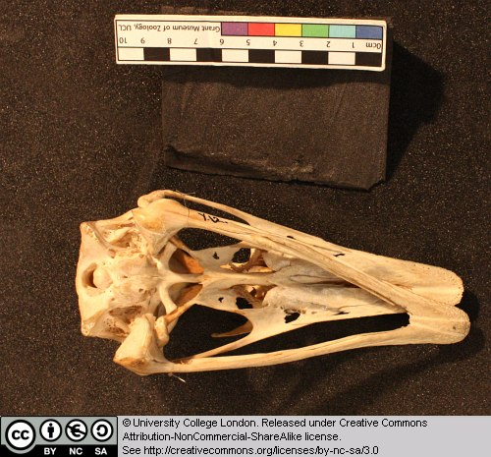

7.4 Fulmaris glacialis (the Fulmar)

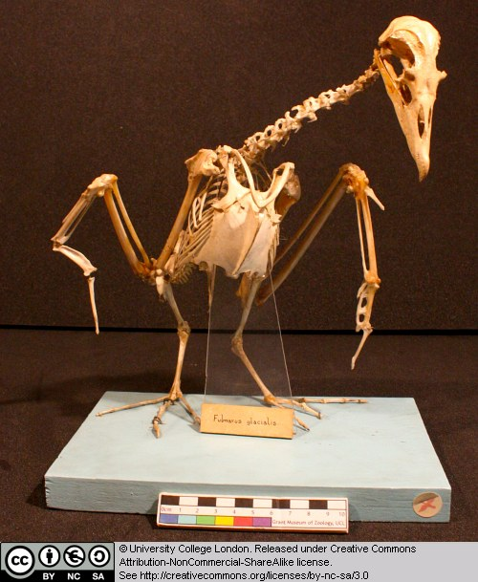

This is the skeleton of a sea bird found around the coasts of western and northern Europe. Examine the following: the rib cage and sternum (breast bone area) where the major flight muscles attach, the furcula (wish-bone), the form of the wing bones (try to identify the humerus, ulna and radius, and fused finger bones), the pygostyle (fused bones at the base of the tail), the short femur, the openings in the skull – note how the diapsid skull has been modified through the loss of some of the struts.

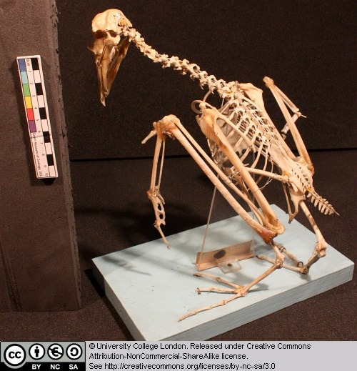

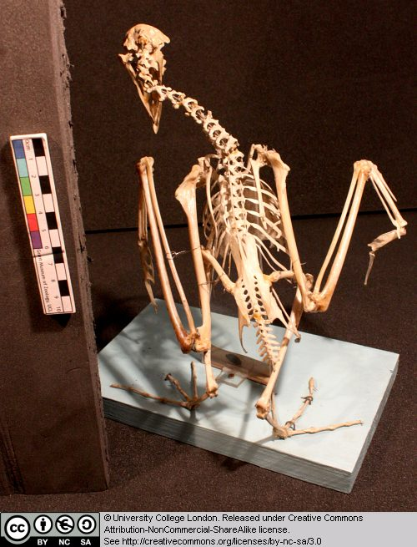

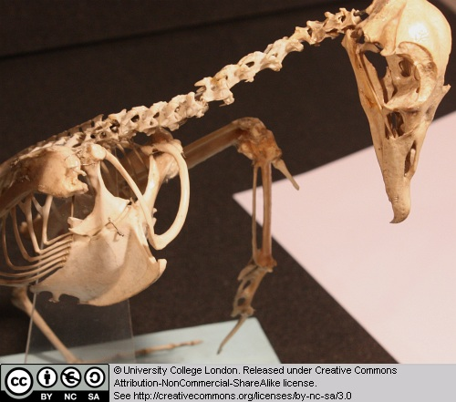

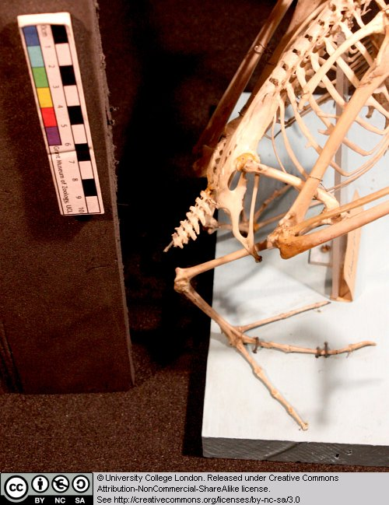

While you are here, look at the skeleton of Archaeopteryx, and those of extant birds, in the cases. Try to identify some of the features listed above while looking at these specimens.

7.5 Penguin (species unknown)

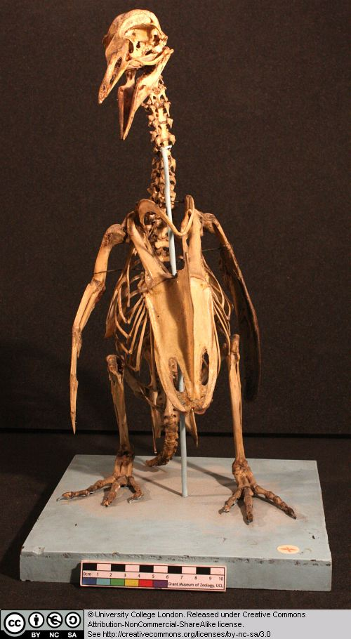

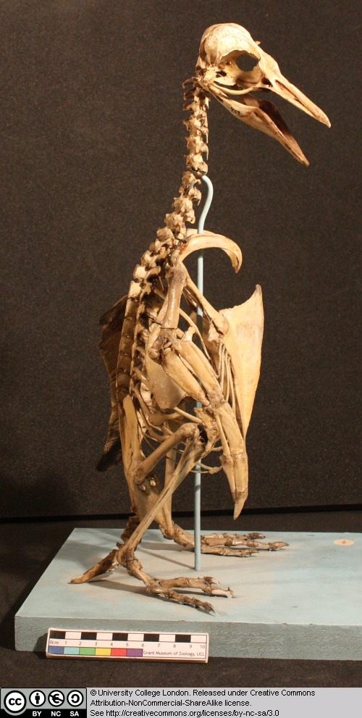

Penguins are flightless birds found around the coast of Antarctica, and also South America and Africa. Note the structure of the skull, including the openings.

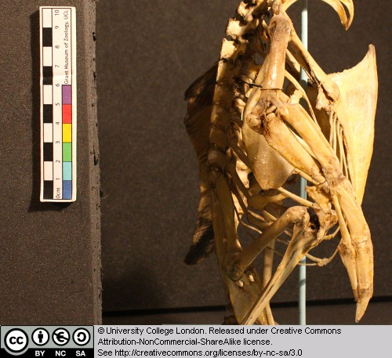

Penguins are unusual because of their relatively upright posture – compare with the other bird skeletons. The wings are used for underwater swimming – compare their structure with that in the Fulmar.

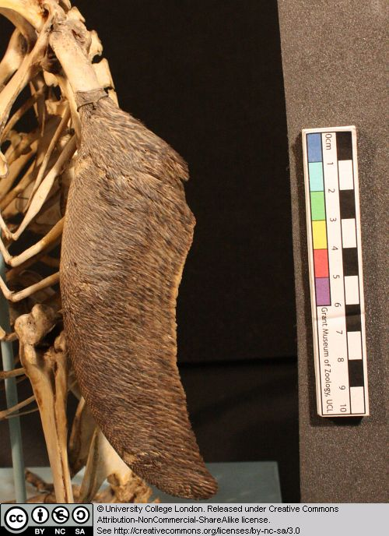

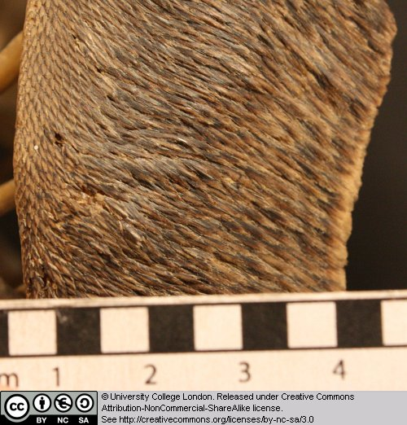

7.6 Gallus

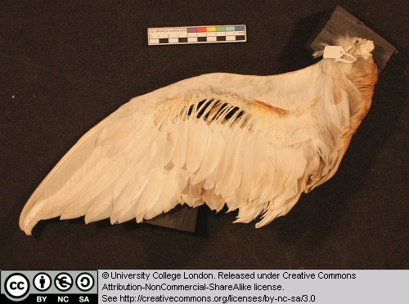

This is the wing of the chicken. Note the insertion points for the large ‘primary’ flight feathers. Examine feather structure. Not the central rachis and the barbs on either side. Are the large flight feathers symmetrical or asymmetrical?

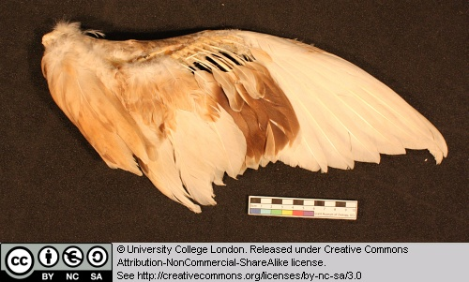

7.7 Other taxa

A good number of taxa from previous chapters were revisited in this session. These were the monitor lizard, the dinosaur Compsognathus and the parrot from Chapter 1, the tuatara, Amphisbaena, the annaconda, and the tortoise from Chapter 5, and finally the pterosaurs Scaphognathus and Pterodactylus from Chapter 6.

Glossary

A

akinetic
In anatomy, this refers to a low level of flexibility in a structure due to a lack of moveable joints.

amniote
Those vertebrates with an amniotic egg. The extant clades are Testudines (turtles), Diapsida (lepidosaurians, crocodilians, and birds), and Synapsida (mammals).

anapsid
Skull possessing no temporal fenestrae (NB. an- = without).
Amniotes with this skull condition form a paraphyletic group including the Parareptilia (turtles and their extinct relatives), the extinct common ancestor of all amniotes, and basal eureptiles (the extinct precursors of diapsids).
Note that the Testudines (turtles and relatives) have modified the anapsid condition through a reduction (emargination) of the posterior region of the skull.

Apatite
Calcium phosphate: the crystalline component of bone.

apomorphy
A derived or specialised character.

Appendicular skeleton
The endoskeletal element of the fins or limbs of a vertebrate, and their associated girdles (pectoral or pelvic).

Axial skeleton
All parts of the vertebrate endoskeleton except the limbs or fins and their associated girdles. That is, the cranium, visceral skeleton, notochord, vertebrae, and ribs.

B

Basal
Of, relating to, located at, or forming a base.

Bicuspid
A tooth bearing two cusps.

C

Calcified cartilage
Cartilage strengthened with a scattering of apatite crystals (calcium phosphate), as seen in Chondrichthians.

Cartilage
A tough, elastic, fibrous connective tissue composed of collagen fibres. Used as skeletal tissue in vertebrates, it is non-mineralised and is often the developmental precursor of bone.

Clade
A phylogenetic lineage comprising a common ancestor and all its descendant species.
Note that the difference between a taxon and a clade is that a clade must include all descendant species from a common ancestor, whereas a taxon need not.

cladistic
Relating to the branching sequences of phylogeny.

cladogram
A branching tree-like diagram representing the phylogenetic relationships (evolutionary history) of a lineage.

cloaca
The common opening for the reproductive, urinary, and digestive tracts, seen in all vertebrates except therian mammals (marsupials and placental mammals).

The term comes from the Latin for sewer.

Cursorial
Adapted for running.

Cusp
The biting point of a tooth.

D

Dentary
The anterior bone of the lower jaw which bears the teeth. It forms the whole of the lower jaw in mammals.

Dentine
A bone-like substance, lacking cell bodies and consisting mainly of calcium phosphate (apatite) in a fibrous matrix.

Dermal bone
A type of bone forming within the dermis - the deep layer of vertebrate skin cells below the surface layer, the epidermis.

diapsid
Skull possessing both an upper and a lower temporal fenestra (NB. di- = two).
Amniotes with this skull condition form the monophyletic clade Diapsida, which includes the lepidosaurs (lizards, snakes, and tuatara), archosaurs (crocodilians, dinosaurs, and birds), and their other extinct relatives.
Note that some diapsids, such as lizards, have lost the temporal bar separating the fenestrae to form one large window. Others, such as the Aves (birds), have merged both fenestrae with the orbit.

E

Enamel
The crystalline material covering the crown of a tooth, or certain scales.

Endopterygota
A clade of insects charachterised by their undergoing complete metamorphosis (i.e. holometabolous).
See Insect Diversity WebBook for the clades within (from Neuroptera down).

Epidermal
Pertaining to, or originating from, the epidermis - the surface layer of skin cells in vertebrates

euryapsid
Skull possessing an upper temporal fenestra only.
However, animals with this skull condition do not represent an important amniote lineage, as they are likely to be a polyphyletic group, originating a least twice within the Diapsida. Euryapsids include the plesiosaurs and ichthyosaurs - Mesozoic marine reptiles.

extant
Not extinct.

F

fossorial
Specialised for burrowing.

furcula
The fused clavicle bones of a bird, also known as the wishbone.

H

Hemimetabolous
Refers to a type of insect development that is categorised by three distinct, progressive life stages: egg, nymph, imago (adult). Changes are gradual, with no pupal stage.
Some hemimetabolous insects include grasshoppers, cicadas, cockroaches, termites, earwigs, and dragonflies.
Also termed incomplete metamorphosis.

Holometabolous
Refers to a type of insect development that is categorised by four distinct, progressive life stages: embryo, larva, pupa, imago (adult).
Seen exlusively in the Endopterygota, which includes beetles, butterflies, wasps, bees, ants, and others.
Also termed complete metamorphosis.

Horny
Consisting of horn - a tough material composed mainly of keratin.

I

ilium
In tetrapods, the dorsal section of the pelvis, which articulates with one or more sacral vertebrae.

K

Kinetic
In anatomy, referring to a high level of flexibility afforded by numerous moveable joints.

L

Lymph heart
Muscular dilation in a lymph vessel, which pumps lymph (fluid containing white blood cells called lymphocytes important in immune response) around the body of some lungfishes, amphibians and reptiles.

M

Metacone
In mammals, the metacone is the distobuccal (rear-most and cheek side) cusp of an upper molar tooth.

monophyletic
Having a single evolutionary origin. A taxon is monophyletic if it contains all the descendants of a common ancestor.

For example, mammals are a monophyletic group, as all species descended from the first known mammal are considered mammals.

See paraphyletic and polyphyletic for alternative terms.

Myrmecophagy
Feeding behaviour categorised by an exclusive (or near exclusive) diet of ants ant termites.

O

Orbit
The bony socket of the eye.

Osteosclerosis
An increase in the density of bone.

P

Pachyostosis
A thickening of the bone, often associated with a reduction in the volume of marrow tissue contained within.

Paracone
In mammals, the paracone is the mesiobuccal (front-most and cheek side) cusp of an upper molar tooth.

Paraphyletic
A taxon including a common ancestor and some but not all of its descendants.
For example, the class Reptilia is paraphyletic, as it does not include birds, who are considered a separate class: Aves. However, birds evolved from theropod dinosaurs, and are therefore reptiles themselves. Similarly, all tetrapods are, evolutionarily speaking, lobe-finned fish.
Importantly, reptiles can be made monophyletic through the addition of birds to the taxon.
See monophyletic and polyphyletic for alternative terms.

Pectoral girdle
In vertebrates, the skeletal structure that provides support for the fore limbs or fins.

Pelvic girdle
In vertebrates, the skeletal structure that provides support for the hind limbs or fins, which also fuses with the sacral vertebrae.

phylogeny
The evolutionary history of organismal lineages as they develop through time.

plesiomorphy
An ancestral character.

polyphyletic
Referring to a group that does not contain the common ancestor of all the taxa within. Therefore, this is not a true taxonomic group, but is often a term used to categorise organisms with a similar ecology, such as insectivorious mammals, or marine mammals.
It is also used when the evolutionary origin of a group, such as snakes, is unsure, and characteristic species within may have originated separately.

Protocone
In mammals, the protocone is the mesiolingual cusp of an upper molar tooth.

Pulp cavity
The space within a tooth, or a dentine scale, occupied by blood vessels and nerves.

S

symplesiomorphy
A character that is shared between groups but was inherited from an ancestor prior to the last common ancestor.
These are characters that - at the level at which they are referred to as symplesiomorphies - are not used to form cladistic groupings, or clades.

synapomorphy
A derived or specialised character that is shared between two or more groups, and was inherited from the common ancestor in which it originated.
These are the characters that morphological systematists use to support the existence of particular clades, forming the basis of the field of cladistics.

synapsid
Skull possessing a lower temporal fenestra only.
Amniotes with this skull condition form the monophyletic clade Synapsida, which includes the mammals and their extinct ancestors, the non-mammalian reptile-like synapsids.
Note that in the Mammalia, the lower temporal fenestra has merged with the orbit.

T

taxon
A group of organisms sharing a common ancestry.
Note that the difference between a taxon and a clade is that a clade must include all descendant species from a common ancestor, whereas a taxon need not.
Pl. taxa.

temporal fenestra
An opening in the temporal region of the skull seen in amniotes, providing a flat edge for the attachment of strong lower jaw closing muscles to the skull.
Amniotes show four skull types, based on the position and number of these temporal fenestrae, two of which define two major lineages of the amniotes. The skull types and associated groups are as follows:
1) Synapsid - Skull possessing a lower temporal fenestra only. Amniotes with this skull condition form the monophyletic clade Synapsida, which includes the mammals and their extinct ancestors, the mammal-like reptiles. Note that in the Mammalia, the lower temporal fenestra has merged with the orbit.
2) Diapsid - Skull possessing both an upper and a lower temporal fenestra (NB. di- = two). Amniotes with this skull condition form the monophyletic clade Diapsida, which includes the lepidosaurs (lizards, snakes, and tuatara), archosaurs (crocodilians, dinosaurs, and birds), and their other extinct relatives. Note that some groups within the Diapsida, such as lizards, have lost the temporal bar separating the fenestrae to form one large window. Others, such as the Aves (birds), have merged both fenestrae with the orbit.
3) Anapsid - Skull possessing no temporal fenestrae (NB. an- = without). Amniotes with this skull condition form a paraphyletic group including the Parareptilia (turtles and their extinct relatives), the extinct common ancestor of all amniotes, and basal eureptiles (the extinct precursors of diapsids). Note that the Testudines (turtles and relatives) have modified the anapsid condition through a reduction (emargination) of the posteriorregion of the skull.
4) Euryapsid - Skull possessing an upper temporal fenestra only. However, animals with this skull condition do not represent an importantamniote lineage, as they are likely to be a polyphyletic group, originating a least twice within the Diapsida. Euryapsids include the plesiosaurs and ichthyosaurs - Mesozoic marine reptiles.

V

vertebrae
From anterior to posterior:
Cervical vertebrae: Facilitate the mobility of the head. The first two, the atlas and the axis are highly specialised, the former articulating with the occipital region of the skull.
Thoracic vertebrae: Articulate with the ribs that fuse with the sternum.
Lumbar vertebrae: Generally larger, with small ribs not attached to the sternum, which support the posterior musculature.
Sacral vertebrae: Fused to the pelvic girdle, allowing the transfer of force from the appendicular skeleton (limbs) during locomotion.
Caudal vertebrae: Small and less specialised, forming the tail.

Vertebrate anatomical directions and axes
The image below illustrates the terms used for anatomical directions and axes in vertebrates.
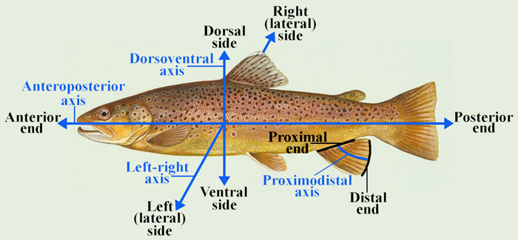

Vestigial
Occurring as a structure that, once functional (whether during development or in earlier evolutionary forms), is now reduced or degenerate. An example is the vestigial pelvic girdle seen in many snakes, including the boas and pythons, which bears no function.

Z

Zygapophysis
Articular process of a vertebra that articulates with the corresponding process of an adjacent vertebra.
Plural = zygapophyses

