Vertebrate Palaeontology and Evolution study pack

This resource is designed to familiarise you with the structure, diversity and evolutionary history of vertebrates through analysing images of specimens held at UCL’s Grant Museum of Zoology. It contains seven chapters: an introduction to vertebrate diversity, Fishes, the fish-tetrapod transition, Amphibians and Amniotes, Lepidosaurs and Chelonians, Archosaurs, and Birds and flight. All images have accompanying text, including information about the specimen plus hints about what to look for and the questions to consider when analysing the images. Please note that this resource does not look at mammals in detail – instead, this fascinating group are given a more thorough treatment in another Object Based Learning for Higher Education (OBL4HE) resource entitled ‘Vertebrate Diversity’ and the Virtual Educational Resource for the Biosciences (VERB) resource ‘Eutherians’.

- Verb Diversity: https://open-education-repository.ucl.ac.uk/id/eprint/204
- Eutherians (VERB): https://open-education-repository.ucl.ac.uk/id/eprint/210

Scalebars are provided throughout (except for models). Please note that there are two different scale bars used, one with 1cm divisions and one with 0.5cm divisions.

Multiple images of specimens are provided to try to illustrate the various anatomical features. However, please note that the limitations of photography (especially for specimens in cases or bottles) means that some distortion may occur or parts may be concealed or generally hard to determine.

To download this resource in its entirety, see the resource's collection page: https://open-education-repository.ucl.ac.uk/195/

Disclaimer: 'Vertebrate Palaeontology and Evolution' was originally designed by UCL staff as an internal teaching resource. The subsequent release of 'Vertebrate Palaeontology and Evolution' as an OER means that any changes to the product received relative to the original content may not reflect the desires of UCL teaching staff, or the original quality of the resource.

CC BY-NC-SA 4.0 International Licence: 'Vertebrate Palaeontology and Evolution' has been released as an open educational resource (OER) on a Creative Commons 'Attribution Non-commercial Share Alike' license. This means that once downloaded, content can be modified and improved to complement a particular course. This requires, however, that improvements are recycled back into the OER community, and full attribution is made to UCL. All content present at the time of download must be accordingly credited and, in turn, novel content must be appropriately licensed. For more information, please refer to the license deed by visiting: https://creativecommons.org/licenses/by-nc-sa/4.0/legalcode

Chapter 5: Lepidosaurs and Chelonians

This chapter will look at lepidosaurs and Chelonians. When you look at the various specimens, focus on the femestration of the skulls, and their kinetic joints [if present].

Contents
Chapter 5: Lepidosaurs and Chelonians 2
5.1 Plesiosaurus microcephalus 5
5.2 Plesiosaurus sp. 6
5.3 Sphenodon (the tuatara) 8
5.4 Homoeosaurus sp. 11
5.5 Homoeosaurus maximilliani 13
5.6 Amphisbaena sp. 14
5.7 Amphisbaena skull 16
5.8 Eunectes murina (the anaconda) 18
5.9 Cholydra serpentina (Ridley's sea turtle) 20
5.10 Eretmochelys imbricata (Hawksbill turtle) 21
5.11 Testudo hermanni (a terrestrial tortoise) 23
5.12 Other taxa 26
Glossary 27

5.1 Plesiosaurus microcephalus

This is a cast of the skull and mandible of a plesiosaur. The sauropterygian reptiles contain a variety of aquatic forms from the Mesozoic, including the plesiosaurs. The relationships of sauropterygians to other reptiles are still controversial, although many workers now believe that sauropterygians and lepidosaurs belong in the same clade (the Lepidosauromorpha).

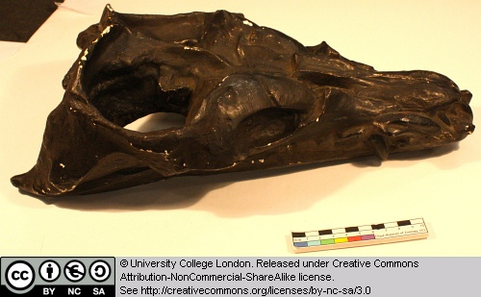

Identify the major openings of the skull. Can you find the temporal openings and bars? Note the narrow and forwardly projecting teeth. What kind of food might this animal have eaten?

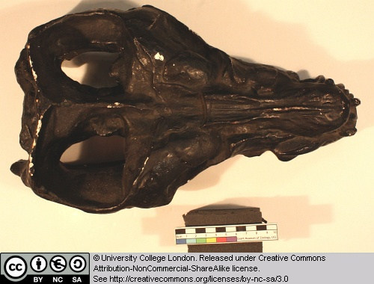

Can you find the external nostrils – these are typically retracted in plesiosaurs, reflecting their aquatic lifestyle.

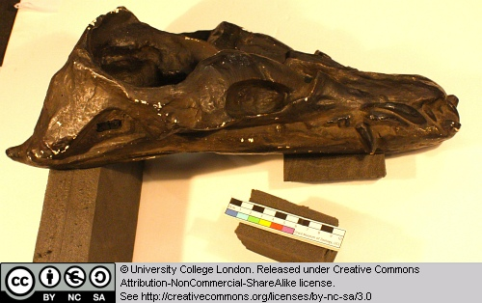

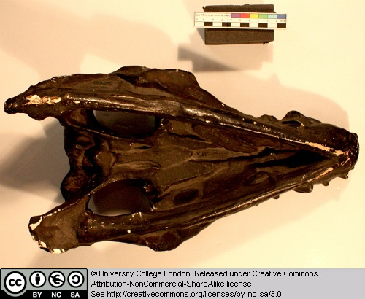

5.2 Plesiosaurus sp.

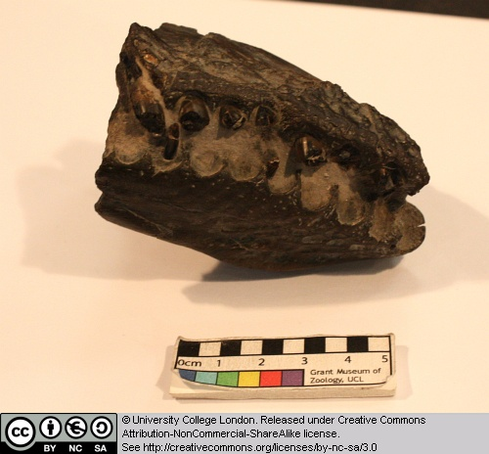

This is the front part of the skull and lower jaw of a plesiosaur. It is difficult to see details because of the state of preservation, but note the shape and orientation of the teeth.

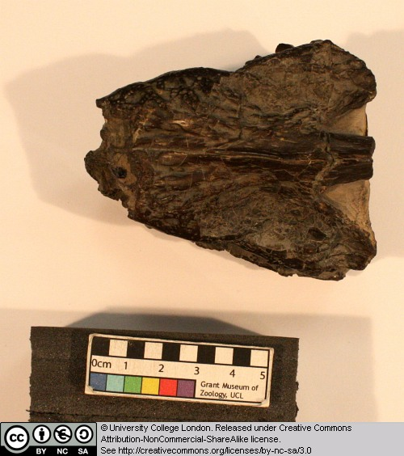

5.3 Sphenodon (the tuatara)

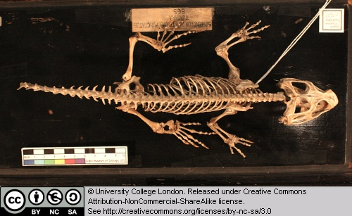

This is the skeleton of Sphenodon, the only extant member of the once diverse sphenodontids (members of the Rhynchocephalia). This group is believed to be the sister-group of the Squamata (lizards, snakes and amphisbaenids), together forming the Lepidosauria.

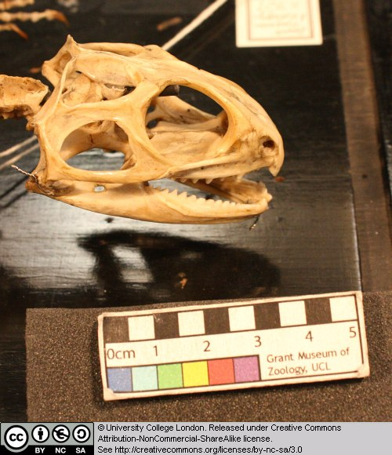

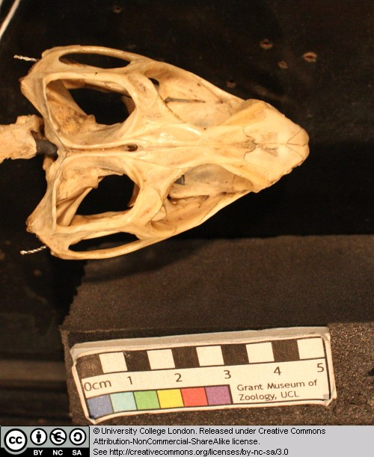

Note the structure of the skull, especially the temporal openings and temporal bars.

5.4 Homoeosaurus sp.

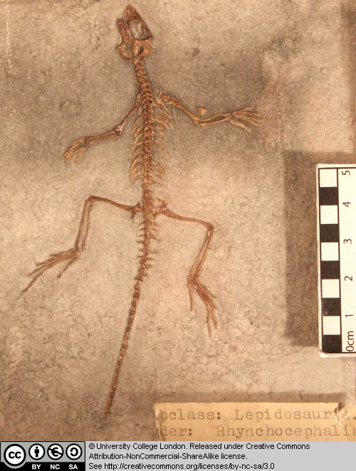

This is a cast of the skull and skeleton of a small sphenodontid from the Late Jurassic of Germany. It is difficult to see details on such a small specimen, but note the long tail and general body proportions.

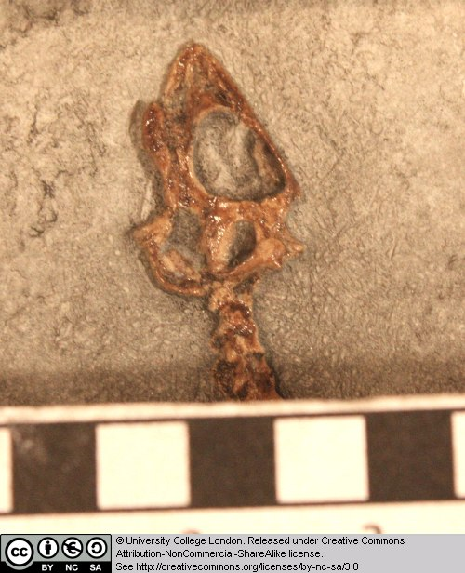

Which openings can you identify in the skull?

5.5 Homoeosaurus maximilliani

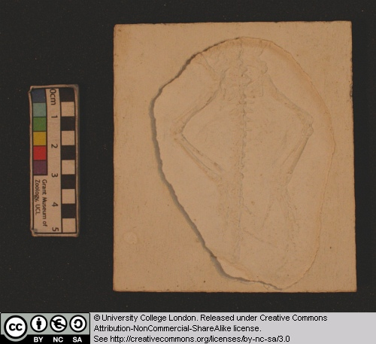

This is the skull and skeleton of a sphenodontid from the Late Jurassic of Germany. Note the general body proportions and the long tail. Can you identify the openings in the skull?

5.6 Amphisbaena sp.

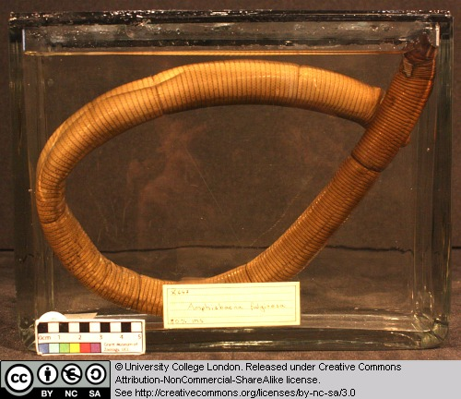

This is a preserved specimen of an extant amphisbaenid squamate. Amphisbaenids are limbless burrowing forms.

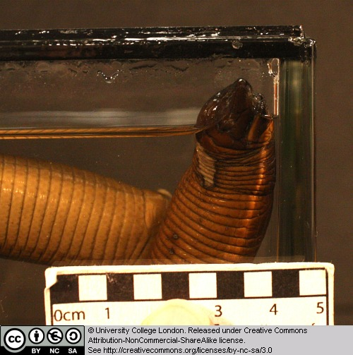

5.7 Amphisbaena skull

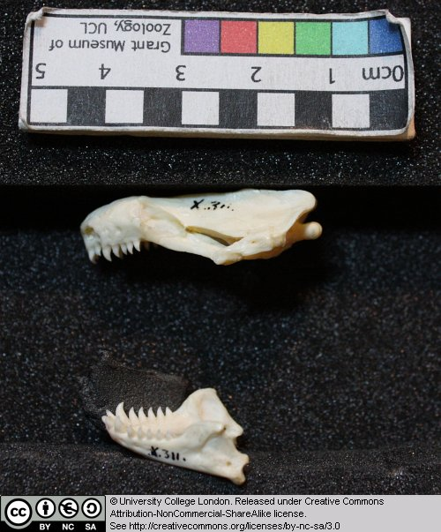

This is the skull of an extant amphisbaenid. Can you identify the openings in the skull, particularly the temporal openings?

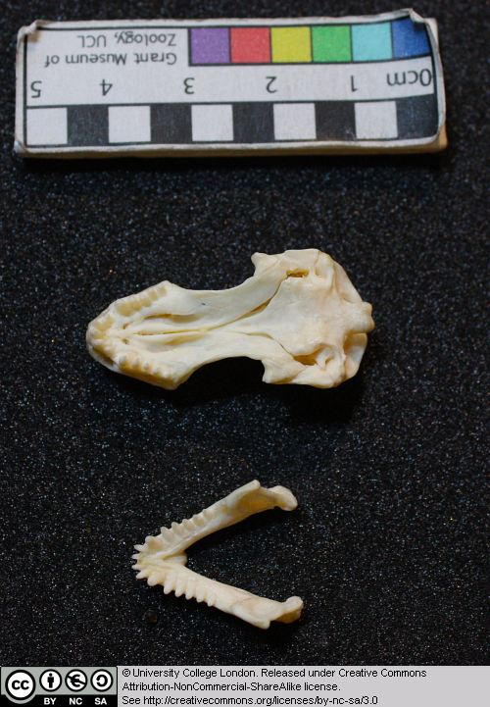

5.8 Eunectes murina (the anaconda)

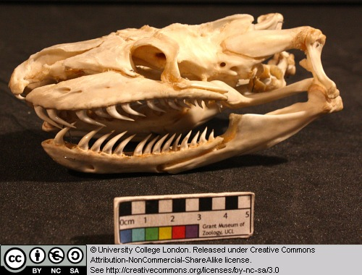

This is the skull of the anaconda – the world’s largest snake. Note the structure of the temporal region, including the absence of temporal bars. Note the shape and position of the teeth.

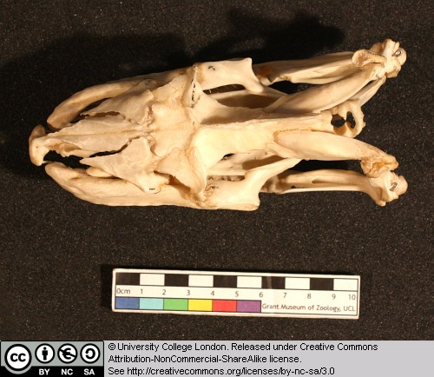

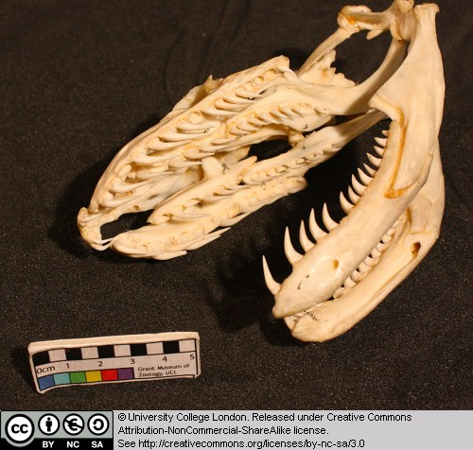

5.9 Cholydra serpentina (Ridley's sea turtle)

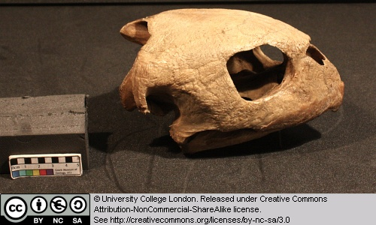

As the name suggests, this is a fully marine turtle. Turtles (the Chelonia) are amniotes, but their precise relationships are still controversial. Some workers have suggested that they evolved from the parareptiles, while others have argued that turtles are highly modified archosaurs (the latter being the group that contains crocodiles, dinosaurs and birds).

Note the main openings in the skull, emargination of the skull's back margin, and the ear region.

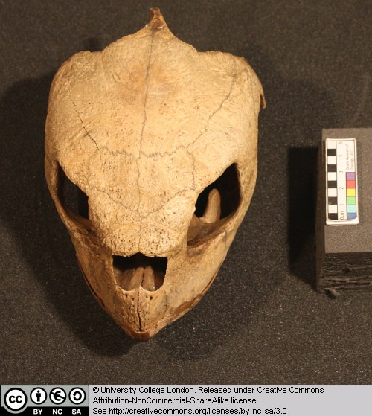

5.10 Eretmochelys imbricata (Hawksbill turtle)

Turtles (the Chelonia) are amniotes, but their precise relationships are still controversial.

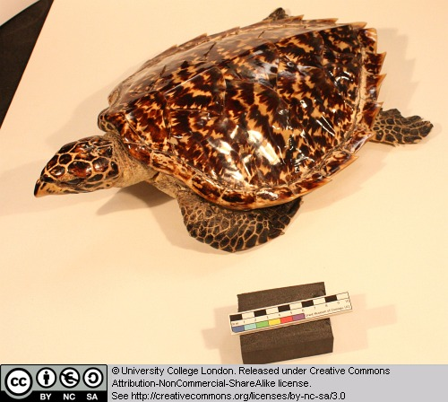

Note the following features: the low and relatively undomed carapace, marine turtles often reduce the carapace, compare the flipper-like structure of the feet in this form, with the less modified versions in the matamata.

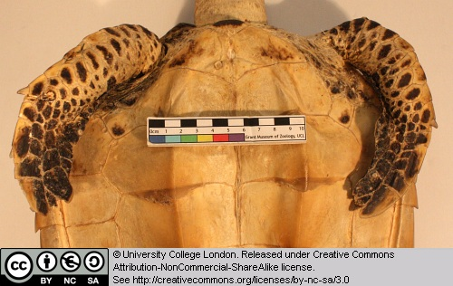

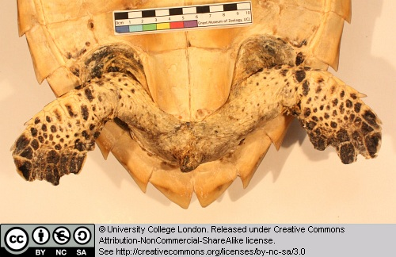

5.11 Testudo hermanni (a terrestrial tortoise)

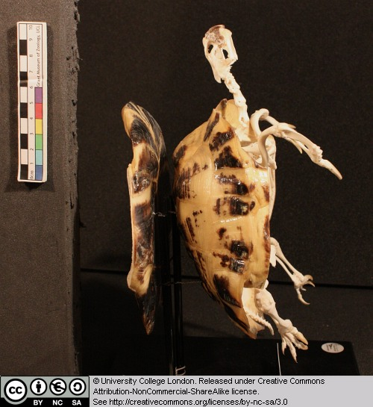

This is the skull, beak, skeleton and shell of a terrestrial tortoise. (Note: this specimen has the plastron [the ventralpice of chest armour] removed and mounted on the back). Look at the structure of the skill and beak – note the absence of teeth and the ridged edge of the beak. Examine the emarginations at the back margin of the skull – these embayments held large jaw closing muscles.

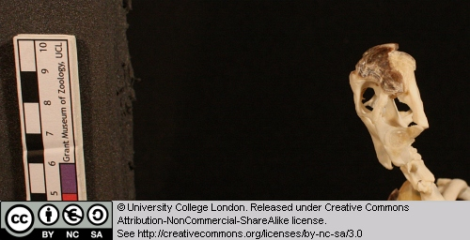

Note the way the pectoral and pelvic girdles are held within the shell, effectively within the rib cage.

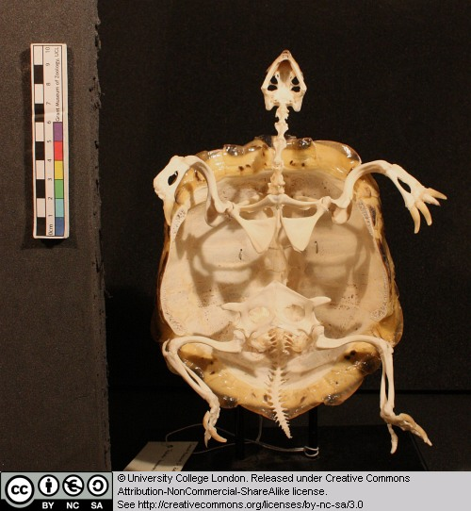

Compare the limbs of this tortoise with those of the aquatic forms. The shell here is more domed that in aquatic forms.

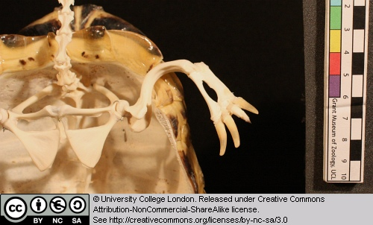

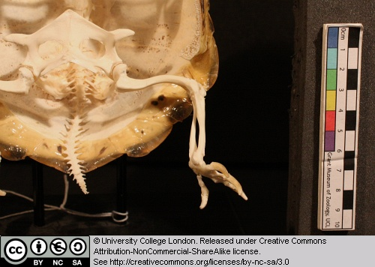

5.12 Other taxa

A number of previously seen species are revisited in this chapter. The toad Bufo, monitor lizard Varanus and matamata Chelys from Chapter 1, and Cryptobranchus and Hypsognathus from Chapter 4.

Glossary

A

akinetic
In anatomy, this refers to a low level of flexibility in a structure due to a lack of moveable joints.

amniote
Those vertebrates with an amniotic egg. The extant clades are Testudines (turtles), Diapsida (lepidosaurians, crocodilians, and birds), and Synapsida (mammals).

anapsid
Skull possessing no temporal fenestrae (NB. an- = without).
Amniotes with this skull condition form a paraphyletic group including the Parareptilia (turtles and their extinct relatives), the extinct common ancestor of all amniotes, and basal eureptiles (the extinct precursors of diapsids).
Note that the Testudines (turtles and relatives) have modified the anapsid condition through a reduction (emargination) of the posterior region of the skull.

Apatite
Calcium phosphate: the crystalline component of bone.

apomorphy
A derived or specialised character.

Appendicular skeleton
The endoskeletal element of the fins or limbs of a vertebrate, and their associated girdles (pectoral or pelvic).

Axial skeleton
All parts of the vertebrate endoskeleton except the limbs or fins and their associated girdles. That is, the cranium, visceral skeleton, notochord, vertebrae, and ribs.

B

Basal
Of, relating to, located at, or forming a base.

Bicuspid
A tooth bearing two cusps.

C

Calcified cartilage
Cartilage strengthened with a scattering of apatite crystals (calcium phosphate), as seen in Chondrichthians.

Cartilage
A tough, elastic, fibrous connective tissue composed of collagen fibres. Used as skeletal tissue in vertebrates, it is non-mineralised and is often the developmental precursor of bone.

Clade
A phylogenetic lineage comprising a common ancestor and all its descendant species.
Note that the difference between a taxon and a clade is that a clade must include all descendant species from a common ancestor, whereas a taxon need not.

cladistic
Relating to the branching sequences of phylogeny.

cladogram
A branching tree-like diagram representing the phylogenetic relationships (evolutionary history) of a lineage.

cloaca
The common opening for the reproductive, urinary, and digestive tracts, seen in all vertebrates except therian mammals (marsupials and placental mammals).

The term comes from the Latin for sewer.

Cursorial
Adapted for running.

Cusp
The biting point of a tooth.

D

Dentary
The anterior bone of the lower jaw which bears the teeth. It forms the whole of the lower jaw in mammals.

Dentine
A bone-like substance, lacking cell bodies and consisting mainly of calcium phosphate (apatite) in a fibrous matrix.

Dermal bone
A type of bone forming within the dermis - the deep layer of vertebrate skin cells below the surface layer, the epidermis.

diapsid
Skull possessing both an upper and a lower temporal fenestra (NB. di- = two).
Amniotes with this skull condition form the monophyletic clade Diapsida, which includes the lepidosaurs (lizards, snakes, and tuatara), archosaurs (crocodilians, dinosaurs, and birds), and their other extinct relatives.
Note that some diapsids, such as lizards, have lost the temporal bar separating the fenestrae to form one large window. Others, such as the Aves (birds), have merged both fenestrae with the orbit.

E

Enamel
The crystalline material covering the crown of a tooth, or certain scales.

Endopterygota
A clade of insects charachterised by their undergoing complete metamorphosis (i.e. holometabolous).
See Insect Diversity WebBook for the clades within (from Neuroptera down).

Epidermal
Pertaining to, or originating from, the epidermis - the surface layer of skin cells in vertebrates

euryapsid
Skull possessing an upper temporal fenestra only.
However, animals with this skull condition do not represent an important amniote lineage, as they are likely to be a polyphyletic group, originating a least twice within the Diapsida. Euryapsids include the plesiosaurs and ichthyosaurs - Mesozoic marine reptiles.

extant
Not extinct.

F

fossorial
Specialised for burrowing.

furcula
The fused clavicle bones of a bird, also known as the wishbone.

H

Hemimetabolous
Refers to a type of insect development that is categorised by three distinct, progressive life stages: egg, nymph, imago (adult). Changes are gradual, with no pupal stage.
Some hemimetabolous insects include grasshoppers, cicadas, cockroaches, termites, earwigs, and dragonflies.
Also termed incomplete metamorphosis.

Holometabolous
Refers to a type of insect development that is categorised by four distinct, progressive life stages: embryo, larva, pupa, imago (adult).
Seen exlusively in the Endopterygota, which includes beetles, butterflies, wasps, bees, ants, and others.
Also termed complete metamorphosis.

Horny
Consisting of horn - a tough material composed mainly of keratin.

I

ilium
In tetrapods, the dorsal section of the pelvis, which articulates with one or more sacral vertebrae.

K

Kinetic
In anatomy, referring to a high level of flexibility afforded by numerous moveable joints.

L

Lymph heart
Muscular dilation in a lymph vessel, which pumps lymph (fluid containing white blood cells called lymphocytes important in immune response) around the body of some lungfishes, amphibians and reptiles.

M

Metacone
In mammals, the metacone is the distobuccal (rear-most and cheek side) cusp of an upper molar tooth.

monophyletic
Having a single evolutionary origin. A taxon is monophyletic if it contains all the descendants of a common ancestor.

For example, mammals are a monophyletic group, as all species descended from the first known mammal are considered mammals.

See paraphyletic and polyphyletic for alternative terms.

Myrmecophagy
Feeding behaviour categorised by an exclusive (or near exclusive) diet of ants ant termites.

O

Orbit
The bony socket of the eye.

Osteosclerosis
An increase in the density of bone.

P

Pachyostosis
A thickening of the bone, often associated with a reduction in the volume of marrow tissue contained within.

Paracone
In mammals, the paracone is the mesiobuccal (front-most and cheek side) cusp of an upper molar tooth.

Paraphyletic
A taxon including a common ancestor and some but not all of its descendants.
For example, the class Reptilia is paraphyletic, as it does not include birds, who are considered a separate class: Aves. However, birds evolved from theropod dinosaurs, and are therefore reptiles themselves. Similarly, all tetrapods are, evolutionarily speaking, lobe-finned fish.
Importantly, reptiles can be made monophyletic through the addition of birds to the taxon.
See monophyletic and polyphyletic for alternative terms.

Pectoral girdle
In vertebrates, the skeletal structure that provides support for the fore limbs or fins.

Pelvic girdle
In vertebrates, the skeletal structure that provides support for the hind limbs or fins, which also fuses with the sacral vertebrae.

phylogeny
The evolutionary history of organismal lineages as they develop through time.

plesiomorphy
An ancestral character.

polyphyletic
Referring to a group that does not contain the common ancestor of all the taxa within. Therefore, this is not a true taxonomic group, but is often a term used to categorise organisms with a similar ecology, such as insectivorious mammals, or marine mammals.
It is also used when the evolutionary origin of a group, such as snakes, is unsure, and characteristic species within may have originated separately.

Protocone
In mammals, the protocone is the mesiolingual cusp of an upper molar tooth.

Pulp cavity
The space within a tooth, or a dentine scale, occupied by blood vessels and nerves.

S

symplesiomorphy
A character that is shared between groups but was inherited from an ancestor prior to the last common ancestor.
These are characters that - at the level at which they are referred to as symplesiomorphies - are not used to form cladistic groupings, or clades.

synapomorphy
A derived or specialised character that is shared between two or more groups, and was inherited from the common ancestor in which it originated.
These are the characters that morphological systematists use to support the existence of particular clades, forming the basis of the field of cladistics.

synapsid
Skull possessing a lower temporal fenestra only.
Amniotes with this skull condition form the monophyletic clade Synapsida, which includes the mammals and their extinct ancestors, the non-mammalian reptile-like synapsids.
Note that in the Mammalia, the lower temporal fenestra has merged with the orbit.

T

taxon
A group of organisms sharing a common ancestry.
Note that the difference between a taxon and a clade is that a clade must include all descendant species from a common ancestor, whereas a taxon need not.
Pl. taxa.

temporal fenestra
An opening in the temporal region of the skull seen in amniotes, providing a flat edge for the attachment of strong lower jaw closing muscles to the skull.
Amniotes show four skull types, based on the position and number of these temporal fenestrae, two of which define two major lineages of the amniotes. The skull types and associated groups are as follows:
1) Synapsid - Skull possessing a lower temporal fenestra only. Amniotes with this skull condition form the monophyletic clade Synapsida, which includes the mammals and their extinct ancestors, the mammal-like reptiles. Note that in the Mammalia, the lower temporal fenestra has merged with the orbit.
2) Diapsid - Skull possessing both an upper and a lower temporal fenestra (NB. di- = two). Amniotes with this skull condition form the monophyletic clade Diapsida, which includes the lepidosaurs (lizards, snakes, and tuatara), archosaurs (crocodilians, dinosaurs, and birds), and their other extinct relatives. Note that some groups within the Diapsida, such as lizards, have lost the temporal bar separating the fenestrae to form one large window. Others, such as the Aves (birds), have merged both fenestrae with the orbit.
3) Anapsid - Skull possessing no temporal fenestrae (NB. an- = without). Amniotes with this skull condition form a paraphyletic group including the Parareptilia (turtles and their extinct relatives), the extinct common ancestor of all amniotes, and basal eureptiles (the extinct precursors of diapsids). Note that the Testudines (turtles and relatives) have modified the anapsid condition through a reduction (emargination) of the posteriorregion of the skull.
4) Euryapsid - Skull possessing an upper temporal fenestra only. However, animals with this skull condition do not represent an importantamniote lineage, as they are likely to be a polyphyletic group, originating a least twice within the Diapsida. Euryapsids include the plesiosaurs and ichthyosaurs - Mesozoic marine reptiles.

V

vertebrae
From anterior to posterior:
Cervical vertebrae: Facilitate the mobility of the head. The first two, the atlas and the axis are highly specialised, the former articulating with the occipital region of the skull.
Thoracic vertebrae: Articulate with the ribs that fuse with the sternum.
Lumbar vertebrae: Generally larger, with small ribs not attached to the sternum, which support the posterior musculature.
Sacral vertebrae: Fused to the pelvic girdle, allowing the transfer of force from the appendicular skeleton (limbs) during locomotion.
Caudal vertebrae: Small and less specialised, forming the tail.

Vertebrate anatomical directions and axes
The image below illustrates the terms used for anatomical directions and axes in vertebrates.
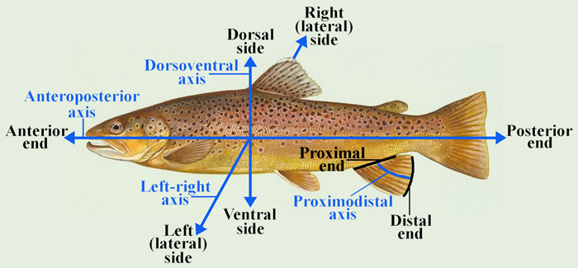

Vestigial
Occurring as a structure that, once functional (whether during development or in earlier evolutionary forms), is now reduced or degenerate. An example is the vestigial pelvic girdle seen in many snakes, including the boas and pythons, which bears no function.

Z

Zygapophysis
Articular process of a vertebra that articulates with the corresponding process of an adjacent vertebra.
Plural = zygapophyses

