Lessons from the Open Source Software communities (and research software)

Introduction

Who am I?
- I was a researcher
- I’m now a RSD
- I love teaching
- OpenAstronomy / SunPy (open source)
- Caprentries (teaching network)
- Sunspotter (citizen science)

Problems

For Teachers
- A place to share
- Get recognition
- Get contributors

For Learners
- Find material and trust it!
- Know the material is still being maintained!
- Be able to contribute back!

Open Source Software

Some examples
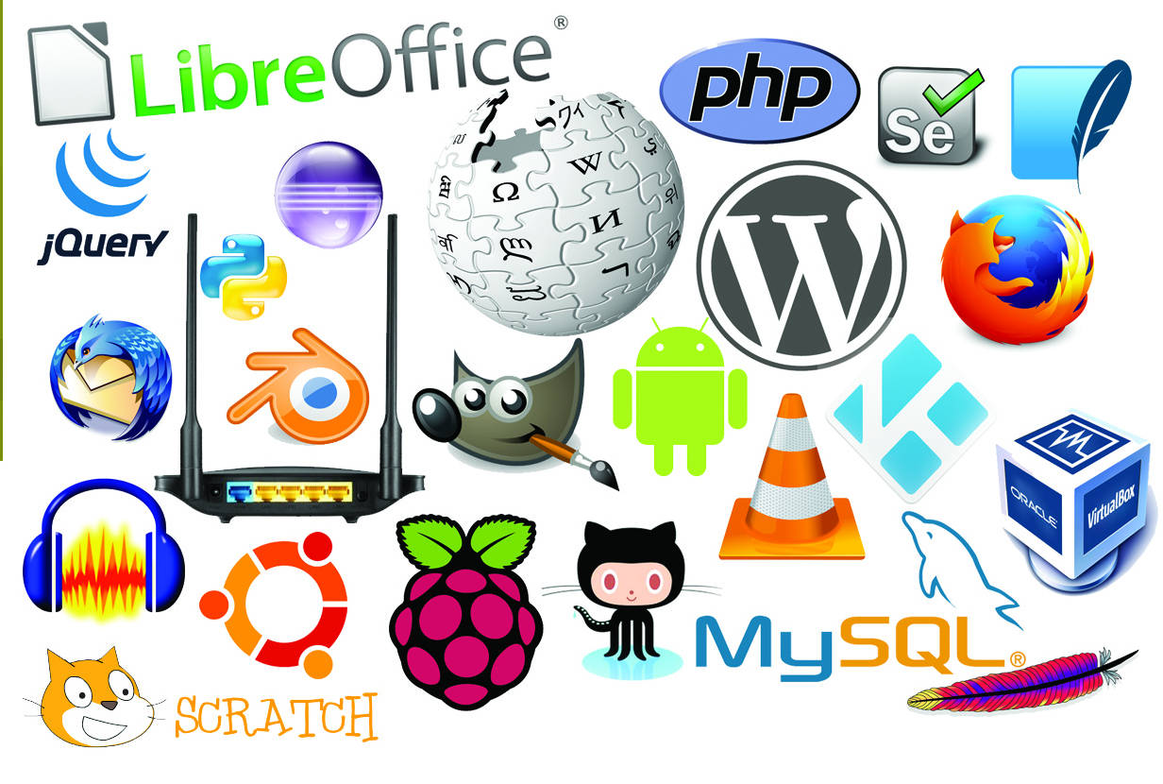

OSS vs Research software

OSS
- To be reused
- Repositories
- Simple to contribute

Research
- Single use (many claim so!)
- Some link on a paper
- Contribute back?

GitHub: open source software more open!
RSD engineering course material.

Metrics in …

Open source
- Downloads (but GH doesn’t give you the number).
- Forks
- Stars
- Contributors

Research software
- Papers and citations
- Publish software as such (Zenodo/Figshare) and Citation File Format.

OER

Impact

Downloads
- self-study (1 download = 1 person)
- delivery (1 download > 30 people)
- bots (1 download = 0 people)

Contributors
Make it easy for people to contribute (and get recognition).
- No PDF
- Share sources! not only final product. E.g., videos.

Remix
Make it easy for people to remix and let the source know!
- mix material
- produce translations

Value added to your programme! Network size! adds value! More users => How? make it accessible to others to modify. PDF? No! Help them to get to that level!

How?
- Create a new “social” network to include these requirements
- reuse what exists and provide mechanisms to help creators to use it.
  - GitHub, gitlab, bitbucket
  - Wikiversity, wikibooks
  - Open Science Framework
  - clara.io (3d models, e.g. jupiter)

