An exploration of the Application of Urban Agroecology in the Context of Sustainable Urban Development in Shanghai and Lima

Tong Chen
The Bartlett Development Planning Unit_University College London

Word count: 10245
Supervisor: Dr. Azadeh Mashayekhi

A dissertation submitted in partial fulfillment of the requirements for
MSc Building and Urban Design in Development
Declaration of Ownership Form
DECLARATION OF OWNERSHIP AND COPYRIGHT FORM
- DECLARATION OF COPYRIGHT
I confirm that I have read and understood the guidelines on plagiarism produced by DPU and UCL, that I understand the meaning of plagiarism as defined in those guidelines, and that I may be penalised for submitting work that has been plagiarised.

Unless not technically possible and with the prior agreement of the Programme Leader for my MSc programme, the dissertation report must be submitted electronically through TurnitinUK®. I understand that the dissertation cannot be assessed unless both a hard copy and an electronic version of the work are submitted by the deadline stipulated.

I declare that all material is entirely my own work except where explicitly, clearly and individually indicated and that all sources used in its preparation and all quotations are clearly cited using a recognised system for referencing and citation.

Should this statement prove to be untrue, I recognise the right of the Board of Examiners to recommend disciplinary action in line with UCL's regulations.
- COPYRIGHT
The copyright of the dissertation report remains with me as its author. However, I understand that a copy may be given to my funders (if requested and if appropriate), alongside limited feedback on my academic performance.

I also understand that a copy may also be deposited in the UCL E-prints public access repository and copies may be made available to future students for reference.
Please write your initials in the box if you DO NOT want this report to be made available publicly either electronically or in hard copy.

YOUR NAME: | TONG CHEN
MSC PROGRAMME: | Building and Urban Design in Development
SIGNATURE:
DATE: | 2021.09.28

Acknowledgements

This dissertation is dedicated to: Dr. Azadeh Mashayekhi, my supervisor, from whom I learned a lot but not only academically; my family, lovely Buddies of my classmates, and all those who have stood by me. Especially, many thanks to my classmates and professors in my module of Food and the City, inspiring discussion and knowledgeable tutors got me interested in the research topic for my dissertation.
Contents

Introduction
Chapter1-On urban agroecology, sustainable development and chosen two cities-Literature review
1.1 Agroecology in cities
1.2 Sustainable urban development from an agroecology perspective
1.3 Road of Ecological urbanization in Shanghai, China
1.4 Urban agroecology in Lima in relation to food system
Chapter 2-Methodology and Theoretical framework
2.1 Research Methodology
2.2 Analytical approach
Chapter 3-Cases study--City Analysis of Shanghai and Lima
3.1 Sustainable energy consumption in the construction of an agroecological city in Shanghai
3.2 The future prospect of urban agricultural ecology in Lima urban food system
Conclusion
List of Figures

Fig.1 Small-scale agriculture in Peru in 1994 and 2012
Fig.2 The Mi Huerta programme strengthened the capacity of urban farmers by transmiting knowledge
Fig.3 The mean scale results of eco-efficiency for the provincial regions in China
Fig.4 Location of the planned Dongtan eco-city project: (a) Chongming Island and (b) Dongtan
Fig.5 The radar chart of environmental eco-efficiency in the Chinese provinces from 2006 to 2015
Fig.6 Map of Lima metropolitan area
Fig.7 Performance of budgetary resources in the San Juan de Lurigancho district of Lima in 2011-2015
Fig.8 Lima's self-built settlements during its informal urbanisation
Abstract

With the exploration of the value and sustainability of developing Urban Agroecology for application to urban development processes, the central question that will be extended and studied in this dissertation is, therefore, how can Urban Agroecology offer new possibilities for sustainable urban development? This can be deeply meaningful for agricultural civilisation contexted cities' problems solving and future development.

Shanghai and Lima are case cities analysed, have been through and are now experiencing some exciting urban eco-building projects. They are urbanising at a fast pace with the global trend; both face complex urban development challenges while still needing further to consider potential and possibilities for further sustainable development and find the right questions during the application of Urban Agroecology. Urban space will be given a new functional definition in the future. The theoretical areas on which this dissertation will focus are the value of developing Urban Agroecology and approaching it sustainably.

Key words: Urban Agroecology, Sustainable urban development, Shanghai, Lima
Introduction

The theory of agroecology can be found in the scientific literature from the 1920s onwards, in the practice of family farming, in grassroots social movements for sustainability and in public policies around the world (FAO, 2018). Furthermore, despite its development in rural systems, agroecology has developed to integrate the management and interdisciplinary research of urban agroecosystems (Egerer and Cohen, 2020). In academic terms, Urban Agroecology, in which we can observe more diverse practices, is not yet a fully developed and institutionalised concept, , but as the concept of sustainable development becomes more widely accepted, more and more countries, cities and communities are beginning to focus on agroecology at different levels. Specifically, the focus of agroecology appears to be more on the city, whose concept is still evolving and does not have a fixed paradigm, depending on the context and practice environment. However, based on existing practice and projects, it is clear that agroecology is very much a practice in urban development and, similar to the agroecology that was majorly based on rural production experience, Urban Agroecology needs innovation and knowledge from diversified social groups and urban dwellers. One important way in which agroecology can contribute to farmers’ innovative practices is through mutual learning and exchangeat a grassroots level, involve more people in the process of building sustainable cities (FAO, 2018).

In 2008, the world’s urban population overtook is rural population for the first time, ushering in the ‘urban millennium’ (UN, 2021). In light of projections that more than two-thirds of the world’s population will live in cities by 2050 (Chandran, 2020), agricultural production patterns, which had been predominantly rural, are changing, with theories and practices such as urban agriculture and urban ecology emerging in people’s social consciousness(Loker and Francis, 2020). Agricultural production that takes place in urban spaces is expected to be the new mode of production, generating innovative forms of social participation, with data suggesting that existing urban agriculture can already produce 10% of global pulses and vegetables (Clinton et al., 2018). In addition to their existing functions as cultural sites of primary economic activity, cities will also become more productive spaces in terms of sustainable development through more innovative means. With UN data indicating that urban areas account for 70% of global GDP (UN, 2021), the world’s productive landscape is changing its focus to find sustainable urban spaces for agricultural production in a way that is becoming particularly important. With the support of relevant technologies and the greater exploration of urban needs, as well as the development of more mature theories of Urban Agroecology, urban space will be given a new functional definition in the future.

According to a recent UN report in which the UN predicts the presence of more megacities in developing regions in the future (UN, 2018), those cities and countries with a rapid pace of urbanisation and low overall urban income levels will need higher levels of urban management systems and innovations in dynamic, revitalising urban sustainability. The two examples that are the focus of this dissertation, namely Shanghai, China, which is urbanising at a very fast pace (and is already an internationalised megacity) and Lima, Peru, which is very dependent on exporting agricultural products and has a low income level in the developing country cohort (Alvarado et al., 2017a), both face complex challenges in planning for their sustainable future.

Urban-based sustainability issues and ecological transformations have received much attention in recent years, and there have been many valuable directions of discussion to address the process of sustainable urban development; for example, through the construction of sustainable urban eco-energy landscapes (Broto, 2017), the transformation of urban food systems (Gliessman, 2017) and the nutritional structure of low-income groups living in cities (Alvarado et al., 2017a). These trends, which unite different academic fields of interest, have helped the theory of Urban Agroecology, as a nascent and evolving concept, to become more mature and transformative. In contrast to the unsustainable modern industrial agriculture of the past, agroecology has a stronger and more sustainable impetus in the social, economic and political spheres (Gliessman, 2013), and this has led to the future of sustainable urban development being seen as a process of integration and systematisation across fields.

Since early 2020, the global pace of urban life has been affected by the Covid-19 pandemic, and the limitations of existing urban living spaces have become apparent to many urban dwelling communities. As the fragility of urban food systems has led more people to think about sustainable changes to food systems (Gliessman, 2020), Urban Agroecology is beginning to take on a social and cultural role beyond food provision in meeting the needs of a wider range of people, guiding the optimisation of urban development as a whole (Loker and Francis, 2020). Unlike the approach taken in the past, when urban transitions were simply thought about in terms of rural-urban links (Tornaghi and Dehaene, 2020), this dissertation explores the value and sustainability of developing Urban Agroecology for application to urban development processes. The central question that will be explored and studied in this dissertation is therefore: How can Urban Agroecology offer new possibilities for sustainable urban development?

One limitation of this dissertation is that, although the selection of the case studies is mainly based on global urban development, Lima and Shanghai were chosen as two representative cases in terms of urban sustainability processes and urban agro-ecological conditions. However, due to the author’s unfamiliarity with the Spanish language, much of the information obtained about Lima is based on secondary translations and the research literature of existing scholars, and this language barrier may have prevented this study from ensuring the timeliness and accuracy of direct access to the literature on the current urban situation in Lima. Even so, some excellent reports and related activities English Speaking researchers, institutions are providing suitable research materials, which made up some lack of original Spanish literature. In contrast, in the case of Shanghai, the author’s native Chinese language skills and real-life situation in Shanghai means that this case has been relatively better documented, especially in terms of capturing new developments and policy-related sources’. While this has led to a certain degree of imbalance in the value of the information available in each of the cases selected for comparison, it does not mean that the study is not of research value, insofar as the theory of Urban Agroecology is still in a process of development and refinement, whose conceptual definitions have not even been discussed in detail until recently. In addition, there is considerable scope for future research on the application of Urban Agroecology to urban sustainable development, in which context this case study makes a useful contribution to the rethinking of urban sustainable development in the face of the Covid pandemic and to filling theoretical gaps in research.

The value of developing Urban Agroecology and how to approach it in a sustainable way are the theoretical areas on which this dissertation will focus. What follows is analysis and discussion of a limited number of practical cases and related theoretical systems. The study cities chosen for this dissertation, Shanghai and Lima, both have a deep agricultural history and culture (Yu et al., 2009, Alain, 2018), in which the profound influence of agricultural culture can be seen in existing urban development policies, pointing to the value and significance of Urban Agroecology. At the same time, the application of theories of Urban Agroecology to Shanghai and Lima is guided by policies and grassroots needs for sustainable development, via a variety of positive and meaningful attempts to show strong trends in the research directions that are the focus of this dissertation .

Chapter 1. On Urban Agroecology and Sustainable Development in Shanghai and Lima: A Literature Review

1.1 Agroecology in cities

Although the principles of agroecology were originally derived from the accumulation of knowledge and innovative practices in agricultural production, mainly in rural areas (Tornaghi and Dehaene, 2020), the current changes in agricultural production are in the midst of a trend of joint urban and rural development (Gao, 2018). Today, urban food production systems including home gardens, community gardens, market farms, and market farms, community gardens, market farms and urban orchards compose contemporary urban agricultural systems (Egerer and Cohen, 2020).

According to the Food and Agriculture Organization of the United Nations, the important value of agroecology in today’s quest for sustainable urban development is based on the application and practice of agroecology concepts and principles to promote better interactions between plants, animals, people and the environment (FAO, 2021) in a way that connects people with other players in the ecosystem. Whereas Urban Agroecology confines the main space of behavioural activities to the city in which the main actors are human beings, the practices connected to Agroecology in cities unite human communities in a sustainable development environment where people exercise the greatest subjectivity of different stakeholders and disciplinary fields. At the same time, this requires that the contribution of wisdom and knowledge accumulated by different groups or individual experiences is used to develop the future of cities in a very cohesive way.
Agroecology can help enhance the productive potential of UA by providing key principles for the design of diversified, productive, and resilient urban farms.(Altieri and Nicholls, 2018)

In contrast to Urban Agriculture, Urban Agroecology seems to be attracting the attention of scholars and urban practitioners with a more sustainable development objective than Urban Agriculture, in which context some scholars have begun to explore the urbanisation transformation of agroecology based on the local agri-food system and have proposed innovative ways of up-scaling and out-scaling the development of agroecology practices (López-García and Molina, 2020). In addition, due to the distinctive nature of agroecology's evolving interdisciplinary and cross-disciplinary basis (Astier et al., 2017), when academics focus on agroecology as a movement with a socially transformative nature in urban spaces (Gliessman, 2016), the plurality of relevant fields of engagement leading to the creation of value in unique cross-disciplinary collaborations has also been the focus of mainstream research directions (Gliessman, 2021).

Urban Agroecology also presents the potential for different entry points in terms of sustainability, and from Friedmann’s perspective on the complexity of large Asian cities (Friedmann, 2005), Urban Agroecology appears to be a way to help large cities maintain their own health in the face of complex internal problems, in which context cities are confronted with dynamic urbanization processes, continued suburbanization, land enclosures, farmer displacement and food-knowledge loss driven by specific lifestyles, consumption patterns and values . In the face of these factors (Tornaghi and Dehaene, 2020), sustainable urban development draws on the theory of Urban Agroecology as a useful direction for ‘urban healing’(Fehr and Capolongo, 2016) . Gliessman's theoretical and practical research takes a more holistic approach, in the hope that Urban Agroecology will lead to changes in urban food systems and in the overall management of cities.

In terms of specific urban development, some cities known to have the potential to develop further urban agriculture, such as Shanghai and Beijing in China, have been shown to provide 76% and 85% of domestic vegetable production, respectively (Altieri and Nicholls, 2018), with urban agriculture in Shanghai also including 100% of China’s milk, 90% of her eggs and 50% of her pork and poultry (Van Veenhuizen and Danso, 2007, De Bon et al., 2010), which shows us potential Urban Agroecology practicers can largely impact the whole Shanghai urban life. In cities such as Havana, Cuba, where urban agriculture has reached a significant scale of production, urban agriculture and peri-urban agriculture produce about 50% of the city’s fresh food, covering about 56,000 ha (Aguilar, 2017), which indicated the importance role of urban agriculture and its potentials for applying agroecology to achive sustainable urban development.

Even before the Covid pandemic influenced us to think more about urban sustainability, agroecology was already very much concerned with sustainability and food production, linking them as ‘social, economic and political drivers’ (Gliessman, 2013). The Green Revolution of the 1960s was criticised as a system that was strongly commercially oriented and input-based (Wezel and Peeters, 2014), which also made people begin to rethink how to build agroecosystems sustainably (Egerer and Cohen, 2020). Following the ‘Green Revolution’, some of the so-called technological ‘silver bullets’(Gliessman, 2009) have quietly begun to repeat the same mistakes: single solutions that obscure the essential need to help farmers and protect the environment, and even focus, as before, on increasing yields, without taking into account the imbalances and injustices that continue to plague the government agricultural sector. This also requires us to be very clear-headed in order to carefully re-expand our definition of sustainability beyond revenue and profit (Gliessman, 2009). As urban sustainability has matured around the world, a more widely accepted academic perspective has emerged: a more systemic and holistic view that integrates the development of agriculture-related practices with integrated social development and creates greater urban social value for human life by focusing on people rather than driving production and consumption (Gliessman, 2020). Urban Agroecology has an urgent need to steer the status quo towards a positive future for sustainable habitats, and in particular the sustainable development of urban spaces. As such, Urban Agroecology is of great importance for the construction of sustainable human environments and especially the sustainable development of urban spaces.

In all regions of the world, and especially in countries and regions with a strong agricultural culture, agroecology tends to begin with predominantly rural agricultural production and is mostly passed on by the cultivation of knowledge on the part of individual agricultural producers. The food sovereignty held by farmers has also influenced the development of the traditional knowledge accumulation aspects of agroecology. It would be a big difference when urban famers were given more rights to make a living by Urban Agroecology. However, the spread of more productive industrial agriculture has had an impact on traditional agroecological practices, and it is hoped that, based on the accumulation of traditional agroecological knowledge from the past, the potential of agroecology can be explored in urban spaces while changing the overly monolithic nature of industrial agriculture in the pursuit of yield.

The shift from a rural to an urban focus in agroecology has become increasingly evident in recent years, with the realisation that, although urban areas make up 3–4% of the world's surface , they account for approximately 80% of the world's resources (Girardet, 2010) and, as such, the development of agroecology in cities will affect a large proportion of global resources and will bring about a change in the growing number of people living in cities. change. In 2021, it is also impossible to ignore the changes in urban lifestyles brought about by Covid-19, in which people have been confined to small urban spaces for longer than ever before. In this context, there is a greater demand for sustainable urban environments and nutritious food, and the urgency of these demands has increased awareness of the importance of high quality accessible spaces for urban agricultural production.

In addition, and leaving aside the current impacts on cities seen in the recent past, , from an urban sustainability perspective agroecology plays a role in supporting urban agricultural productivity, as well as improving urban environmental issues, including the conservation of plant and insect biodiversity, carbon dioxide uptake and resilience to climate change (Altieri and Nicholls, 2018). This shows that Agroecology can be useful for many complex urban issues as well as for global climate solutions. Morever, based on experience and ideas accumulated during production in rural areas, the urban environment is an important place to consider promoting agroecology as a way to achieve sustainable development and food justice in the future, in order to achieve a more direct and effective positive effect on urban spaces (UN, 2018).
1.2 Sustainable urban development from an agroecology perspective

Building on the development of agroecology and urban agriculture, Urban Agroecology is also inseparable from its emergence and development in some early scholarly studies in relation to a resistance to industrial agricultural production(Egerer and Cohen, 2020), in addition to environmental justice and public health being repeatedly highlighted by scholars of agroecology (Anderson et al., 2019, Altieri and Nicholls, 2020) in their exploration of future trends, In this way, transformative Urban Agroecology has been given a more positive meaning in relation to sustainable urban ecological landscapes (Pimbert, 2017). Furthermore. Urban Agroecology is also gaining attention in terms of policy development and acceptance in urban management of the common problem of global climate change challenges (Barrios et al., 2020). At the same time, in the inexorable global process of urbanisation,new breakthroughs are being sought in the direction of ecological development.

In addition, on a global scale, reducing hunger and ensuring healthy diets has been an initial focus of research on agroecology in some regions (Anderson et al., 2019). Agroecology plays an important role in combating hunger and extreme poverty and is a means to facilitate the transition to more productive, sustainable and inclusive food systems. Raising awareness of agroecology and its advantages is an important step in helping policy makers, farmers and researchers apply this approach to building a hunger-free world. Finally, the carbon footprint of cities is not negligible on a global scale, and agroecology can play an important role in improving resilience and adaptation to climate change (FAO, 2018). In a practical sense, one popular approach is Growing Communities, which in London, after the guided training of producers, can both enable local consumers to access affordable agroecological products and support the livelihoods of agroecological producers, resulting in an emerging community-led network of urban agriculture (Nicol, 2020).

However, agroecology is a widely varying theoretical approach and system of practice, a social structure and dynamic concept collectively defined within and between communities for horizontal exchange and mutual learning among food producers. As a dynamic, changing and evolving cognitive concept for the continued co-creation and reproduction of agricultural knowledge (FAO, 2021), it is moving into a phase of more mature theoretical research. While it is known that existing and traditional agricultural activities have been largely rural in nature, the author notes some phenomena in the urban development processes of Shanghai and Lima that have generated more thought and interest in Urban Agroecology and suggests that there is a need to practice agroecology in cities and to explore its value and significance for sustainable urban development.

In the past, Chinese government planning departments have tended to intervene to a great extent in the construction and transformation of urban spaces with well-developed holistic planning schemes, influenced to some extent by the particular political context of China’s urban management model and the fact that China had a large population at the time (2006–2010) and that urban, social and economic development was accelerating together under the demographic dividend. The construction of an eco-town in Shanghai (Sze, 2015) was also a positive practical response to China's 11th Five-Year Plan for 2006–2010 to ‘build a resource-saving and environment-friendly society’ and ‘promote healthy urbanisation’ (Wen, 2005). In Lima , which does not have a very advanced level of socio-economic development compared to Shanghai, the most significant difference between the management and development of Lima compared to Shanghai concerns the need for individuals to take more initiative due to the geographical and political environment in which it is located. Unlike Chinese cities, which need to work together to achieve a national goal under a policy system, the autonomy of individual Urban Agroecology practitioners is a feature of Lima's sustainable urban development process. For Lima, as the largest population city in Peru and capital city of one of the world's most welcomed exporter of agricultural products(Dubbeling et al., 2010), the role of urban agriculture is to improve the livelihoods of local residents (Villavicencio, 2012) and to explore more sustainable approaches based thereon. This is in contrast to China, where sustainable urban development is more a matter of arriving at a model that is more suited to mitigating and alleviating the problems that arise from the process of rapid urban development.

Thus, for Shanghai,, the practical measures that the city needs to adopt for effective urban agroecology will be undertaken in two very different ways from those in Lima The role that Urban Agroecology in Shanghai can play in sustainable urban development must be based on the existing concept of urban planning as a whole from the point of view of possible conceptual deficiencies in broad planning, whereas Urban Agroecology in Lima will take the form of an innovative practice to which many individual practitioners contribute. In sum, in the case of those studies that are the focus of this dissertation, sustainable cities have a rich potential for practising different forms of the eclipse of Urban Agroecology practice. In one direction, this moves from holistic and systemic urban planning reform as the main form of urban sustainable development exploration in an urban development context such as China to a more top-down integration of Urban Agroecology into national urban development policies, which can be used to guide and influence urban dwellers. This is used to guide and influence urban dwellers and to achieve a socio-culturally sound and economically sustainable approach. The other direction is a more bottom-up and diverse movement of innovation and practice in the development of Urban Agroecology based on the specificities of the city of Lima, with a focus on the innovation and practice of individual participants in improving their livelihoods and helping more people to take ownership of their lives.

However, whether in the form of top-down, holistic reforms or bottom-up, innovative practices that continue to add dynamism to development, Urban Agroecology is becoming increasingly important in sustainable urban development and, with the accumulation of practice and the refinement of theory, continues to generate new implications for sustainable development. While for cities such as Lima, in which good food is one of its cultural characteristics (Meza-Hernández et al., 2020), Urban Agroecology is an important way of evolving food systems and improving food nutrition for local inhabitants, while in urban spaces agroecology is not only a way of providing food but also of promoting sustainable livelihoods and environmental integrity (Windfuhr and Jonsén, 2005), which in part combines consideration of the future sustainability of Urban Agroecology in the context of the need to reconcile the needs of of urban integrity and individual practitioners .

Urban Agroecology, on the other hand, is based on the development of agroecology and is therefore inevitably characterised by the need to accumulate and pass on relevant experience and knowledge. The need for more people to acquire the skills and knowledge of sustainable urban development and the obligation of the relevant authorities to help more people to acquire this knowledge has been recognised. In light of some scholars’ prediction that ‘the knowledge, expertise, social organisation and social technologies needed to sustain the economic and social role of cities are likely to be the defining features of 21st century urbanism’ (Hodson and Marvin, 2010), Urban Agroecology is a discipline that has developed through the exchange of knowledge and experience, and the accumulation of practical innovations. These disciplinary characteristics make it possible to argue that Urban Agroecology has excellent potential for sustainable development in the new era of urban construction.
In addition to the above-mentioned important role of Urban Agroecology in relation to the city as a whole, the individual and sustainability, based on the existed significant contribution of agroecology in reducing input costs and increasing incomes (Ong and Fitch, 2020), Urban Agroecology is expected more to be guided by ecologically relevant and environmentally friendly practical experiences and benefit for sustainable development and climate change solution. A healthier growth model in terms of not only yield and increased income, but also an eco-friendly urban environment, is thus being explored.
1.3 Ecological urbanisation in Shanghai, China

During the first Five-Year Plan period (2006–2010), scholars observed the potential of sustainable cities in China in terms of compactness and diversity (Qiu, 2006), and in the face of the increasing trend of globalisation at that time, domestic urban development began to learn more from the cases and practices of foreign sustainable cities. Especially in large Chinese cities, the concept of eco-city construction promoted by globalisation was increasingly embraced. Shanghai has the first modern agricultural development zone in China and, according to the seventh census of China, the population of Shanghai is 22,209,400 or 89.3% in rural areas (National Bereau of Statistics, 2021). The high proportion of urban population and the context of urban-rural integration in China's urban development makes the focus of agroecology research more valuable to cities, which is an important rationale for this dissertation’s exploration of participatory urban development through agroecology. However, Urban Agroecology has positive implications far beyond the provision of fresh and healthy food, at least in China, as it aims to provide a sustainable approach to urban development ‘as a social movement that pursues the multifunctional role of agriculture, promotes the development of social justice, and fosters identity and culture’ (Shanghai Municipal People's Government, 2021).

Urban Agroecology in Shanghai begins, with the construction of an ecological city. In 2005, Arup, the global planning, engineering and design consultancy, signed a contract with the Shanghai Industrial Investment Corporation (SIIC) to plan the world’s first sustainable eco‐cityat Dongtan in Shanghai.（Hodson and Marvin, 2010. However, this construction project waked many people, especially those who believed in everthing ecologically and sustainablely for the better future, with no sign of further progress as of 2010, and was thus described in the western media as a failed eco-city (Friedmann, 2019).

China's large cities tend to have a very rapid rate of renewal for policy-led reasons. However, for Chinese cities that need to slow down their development to address more social issues first, this is not always a good thing, and some scholars have summarised the super-complexity of many mega-cities in Asia (Friedmann, 2019) by explaining the dilemmas that cities like Shanghai can face when planning for sustainable development. Due to its special status in terms of its international influence, Shanghai has very much led the country in experimenting with new approaches to urban development, and it can be argued that the urban development process in Shanghai is expected to serve as a location for pioneering experimentation and, if successful, national implementation. This is a process that many Chinese cities are undergoing in pioneering exploration of urban development models as pilot projects for other cities to follow. The Chinese government’s operational approach to promoting these newly developed urban development theories from a few years ago is based on the ‘garden city’ model (Xu, 2009), the concept of the 15-minute walkable neighbourhood (Weng et al., 2019) which was borrowed from the successful urban development case of Singapore and the Characteristic Town Development model (Wu et al., 2016). These concepts, while representing different development purposes ( the stimulation of business, the economy and the future growth of the city) are promoted through innovation and entrepreneurship development, as well as ecological civilisation construction (Meng et al., 2021). However, each is popular and supported by policy at different stages of development in economically developed cities in China. The process of Eco-urbanism in Shanghai and its implications for Urban Agroecology are positive in the sense of being an early experiment, but there is more to be learned from later reflections on this process of practice. Shanghai is an example of a more advanced developing city that is exploring the specific technical and implementation issues associated with sustainable development. The first hypothesis in the case of Shanghai is that it represents a useful experiment in Urban Agroecology as an ecological city based on the concept of sustainable development, in that it explores the impact of certain social conditions (acceptance and support from local residents for the direction of urban development) and hardware (land, policies and funding) on sustainable urban development from an urban ecological perspective.

However, initial attempts to transform the city were immature, and there was a lack of awareness and knowledge of sustainable development among urban planners and managers. The urbanisation that resulted from this phase was characterised by the ‘hardening’ of urban roads and the industrial design of traditional buildings, which led to urban rainfalls and unsustainable consumption of large amounts of urban electricity. In recent years, Chinese urban development has begun to place greater importance on ecological civilisation, with ecologically sustainable urban development becoming the desired direction for the future transformation of more cities. The Chinese government has indicated that it attaches great importance to the need for ‘low carbon living’ in sustainable cities and has introduced ‘carbon neutral’ and ‘carbon peaking’ planning elements while the Shanghai government is also actively working to control and reduce carbon emissions by focusing on the ecological benefits of doing so. Shanghai's 14th Five-Year Plan refers to the expansion of ecological space and the improvement of ecological quality, whose document clearly states that it is hoped that a more complete modern environmental governance system will be formed as soon as possible for the promotion of healthy living with low-carbon production (Zhang et al., 2011). The concept of eco-city ecological construction, such as in the ‘sponge city’, is gradually gaining more attention in China’s guiding policy documents related to urban planning (Yu, 2017)). Influenced by global urban development, the benefits of eco-city construction have begun to attract Chinese cities to make useful attempts. Some technological innovations in urban architecture have also begun to flourish under the influence of the wider policy environment, such as the introduction of new office buildings that combine artificial intelligence and urban agriculture, and the practice of combining eco-building with the construction of eco-integrated communities in vertical industries in those developed Chinese cities where Internet-based industry is growing rapidly (Zhang, 2020). Thus, Chinese cities are being encouraged to develop policies related to eco-sustainable construction, and the use of eco-city construction for sustainable urban development is being widely recognised and actively practised, both by Chinese city planning managers and by Internet companies and technology firms.

1.4 Urban Agroecology in Lima in relation to the food system

One recurrent question in urban food systems planning is whether or not there is a better entry point to generate a sustainable process and high-quality food planning results. (Cabannes and Marocchino, 2018)

In the case of Shanghai, the initial construction of an eco-city with ambitious but unsustainable energy consumption has shown the downside of the impact of globalisation. In the case of Lima, however, due to its favourable geographical position for the production of agricultural products and its dependence on agricultural farming, globalisation has forced many local producers of food ingredients to grow specific export produce to meet the global demand for food. For a short time, this has had the effect of revitalising the economy and reaping some of the benefits, but this trend towards industrial agriculture has had a negative impact on the rich biodiversity of Lima and Peru, as well as on the nutritional levels of the local population and even on employment. The lack of trust in the political governance of the Peruvian state, coupled with the fact that agriculture in Lima is dominated by the production of small-scale individual farmers, makes the process of sustainable urban development in Lima seem to be more dependent on the efforts of small individuals or communities.

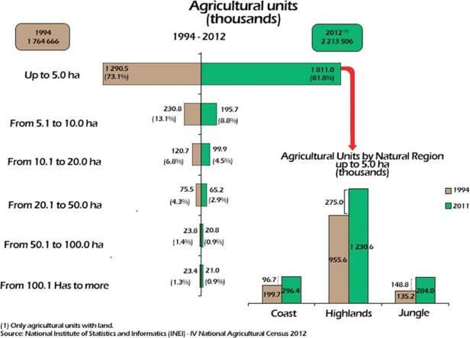
Fig.1 Small-scale agriculture in Peru in 1994 and 2012 (Alvarado et al., 2017b)

The predominance of small-scale, self-employed farmers is one of the basic realities on which the development of Urban Agroecology in Lima needs to be based (Fig1). In this context, the Peruvian agroecological movement has been making progress over the last few decades while actively exploring regional fairs, rural tourism and local brands, and highlighting many traditional foods to develop short-haul distribution channels (Alvarado et al., 2017b). What makes this so different from Chinese cities, with its quite different city management traditions, is how Urban Agroecology in Lima tends to present a personal creation, with the intention of fighting for local people and communities' empowerment. Emphasis on intra-city agro-production is here geared more towards self-consumption than sales (Santandreu, 2018).

In order to address the issue of food nutrition in poor areas, and with the expectation that this would solve the problem of securing stable livelihoods for most urban agricultural producers, the regional government of Villa Maria del Triunfo (VMT) in western Lima took the lead in promoting urban agriculture institutionally (Santandreu, 2018). This is a milestone for Urban Agroecology in the food system, in which context, although the political system in Lima has prevented such a policy from being sustainable in the long term, it is at least the case that more cities are seeing that the food system can evolve and make a real difference to the lives of local people through Urban Agroecology in a sustainable way.

In Latin American cities such as Lima, where agriculture accounts for a large share of economic benefits, Urban Agroecology has been the theoretical underpinning of policies related to urban development for some time (Altieri and Toledo, 2011). Whether or not the practical aspects of its implementation have been highly desirable, this has shown that Urban Agroecology has attracted sufficient attention from urban management and construction. Lima is a city located in the desert, with very limited green space per capita, and the environmental problems it faces are of great importance. In the earlier urban history, among other things, the urbanisation process was artificially accelerated by a historical armed conflict, which also seriously affected the traditional agricultural production areas around the city. Immediately afterwards, the growing demand for middle-class housing at a later stage triggered a further urbanisation conflict (Santandreu, 2018), which, together with the fact that Lima is the most populous city in Peru, the 'informal urbanisation' of the urban periphery (hillside areas) of Lima (Allen et al., 2018) and the artificial exposure of people living in poor areas to natural disasters, means that Lima faces many complexities in terms of sustainable urban development.
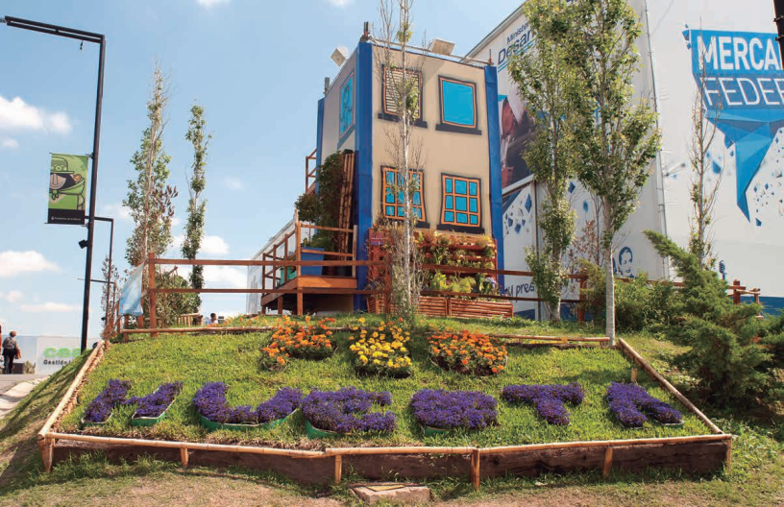
Fig.2 The Mi Huerta programme strengthened the capacity of urban farmers by transmiting knowledge. (Schonwald and Pescio, 2015)

Peru is also a country in which individual small farmers are a key industrial component, while the promotion of the practice of agroecology has provided opportunities for many producers of traditional agricultural products. With advocacy and encouragement from the government, international organisations and relevant academic groups, agroecology is already improving the livelihoods of farmers in the region and the nutritional structure of local diets, as well as reducing poverty among those on low incomes. In shifting the focus of its interventions to urban areas, Urban Agroecology is not just about preserving traditional crops but is also expected to bring together local communities by sharing local knowledge and promoting local cuisine . The Mi Huerta (Fig.2) project (Schonwald and Pescio, 2015), which was set up through local trainers who taught relevant agricultural knowledge, is a good example of Urban Agroecology in practice (although the project is not explicitly Urban Agroecology in practice but more linked to urban agriculture and sustainable urban development). The benefits of a good urban sustainability orientation can be seen through the urban activities of such projects that encourage the participation and innovative practices of local inhabitants and strengthen the ecological capacity of urban farmers. However, a major problem for the city of Lima is how to gain the trust of the local population and to lead them into active action and participation during the different terms of government. Changes in the administration have also shown that the legal framework (and even the specific budget) does not guarantee continuity in public policy (Schonwald and Pescio, 2015).

Because of the brutal control of food sovereignty by capital, which prevents farmers from making their own choices about how to grow and what to produce, in Lima, a common feature of agroecology-related project activities involve saying 'no' to the involvement of large companies. Many innovative participatory practices have resulted in good training for local people and access to resources from government and related institutions. These fruitful projects not only represent an improvement in the quality of local agricultural production and a change in the lives of the inhabitants, but more importantly, these positive attempts to make the city and its communities function and be governed more healthily can also contribute to sustainable urban development in the long term. In this context, the agroecological movement in Peru will have to make farmer empowerment and the development of policies to support organic agriculture its next priority (Alvarado et al., 2017b).

In addition to the practice of Urban Agroecology in Lima, many organisations and institutions have seen the value and potential of developing Urban Agroecology in Lima. For example, DEAS and CLADES championed the Fast Rural Diagnostic (DDR) and Agroecological Design Plot methodologies from the 1990s onwards. ANPE-Perú has been politically active in the agroecological movement, particularly in the conservation of biodiversity and in the AGROECO project in Peru, which has contributed to the Agroecological Alliance for the conservation of production sites around the city of Lima (Alvarado et al., 2017a).

Chapter 2. Methodology and Theoretical Framework

2.1 Research methodology

In this dissertation, two cities, Lima and Shanghai, are selected for a case comparison regarding the background to the development of Urban Agroecology and the different directions of the demand for ecological agriculture according to differing urban conditions. . It further explores the ways to achieve sustainable urban development through the development of Urban Agroecology in each of these two cities, in addition to the role Urban Agroecology plays in the urban ecosystems of both cities, how to ensure their effectiveness in practice and the possible challenges of sustainable urban development in the future.

As developing countries in the southern hemisphere (and at very different stages from one another), Peru and China are both facing the challenge of sustainable urban development. In this domain, Shanghai and Lima have their own focus based on their different contexts, meaning that a study from the perspective of Urban Agroecology is very useful to enrich the practical examples and theoretical applications in this field. This dissertation takes a comparative approach, comparing the development and practice of Urban Agroecology in Shanghai and Lima, and analysing the current situation and processes of sustainable urban development in both cities.

The reason for choosing a comparative analysis approach as the research method for this dissertation is that the theories related to Urban Agroecology that form part of its focus are very much attuned to the specificity of each geographical and social context. In the case of Shanghai, a megacity under the influence of very strong urban planning-related policies, the problems encountered in the early stages of the construction of an ecological city are the same that many megacities around the world which have an important economic and cultural role and are ambitious for future urban development are facing or will soon face. The question thus arises as to how sustainable energy consumption in cities can be adequately considered within the context of Urban Agroecology. In the case of Lima, where the government is not able to implement sustainable urban development policies on a permanent basis, how can a sustainable urban food system be upgraded and improved through the practice of Urban Agroecology, with the participation and influence of international organisations and institutions?

This study takes a different perspective on the positioning of Urban Agroecology in the two cities in focus, based on their different contexts of sustainable urban development. The following analysis will locate the position of Urban Agroecology in Shanghai, which has led other major cities in China in the process of advocating sustainable development by building eco-cities, based on the focus on Eco-urbanism and the practice of actual cases in Shanghai in the last decade. Secondly, it will analyse the creative value that can be derived from Urban Agroecology in the construction of an eco-city in a policy-driven, economically developed city. As a major global exporter of agricultural products, Lima has developed practices and policies related to agroecology in the city, but from the sustainability perspective of Urban Agroecology, the local food system in Lima is not well developed and even has a food sovereignty crisis. This has led to a focus of Urban Agroecology in Lima on the sustainable development of the food system, which is currently a major focus of development or practice in Urban Agroecology-related disciplines.

2.2 Analytical approach
Based on the core theories in the research questions of Urban Agroecology and sustainable urban development, different analyses are conducted for the two cases of Shanghai and Lima. The expectation is that more valuable forms of sustainable urban development through the concept of Urban Agroecology can be drawn from the results of successful or unsuccessful urban agroecological practices in the two cities, starting from the current state of urban development in the two cities. However, each is popular and supported by policy at different stages of development in economically developed cities in China.

At the same time, urban Agroecology is a relatively new concept of urban construction for a Chinese city like Shanghai, as a way to solve complex problems in urbanisation. Based on the context of urban development in China, the author actively and practically explores the direction of urban development-related policies and sustainable ecological energy consumption in urban construction. For Lima, a city where food export and food cultivation are very important sources of economic and social benefits, what role can Urban Agroecology play in these two different aspects, and how can it influence individual Urban Agroecology practitioners as urban subjects to upgrade the local urban food system in the absence of the stable and sustainable implementation of an active and effective policy? The role of urban ecology in helping to improve the livelihoods of the poorer inhabitants and the health and safety of the places they live is also discussed in the context of sustainable urban development.

The study of Shanghai is based on the lessons learned from the construction of the ‘Dongtan’ eco-city, which was expected to be completed in 2010, and analyses the shortcomings of sustainable urban development in the context of China’s urban development policies. More importantly, the Dongtan project was an urban ecological project that was found to have failed in its over-idealistic design that ignored some of the realities of the actual implementation of the project, to the extent that it is now unable to achieve sustainable energy consumption. It can be seen that the case of the 'East Beach' in Shanghai, China, is an experiment in urban ecology with a severe imbalance between what is given and what is received in a short period.

The analysis related to Urban Agroecology in Lima will look at the shortcomings of urban management and the rights of the practitioners involved, seeing multiple actors making changes and helping in the local dissemination of agricultural knowledge and practices in Lima, but more importantly, for each and every urban individual in Lima, even if poor and unjustly treated in terms of food nutrition, also uniting and coalescing as much as possible as individuals and communities in the practice and development of Urban Agroecology, in such a way that urban citizens can be encouraged to actively innovate and strive for more autonomy in a more sustainable approach to urban development.
Chapter 3. Cases Studies:City Analyses of Shanghai and Lima

3.1 Urban sustainable development in Shanghai from an Agroecological perspective

As China's economic, financial, trade and shipping centre, and second most populous city (National Bereau of Statistics, 2021), Shanghai is exploring and innovating for more sustainable urban development, especially modern urban agriculture with its sustainable urban development components , in the face of the social problems facing large cities. Although it is only in recent years that the application and promotion of Urban Agroecology in urban construction has received more discussion and attention, the urban construction projects in Shanghai in their early years can be seen as the first bold attempts of Urban Agroecology.Although there are some negative cases, it is better to know what needs to keep in mind when practising Urban Agroecology in Asian megacities, from which lessons have to be learned.

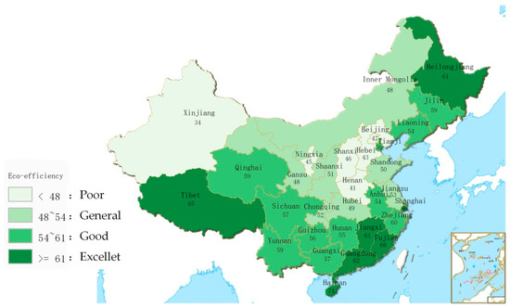
Fig.3 The mean scale results of eco-efficiency for the provincial regions in China (Liang et al., 2018)

According to data from the World Bank, China’s annual economic loss due to environmental pollution is about 10% of its GDP (Liang et al., 2018), and Chinese cities are responsible for a large share of environmental pollution and having a significant negative impact on social stability and human health (Meng et al., 2021). In recent years, China has reached a stage of urban development where urbanisation has become more serious, placing greater demands on sustainable urban ecological development planning. The eastern coastal region where Shanghai is located also has high humidity and abundant vegetation, which makes it easy for pollutants to spread.

With economic development and increased investment in the environment, however, the eco-efficiency (Fig.3) of this region showing that provinces with excellent eco-efficiency are mainly concentrated in the southeast coastal region (Liang et al., 2018). These areas are therefore beginning to explore and more actively implement the contribution that Urban Agroecology can make to sustainable urban development, as exemplified (albeit more counter-intuitively) by the Dongtan project in Shanghai.

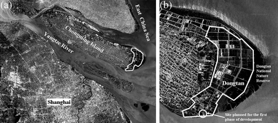
Fig.4 Location of the planned Dongtan eco-city project: (a) Chongming Island and (b) Dongtan (Cheng and Hu, 2010)

Located on the southeast coast of China, Shanghai has been boldly embracing new ideas and actively experimenting with urban ecology, and more than most of the other more inland cities in the country that need to learn from the more advanced cities under the guidance of policies. It is undergoing a fundamental change in urban planning, with the modernised city designed to be eco-friendly, following the principles of carbon neutrality and self-sufficiency (Cheng and Hu, 2010). In 2005, the Arupconsultancy, and the Shanghai Industrial Investment Corporation (SIIC) planned to work together on the Dongtan project in Shanghai with the aim of building the world's first sustainable city (Jan, 2015). The location of Dongtan (Fig.4) on an island seemed very conducive to the creation of a self-sustaining 'eco-island', which was the reseason of been given highly focus by many city builders at the time and was the subject of much international debate.

Around 2005, many Chinese urban managers believed that ecology and sustainability could make everything bette’", as if new projects were automatically glorified in people's minds when they were labelled as ‘eco-cities’ and ‘sustainable development’. The Dongtan project was approved because people at the time were overly idealistic about urban ecology and expected to gain both economic and social benefits from the eco-city's reputation as an environmentally friendly construction, while ensuring a high quality of life for local residents. However, there has been no fundamental consideration of the nature of sustainable urban eco-agriculture and what kind of effort is required to achieve the goals of such an attempt. Indeed, it is understood that the Dongtan project wasn’t mainly benefit local residents but more for the indicator of buiding the eco city and attract investment, that the original inhabitants were even forced to leave their original area without negotiation and that large energy-consuming facilities were even built to achieve economic benefits (Sze, 2015).

However, Shanghai's positive attempts are worthy of recognition, and at least the Dongtan project was an effective ‘trial and error’ project, even if the costs of trial and error were great (The planned projects in the Eco-city have been stalled and the displaced residents have been deprived of their familiar surroundings) , with the investment and the residents affected by the project’s stagnation, as well as the consumption of local sustainable energy, leaving Dongtan to function as a primitive ecological wetland for environmental protection purposes. In addition, the Dongtan project was built in full accordance with the urbanisation process, but Chongming Island, where it is located, was originally a rural area with a large proportion of agricultural cultivation.After the new urban development project, however, the measures taken for the local farmers and rural dwellers were not designed to give them a better life in the area they were living in but to passively relocate them to other centralised areas.This has been a consistent practice in the construction of new urban areas in China, and is still the case in many areas today.

The author believes that Urban Agroecology may help to change this situation in this respect. Even when new projects or areas are built in the course of urbanisation, the displaced residents should still have the right to participate in and help to implement the local development plans. In China, these newly developed urban areas are often predominantly agricultural, so how to ensure that more people can enjoy the convenience of urban living while ensuring high- quality urban agricultural production may require solutions such as community farming, which is already being successfully practised by Urban Agroecology.

There are a number of reasons why urban food is rarely included in China’s urban planning system.This is the characteristic trend towards the integration of urban and rural areas, coupled with the fact that cities are very dependent on urban food systems that are very rapidly developing in terms of urban logistics and transport. However, even so, Urban Agroecology and food planning systems are still a very interesting direction in the future. However, in addition to the strong policy influences that characterise China’s urban development, China's large cities tend to have modern urban transport systems that are well developed in the world, due to the country’s vast territory and urban population. As a result, the development of Urban Agroecology in China is limited in terms of food systems, and Chinese agricultural products can be quickly supplied from the rural areas around the cities to the city centres by virtue of fast transport and a well-developed logistics system in this respect.

There are, however, many problems of unsustainable energy consumption in China's urban development and the harmonisation of agroecological landscapes with the modern style of Chinese cities. For example, Professor Yu Kongjian's once very brave attempt to construct Vernacular Landscapes (Chen and Yu, 2013) in Chinese urban spaces has been highly questionable for some time, and the inherent perception of Chinese urban design practitioners is that urban landscapes are still modern, high- class, beautiful and very different from rural agricultural environments. This has led to Urban Agroecology being based on the idea of cultivation, which is the most common form of agriculture in China, and to a period of acceptance of Urban Agroecology as a form of landscape planting in China's major cities. However, in terms of practical benefits, Urban Agroecology in urban spaces is a highly desirable and promising direction for the integration of food production, landscape creation and the ecological philosophy of the inhabitants, if it is practised in a planted way and expands the participation of people in the sustainable development of the city.

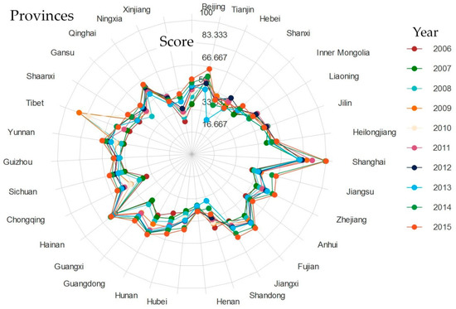

Fig.5 The radar chart of environmental eco-efficiency in the Chinese provinces from 2006 to 2015 (Liang et al., 2018)

Among the many cities in China, Shanghai’s exceptionallyoutstanding eco-efficiency from 2006-2015 (Fig5.) makes it the most suitable urban case for Urban Agroecology exploration in China. Taken together, from the perspective of a more advanced developing city, it would be valuable to explore more the specific technical and implementation issues related to sustainable development in Shanghai. What is certain, however, is that Shanghai's valuable effort in the direction of Urban Agroecology is based on the concept of sustainable urban development as an ecological city and explores the impact of certain social conditions (recognition and support from local residents for the direction of urban development) and hardware (land, policies and funding) on such development from an urban ecological perspective. This also leads to the support of the technical and hardware side of Urban Agroecology and the self-adaptability of the theory in large cities where the world's economic development is dominant.

Urban Agroecology is not currently a fixed paradigm ; however, it is characteristic of China’s urban development that those responsible for managing and planning the design of China’s cities tend to research and explore the development of a set of urban development models that can be replicated and then implemented through policy diffusion. Therefore, in an urban development context in which the Chinese government is playing a very dominant role, the learning and popularisation of new and updated urban development theories is very rapid, and the promotion and practice of a new and growing urban development theory such as Urban Agroecology is very effective, which is very conducive to the continued advancement and development of the discipline of Urban Agroecology. The theory of Urban Agroecology is evolving, but it is clear that the practical and extension aspects are still very much lacking, with many urban agroecologies still being practised by small units of urban agricultural product producers. At the same time, Chinese cities can quickly see the positive effects of Urban Agroecology due to the speed of policy implementation and diffusion. Shanghaiis one of the more promising cities to see the results of Urban Agroecology development due to its excellent hardware facilities and urban development funds and opportunities. In this sense, it is very favourable to explore and promote Urban Agroecology in China.

3.2. The future prospect of urban agricultural ecology in Lima’s urban food system

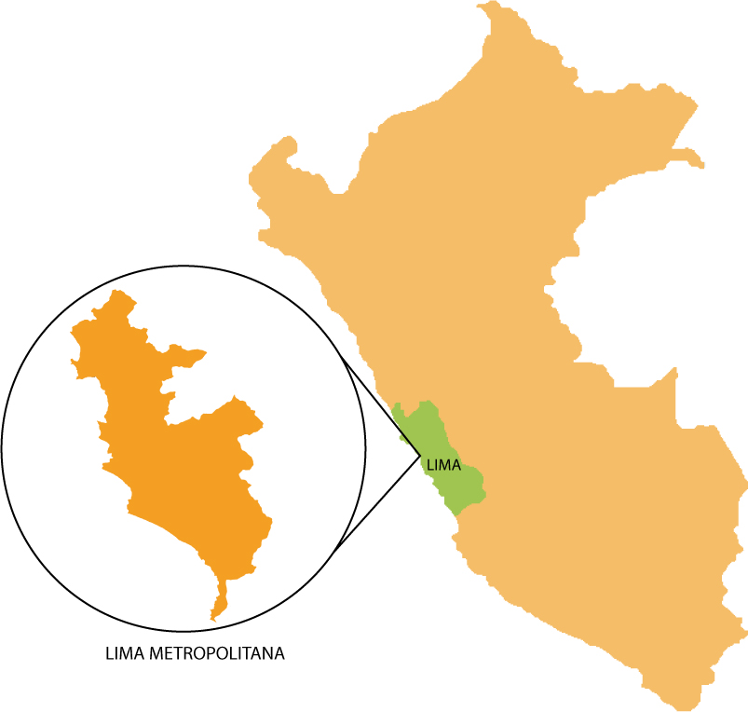
Fig.6 Map of Lima metropolitan area (Commons, 2014)
Urban Agroecology explores sustainable urban development based on the development of agroecology in the past. In this context, and similarly to Chinese cities, Peru has a strong agricultural culture. While the history of agroecology varies from country to country, with some countries well developed and others in their early infancy, it appears to be most developed in countries with deep local and traditional agricultural cultures (Gliessman, 2017). Lima’s most notable contribution to Urban Agroecology is its integration of Urban Agroecology into urban management policies, in which Mayor Susana Villaran's (2011–14) tenure included urban agriculture as part of a strategic vision that sought to establish the foundations of a new urban development model in the capital, an initiative with the primary aim of helping the livelihoods of poor agricultural producers in the city of Lima but also encouraging innovative exploratory practices in sustainable urban ecological development by individual practitioners of local urban agriculture.

Agriculture has always been an important factor in Lima’s development and, in recent years, although agricultural exports still account for a very large part of its agricultural production activities, it is said that Lima, as well as becoming more influenced by international organisations and related institutions, is beginning to pay more attention to the importance of providing more nutritious food for the local population. In Peru, studies have shown that organised agroecological farmers have commonalities with most of the major agroecological movements China is developing, such as concern about the expansion of agro-industrial food and the threat it poses to the product,a desire to preserve local food culture, and a commitment to promoting short supply chains of urban food in a way that can be met (Alvarado et al., 2017b). Despite this, in poor communities, nutritious fruits and vegetables are still consumed at very low levels. To address some of the social, economic, nutritional and environmental concerns of the poor, Lima has promoted urban agriculture with the help of various NGOs, universities and partner institutions. Urban Agroecology may be the next key step in sustainable urban development, taking into account other environmental factors.
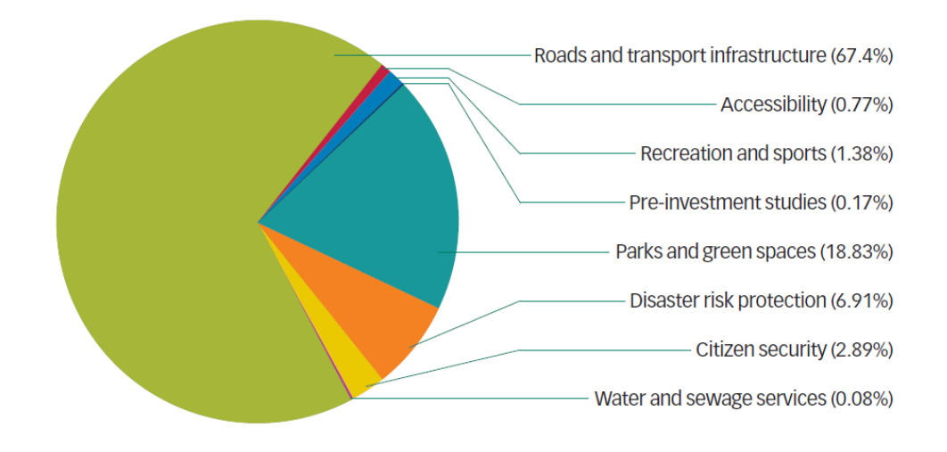
Fig.7 Performance of budgetary resources in the San Juan de Lurigancho district of Lima in 2011-2015 (Allen et al., 2018)

However, Urban Agroecology in Lima has a number of currently complex problems.The government budget for urban agriculture is not very large, especially in poorer areas（Fig.7）, and this small budget is very limited in terms of government funding. In addition, trust in the local government is not high among the population, and more urban agro-ecological practitioners prefer to choose those practices that are most beneficial for improving their livelihoods; furthermore, even if the government authorities in Lima have implemented urban agriculture policies to address the problems of poor urban communities, the sustainability of such policies is difficult to achieve during the tenure of different administrators. In Lima, the change of mayor has also meant a wholesale abandonment of almost all of the previous administration’s most representative achievements (including urban agriculture) (Santandreu, 2018), which resulted in a number of long-term goals not being able to be achieved through well-designed programmes and phased implementation. Finally, poor communities in Lima are at great risk in terms of living conditions and places to live, in addition to making a living, This was reflected by the informal urbanisation of the sloping areas around the periphery of Lima (Lambert, 2020). Some insecure sites have been known to be risky in terms of living conditions, even though occupants without a stable source of income have engaged in irregular independent construction and housing projects (Fig.8).
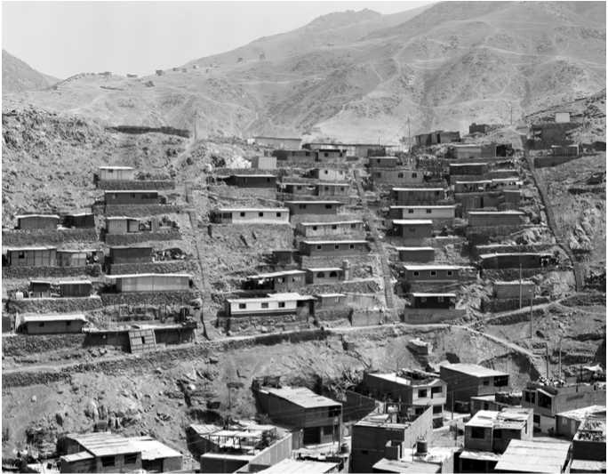
Fig.8 Lima's self-built settlements during its informal urbanisation (‘barriadas’) (Lambert, 2020)

The origins of agroecological practices in Lima were initiated by national and international cooperation agencies and NGOs and began to be accepted by the private sector by many innovative farmers who had the technical knowledge to proligerate their production. However, due to all of these difficulties, many people are now seeking solutions for sustainable development based on the current urban situation in Lima. One of the directions of practice that seems to be worth exploring is the construction of food systems under an improved urban eco-agriculture system. Urban Agroecology, with its emphasis on individual innovation, knowledge exchange and a sustainable and environmentally friendly approach to development, also engages with the autonomy of individual small-scale urban agricultural producers in Lima and the lack of knowledge and technology for sustainable agroecological farming in poor communities.

Agroecological innovations are born in situ with the participation of farmers in a horizontal (not vertical) manner, and technologies are not standardized but rather flexible and respond and adapt to each particular situation.(Altieri and Nicholls, 2017)

The integration of food systems into urban planning, as many cities are also advocating and actively practising (Cabannes and Marocchino, 2018), is one of the ways in which Urban Agroecology is being actively explored as a practice. In turn, the development and practice of Urban Agroecology, whether in the innovative farming models of small individual farmers or the design of communal community gardens, has important implications for the people of Lima, beyond individual income generation and addressing poverty, in terms of the empowerment of urban citizens and local communities.Uurban food systems should be more innovative and explored by those living in the area, within the framework of appropriate political guidance to generate a more locally appropriate operating model.

Conclusion

The widespread participation of Urban Agroecology at the global level guarantees not only the right to equal participation in the empowerment and well-being of producers of agricultural products or food ingredients in an evolving food system but also a good and healthy consumption culture for consumers and a fairer environment. Shanghai, as an international megacity, brings enormous international economic and cultural benefits to an advanced developing country but also needs to take into account the prospect of urbanisation (UN, 2018) and the enormous challenges of sustainable urban development that lie ahead. Since 2012, China has been building ecological civilization cities (Pow, 2018), which means that more urban ecological construction projects are being approved and that there is more opportunity and space for cities to develop urban ecological agriculture practices. However, after some exciting times with urban eco-building, China’s large cities need to further consider whether they are building ecologically blindly and, most importantly, whether sustainable urban development that safeguards the livelihoods of local people is a prerequisite for new projects. The changes that need to be made in Shanghai may be more in terms of urban management and related policy advances, and active academic exploration will undoubtedly lead to more comprehensive and sustainable Urban Agroecology practices being put in place sooner.

In the practice of Urban Agroecology in Lima, a better urban food system is necessary and should take into account all relevant factors, from farmers’ productive learning and individual innovation to the consumption and cooking of food at the end of the process. Lima’s urban conditions allow her to take advantage of the strengths of individuals , who also need a platform or organisation for the exchange of knowledge and experience. What is certain,. however, is that the power of such small innovative practices together is infinite, not only in helping local practitioners related to Urban Agroecology gain more food autonomy but also in giving them the opportunity to gain access to ways of improving their own living conditions and those of the city as a whole through sustainable urban construction. A further point to emphasise is that for cities like Lima, conceptualising and implementing the practice and sustainability of Urban Agroecology is a synergy that must be considered to address disaster risk reduction (Allen et al., 2018) and prevent informal urbanisation from bringing about aberrations in the social and ecological construction of the city.

References
AGUILAR, F. F. 2017. Reseña sobre el estado actual de la agroecología en Cuba. Agroecología, 12, 7–18.
ALAIN, S. 2018. Urban agriculture in Lima metropolitan area: One (short) step forward, two steps backwards – the limits of urban food planning. UCL Press, 117–133.
ALLEN, A., ZILBERT SOTO, L., WESELY, J., BELKOW, T., FERRO, V., LAMBERT, R., LANGDOWN, I. & SAMANAMÚ, A. 2018. De las agencias estatales a los ciudadanos comunes: Una mirada crítica a las inversiones en mitigación de riesgos y su impacto para interrumpir las trampas de riesgo urbano en Lima, Perú. Medio Ambiente y Urbanización, 89, 107–145.
ALTIERI, M. & NICHOLLS, C. 2018. Urban agroecology: designing biodiverse, productive and resilient city farms. Agro Sur, 46, 49–60.
ALTIERI, M. A. & NICHOLLS, C. I. 2017. Agroecology: a brief account of its origins and currents of thought in Latin America. Agroecology and Sustainable Food Systems, 41, 231–237.
ALTIERI, M. A. & NICHOLLS, C. I. 2020. Agroecology and the reconstruction of a post-COVID-19 agriculture. The Journal of Peasant Studies, 47, 881–898.
ALTIERI, M. A. & TOLEDO, V. M. 2011. The agroecological revolution in Latin America: rescuing nature, ensuring food sovereignty and empowering peasants. Journal of peasant studies, 38, 587–612.
ALVARADO, F., SIURA, S. & MANRIQUE, A. 2017a. Peru: agroecological movement history 1980–2015. Agroecology and Sustainable Food Systems, 41, 366–379.
ALVARADO, F., SIURA, S. & MANRIQUE, A. 2017b. Peru: agroecological movement history 1980–2015. Agroecology and Sustainable Food Systems, 41, 366-379.
ANDERSON, C. R., BRUIL, J., CHAPPELL, M. J., KISS, C. & PIMBERT, M. P. 2019. From transition to domains of transformation: Getting to sustainable and just food systems through agroecology. Sustainability, 11, 52–72.
ASTIER, M., ARGUETA, J. Q., OROZCO-RAMÍREZ, Q., GONZÁLEZ, M. V., MORALES, J., GERRITSEN, P. R. W., ESCALONA, M. A., ROSADO-MAY, F. J., SÁNCHEZ-ESCUDERO, J., MARTÍNEZ SALDAÑA, T., SÁNCHEZ-SÁNCHEZ, C., ARZUFFI BARRERA, R., CASTREJÓN, F., MORALES, H., SOTO, L., MARIACA, R., FERGUSON, B., ROSSET, P., RAMÍREZ, H., JARQUIN, R., GARCÍA-MOYA, F., AMBROSION MONTOYA, M. & GONZÁLEZ-ESQUIVEL, C. 2017. Back to the roots: understanding current agroecological movement, science, and practice in Mexico. Agroecology and Sustainable Food Systems, 41, 329–348.
BARRIOS, E., GEMMILL-HERREN, B., BICKSLER, A., SILIPRANDI, E., BRATHWAITE, R., MOLLER, S., BATELLO, C. & TITTONELL, P. 2020. The 10 Elements of Agroecology: enabling transitions towards sustainable agriculture and food systems through visual narratives. Ecosystems and People, 16, 230–247.
BROTO, V. C. 2017. Energy landscapes and urban trajectories towards sustainability. Energy Policy, 108, 755–764.
CABANNES, Y. & MAROCCHINO, C. 2018. Integrating food into urban planning, UCL Press.
CHANDRAN, R. 2020. Grow your own: Urban farming flourishes in coronavirus lockdowns. Thomson Reuters Foundation News. April, 23, 15–19.
CHEN, Y. & YU, K. 2013. Theory and Practice in the Study of American Vernacular Landscapes - Discovering Vernacular Landscapes Introduction. Human Geography, 28, 155–160.
CHENG, H.-F. & HU, Y.-A. 2010. Planning for sustainability in China's urban development: Status and challenges for Dongtan eco-city project. Journal of Environmental Monitoring, 12, 119–126.
CLINTON, N., STUHLMACHER, M., MILES, A., ULUDERE ARAGON, N., WAGNER, M., GEORGESCU, M., HERWIG, C. & GONG, P. 2018. A global geospatial ecosystem services estimate of urban agriculture. Earth's Future, 6, 40–60.
COMMONS, W. 2014. Map of Lima metropolitan area inside the department of Lima [Online]. Available: https://commons.wikimedia.org/wiki/File:Mapa_Provincia_Lima-Regi%C3%B3n_Lima-Per%C3%BA.jpg [Accessed 28 August, 2021].
DE BON, H., PARROT, L. & MOUSTIER, P. 2010. Sustainable urban agriculture in developing countries. A review. Agronomy for sustainable development, 30, 21–32.
DUBBELING, I. M. C. E., MERZTHAL, G. & SOTO, N. 2010. Multistakeholder policy formulation and action planning for urban agriculture in Lima, Peru. Journal of Agriculture, Food Systems, and Community Development, 1, 145–154.
EGERER, M. & COHEN, H. 2020. Urban Agroecology: Interdisciplinary Research and Future Directions, CRC Press.
FAO. 2018. The 10 elements of agroecology: Guiding the transition to sustainable food and agricultural systems [Online]. Rome, Italy: FAO. Available: chrome-extension://efaidnbmnnnibpcajpcglclefindmkaj/viewer.html?pdfurl=http%3A%2F%2Fwww.fao.org%2F3%2FI9037EN%2Fi9037en.pdf&clen=3961178 [Accessed 14 Aug, 2021].
FAO. 2021. Overview | Agroecology Knowledge Hub | Food and Agriculture Organization of the United Nations [Online]. Available: http://www.fao.org/agroecology/overview/en/ [Accessed 13 August, 2021].
FEHR, R. & CAPOLONGO, S. 2016. Healing environment and urban health. Epidemiol Prev, 40, 151–152.
FRIEDMANN, J. 2005. China's urban transition, U of Minnesota Press.
FRIEDMANN, J. 2019. Thinking about complexity and planning. International Planning Studies, 24, 13–22.
GAO, N. 2018. Study on the expansion of urban and rural construction land in urban fringe areas. Shandong University of Construction.
GIRARDET, H. 2010. Regenerative Cities, World Future Council [Online]. Available: https://www.worldfuturecouncil.org/regenerative-cities/ [Accessed 24 July, 2021].
GLIESSMAN, S. 2009. Editorial: Sustainability and “Silver Bullets”. Journal of Sustainable Agriculture, 33, 617–618.
GLIESSMAN, S. 2013. Agroecology: Growing the Roots of Resistance. Agroecology and Sustainable Food Systems, 37, 19–31.
GLIESSMAN, S. 2016. Transforming food systems with agroecology. Agroecology and Sustainable Food Systems, 40, 187–189.
GLIESSMAN, S. 2017. A brief history of agroecology in Spain and Latin America. AGROECOL SUST FOOD, 41, 229–230.
GLIESSMAN, S. 2020. Confronting Covid-19 with agroecology. Agroecology and Sustainable Food Systems, 44, 1115–1117.
GLIESSMAN, S. 2021. Coming together for food system transformation. Agroecology and Sustainable Food Systems, 45, 791–793.
HODSON, M. & MARVIN, S. 2010. Urbanism in the anthropocene: Ecological urbanism or premium ecological enclaves? City, 14, 298–313.
JAN, M. 2015. Why eco-cities fail [Online]. Available: https://chinadialogue.net/zh/2/42736/ [Accessed 1 September, 2021].
LAMBERT, R. 2020. Examinando la relación entre la planeación y la urbanización periférica en Lima. Ensayo: Revista de arquitectura, urbanismo y territorio, 1, 71–93.
LIANG, Z.-F., ZHANG, M.-L., MAO, Q.-D., YU, B.-X. & MA, B. 2018. Improvement of eco-efficiency in China: A comparison of mandatory and hybrid environmental policy instruments. International journal of environmental research and public health, 15, 1473.
LOKER, A. & FRANCIS, C. 2020. Urban food sovereignty: urgent need for agroecology and systems thinking in a post-COVID-19 future. Agroecology and Sustainable Food Systems, 44, 1118-1123.
LÓPEZ-GARCÍA, D. & MOLINA, M. G. D. 2020. Co-producing agro-food policies for urban environments: towards agroecology-oriented local Agri-food systems. Urban Agroecology, 189–208.
MENG, F.-X., GUO, J.-L., GUO, Z.-Q., LEE, J. C. K., LIU, G.-Y. & WANG, N. 2021. Urban ecological transition: The practice of ecological civilization construction in China. Science of The Total Environment, 755, 14, 26, 33.
MEZA-HERNÁNDEZ, M., VILLARREAL-ZEGARRA, D. & SAAVEDRA-GARCIA, L. 2020. Nutritional quality of food and beverages offered in supermarkets of Lima according to the Peruvian law of healthy eating. Nutrients, 12, 1508.
NATIONAL BEREAU OF STATISTICS 2021. Key facts about China's seventh national census data. National Bereau of Statistics.
NICOL, P. 2020. Pathways to Scaling Agroecology in the City Region: Scaling out, Scaling up and Scaling deep through Community-Led Trade. Sustainability, 12, 7, 8, 42.
ONG, T. W. Y. & FITCH, G. 2020. How to Study the Ecology of Food in the City: An Overview of Natural Science Methodologies. Urban Agroecology, 247–274.
PIMBERT, M. 2017. Towards a transformative urban agroecology. Urban Agriculture Magazine, 33, 15–17.
POW, C.-P. 2018. Building a harmonious society through greening: Ecological civilization and aesthetic governmentality in China. Annals of the American Association of Geographers, 108, 864–883.
QIU, B. 2006. Compactness and diversity - the core concepts of sustainable urban development in China. 城市规划, 30, 18–24.
SANTANDREU, A. 2018. One (short) step forward, two steps backwards–the limits of urban food planning. Integrating Food into Urban Planning, 117–133.
SCHONWALD, J. & PESCIO, F. 2015. Mi casa, mi huerta. Ciudad autónoma de Buenos Aires: ediciones INTA, 13–17.
SHANGHAI MUNICIPAL PEOPLE'S GOVERNMENT 2021. Outline of the 14th Five-Year Plan and the 2035 Vision for National Economic and Social Development of Shanghai. Shanghai Municipal People's Government.
SZE, J. 2015. Fantasy Islands, University of California Press.
TORNAGHI, C. & DEHAENE, M. 2020. The prefigurative power of urban political agroecology: rethinking the urbanisms of agroecological transitions for food system transformation. Agroecology and Sustainable Food Systems, 44, 594–610.
UN. 2018. 2018 Revision of World Urbanization Prospects [Online]. UN DESA. Available: https://www.un.org/development/desa/publications/2018-revision-of-world-urbanization-prospects.html [Accessed 16 July, 2021].
UN. 2021. Sustainable cities and human settlements [Online]. Department of Economic and Social Affairs, United Nations. Available: https://sdgs.un.org/topics/sustainable-cities-and-human-settlements [Accessed 8 September, 2021].
VAN VEENHUIZEN, R. & DANSO, G. 2007. Profitability and sustainability of urban and periurban agriculture, Food & Agriculture Org.
VILLAVICENCIO, L. M. 2012. Urban agriculture as a livelihood strategy in Lima, Peru. Agriculture in Urban Planning. Routledge.
WEN, J.-B. 2005. Notes on the Formulation of Proposals for the Eleventh Five-Year Plan for National Economic and Social Development.
WENG, M., DING, N., LI, J., JIN, X.-F., XIAO, H., HE, Z.-M. & SU, S.-L. 2019. The 15-minute walkable neighborhoods: Measurement, social inequalities and implications for building healthy communities in urban China. Journal of Transport & Health, 13, 259–273.
WEZEL, A. & PEETERS, A. 2014. Agroecology and herbivore farming systems–principles and practices. Options Méditerranéennes, 109, 753–768.
WINDFUHR, M. & JONSÉN, J. 2005. Food sovereignty: towards democracy in localized food systems [Online]. Warwickshire, UK: ITDG Publishing. Available: http://www.ukabc.org/foodsovpaper.htm [Accessed August 14, 2021].
WU, Y.-Z., CHEN, Q.-H. & ZHENG, X.-H. 2016. Indices system and evaluation method of characteristic town development. Planners, 32, 123–127.
XU, Z. 2009. Discussion on Building the Ecological Garden City of Man & Nature in Harmony [J]. Journal of Anhui Agricultural Sciences, 14, 22–27.
YU, J.-S., WU, Y.-Y. & LUO, Q. 2009. Urban eco-agriculture model and countermeasures for Shanghai metropolis: Urban eco-agriculture model and countermeasures for Shanghai metropolis. Chinese Journal of Eco-Agriculture, 17, 1002–1006.
YU, K.-J. 2017. On "Sponge Cities" and "Sponge Land". Architectural design management, 34, 5–6.
ZHANG, H.-Y., WANG, Q. & ZHENG, X.-B. 2011. "Opportunities, Challenges and Responses to Urban and Rural Development in the Context of the Twelfth Five-Year Plan: Tasks, Approaches and Typical Models of Integrated Urban and Rural Development. Planners, 27, 10–15.
ZHANG, Z.-Y. 2020. Research on the ecological design of buildings in the context of the concept of urban agriculture. Collection, 5, 10–15.

