Information and Literature Searching for MPhil/PhD Students

Welcome

Course description
This course focuses on the centrality of the literature review in the dissertation/thesis and aims to develop the information and digital literacy skills of students.

Learning outcomes
The course should develop your capacity to:
- adopt effective information/literature searching strategies by using a range of search interfaces to find resources through library catalogues, indexing and abstracting services, web portals and general internet search engines;
- discover and evaluate critically a wide range of literature, in all formats, that are relevant for your research;
- use emerging technologies relevant to the research process, including reference management software to help you organise and manage the referencing and citing process and;
- evaluate opportunities for the use of the social web in order to establish your digital presence as a researcher;

You will learn how to construct searches and develop search strategies in order to find and access relevant information resources in all formats. You will be introduced to new technologies that allow you to organise and manage your references and to critically evaluate this information. You will be encouraged to consider primary sources and to familiarise yourself with resources in other libraries. Additionally, you will use new technologies to organise and manage your research findings, and to keep current. The appropriate use of social media and the use of emerging technologies will also be covered.

The IOE Library's 'Information and Literature Searching Course' for PG Students

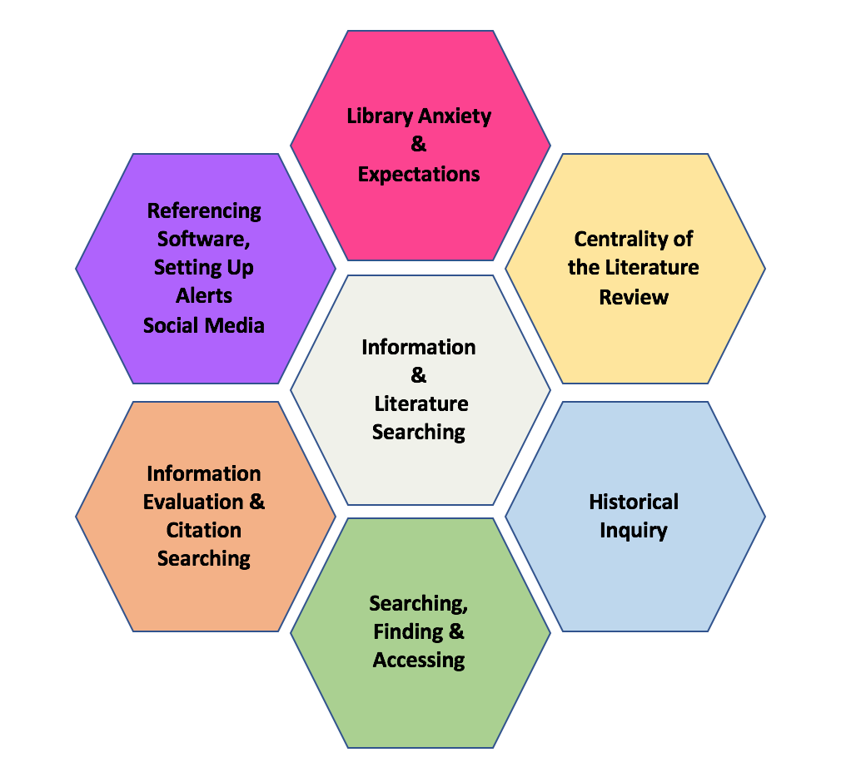

Researchers of Tomorrow: a longitudinal study of the information-seeking behaviours of PhD students

The learning outcomes for the Information and Literature searching course are underpinned by the findings from the three-year Researchers of Tomorrow (2012) study conducted by the British Library (with JISC). The study involved 17,000 doctoral students from 70 universities at various stages of their PhDs. The study found that:

- Doctoral students are increasingly reliant on secondary research resources (e.g. journal articles, books), moving away from primary materials (eg primary archival material and large datasets).
- Access to relevant resources is a major constraint for doctoral students’ progress. Authentication access and licence limitations to subscription-based resources, such as e-journals, are particularly problematic.
- Open access and copyright appear to be a source of confusion for Generation Y doctoral students, rather than encouraging innovation and collaborative research.
- This generation of doctoral students operate in an environment where their research behaviour does not use the full potential of innovative technology.
- Doctoral students are insufficiently trained or informed to be able to fully embrace the latest opportunities in the digital information environment.

The findings raise important questions about researcher development and the training provided in research intensive organisations. The Information and Literature searching course addresses these questions.

Testimonies from past students
The feedback on the course has thus far been positive. Video feedback is available here. Some comments received include the following:

Summer 2018 Online Course
- "The focuses of this module were exactly the skills and knowledge that I need to research and write my PhD thesis and to succeed professionally. My only criticism is that this course is not the first course students study when they begin their PhD. It should be. Teachers running the research methods, and approaches to educational research modules could learn how to better run an online course from Nazlin."
- "This is a very useful course for students and one of the best in the courses I have taken at UCL. Hats off to Nazlin for a superb job. As an online student, I benefited from taking this course and endorse other students in saying that we need more of this in our roster of courses."
- "This module has help me to create a frame to organise my work. The basis created to develop a strong lit review is there and probably it will grow stronger as I start applying all the knowledge acquired."

Autumn 2017 Face-to-Face Course
- "This is a well-structured course."
- "The strong focus on literature search using a scholarly approach was a great strength."
- "The course exceeded my expectations. So many areas were covered and this has given me a good platform to start my PhD journey. Thank you."
- "This module is very useful and especially as one is starting with a PhD."

