Teaching Practice in Higher Education

Home

Useful Links for T&L at UCL
- Arena
- Arena Centre for Research Based Education
- News
- Events
- Guides & Case studies
- Connected Curriculum
- Strategy &Priorities
- Awards & Funding
- Student Surveys
- Technology
- Support
- Vice-Provost (Education & Student Affairs)
- Digital Education
- Library Services
- Museums & Collections
- Academic Services
- Life Learning

Quick Links
- UCL Explore
- Databases
- DERA
- eJournals
- Moodle

About this guide
This guide on teaching practice in higher education points to resources on good practice in teaching and learning in higher education. It is to be used in conjunction with the training provided by the UCL Arena Centre for Research-based Education (Arena Centre)) and by the sessions put out by Arena.

If there are aspects of teaching and learning that are not covered in this guide, please let us know by sending a message to ioe.information-literacy@ucl.ac.uk. The full collection is found here: https://open-education-repository.ucl.ac.uk/id/eprint/252

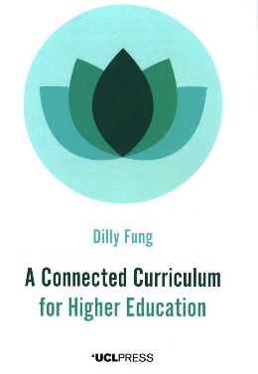

Focus on ...
- A Connected Curriculum for Higher Education by Fung, Dilly Call Number: Freely available to download via UCL Press. ISBN: 9781911576358; Publication Date: 2017. Is it possible to bring university research and student education into a more connected, more symbiotic relationship? If so, can we develop programmes of study that enable faculty, students and ‘real world’ communities to connect in new ways? In this accessible book, Dilly Fung argues that it is not only possible but also potentially transformational to develop new forms of research-based education. Presenting the Connected Curriculum framework already adopted by UCL, she opens windows onto new initiatives related to, for example, research-based education, internationalisation, the global classroom, interdisciplinarity and public engagement.

The Connected Curriculum
Link: https://youtu.be/JNj2_kLtz00

Recent Additions to @IOELibrary
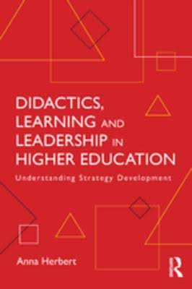
Didactics, Learning and Leadership in Higher Education by Anna Herbert
ISBN: 9781315294773
Publication Date: 2017

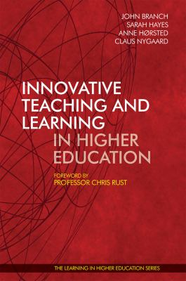
Innovative Teaching and Learning in Higher Education by John Branch (Editor); Sarah Hayes (Editor); Anne Hørsted (Editor); Claus Nygaard (Editor)
ISBN: 9781911450085
Publication Date: 2017

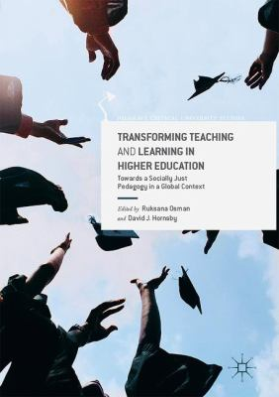
Transforming Teaching and Learning in Higher Education by Ruksana Osman (Editor); David J. Hornsby (Editor)
ISBN: 9783319461755
Publication Date: 2017

Other links
- HEA Research
- Support

