Man: A Course of Study (MACOS)

Printed Materials

Booklets

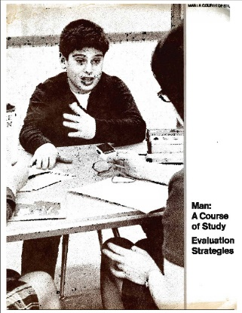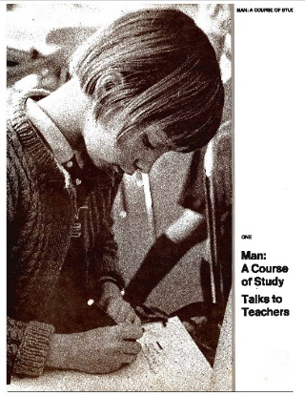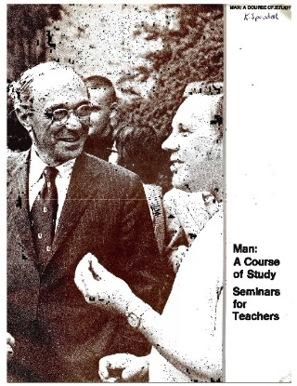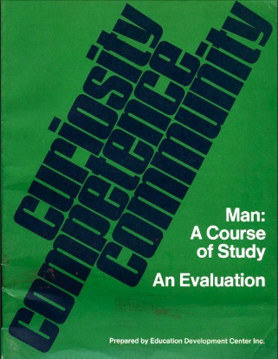

MACOS Teacher's Materials held in the Newsam Library

Man, A Course of Study. 1, Talks to teachers (EDC, 1970)
Man, A Course of Study. 2, A guide to the course (EDC, 1970) *
Man, A Course of Study. 3, Introductory lessons. Salmon (EDC, 1970)
Man, A Course of Study. 4, Herring gulls (EDC, 1970)
Man, A Course of Study. 5, Baboons (EDC, 1970)
Man, A Course of Study. 6, The Netsilik Eskimos at the inland camps (EDC, 1970)
Man, A Course of Study. 7, The Netsilik Eskimos on the sea ice (EDC, 1970)
Man: A Course of Study. Seminars for Teachers (EDC, 1970)
Man, A Course of Study. Evaluation Strategies (EDC, 1970)
Man, A Course of Study. An evaluation. Curiosity, competence, community (EDC, 1970)
The observer's handbook (EDC, 1970)
Man, A Course of Study newsletter. No. 3, 1979, Spring *

*No digitised version on http://www.macosonline.org/course/

MACOS Curriculum Materials held in the Newsam Library
The Newsam Library has the following MACOS materials which were commercially published in the late 1960s and in 1970 by the Education Development Centre under grants from the National Science Foundation. They were disseminated by the Curriculum Development Associates.

- All living things are part of a life cycle (EDC, 1970)
- Natural selection. Workbook (EDC, 1964-70?) *
- Natural selection (EDC, 1970)
- Innate and learned behaviour (1970)
- Information and behaviour (EDC, 1970)
- Animal adaptation (EDC, 1970)
- Antler and fang / illustrated by Arielle Mather (EDC, 1970)
- Salmon (EDC, 1970)
- Herring gulls (EDC, 1970)
- Baboons (EDC, 1970)
- The baboon troop (EDC, 1970)
- Baboon communication (EDC, 1970)
- Animals of the African savanna (EDC, 1970)
- Selections from field notes, 1959, March-August / Irven DeVore (EDC, 1970)
- The wolf (EDC, 1968)
- The grizzly bear (EDC, 1968)
- The bottlenose porpoise (EDC, 1968)
- The brown rat (EDC, 1968)
- The gnu (EDC, 1968)
- The chimpanzee (EDC, 1969)
- The African elephant (EDC, 1968)
- The Arctic (EDC, 1970)
- A journey to the Arctic (EDC, 1970)
- The Arctic and Arctic animals (EDC, 1967) *
- The Netsilik Eskimos. 1 (1968-70?) *
- The Netsilik Eskimos. 2, The inland camps (1968-70?) *
- The Netsilik Eskimos. 3, Tools: humanising force (1968-70?) *
- The Netsilik Eskimos. 4 > Help us find this resource!
- The Netsilik Eskimos. 5, The winter season (1968-70?) *
- The Netsilik Eskimos. 6, Kinship and social organisation (1968-70?) *
- True stories from Arctic adventure / Peter Freuchen (1968-70?) *
- Extracts from Kabloona / Gontran de Poncins (1968-70?) *
- MAN, A Course of Study. Survival project: comparing Eskimo and British survival (1968-70?) *
- Songs and stories of the Netsilik Eskimos / Edward Field (EDC, 1967) *
- Songs and stories of the Netsilik Eskimos / Edward Field (EDC, 1970)
- On firm ice / Carter Wilson; illustrated by William A. Berry (EDC, 1967) *
- On firm ice / Carter Wilson; illustrated by William A. Berry (EDC, 1970)
- This world we know: beliefs and traditions of the Netsilik Eskimos (EDC, 1970)
- The many lives of Kiviok : traditional tales of the Netsilik Eskimos (EDC, 1970)
- The true play: how Itimangnark got Kingnuk, the girl he really wanted / Carter Wilson (EDC, 19670)
- Structure and function (EDC, 1970)
- Making a bow (EDC, 1964-1970?) *
- The Eskimos' transport tools and hunting, The (EDC, 1964-1970?) *
- Stalking the [...] (1967) *
- The data book : a guide to the Eskimo cards (EDC, 1970)
- Netsilik Eskimos series : nine color films in 21 half-hour parts (NFB, 1967?) *
* no digitised version on http://www.macosonline.org/course/

Download MACOS
The course materials consist of films, booklets (Bruner did not believe in children learning from the traditional, authoritative texbook). The booklets are downloaded from the (Hu)mans: A Course of Study site for free at http://www.macosonline.org/course/

The curriculum consists of more than 60 lessons, grouped into 6 sections. These materials were created by the Education Development Center (for more information about EDC, visit www.edc.org).

Books about MACOS in the Library
- The tragedy of American school reform [electronic resource] ; How curriculum politics and entrenched dilemmas have diverted us from democracy by Evans, Ronald W.
ISBN: 9780230119109
Publication Date: 2011
- Man : a course of study in an East Anglian middle school by Hopkins, Eric.
ISBN: 0904510093
Publication Date: 1981
- Curriculum design and development. Unit 14-15 , Design issues. Part 1, Teacher education. Part 2, Art education. Part 3, Man : a course of study by Open University. E203 Course Team.
ISBN: 0335065554
Publication Date: 1976
- An evaluation of Man - A Course of Study by Liss, R.
Publication Date: 1974

Additional Materials
Some workbooks are photocopied, bound and coloured in by hand:
- All living things are part of a life cycle
- Are we like our parents?
- Salmon

The leaflet "Stalking the [...]" never names the prey!

Help us find more resources!
Have you got any printed MACOS materials?
We lack a hard copy of at least one leaflet: Building a skin sled. Would you consider donating it?

We lack at least one issue of a series: The Netsilik Eskimos. 4. Have you got a copy we could digitise?

