Man: A Course of Study (MACOS)

Contents
Welcome 2
Archive & Special Collections 2
About this guide 2
Man: A Course of Study 2
Useful Weblinks 3
Context 4
America 4
Great Britain 4
The Controversy 5
MACOS: Controversy 5
Documentary Film on MACOS: 'Through These Eyes' (Charles Laird, 2004) 5
Comments by Parents & Teachers 6
Printed Materials 7
Booklets 7
MACOS Teacher's Materials held in the Newsam Library 7
MACOS Curriculum Materials held in the Newsam Library 7
Download MACOS 9
Books about MACOS in the Library 9
Additional Materials 9
Help us find more resources! 9
Audio and Visual Materials 10
Collection of eleven portraits of a Netsilik family 10
Articles listed in the database ERIC (Education Resource Information Centre) 10
Newsam Library Holdings 11
Course Materials 11

Welcome

Archive & Special Collections

Link to: http://libguides.ioe.ac.uk/archspecoll

About this guide
We are indebted to Mr. Barry D. Varley-Tipton for his generous donation of the MACOS curriculum project materials to the Newsam Library. The list of materials are on the following pages: Printed Materials and Audio and Visual Materials.

Man: A Course of Study (commonly referred to by the acronym MACOS or M.A.C.O.S.) is an American humanities curriculum project based on the theories of Jerome Bruner. Bruner believed that it was possible to teach children to be more humane and eliminate racism and ethnocentrism by studying another culture closely.

This guide provides information about the project, the context and the controversy surrounding it. It also includes useful links to websites and resources on MACOS held at the Newsam Library. The bibliography at the end of the guide is a list of articles and reports on the MACOS project which has been obtained from a search on the database ERIC.

Man: A Course of Study
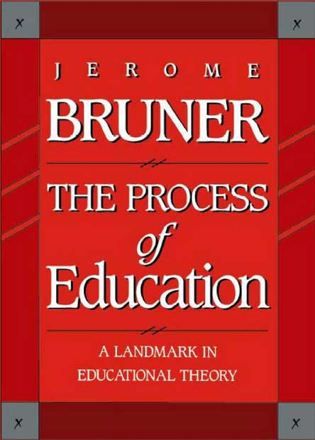
Jerome S. Bruner (1915) is a well-known and influential American cognitive psychologist whose work has made a huge impact in education. In particular, two of his books, The Process of Education (1960) and Toward a Theory of Instruction (1966), are regarded as classics and have had immense influence.

In 1964, Bruner took a leave of absence from his post at Harvard University to work on the MACOS project at the Educational Services Incorporated (ESI), now Educational Development Center (EDC). The course materials based on the theories Bruner expounded in The Process of Education were for primary-school level and included films and images of the Netsilik Eskimo.

MACOS (Man: A Course of Study) tries to inculcate in children the quest for the following issues:

- What is human about human beings?
- How did they get that way?
- How can they be made more so?

At its peak in the early 1970s, the MACOS curriculum, which took a year out of the normal curriculum, was taught in 47 states in elementary and middle schools in the U.S. and reached approximately 400,000 students. The programme used film in an innovative way and won several awards, including the American Educational Publishers Institute award, an American Film Festival award, two CINE Golden Eagle awards, and an Emmy Award (1971). It was funded by the National Science Foundation and the Ford Foundation (see EDC for further information).

The course used a socio-anthropological approach to collate materials (film and images) about the Netsilik Inuits of Pelly Bay (now the Kugaaruk region of the Arctic coast of Canada, west of Hudson Bay) and their everyday life as well as the natural life surrounding them. The purpose was to teach children about a different race and allow them to equate their understanding of that race with their own - in the hope of eradicating racism and ethnocentricity.

Bruner was convinced that even young children are able to engage with any material as long as it is presented in an appropriate and motivating way. He developed a holistic model of learning and proposed a spiral curriculum. To him, learning skills was more important than learning facts - including the skills of questioning and debating. The MACOS project was both highly acclaimed and severely criticised.

Jerome Bruner served as advisor to US Army intelligence and US Presidents and continued researching and teaching psychology until the age of 100. He died in 2016.

Useful Weblinks
- (Hu)mans : A Course of Study: course materials and references MACOS online archive
- (Hu)mans : A Course of Study: online course materials Some written materials have been digitised and may be downloaded free of charge.
- Jerome Bruner and the process of education (Mark K. Smith 2002)
- Jerome Bruner : the lesson of the story (Interview in The Guardian 2007)

Context

America
The escalation of the Cold War in the late 1950s and the launch of Sputnik in 1957 created quite a storm in the US. The Americans blamed the 'pathetic’ state of their schooling system for losing the technological space race against the Russians. A debate about the schooling system resulted in the National Defence Education Act (NDEA) of 1958. The NDEA ensured that there were enough funds for revamping and refocusing the curriculum in order to ensure greater academic and intellectual rigour. Empiricism and scientism were the objectives of this reappraisal.

A conference with the top US scientists and academics, including Robert Gagnė and B.F. Skinner, was called to consider how to embed this empiricism and scientism into the American school curriculum. The conference was chaired by the eminent cognitive psychologist/Harvard academic, Jerome Bruner. Bruner introduced his theories of meaningful learning through an understanding of concepts (not facts) in order to develop critical thinking. He wrote about his theories soon after the conference in his book, Process of Education, (1962). Bruner realised this concept in a unique, federally-funded curriculum project for social studies called Man: A Course of Study or MACOS.

For more information, see: Fitchett, Paul G. and Russell, William Benedict. (2012). "Reflecting on MACOS: why it failed and what we can learn from its demise". Paedagogica Historica 48(3), pp. 469-484.

Great Britain
The UK also went through a crisis in education due to the unfairness of the selective system of education (grammar vs. secondary modern) and the 11+ examinations that determined the future of young children and which caused a great deal of unhappiness among the growing middle class. Under Harold Wilson’s leadership, the economy was buoyant and for the first time more was spent on education than on defence as the government realised the importance of educating the young for the future of the country. The government’s investment in education resulted in 1,800 new secondary schools being built in England and Wales from the mid-60s onwards. During this time, the benefits of child centred education were discussed widely and this resulted in the rise of many subject and age specific curriculum development projects. It is for this reason that the 60s are generally considered the ‘Golden Age of Curriculum Development’.

The promise of secondary education for all was fulfilled and the school leaving age was finally raised to 16 in 1972. Provision of life skills for the older children resulted in discussions about a development programme. A comparable programme to MACOS was the Humanities Curriculum Project which was developed under the auspicious of the Schools Council (established in 1964 by the Secretary of State for Education and who took responsibility for curriculum and examinations) which was a powerful body dominated by teacher representatives.
For more information, see: Gillard, D. Chapter 6 : 1951-1970 : The wind of change. Education in England: a brief history. Available at: http://www.educationengland.org.uk/history/chapter06.html.

The Controversy

MACOS: Controversy

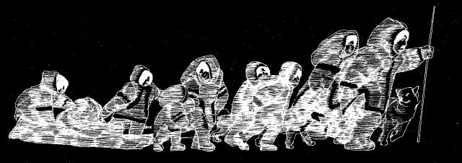

The MACOS curriculum developers began with the idea that if children were taught how to understand human behaviour, they would be more likely to become better adults and ensure the survival of the (American) human race against "the catalogue of problems they will face: the rising crime rate, the breakdown of urban life; the population boom; the energy crunch; the ecocrisis; health care; ethnic and racial conflicts;and our global economic, political and military challenges - not to mention the search for useful employment", as Peter Dow, the Project Director stated a decade after the MACOS programme was launched.*

MACOS attempted to promote scientific literacy, i.e. "to help children learn to think like social scientists". However by the early 1970s under the Nixon administration in America, there was a widespread distrust of government funded educational projects and MACOS received a lot of negative publicity. As Dow explains, the first sign of impending trouble appeared in a school (the Minnie J. Niblack Elementary) in Lake City (a small town in northern Florida) which was under court integration order and which had implemented the MACOS programme to ease existing racial tensions. A sixth-grade pupil's father (a Baptist Minister by the name of Reverand Don Glenn) asked for copies of the MACOS materials from the teacher (Dow 1991, p.178).

Reverend Glenn formed a study group to examine the MACOS materials in detail and then claimed that the materials were a threat to democracy, he said in a four-hour long programmes on radio that they advocated evolution, a 'hippie-yippee philsophy', pornography and gun control and tried to prove his case by reading from the teacher and pupil materials. This led to much negative publicity with the programme being debated in Congress in 1975 and the National Science Foundation, the government department that had funded the programme, being audited for its management of the project which resulted in the downsizing of the Education Directorate and a cut in the number of funded programmes for a whole decade following this controversy.
*Source: Dow, P.B. (1975). "MACOS: The Study of Human Behaviour as One Road to Survival. The Phi Delta Kappan, 57(2), pp.79–81. Available via JSTOR at: http://www.jstor.org/stable/20298151 [Accessed June 29, 2017].

Documentary Film on MACOS: 'Through These Eyes' (Charles Laird, 2004)
Through These Eyes Charles Laird, National Film Board of Canada

Comments by Parents & Teachers
- Comments on the (Hu)mans: A Course of Study site
- Comments on the film 'Through These Eyes'
- Metafilter Community Weblog

Printed Materials

Booklets

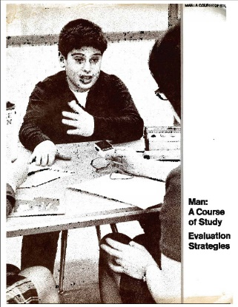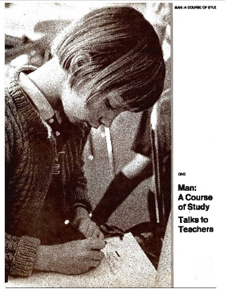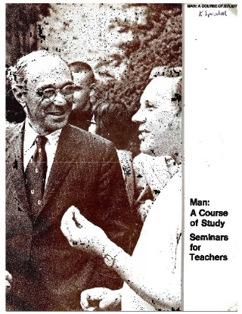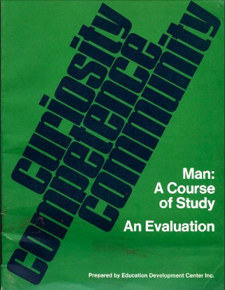

MACOS Teacher's Materials held in the Newsam Library

Man, A Course of Study. 1, Talks to teachers (EDC, 1970)
Man, A Course of Study. 2, A guide to the course (EDC, 1970) *
Man, A Course of Study. 3, Introductory lessons. Salmon (EDC, 1970)
Man, A Course of Study. 4, Herring gulls (EDC, 1970)
Man, A Course of Study. 5, Baboons (EDC, 1970)
Man, A Course of Study. 6, The Netsilik Eskimos at the inland camps (EDC, 1970)
Man, A Course of Study. 7, The Netsilik Eskimos on the sea ice (EDC, 1970)
Man: A Course of Study. Seminars for Teachers (EDC, 1970)
Man, A Course of Study. Evaluation Strategies (EDC, 1970)
Man, A Course of Study. An evaluation. Curiosity, competence, community (EDC, 1970)
The observer's handbook (EDC, 1970)
Man, A Course of Study newsletter. No. 3, 1979, Spring *

*No digitised version on http://www.macosonline.org/course/

MACOS Curriculum Materials held in the Newsam Library
The Newsam Library has the following MACOS materials which were commercially published in the late 1960s and in 1970 by the Education Development Centre under grants from the National Science Foundation. They were disseminated by the Curriculum Development Associates.

- All living things are part of a life cycle (EDC, 1970)
- Natural selection. Workbook (EDC, 1964-70?) *
- Natural selection (EDC, 1970)
- Innate and learned behaviour (1970)
- Information and behaviour (EDC, 1970)
- Animal adaptation (EDC, 1970)
- Antler and fang / illustrated by Arielle Mather (EDC, 1970)
- Salmon (EDC, 1970)
- Herring gulls (EDC, 1970)
- Baboons (EDC, 1970)
- The baboon troop (EDC, 1970)
- Baboon communication (EDC, 1970)
- Animals of the African savanna (EDC, 1970)
- Selections from field notes, 1959, March-August / Irven DeVore (EDC, 1970)
- The wolf (EDC, 1968)
- The grizzly bear (EDC, 1968)
- The bottlenose porpoise (EDC, 1968)
- The brown rat (EDC, 1968)
- The gnu (EDC, 1968)
- The chimpanzee (EDC, 1969)
- The African elephant (EDC, 1968)
- The Arctic (EDC, 1970)
- A journey to the Arctic (EDC, 1970)
- The Arctic and Arctic animals (EDC, 1967) *
- The Netsilik Eskimos. 1 (1968-70?) *
- The Netsilik Eskimos. 2, The inland camps (1968-70?) *
- The Netsilik Eskimos. 3, Tools: humanising force (1968-70?) *
- The Netsilik Eskimos. 4 > Help us find this resource!
- The Netsilik Eskimos. 5, The winter season (1968-70?) *
- The Netsilik Eskimos. 6, Kinship and social organisation (1968-70?) *
- True stories from Arctic adventure / Peter Freuchen (1968-70?) *
- Extracts from Kabloona / Gontran de Poncins (1968-70?) *
- MAN, A Course of Study. Survival project: comparing Eskimo and British survival (1968-70?) *
- Songs and stories of the Netsilik Eskimos / Edward Field (EDC, 1967) *
- Songs and stories of the Netsilik Eskimos / Edward Field (EDC, 1970)
- On firm ice / Carter Wilson; illustrated by William A. Berry (EDC, 1967) *
- On firm ice / Carter Wilson; illustrated by William A. Berry (EDC, 1970)
- This world we know: beliefs and traditions of the Netsilik Eskimos (EDC, 1970)
- The many lives of Kiviok : traditional tales of the Netsilik Eskimos (EDC, 1970)
- The true play: how Itimangnark got Kingnuk, the girl he really wanted / Carter Wilson (EDC, 19670)
- Structure and function (EDC, 1970)
- Making a bow (EDC, 1964-1970?) *
- The Eskimos' transport tools and hunting, The (EDC, 1964-1970?) *
- Stalking the [...] (1967) *
- The data book : a guide to the Eskimo cards (EDC, 1970)
- Netsilik Eskimos series : nine color films in 21 half-hour parts (NFB, 1967?) *
* no digitised version on http://www.macosonline.org/course/

Download MACOS
The course materials consist of films, booklets (Bruner did not believe in children learning from the traditional, authoritative texbook). The booklets are downloaded from the (Hu)mans: A Course of Study site for free at http://www.macosonline.org/course/

The curriculum consists of more than 60 lessons, grouped into 6 sections. These materials were created by the Education Development Center (for more information about EDC, visit www.edc.org).

Books about MACOS in the Library
- The tragedy of American school reform [electronic resource] ; How curriculum politics and entrenched dilemmas have diverted us from democracy by Evans, Ronald W.
ISBN: 9780230119109
Publication Date: 2011
- Man : a course of study in an East Anglian middle school by Hopkins, Eric.
ISBN: 0904510093
Publication Date: 1981
- Curriculum design and development. Unit 14-15 , Design issues. Part 1, Teacher education. Part 2, Art education. Part 3, Man : a course of study by Open University. E203 Course Team.
ISBN: 0335065554
Publication Date: 1976
- An evaluation of Man - A Course of Study by Liss, R.
Publication Date: 1974

Additional Materials
Some workbooks are photocopied, bound and coloured in by hand:
- All living things are part of a life cycle
- Are we like our parents?
- Salmon

The leaflet "Stalking the [...]" never names the prey!

Help us find more resources!
Have you got any printed MACOS materials?
We lack a hard copy of at least one leaflet: Building a skin sled. Would you consider donating it?

We lack at least one issue of a series: The Netsilik Eskimos. 4. Have you got a copy we could digitise?

Audio and Visual Materials

Collection of eleven portraits of a Netsilik family

- Materials can be downloaded or purchased from the MACOS Online Site

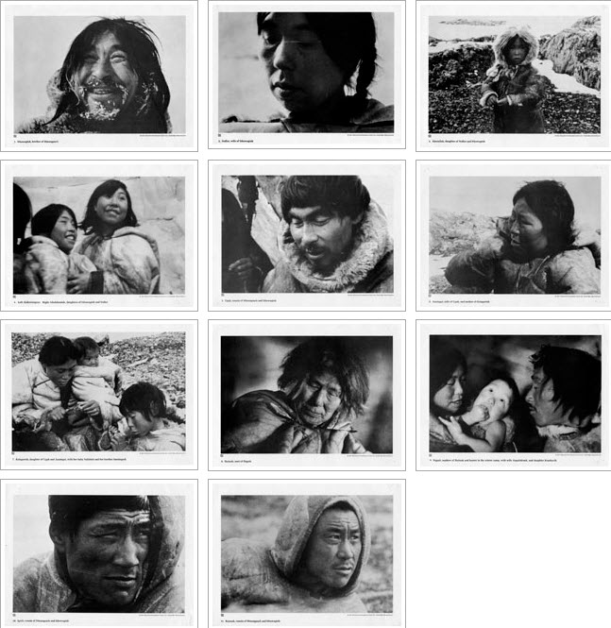

Articles listed in the database ERIC (Education Resource Information Centre)

- BOOST YOUR BATTERY Opens in a new window Collins, Barry PC Pro [London] 01 Mar 2019 : pp. 30 (Jan 18, 2019)
  - Formats: Citation/Abstract, FindIt@UCL
- One last thing... Opens in a new window Honeyball, Jon PC Pro [London] 01 Mar 2019 : pp. 130 (Jan 18, 2019)
  - Formats: Citation/Abstract, FindIt@UCL
- Did I mention there's no 'select all' feature? Yet another symptom of a lack of basic business thinking Opens in a new window Honeyball, Jon PC Pro [London] 01 Mar 2019: pp. 110-113 (Jan 18, 2019)
  - Formats: Citation/Abstract, FindIt@UCL
- Switch your business to Chrome OS Opens in a new window Winder, Davey PC Pro [London] 01 Mar 2019 : pp. 104-107 (Jan 18, 2019)
  - Formats: Citation/Abstract, FindIt@UCL
- I'm guessing that there will be cars in their hundreds and thousands that will never get patched Opens in a new window Winder, Davey PC Pro [London] 01 Mar 2019 : pp. 118-120 (Jan 18, 2019)
  - Formats: Citation/Abstract, FindIt@UCL

Newsam Library Holdings
The Newsam Library has the following materials from the MACOS curriculum project:
Two complete sets of Netsilik Eskimo family images
Twelve 8 mm film cartridges:

- At the Autumn River Camp. Parts 1, 2, 3, 4
- At the Winter Sea Ice Camp. Parts 1, 2 3, 4
- Fishing at the stone weir. Parts 1, 2
- Life cycles of the salmon
- Herring gull behaviour

Course Materials

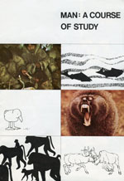

Link: http://www.macosonline.org/course/

