Literacy Attainment: Historical Resources

Shaping Education

1. Journal of the Royal Statistical Society
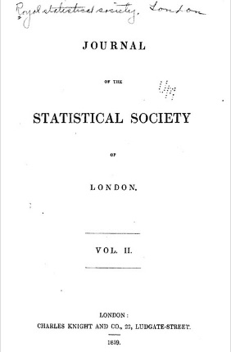
Statistical societies began to form in the 1830s. The first were locally-based and committed to collecting information that might help shape social reform through demonstrating a need, or charting the population in a local area. Statistics were originally regarded as a class of information about the public realm, not necessarily information in numerical form. Some of the earliest statistical reports on education combined quantitative with qualitative methods. They might focus on conducting enquiries door-to-door about family composition and financial resources in an attempt to identify the likely need for educational provision in a specific area. For a list of the main studies, see Phil Gardner's 1984 book The lost elementary schools of Victorian England: the people's education.

2. Transactions of the National Association for the Promotion of Social Science
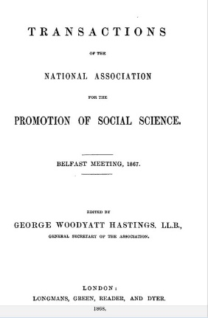
During the second half of the nineteenth century, education became a key topic for organisations and associations interested in fostering social reform and developing a knowledge base from which to act. Women fought their way into many of these associations. The National Association for the Promotion of Social Science had its heyday in the 1850s-60s, when it was particularly concerned to influence policy makers. Later it became a forum for sharing and developing a professional knowledge base about pedagogy. See Science, Reform, and Politics in Victorian Britain by Lawrence Goldman for an account of its activity.

The Transactions are also available in the Library Special Collections.

3. Reformatory schools, for the children of the perishing and dangerous classes, and for juvenile offenders
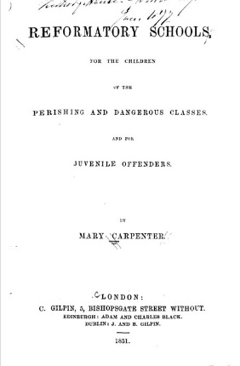
Mary Carpenter (1807-1877) was one of several women who actively campaigned for increased educational provision. She was particularly concerned with those children classed as "street arabs", whose absolute poverty meant they were excluded from ordinary schools, and those who were categorised as juvenile criminals. She established reformatory schools for the latter in her home town, Bristol, and ran a long campaign for funding for Ragged Schools to cater for the former. She presented papers at the British Association for the Advancement of Science and published in the Journal of the Statistical Society of London as part of her attempt to gain wider recognition of the needs of these children. See also Jane Martin and Joyce Goodman's Women and Eduation, 1800-1980 (Macmillan, 2004).
The item is also available in the Newsam Library.

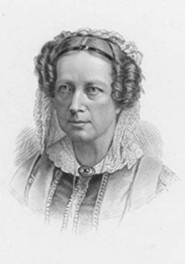
Mary Carpenter: Some Additional Resources
Additional resources on and by Mary Carpenter include:
Juvenile delinquency in its relation to the educational movement
Juvenile Delinquents, Their Condition and Treatment
Mary Carpenter and the children of the streets by Jo Manton
Mary Carpenter, reformatory schools and education
List of journal articles via History of Education Society
The Library's holdings are listed in the Library Catalogue.

