Vertebrate Diversity study pack

The following web-book contains a series of information chapters broadly outlining the diversity of living vertebrates, with a few notes on their fossil relatives. Below is a collage of specimens from UCL's Grant Museum of Zoology illustrating the wide diversity covered in this web-book – from jawless vertebrates, sharks, and ray-finned fishes, to amphibians, reptiles, and mammals.

To download this resource as a single file, see the collection page: https://open-education-repository.ucl.ac.uk/id/eprint/204

Also see the related resource Vertebrate Palaeontology and Evolution study pack here: https://open-education-repository.ucl.ac.uk/id/eprint/195

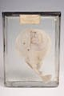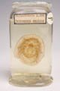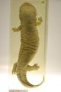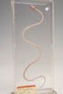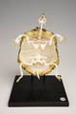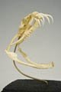
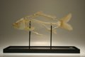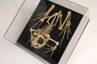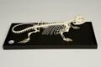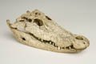
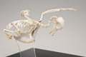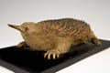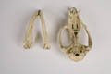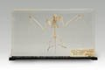
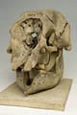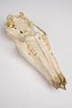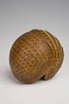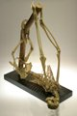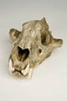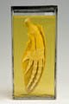

Disclaimer: 'Vertebrate Diversity' was originally designed by UCL staff as an internal teaching resource. The subsequent release of 'Vertebrate Diversity' as an OER means that any changes to the product received relative to the original content may not reflect the desires of UCL teaching staff, or the original quality of the resource.

CC BY-NC-SA 4.0 International Licence: 'Vertebrate Diversity' has been released as an open educational resource (OER) on a Creative Commons 'Attribution Non-commercial Share Alike' license. This means that once downloaded, content can be modified and improved to complement a particular course. This requires, however, that improvements are recycled back into the OER community, and full attribution is made to UCL. All content present at the time of download must be accordingly credited and, in turn, novel content must be appropriately licensed. For more information, please refer to the license deed by visiting: https://creativecommons.org/licenses/by-nc-sa/4.0/legalcode
Contents
Introduction 3
Squamata 5
Synapomorphies of the Squamata 5
Phylogenetic relationships of the Squamata 5
Dibamidae - blind lizards 8
Diversity and Lower Taxonomy 8
Distribution and Habitat 8
Conservation Status (IUCN) 8
Features 9
Gekkota - geckoes and pygopodids 9
Diversity and Lower Taxonomy 9
Description 10
Distribution and Habitat 10
Conservation Status (IUCN) 11
Scincomorpha - skinks, wall lizards, and relatives 11
Diversity and Lower Taxonomy 11
Amphisbaenia - worm lizards 11
Description 13
Distribution and Habitat 14
Conservation Status (IUCN) 14
Synapomorphies of the Amphisbaenia and its families (sensu Kearney 2003) 14
Anguimoprpha - monitor lizards, glass lizards, and relatives 15
Iguania - iguanas, chamaeleons, and agamids 15
Conservation Status (IUCN) 18
Serpentes - snakes 19
Glossary 21

Introduction

The first chapter considers the lampreys - a clade of jawless vertebrates that are thought, based on analysis of their morphology, to be the group that first diverged from the remaining vertebrate clades.

Subsequent chapters follow a structure that roughly reflects the evolutionary relationships (or phylogeny) between the higher level vertebrate groups - for example, the turtles, lizards, tuatara, crocodiles, and birds are all reptiles and, as such, their chapters are clustered together. This structure need not imply any increase in complexity or morphological "progress" as one descends through the chapters - indeed, every taxon discussed in this web-book is extant, meaning that it has some members that are still living, and are therefore also evolving under the selection pressures of their current environment. Rather, the structure reflects the greater focus of this web-book on those four-limbed vertebrates (tetrapods) whose ancestors colonised the terrestrial world in the Devonian swamps of nearly 400 million years ago - in particular the hair-covered, milk-producing mammals.

While the structure of the web-book may not always act as an accurate representation of the evolutionary history of vertebrates, the phylogenetic tree below illustrates how all the major vertebrate clades are thought to be related.

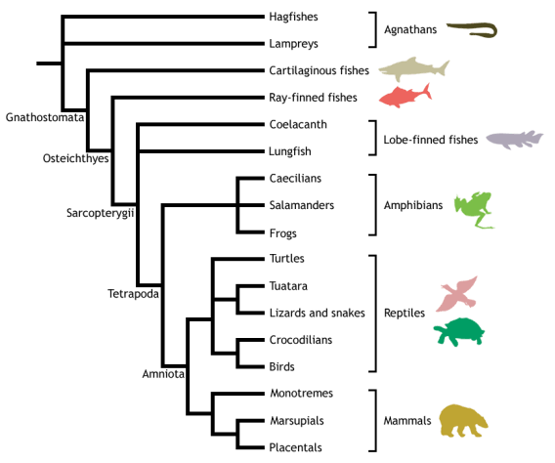

Adapted from Meyer & Zardoya (2003), this is a conservative estimate of vertebrate phylogeny, reflecting the prevailing consensus between morphological and molecular data. Conflict between morphology and molecules is manifest at the unresolved nodes, or polytomies - those nodes that are formed when greater than two branches coalesce.

For example, the most popular view of morphologists is that lampreys represent the closest living relatives of the jawed vertebrates (Gnathostomata), together forming the Vertebrata. This hypothesis excludes hagfishes from the vertebrates on the basis that they do not possess some of the derived morphological features shared by lampreys and gnathostomes - in particular, they lack a vertebral column. Instead, hagfishes are placed as the sister group to the vertebrates, together forming the Craniata (or craniates) - animals possessing a skull, or cranium. This view of craniate evolution makes the living jawless vertebrates, or agnathans, a paraphyletic group. This means that the jawless vertebrates do not form a natural (or monophyletic) grouping, as their most recent common ancestor is not unique to them - it is shared with the jawed vertebrates as well.

In contrast, molecular data tend to group the lampreys and hagfishes to the exclusion of the gnathostomes, making the living agnathans a monophyletic group termed Cyclostomi. Under the cyclostome hypothesis, it is presumed that the common ancestor of the cyclostomes and gnathostomes possessed a vertebral column, which was subsequently lost in the evolution of the hagfishes.

Despite the disparities between morphological and molecular data evident from the cladogram above, the evolutionary history of the vertebrates is fairly well resolved, with many major traditionally identified groupings persisting through recent advances in methods for phylogenetic inference and the advent of molecular systematics. Consequently, this tree should be used as a working guide while exploring the taxa described within the web-book, providing an evolutionary context that highlights the shared ancestry of the different vertebrate lineages, as well as helping to trace some of the evolutionary innovations that gave rise to the many different forms - including the origin of jaws, ossification of the endochondral skeleton, evolution of terrestrially adapted limbs, and the amniotic egg.

Squamata

Squamata - lizards and snakes

Vertebrata; Gnathostomata; Osteichthyes; Sarcopterygii; Tetrapoda; Amniota; Sauropsida;
Reptilia; Diapsida; Sauria; Lepidosauromorpha; Lepidosauria; Squamata

Squamates are a highly successful and familiar group of reptilies including lizards (e.g. gekkotans, skinks, chamaeleons), snakes, and amphisbaenians. With over 7000 species, they are present on every continent except Antarctica, and have invaded marine environments (e.g. sea snakes, mosasaurs), as well as diversifying into many different specialised terrestrial forms, including burrowers (e.g. amphisbaenians), gliders (e.g. Draco), bipedal runners (e.g. Basiliscus), climbers (e.g. chameleons), and active predators (e.g. Varanus).

In addition to the plesiomorphic reptilian condition of egg-laying (oviparity), some groups give birth to live young (viviparity). More surprisingly, at least eight groups contain a species with only female members, reproducing by a process called parthenogenesis - the development of unfertilised eggs into functional (female) offspring.
Squamates range in size from approximately 3 cm (pygmy chamaeleons, e.g. Brookesia minima) to several metres (e.g. komodo dragon, anaconda, extinct marine mosasaurs). Limblessness is common in squamates (incluing snakes, amphisbaenians, dibamids, and members of each major lizard group), and is thought to have evolved as many as five times independently. For more information on squamate diversity, please visit the squamate subgroup headingss visible in the table of contents.
The Squamata is the sister group to the Rhynchocephalia (the Tuatara and extinct relatives), sharing a common ancestor around 250 million years ago at the start of the Mesozoic. Together, they form the monophyletic Lepidosauria. For lepidosaurian synapomorphies and phylogeny, see the information in the rhynchocephalian chapter.

Synapomorphies of the Squamata
- Cranial kinesis - a high degree of flexibility between the bones of the back of the skull, allowing relative movements between them.
- Paired hemipenes (present in all lepidosaurs) are fully eversible.
- Pleurodont dentition - teeth set into the side of the inner surfaces of the jaws, and periodically replaced.
- Loss of gastralia (ventral belly ribs).
- Double-hooked fifth metatarsal, functionally analagous to the mammalian heel.
- Further complexity to the mesotarsal joint (in comparison to non-squamate lepidosaurs).

Phylogenetic relationships of the Squamata
Researchers in squamate phylogeny have yet to reach a consensus on the evolutionary affinities of the group's different lineages. Traditionally, the crown-group Squamata was divided into Lacertilia (lizards and amphisbaenians) and Ophidia (snakes). Modern cladistic analysis, however, has demonstrated that both snakes and amphisbaenians can be grouped with certain lizards to the exclusion of other lizard groups (e.g. Estes et al. 1988), and thus the term 'lizard' is not a natural grouping (i.e. not monophyletic). Therefore, formal terms like Lacertilia should be avoided, as they are phylogenetically misleading. The term lizard can be used informally to indicate any squamate that is not a snake or amphisbaenian.
Studies based on cladistic analysis of the morphological characteristics of both extant and fossil taxa assert that the primary split in the crown-group Squamata was between the Iguania and the Scleroglossa around 206 million years ago, at the Triassic-Jurassic boundary. The Iguania contains the familiar iguanas and chamaeleons, as well as the agamids, and its monophyly is well supported. For more information see the Iguania chapter.

The first major phylogenetic analysis of the Squamata (Estes et al. 1988) defined three major scleroglossan clades - Gekkota, Anguimorpha, and Scincomorpha. The phylogeny of Squamata as proposed by Estes et al. (1998) is illustrated in the cladogram below (note the colour-coding of proposed clades, for comparison with conflicting theories below):
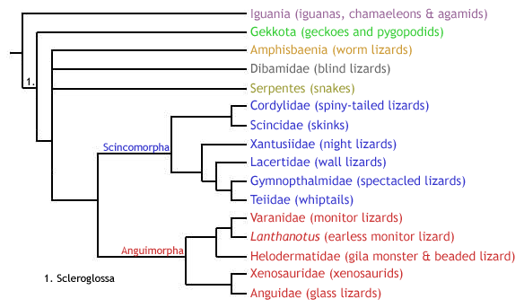
While the monophyly of Gekkota and Anguimorpha is usually supported by morphological studies, the monophyly of the Scincomorpha is not always reconciled (e.g. Lee et al.1998), and the interrelationships of these clades has been difficult to resolve. In addition to the three principle lineages, there are three other groups of limbless scleroglossans that have been difficult to place into the phylogeny (see cladogram above). These are the snakes (Serpentes), amphisbaenians (Amphisbaenia), and dibamids (Dibamidae). Snakes are usually placed within the anguimorphs (e.g. Lee et al. 1998), although their origins are a major subject of scientific dispute. Amphisbaenians and dibamids are, however, something of a phylogenetic mystery. Often grouped as a clade (Amphisbaenia + Dibamidae), some authors place them as sister to the Gekkota (e.g. Lee et al. 1998), while others suggest a close affinity with snakes (e.g. Rieppel & Zaher 2000).
Lee et al. (1998) suggested that the apparent grouping of these three problematic taxa as a clade within the anguimorphs seen in many phylogenetic studies is a misleading result, as it is almost exclusively supported by specialisations for a burrowing mode of life, such as cranial consolidation, loss of limbs and elongation of the body, which are known to convergently evolve in other tetrapods (e.g. caecilians). They argue that the addition of fossil taxa is crucial to understanding the evolutionary transition of these groups to leglessness, in order to detect any convergence, or homoplasy. Indeed, their inclusion of certain fossil taxa (namely the large marine mosasauroids, the basal snake Pachyrhachis, and the limbed amphisbaenian-like Sineoamphisbaenia) produced an amphisbaenian-dibamid clade as sister group to the Gekkota, away from snakes and anguimorphs. Snakes, however, remained as anguimorphs, forming the clade Pythonomorpha with the large marine mosasaurs of the Cretaceous, which is then sister group to the monitor lizards (family Varanidae) in the Varanoidea.
In addition, Lee et al. (1998) questioned the monophyly of the Scincomorpha, defined by (Estes et al. 1988). First, they proposed that scincids and cordylids are more closely related to anguimorphs than to other "scincomorphs". Second, they placed the xantusiids in a new clade, Nyctisaura, as sister group to the Gekkota-Amphisbaenia-Dibamida clade. The remaining "scincomorphs" persisted in the clade Lacertiformes.
The phylogeny of squamates proposed by Lee et al. (1998) is shown below (note the polyphyly of Scincomorpha, as well as the positions of Serpentes, Amphisbaenia, and Dibamidae, and the addition of mosasaurs):
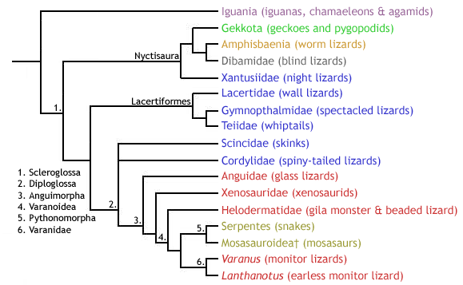
More recently, the monophyly of the Scleroglossa has been questioned by researchers studying squamate DNA sequence data. For example, Townsend et al.(2004), who compared around 4600 DNA base pairs in 69 squamate species, placed the Iguania as well-nested within a consequently paraphyletic Scleroglossa - contrary to the usual Iguania-Scleroglossa dichotomy. Instead, they proposed that geckoes (plus relatives) and dibamids were the first squamate groups to diverge. The monophyly of the traditional Anguimorpha was supported, although it did not include snakes, and refuted the monophyly of Xenosauridae by proposing separate origins for the genera Xenosaurus and Shinisaurus. Again, the monophyly of Scincomorpha was refuted, albeit in a different manner (see below) to that proposed by Lee et al. (1998). Amphisbaenians were placed in yet another position, this time embedded within the Lacertiformes as sister group to the family Lacertidae. The authors showed that amphisbaenians share almost identical multicodon deletions in a gene called c-mos with members of a particular lacertid genus (Gallotia). This provided additional support to their sequence comparison results that demonstrated that dibamids are not closely related to snakes or dibamids, but to lacertids. Finally, the relationships between Anguimorpha, Lacertiformes, Serpentes, and Iguania were not resolved. The cladogram below illustrates the squamate molecular phylogeny sensuTownsend et al. (2004):

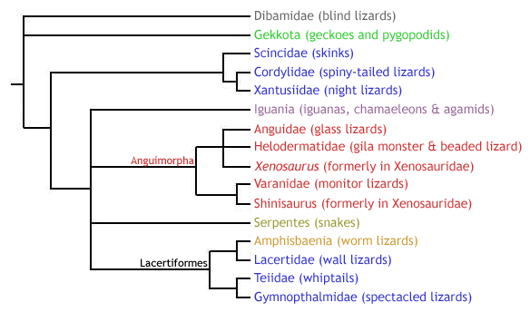

Dibamidae - blind lizards

Lepidosauria; Squamata; Dibamidae

The dibamids (or blind lizards) are a group of small, limbless lizards whose phylogenetic affinities have long been disputed. To learn more about their place in squamate phylogeny, please return to the Squamata heading.

Diversity and Lower Taxonomy
There are 10 species of dibamid, divided between two genera: Dibamus and Anelytropsis. The former contains all but one species.

Distribution and Habitat
- Dibamus spp. - inhabit the rainforests of southeast Asia (including Indonesia and the Philippines) and Western New Guinea.
- Anelytropsis papillosus - present only in Mexico, inhabiting dense forest, pine-oak forest, semi-arid deciduous brush, or open shrubland.
All dibamids are fossorial, burrowing in soil or under rocks or felled logs on the forest floor.

Conservation Status (IUCN)
No members of the genus Dibamus have been issued a conservation status by the IUCN. Anelytropsis papillosus is listed as Least Concern (LC).

Features
- Limbless - although males have small, vestigial hind limbs; these are flap-like and used to grasp females during mating.
- Vestigial eyes covered by a scale.
- Lack external ear openings.
- Cranial consolidation - rigidly fused skull - an adaptation for a burrowing mode of life

Gekkota - geckoes and pygopodids

Lepidosauria; Squamata; Gekkota

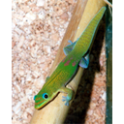  Gold dust day gecko (Phelsuma l. laticauda) | 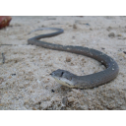  Common Scaly-Foot (Pygopus lepidopodus)

The Gekkota is a monophyletic clade containing the familiar geckoes, as well as the pygopodids - a group of limbless lizards commonly referred to as Australasian legless lizards. To learn more about their place in squamate phylogeny, please return to the Squamata heading.
Diversity and Lower Taxonomy
Traditionally (e.g. Estes et al. 1988), the geckoes and pygopodids have been divided into two distinct families, as follows:
- Family Gekkonidae (geckoes) - comprising approximately 1180 species of gecko divided between five subfamilies.
  - Subfamily Gekkoninae - containing 75 genera.
  - Subfamily Teratoscincinae - containing a single genus, Teratoscincus.
  - Subfamily Diplodactylinae - containing 18 genera.
  - Subfamily Eublepharinae - containing 5 genera.
  - Subfamily Aeluroscalabotinae - containing one genus, Aeluroscalabotes.
- Family Pygopodidae - 39 species of pygopodid divided between seven genera in two subfamilies.
  - Subfamily Pygopodinae - conatining 23 species divided between 3 genera.
  - Subfamily Lialisinae - containing 16 species in 4 genera.

This Gekkonidae-Pygopodidae dichotomy proposed the monophyly of the two groups, and Gekkota was therefore defined as encompassing the last common ancestor of these two families, plus all its descendents. Both morphological (e.g. Kluge 1987) and molecular (e.g. Saint et al. 1998) phylogenetic studies have, however, demonstrated that Pygopodidae is nested within Gekkonidae, more closely related to the diplodactylines (subfamily Diplodactylinae) than to other gekkotans. Under these conditions, the term Gekkonidae becomes phylogenetically redundant, as if Pygopodidae is excluded from its definition, then Gekkonidae is paraphyletic, and if Pygopodidae is included, then Gekkonidae becomes equivalent to the higher Gekkota (including geckoes and pygopodids).

Nonetheless, Gekkotan interrelationships are by no means fully resolved, and not all researchers agree with a nested position for Pygopodidae. More recently, a molecular study conducted by Jonniaux & Kumazawa (2008) proposed that the subfamilies Eublepharinae and Aeluroscalabotinae form a distinct family, Eublepharidae, that is siter to Gekonidae (containing the three remaining traditional gekkonid genera), and in turn this clade is sister to Pygopodidae. This molecular-based grouping is interesting as it corroborates certain morphological differences between these groups (see Descriptions section below).

Description
It is useful to describe the appearance and morphology of geckoes and pygopodids separately, as they are clearly distinct. Bear in mind, however, that it is possible that the pygopodids evolved within the geckoes. If this is the case, then pygopodids are in fact geckoes themselves, and may have secondarily lost many gekkotan features in favour of specialisation for a burrowing mode of life. Consequently, the term 'gecko' below refers to an informal (i.e., not phylogenetic) grouping meaning 'any non-pygopodid gekkotan'.

Geckoes are a familiar group of often strikingly coloured small to average-sized lizards, ranging from 30 mm (Sphaerodactylus ariasae) to 350 mm (e.g. Rhacodactylus leachianus, Gekko gecko), with a tail that is similar in length to the snout-vent length (s-v; distance between the snout and the cloacal opening, or vent, at the base of the tail). Most are nocturnal (these species have vertically slitted pupils), but some genera are diurnal (with rounded pupils, e.g. Phelsuma), and a few even show both diurnal and nocturnal activity. The majority are insectivorous, but some will eat small reptiles, and some larger species have been known to consume small rodents. They are oviparous, with the exception of members of the following three live-bearing genera: Hoplodactylus, Naultinus and Rhacodactylus.

Geckoes can be divided into two main forms: those with moveable eyelids (the eublepharines & aeleuroscalabotines, corresponding to the potential family Eublepharidae, as above), and those with fixed eyelids (the gekkonines, teratoscincines, and diplodactylines, corresponding to the remaining members of the traditional family Gekkonidae). Within the latter grouping, there is a further division based on the presence (arboreal species) or absence (usually terrestrial species) of adhesive toe pads - a specialisation for arboreal locomotion. These pads consist of a set of overlapping expanded scales on the base of the toes, possessing millions of microscopic hair-like protrusions (called setae), each of which branches into hundreds of 200 nm wide tips (called spatulae). This microstructure acts as an extremely strong adhesive (each hair can resist 200 µN of force), allowing these geckoes to walk up smooth vertical surfaces, and even upsidedown. In fact, these hairs are so sticky that a gecko can hang from a ceiling by just a single toepad, and a single hair (seta) could lift an ant!

Pygopodids are a small group of average sized (7-25 cm s-v) limbless lizards, feeding mainly on insects and some lizards. They are slender and elongate, with no traces of pectoral skeleton. The pelvic girdle is, however, still present in part, and the hindlimbs persist as vestigial scaly flaps. The majority of pygopodids are diurnal, but Paradelma orientalis, as well as subsepecies of Pygopus nigriceps are nocturnal. Like most geckoes, they are oviparous.

Distribution and Habitat
Geckoes are distributed worldwide, and are most speciose in the tropics, subtropics, and deserts. They are either terrestrial or arboreal.
Pygopodids are found in Australia, with Lialis also present in Indonesia. While two genera, Aprasia and Ophidiocephalus, are burrowing, the majority inhabit grass and litter.

Conservation Status (IUCN)
Geckoes - Of the 91 species of gecko listed in the IUCN Red List, the majority (52 species) have been assessed as Least Concern (LC). Two species (Lepidoblepharis montecanoensis and Phelsuma antanosy) are Critically Endangered (CR), while four are Endangered (EN), ten are Vulnerable (VU), and eleven are Near Threatened (NT). The remainder (10 species) are Data Deficient (DD).
Pygopodids - the conservation status of seven pygopodid species has been assessed by the IUCN. All but one are Vulnerable (VU), and the other is Near Threatened (NT).

Synapomorphies of the Gekkota
- Upper temporal bar absent.
- Incomplete post-orbital bar.
- Absence of the lacrimal - the anterior-most bone in the medial wall of the orbit.

Scincomorpha - skinks, wall lizards, and relatives

Lepidosauria; Squamata; Scincomorpha

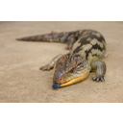  Blotched Blue-tongued Skink (Tiliqua nigrolutea) | 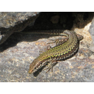  Common wall lizard (Podarcis muralis)

Diversity and Lower Taxonomy
Traditionally, the Scincomorpha consisted of the following six families:
- Scincidae (skinks) - the most speciose lizard family, with approximately 1200 species.
- Cordylidae (spiny-tailed lizards)
- Xantusiidae (night lizards) - 29 species of diurnal, viviparous lizards across three genera: Cricosaura (monospecific; subfamily Cricosaurinae), Lepidophyma (18 species; subfamily Xantusiinae), and Xantusia (10 species; subfamily Xantusiinae).
- Lacertidae (wall lizards) - 32 genera.
- Gymnophthalmidae (spectacled lizards)
- Teiidae (whiptails)

While the Lacertidae, Gymnophthalmidae, and Teiidae have remained closely affiliated in the monophyletic clade Lacertiformes (as shown on the Squamata chapter), the remaining three groups are often placed away from the Lacertiformes.

Amphisbaenia - worm lizards

Lepidosauria; Squamata; Amphisbaenia

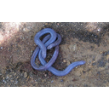
Iberian Worm Lizard (Blanus cinereus)

The Amphisbaenia are a poorly known group of limbless burrowing squamates, called amphisbaenians, or worm lizards. While the monophyly of Amphisbaenia is well supported, their affinities to other squamate groups remain unresolved. For more information regarding the position of the Amphisbaenia in squamate phylogeny, please refer to the Squamata heading.
Diversity and Lower Taxonomy
There are approximately 169 species of amphisbaenian, contained within 24 well-established genera. The position of these genera at the family-level, however, has been the subject of scientific debate.
In 2003, Kearney performed a comprehensive morphological cladistic analysis of the Amphisbaenia, and proposed the following five families (including one new family, Blanidae, previously placed in Amphisbaenidae):
- Bipedidae - conaining three species in the single genus Bipes. These are the only amphisbaenians to have forelimbs.
- Blanidae - containing four species in the genus Blanus.
- Amphisbaenidae - containing 153 species divided between 13 genera. The most speciose genus is Amphisbaena (69 species).
- Trogonophidae - containing six species in four genera.
- Rhineuridae - containing the monospecific Rhineura floridana.

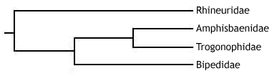
The family status of the four remaining genera - Aulura, Dalophia, Leposternon, and Monopeltis - was not resolved, but they were placed in the superfamily Rhineuroidea with the family Rhineuridae. These are united by the possession of a shovel-like skull shape, amongst other characteristics (see below).
See below for the synapomorphies of these clades.
Since Kearney's (2003) phylogeny, molecular studies have demonstrated a different evolutionary history for the Amphisbaenia. In 2004, Macey et al. analysed the full mitochodrial genomes of 12 amphisbaenian species in four families (Blanidae was not recognised in this study, and no Blanusspecies were used) - a total of 5797 parsimony informative sites. They found that the family Rhineuridae was the first to split from other extant amphisbaenians, followed by the family Bipedidae - a reversal of the relationships proposed by Kearney (2003). Both, however, agreed on the nested position and monophyly of the Amphisbaenoidea - the clade formed of the sister families Amphisbaenidae and Trogonophidae. The cladogram below illustrates Macey et al.'s results:
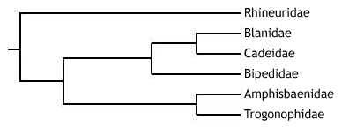
An even more recent study (Vidal et al. 2007) proposed, using molecular and biogeographic evidence, that the Cuban genus Cadea should be removed from the family Amphisbaenidae, and placed in its own new family, Cadeidae, as sister group to Blanidae. The Blanidae-Cadeidae clade was sister to the Bipedidae, together forming the sister group to the Amphisbaenoidea. Like Macey et al. (2004), Rhineuridae was the first family to diverge.
Description
Amphisbaenians are highly specialised for a fossorial (burrowing) mode of life. Almost all are completely limbless, except the three species of the Mexican genus Bipes, which have small, well-developed forelimbs. All are elongate, ranging in size from around 10 to 70 cm, with a long trunk region and short tail (the musculature required for burrowing is present in the trunk).
They have an extremely distinctive skin, consisting of conspicuous rings of scales, called annuli, which encircle the trunk. Only loosely connected to the main trunk, this specialised integument forms a tube in which the animal can move forwards and backwards. This is key to the ability of amphisbaenians to burrow. An amphisbaenian can use longitudinal muscular contractions between each annulus to bunch up the skin in order to anchor a part of the body in the soil. Trunk muscles can then be used to move the body forward within the integumentary tube. The front can then be anchored whilst the posterior integument is brought forward, after which the cycle can restart, allowing the amphisbaenian to advance.
Amphisbaenians are headfirst burrowers, and so the skull is highly modified for digging. While all have a rigid, compact skull, there are three main amphisbaenian skull types, which are functionally related to the way in which they burrow:

- "Shovel-headed" (e.g. Rhineura and Leposternon) - dorsoventrally flattened snout, with a sharp craniofacial angle. Amphisbaenians with this skull form dig by forcing the head forwards and slightly downwards, and then lifting the head dorsally to pack the soil onto the top of the tunnel. The sides of the tunnel are smoothed with the pectoral musculature.
- "Spade-headed" (trogonophids) - again a dorsoventrally flattened snout, with a strong craniofacial angle. The burrowing method, is however, quite distinct. Trogonophids use the sharp sides of their head (called lateralcanthi) to shave off soil from the front of the tunnel in an oscillatory motion. Soil is pushed and packed using the sides of the head and the body.
- "Keel-headed" (e.g. Anops and Mesobaenia) - laterally compressed head. These amphisbaenians dig by ramming the head forwards, and then push and pack soil rearwards by forcing the head alternately left and right.
- "Round-headed" or "bullet-headed" (the majority of amphisbaenians, e.g. Amphisbaenia, Blanus, Cadea,Zygaspis) - dig by using the head as a simple battering ram, followed by pushing the head in different directions to pack soil.

While the majority of amphisbaenians have a similar appearance, close to that described above, some are more distinct, and warrant further description. As already noted, members of the family Bipedidae (genus Bipes) have functional forelimbs. These are used for the initial surface excavation of a tunnel, and the first digit possesses extra phalanges to increase the efficiency of this digging process.
The trogonophids (family Trogonophidae) also have some features that make them distinct. First, they have a triangular cross-section, as opposed to cylindrical. Second, they have an acrodont dentition, in contrast to the pleurodont dentition of other amphisbaenians. Third, they do not exhibit caudal autotomy (the ability to self-amputate the tail). Finally, they are "spade-headed" and exhibit a unique burrowing behaviour (see above).
Distribution and Habitat
While the majority of amphisbaenians are located in Africa and South America (members of Amphisbaenidae, Blanidae, and Trogonophidae), others are present in Florida (Rhineura floridana), Cuba (Cadea spp.), the Carribean (members of Amphisbaenidae), Mexico (Bipedidae), the Middle East (members of Trogonophidae), and the Mediterranean region (members of Blanidae).
All amphisbaenians burrow in soil or dry, loose sand.
Conservation Status (IUCN)
Only nine species of amphisbaenian are present on the IUCN Red List. All of these are listed as Least Concern (LC), and have been assessed since at least 2006.
Synapomorphies of the Amphisbaenia and its families (sensu Kearney 2003)
- Amphisbaenia:
- High degree of cranial consolidation.
- Brain completely surrounded by frontal bone (anteriorly) and enlarged, azygous orbitosphenoid plate (ventrally).
- Presence of annuli - ring-like arrangement of scales.
- Enlarged median tooth in the premaxillary bone of the upper jaw. This tooth fits into a groove between the two lower teeth, forming an efficient 'nipper' that can take a chunk of flesh from its prey.
- Modified extracolumellar system of the ear, sensitive to low frequency sounds - improving subterranean hearing.
- Absence of the epipterygoid.
- Right lung reduced in size or lost (in contrast to other limbless squamates, which show reduction of the left lung).

- Family Bipedia only:
- Presence of (functional) forelimbs, with anteriorly shifted pectoral girdle.
- Fused fronto-parietal complex.
- Digit I exhibits polyphalangy (the presence of extra phalanges).

- Family Blanidae only:
- Reduced clavicles.
- Anteriorly truncated nasals.

- Family Amphisbaenidae only:
- Absence of squamosal.
- Absence of the sternum.

- Family Trogonophidae only:
- Acrodont dentition.
- Absence of caudal autotomy - no fracture planes to self-amputate.
- Strong craniofacial angle.
- Enlarged sternal plate.
- Short tail.

- Family Rhineuridae only:
- Anterior edge of the snout is squared-off.
- External naris opens ventrally.
- Pterygoid vomer contact.
- Absence of posterodorsal rib processes.

Anguimoprpha - monitor lizards, glass lizards, and relatives

Lepidosauria; Squamata; Anguimorpha

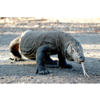  Komodo dragon (Varanus Komodoensis) | 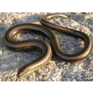  Slow-worm (Anguis fragilis)

Iguania - iguanas, chamaeleons, and agamids

Lepidosauria; Squamata; Iguania

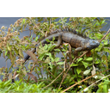  Green Iguana (Iguana iguana) | 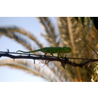  Common Chameleon (Chamaeleo chamaeleon) | 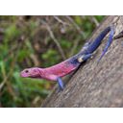  Mwanza flat-headed agama (Agama mwanzae)

To learn more about their place in squamate phylogeny, please return to the Squamata heading.
Diversity and Lower Taxonomy
Like most other squamate groups, the taxonomy of the over 1550 species-rich Iguania has long been a topic of dispute. An early classification of the Iguania by Charles Camp in 1923 defined three families:
- Iguanidae - Approximately 956 species of iguanas, anoles, horned lizards, collared lizards, and relatives.
- Chamaeleonidae - Approximately 178 species of chamaeleon.
- Agamidae - Approximately 416 species of agamid, such as the gliding Draco, and the thorny devil Moloch horridus.

This simple classification remained for over 50 years, but there became a strong need to readdress these relationships in a phylogenetic framework, i.e. one that uses cladistics to understand evolutionary history by identifying monophyletic groups, or clades. This led Etheridge and de Queiros (1988) to examine the contents of the family Iguanidae and, through analysis of morphological characteristics, identify eight major groups within. These were the subfamilies Corytophaninae (helmet lizards), Crotaphytinae (collared lizards),Hoplocercinae (dwarf and spiny tail iguanas), Iguaninae (iguanas), Oplurinae (Madagascan iguanas), Phrynosomatinae (spiny lizards, horned lizards, and relatives), Polychrotinae (anoles), andTropidurinae (neotropical ground lizards).
After further study, however, Frost and Etheridge (1989) failed to find sufficient support for the monophyly of Iguanidae, and so proposed to raise the eight subfamilies to family status (all had the same name but with a -dae suffix rather than a -nae suffix). While some authors still use this taxonomy, many refute it. For example, Macey et al. (1997) found strong support for the monophyly of the traditional Iguanidae using a combined morphological and DNA sequence analysis, and proposed that the families promoted by Frost and Etheridge (1989) be returned to their initial statuses as subfamilies of Iguanidae. This was corroborated by more comprehensive combined analyses by Schulteet al. (1998, 2003), who also brought into question the monophyly of two of the subfamilies of the Iguanidae, the Tropidurinae and Polychrotinae. The monophyly of all the remaining subfamilies was strongly supported, although the phylogenetic interrelationships between these subfamilies failed to be reconciled.
The sister group to the Iguanidae is the monophyletic Acrodonta (Estes et al. 1998). This contains the remaining iguanians: the chamaeleons and agamids. Within the Acrodonta, studies such as Maceyet al. (1997, 2000) have found little statistical support for the monophyly of the traditional family Agamidae. That is, some agamids may be more closely related to the chamaeleons than to other agamids. Nonetheless, it is useful to use the term Agamidae in the meantime, as what is termed ametataxon - a traditionally recognised group whose monophyly is statistically uncertain. Macey et al. (2000) defined six agamid subfamilies:
- Agaminae - the African-West Asian clade of agamids, containing 6 genera, including Agama.
- Amphibolurinae - the clade comprising the Chinese water dragon, Physignathus cocincinus, plus all Australian or New Guinean agamids, in 14 genera.
- Draconinae - the South Asian clade of agamids, containing 14 genera, including the gliding Draco.
- Hydrosaurinae - the sailfin lizards, Hydrosaurus.
- Leiolepidinae - the butterfly lizards, Leiolepis.
- Uromastycinae - the spiny-tailed lizard, Uromastyx.

The following cladogram illustrates the evolutionary history of these taxa, as proposed by Macey et al. (2000). While the monophyly of the subfamilies was well supported, among the group phylogenetic relationships and the monophyly of Agamidae shown in the diagram received little statistical support.

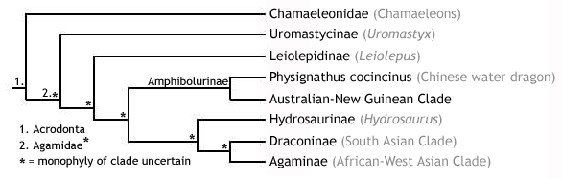
The chamaeleons, on the other hand, remain in the monophyletic clade Chamaeleonidae. This family is divided into two subfamilies, Brookesiinae (containing three genera, including Brookesia) andChamaeleoninae (containing 6 genera, including Chamaeleo).
Description
The iguanids. Living agamids are a highly diverse group of average to large-sized lizards with a wide range of specialisations. As a result, it would be difficult to describe the appearance of a "typical" agamid. For example, members of the South Asian arboreal genus Draco (subfamily Draconinae) have evolved extremely elongate, protruding ribs, which stretch the skin out into two wing-like patagial membranes, allowing individuals to perform extensive glides between trees (recorded as far as 60 m, with only a 10 m descent). Some groups possess modified spiny scales, which may cover the body (as in the Australian thorny devil, Moloch horridus) or the tail (as in members of the genus Uromastyx), while another group, the Southeast Asian sailfin lizards (Hydrosaurus), possess a laterally compressed dorsal extension of the tail, making them proficient swimmers.
Most agamids are diurnal, feeding mainly on insects and other small prey. A few, e.g. Uromastyx, are partly herbivorous. They are all oviparous, except for members of the genus Phrynocephalus, which give birth to live young (viviparous).
The chamaeleons are a familiar and charismatic group of lizards, with a large suite of unique physical characteristics making them extremely distinct. Ranging in size from around 2.5 cm (e.g. Brookesia spp.) to over 50 cm (e.g. Furcifer oustaleti), they are probably most famous for their ability to change colour - made possible by the presence of specialised chromatophores (cells containing pigment that reflect light) in the skin - which is often used in social signalling. The body of a chamaeleon is laterally compressed, and the head often bears many horns and ridges. These features are likely to play a role in sexual selection, as males are usually considerably more ornamented than females.
Chamaeleons are highly specialised for arboreal life. Not only do they have a strong grasping prehensile tail, but their feet are zygodactylus - meaning that two digits face forwards and two face rearwards, allowing a firm grip on a branch. In addition, they have an extremely long, rapidly protractable tongue, with which insect prey can be seized efficiently from a distance often as far away as the length of their own body. This kind of accuracy is afforded by the positioning of their eyes, which are bulbous and protruding, allowing the two fields of vision to overlap and result in stereopsis(depth perception). The eyes can also be moved independently. The tip of the tongue is highly muscular and covered in mucus, forming a suction cup that is extremely difficult for prey to escape.
Distribution and Habitat
- Iguanids
- Agamids are distributed throughout Asia, Oceania, Africa, and Europe. Thus, they are a strictly Old World group. Inhabiting areas from desert to tropical rainforest, they are mostly terrestrial, although some groups, e.g. Draco, are abrboreal.
- Chamaeleons are mainly found in Africa and Madagascar, but a few species occur in Southern Europe, the Middle East, and Asia. Like agamids, chamaeleons are an Old World group. They are, for the most part, an arboreal group, again inhabiting regions as diverse as desert to tropical rainforest.

Conservation Status (IUCN)
There are 223 species of iguanid present on the IUCN Red List. Almost 25% of these are recognised as either Critically Endangered (CR; 5%), Endangered (EN; 7%), or Vulnerable (VU; 12%). Thankfully, the majority (55%) are considered Least Concern (LC). The remainder are either Near Threatened (NT; 4%) or Data Deficient (DD; 17%).
Only 13 of the 416 species of agamid are present on the Red List. Of these, 2 are Critically Endangered (CR), whilst 2 are Endangered (EN), and 3 are Vulnerable (VU). Of the remaining 6 species, 2 are Data Deficient (DD), and the rest are Lower Risk (LR) - either Near Threatened (NT) or Least concern (LC).
There are 9 species of chamaeleon on the Red List. Smith's dwarf chamaeleon, Bradypodion taeniabronchum, is the only Critically Endangered (CR) species. Of the rest, 2 are Endangered (EN), 4 are Vulnerable (VU), and 2 are Near Threatened (NT).
Synapomorphies of the Iguania and Acrodonta
- Iguania:
  - Postfrontal either reduced or absent.
  - Anteroventral margin of the orbit formed by the jugal.
  - Ridges near the orbital margin.
  - Frontal shelf underlying the nasal.
  - Pineal foramen located on the frontoparietal suture or within frontals.
  - Articular separate from prearticular and surangular.
  - A contact between the jugal and squamosal along the upper temporal arch.
- Acrodonta
  - Acrodont dentition.
  - No replacement teeth.
  - Postfrontal absent.
  - Contact between palatines across the entire midline.
  - No intravertebral fracture planes for caudal autotomy.
  - No depression on ventral surface of the pterygoid.
  - Unique mitochondrial gene order, involving the rearrangement of two tRNA genes - a molecular synapomorphy.

Serpentes - snakes

Lepidosauria; Squamata; Serpentes

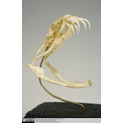  Lateral view of Gaboon Viper skull | 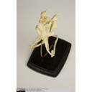  Dorsal view of Gaboon Viper skull | 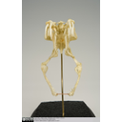  Front view of Gaboon Viper skull

The Serpentes, commonly known as snakes, are a familiar and well defined group, whose monophyly has strong support from a suite of both morphological and molecular characteristics (see below). Their position within the squamates, however, has proved extremely difficult to resolve. For more information regarding higher level squamate phylogeny, please refer to the Squamata heading.

Diversity and Lower Taxonomy
Extant snakes are divided into two well-supported monophyletic sister groups: the Scolecophidia and the Alethinophidia.

Description
- Scolephidians are a poorly known group of snakes that are small, fossorial, and worm-like.
- Alethinophidians, however, are the more familiar group, possessing what would generally be considered a snake-like body. They are generally larger and less fossorial.

Features
- Limbless, but many retain traces of a pectoral girdle. Members of some of the more primitive families, such as the boas and pythons (contained within the superfamily Booidea), show external traces in the form of vestigial hind limbs, called anal spurs, which flank the cloacal opening and are now only used for clasping during courtship.
- Well-developed chemosensation, with forked tongue.
- Highly kinetic skull with eight points of rotation, allowing large prey to be swallowed whole. Each side of the skull can move independently.
- Many elements of the skull reduced or lost, facilitating the evolution of kinesis.
- The two sides of the mandible are loosely connected with cartilage at the rostral midline (in other jawed vertebrates, the two sides of the mandible are strongly fused to form the mandibular symphysis).
- Recurved teeth, preventing the escape of seized prey victims.
- No external ear openings.

Glossary

A

akinetic
In anatomy, this refers to a low level of flexibility in a structure due to a lack of moveable joints.

amniote
Those vertebrates with an amniotic egg. The extant clades are Testudines (turtles), Diapsida (lepidosaurians, crocodilians, and birds), and Synapsida (mammals).

anapsid
Skull possessing no temporal fenestrae (NB. an- = without).
Amniotes with this skull condition form a paraphyletic group including the Parareptilia (turtles and their extinct relatives), the extinct common ancestor of all amniotes, and basal eureptiles (the extinct precursors of diapsids).
Note that the Testudines (turtles and relatives) have modified the anapsid condition through a reduction (emargination) of the posterior region of the skull.

Apatite
Calcium phosphate: the crystalline component of bone.

apomorphy
A derived or specialised character.

Appendicular skeleton
The endoskeletal element of the fins or limbs of a vertebrate, and their associated girdles (pectoral or pelvic).

Axial skeleton
All parts of the vertebrate endoskeleton except the limbs or fins and their associated girdles. That is, the cranium, visceral skeleton, notochord, vertebrae, and ribs.

B

Basal
Of, relating to, located at, or forming a base.

Bicuspid
A tooth bearing two cusps.

C

Calcified cartilage
Cartilage strengthened with a scattering of apatite crystals (calcium phosphate), as seen in Chondrichthians.

Cartilage
A tough, elastic, fibrous connective tissue composed of collagen fibres. Used as skeletal tissue in vertebrates, it is non-mineralised and is often the developmental precursor of bone.

Clade
A phylogenetic lineage comprising a common ancestor and all its descendant species.
Note that the difference between a taxon and a clade is that a clade must include all descendant species from a common ancestor, whereas a taxon need not.

cladistic
Relating to the branching sequences of phylogeny.

cladogram
A branching tree-like diagram representing the phylogenetic relationships (evolutionary history) of a lineage.

cloaca
The common opening for the reproductive, urinary, and digestive tracts, seen in all vertebrates except therian mammals (marsupials and placental mammals).

The term comes from the Latin for sewer.

Cursorial
Adapted for running.

Cusp
The biting point of a tooth.

D

Dentary
The anterior bone of the lower jaw which bears the teeth. It forms the whole of the lower jaw in mammals.

Dentine
A bone-like substance, lacking cell bodies and consisting mainly of calcium phosphate (apatite) in a fibrous matrix.

Dermal bone
A type of bone forming within the dermis - the deep layer of vertebrate skin cells below the surface layer, the epidermis.

diapsid
Skull possessing both an upper and a lower temporal fenestra (NB. di- = two).
Amniotes with this skull condition form the monophyletic clade Diapsida, which includes the lepidosaurs (lizards, snakes, and tuatara), archosaurs (crocodilians, dinosaurs, and birds), and their other extinct relatives.
Note that some diapsids, such as lizards, have lost the temporal bar separating the fenestrae to form one large window. Others, such as the Aves (birds), have merged both fenestrae with the orbit.

E

Enamel
The crystalline material covering the crown of a tooth, or certain scales.

Endopterygota
A clade of insects charachterised by their undergoing complete metamorphosis (i.e. holometabolous).
See Insect Diversity WebBook for the clades within (from Neuroptera down).

Epidermal
Pertaining to, or originating from, the epidermis - the surface layer of skin cells in vertebrates

euryapsid
Skull possessing an upper temporal fenestra only.
However, animals with this skull condition do not represent an important amniote lineage, as they are likely to be a polyphyletic group, originating a least twice within the Diapsida. Euryapsids include the plesiosaurs and ichthyosaurs - Mesozoic marine reptiles.

extant
Not extinct.

F

fossorial
Specialised for burrowing.

furcula
The fused clavicle bones of a bird, also known as the wishbone.

H

Hemimetabolous
Refers to a type of insect development that is categorised by three distinct, progressive life stages: egg, nymph, imago (adult). Changes are gradual, with no pupal stage.
Some hemimetabolous insects include grasshoppers, cicadas, cockroaches, termites, earwigs, and dragonflies.
Also termed incomplete metamorphosis.

Holometabolous
Refers to a type of insect development that is categorised by four distinct, progressive life stages: embryo, larva, pupa, imago (adult).
Seen exlusively in the Endopterygota, which includes beetles, butterflies, wasps, bees, ants, and others.
Also termed complete metamorphosis.

Horny
Consisting of horn - a tough material composed mainly of keratin.

I

ilium
In tetrapods, the dorsal section of the pelvis, which articulates with one or more sacral vertebrae.

K

Kinetic
In anatomy, referring to a high level of flexibility afforded by numerous moveable joints.

L

Lymph heart
Muscular dilation in a lymph vessel, which pumps lymph (fluid containing white blood cells called lymphocytes important in immune response) around the body of some lungfishes, amphibians and reptiles.

M

Metacone
In mammals, the metacone is the distobuccal (rear-most and cheek side) cusp of an upper molar tooth.

monophyletic
Having a single evolutionary origin. A taxon is monophyletic if it contains all the descendants of a common ancestor.

For example, mammals are a monophyletic group, as all species descended from the first known mammal are considered mammals.

See paraphyletic and polyphyletic for alternative terms.

Myrmecophagy
Feeding behaviour categorised by an exclusive (or near exclusive) diet of ants ant termites.

O

Orbit
The bony socket of the eye.

Osteosclerosis
An increase in the density of bone.

P

Pachyostosis
A thickening of the bone, often associated with a reduction in the volume of marrow tissue contained within.

Paracone
In mammals, the paracone is the mesiobuccal (front-most and cheek side) cusp of an upper molar tooth.

Paraphyletic
A taxon including a common ancestor and some but not all of its descendants.
For example, the class Reptilia is paraphyletic, as it does not include birds, who are considered a separate class: Aves. However, birds evolved from theropod dinosaurs, and are therefore reptiles themselves. Similarly, all tetrapods are, evolutionarily speaking, lobe-finned fish.
Importantly, reptiles can be made monophyletic through the addition of birds to the taxon.
See monophyletic and polyphyletic for alternative terms.

Pectoral girdle
In vertebrates, the skeletal structure that provides support for the fore limbs or fins.

Pelvic girdle
In vertebrates, the skeletal structure that provides support for the hind limbs or fins, which also fuses with the sacral vertebrae.

phylogeny
The evolutionary history of organismal lineages as they develop through time.

plesiomorphy
An ancestral character.

polyphyletic
Referring to a group that does not contain the common ancestor of all the taxa within. Therefore, this is not a true taxonomic group, but is often a term used to categorise organisms with a similar ecology, such as insectivorious mammals, or marine mammals.
It is also used when the evolutionary origin of a group, such as snakes, is unsure, and characteristic species within may have originated separately.

Protocone
In mammals, the protocone is the mesiolingual cusp of an upper molar tooth.

Pulp cavity
The space within a tooth, or a dentine scale, occupied by blood vessels and nerves.

S

symplesiomorphy
A character that is shared between groups but was inherited from an ancestor prior to the last common ancestor.
These are characters that - at the level at which they are referred to as symplesiomorphies - are not used to form cladistic groupings, or clades.

synapomorphy
A derived or specialised character that is shared between two or more groups, and was inherited from the common ancestor in which it originated.
These are the characters that morphological systematists use to support the existence of particular clades, forming the basis of the field of cladistics.

synapsid
Skull possessing a lower temporal fenestra only.
Amniotes with this skull condition form the monophyletic clade Synapsida, which includes the mammals and their extinct ancestors, the non-mammalian reptile-like synapsids.
Note that in the Mammalia, the lower temporal fenestra has merged with the orbit.

T

taxon
A group of organisms sharing a common ancestry.
Note that the difference between a taxon and a clade is that a clade must include all descendant species from a common ancestor, whereas a taxon need not.
Pl. taxa.

temporal fenestra
An opening in the temporal region of the skull seen in amniotes, providing a flat edge for the attachment of strong lower jaw closing muscles to the skull.
Amniotes show four skull types, based on the position and number of these temporal fenestrae, two of which define two major lineages of the amniotes. The skull types and associated groups are as follows:
1) Synapsid - Skull possessing a lower temporal fenestra only. Amniotes with this skull condition form the monophyletic clade Synapsida, which includes the mammals and their extinct ancestors, the mammal-like reptiles. Note that in the Mammalia, the lower temporal fenestra has merged with the orbit.
2) Diapsid - Skull possessing both an upper and a lower temporal fenestra (NB. di- = two). Amniotes with this skull condition form the monophyletic clade Diapsida, which includes the lepidosaurs (lizards, snakes, and tuatara), archosaurs (crocodilians, dinosaurs, and birds), and their other extinct relatives. Note that some groups within the Diapsida, such as lizards, have lost the temporal bar separating the fenestrae to form one large window. Others, such as the Aves (birds), have merged both fenestrae with the orbit.
3) Anapsid - Skull possessing no temporal fenestrae (NB. an- = without). Amniotes with this skull condition form a paraphyletic group including the Parareptilia (turtles and their extinct relatives), the extinct common ancestor of all amniotes, and basal eureptiles (the extinct precursors of diapsids). Note that the Testudines (turtles and relatives) have modified the anapsid condition through a reduction (emargination) of the posteriorregion of the skull.
4) Euryapsid - Skull possessing an upper temporal fenestra only. However, animals with this skull condition do not represent an importantamniote lineage, as they are likely to be a polyphyletic group, originating a least twice within the Diapsida. Euryapsids include the plesiosaurs and ichthyosaurs - Mesozoic marine reptiles.

V

vertebrae
From anterior to posterior:
Cervical vertebrae: Facilitate the mobility of the head. The first two, the atlas and the axis are highly specialised, the former articulating with the occipital region of the skull.
Thoracic vertebrae: Articulate with the ribs that fuse with the sternum.
Lumbar vertebrae: Generally larger, with small ribs not attached to the sternum, which support the posterior musculature.
Sacral vertebrae: Fused to the pelvic girdle, allowing the transfer of force from the appendicular skeleton (limbs) during locomotion.
Caudal vertebrae: Small and less specialised, forming the tail.

Vertebrate anatomical directions and axes
The image below illustrates the terms used for anatomical directions and axes in vertebrates.
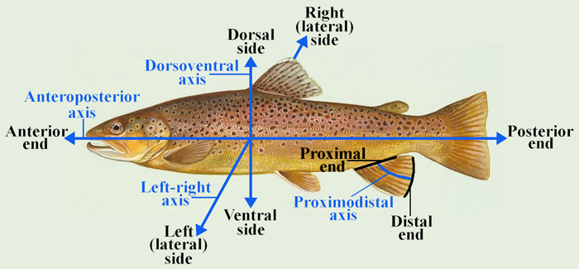

Vestigial
Occurring as a structure that, once functional (whether during development or in earlier evolutionary forms), is now reduced or degenerate. An example is the vestigial pelvic girdle seen in many snakes, including the boas and pythons, which bears no function.

Z

Zygapophysis
Articular process of a vertebra that articulates with the corresponding process of an adjacent vertebra.
Plural = zygapophyses

