Vertebrate Palaeontology and Evolution study pack

This resource is designed to familiarise you with the structure, diversity and evolutionary history of vertebrates through analysing images of specimens held at UCL’s Grant Museum of Zoology. It contains seven chapters: an introduction to vertebrate diversity, Fishes, the fish-tetrapod transition, Amphibians and Amniotes, Lepidosaurs and Chelonians, Archosaurs, and Birds and flight. All images have accompanying text, including information about the specimen plus hints about what to look for and the questions to consider when analysing the images. Please note that this resource does not look at mammals in detail – instead, this fascinating group are given a more thorough treatment in another Object Based Learning for Higher Education (OBL4HE) resource entitled ‘Vertebrate Diversity’ and the Virtual Educational Resource for the Biosciences (VERB) resource ‘Eutherians’.

- Verb Diversity: https://open-education-repository.ucl.ac.uk/id/eprint/204
- Eutherians (VERB): https://open-education-repository.ucl.ac.uk/id/eprint/210

Scalebars are provided throughout (except for models). Please note that there are two different scale bars used, one with 1cm divisions and one with 0.5cm divisions.

Multiple images of specimens are provided to try to illustrate the various anatomical features. However, please note that the limitations of photography (especially for specimens in cases or bottles) means that some distortion may occur or parts may be concealed or generally hard to determine.

To download this resource in its entirety, see the resource's collection page: https://open-education-repository.ucl.ac.uk/195/

Disclaimer: 'Vertebrate Palaeontology and Evolution' was originally designed by UCL staff as an internal teaching resource. The subsequent release of 'Vertebrate Palaeontology and Evolution' as an OER means that any changes to the product received relative to the original content may not reflect the desires of UCL teaching staff, or the original quality of the resource.

CC BY-NC-SA 4.0 International Licence: 'Vertebrate Palaeontology and Evolution' has been released as an open educational resource (OER) on a Creative Commons 'Attribution Non-commercial Share Alike' license. This means that once downloaded, content can be modified and improved to complement a particular course. This requires, however, that improvements are recycled back into the OER community, and full attribution is made to UCL. All content present at the time of download must be accordingly credited and, in turn, novel content must be appropriately licensed. For more information, please refer to the license deed by visiting: https://creativecommons.org/licenses/by-nc-sa/4.0/legalcode

Chapter 2: Fishes

This chapter will introduce you to various early vertebrates and fish. In particular, it covers some jawless forms, acanthodians, placoderms, sharks and rays, and several ray-finned fish. It is not essential that you look at the specimens in any particular order.

Contents
Chapter 2: Fishes 2
2.1 Pteraspis 5
2.2 Models of Pteraspis 5
2.3 Acanthodes 7
2.4 Gyrocanthus 8
2.5 Bothriolepis canadensis 9
2.6 Model of Bothriolepis 10
2.7 Cladoselache 12
2.8 Megalodon 13
2.9 Carcharodon angustidens 14
2.10 Myliobatis 15
2.11 Orodus (pavement tooth shark) 16
2.12 Rhinoptera 17
2.13 Palaeoniscus 17
2.14 Sturgeon 18
2.15 Lepidotes minor 21
2.16 Scombrocolupea 22
2.17 Clupea 22
2.18 Other taxa 23
Glossary 24

2.1 Pteraspis

Pteraspis is a small (usually just a few centimetres long) jawless fish from the Late Devonian of the U.K. This slab shows fragments of head-shield and several more complete individuals. Compare these specimens with the model (next section).

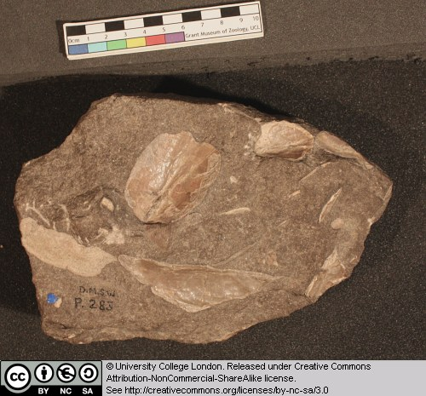
Figure 57 Above: Various elements of Pterapsis.

2.2 Models of Pteraspis

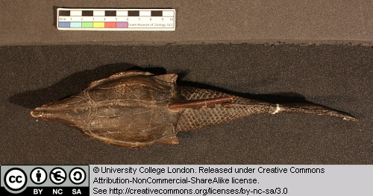
Figure 58 Above: Model Pterapsis seen from above.

This model of the jawless vertebrate Pteraspis are somewhat larger than the real animal, but give a fairly accurate idea of what we know about this form. Note the following features:
- The large head-shield.
- The smaller scales covering the posterior half of the animal.
- The hypocercal tail.
- The dorsal and lateral spines.

Can you identify the eyes, mouth, single combined gill opening, and nasal openings?

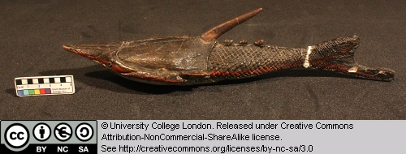
Figure 59 Above: Model Pterapsis seen from the right.

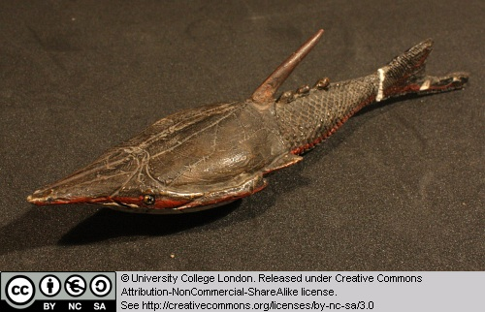
Figure 60 Above: Model Pterapsis seen from the front right.

2.3 Acanthodes

Acanthodian fish first appear in the Late Ordovician and die out in the Early Permian. They are of particular interest because they represent some of the earliest jawed vertebrates and may therefore provide clues to the origin of this highly successful feeding structure.

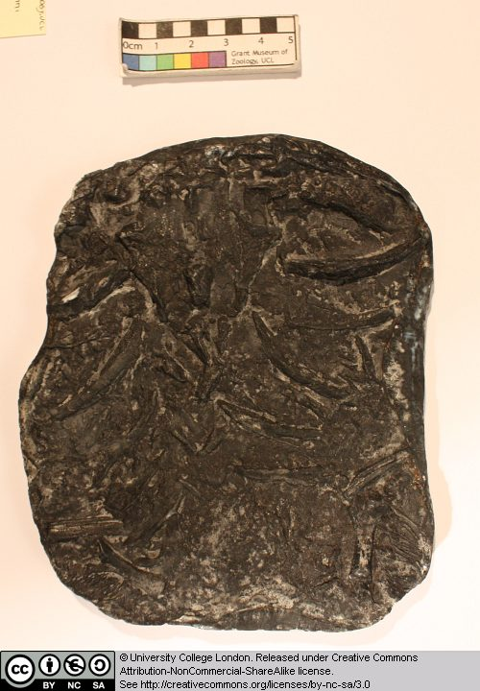
Figure 61 Above: Elements of Acanthodes.

This specimen of Acanthodes is not easy to interpret, but includes material from the jaws and gills. See if you can identify any of the jaw and gill elements.

2.4 Gyrocanthus

Gyrocanthus is an acanthodian fish (see Acanthodes for more details) from the Carboniferous.

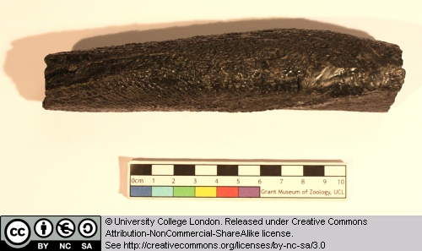
Figure 62 Above: Fin spine of Gyrocanthus seen from the side.

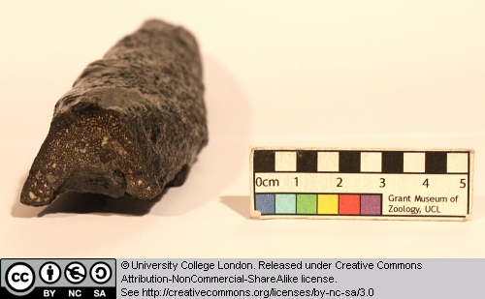
Figure 63 Above: broken distal end of the fin spine of Gyrocanthus.

This specimen is a fin-spine. Acanthodians are characterised by possessing a prominent spine along the leading edge of many of their fins.

2.5 Bothriolepis canadensis

This specimen is the head-shield of a placoderm in dorsal view. Placoderms were heavily armoured jawed fish that thrived during the Devonian. They had a nearly global distribution, and lived in marine and freshwater habitats. They range in size from a few centimetres to 10 metres or longer. One unique feature of the placoderms is the joint between the head-shield and the main trunk of the animal.

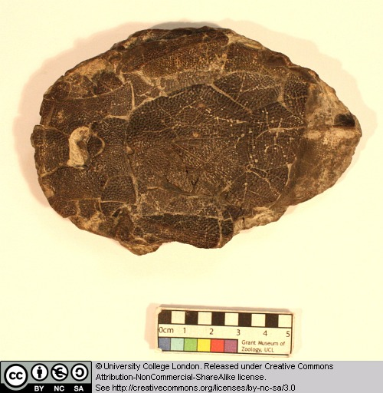
Figure 64 Above: Head shield of Bothriolepis seen from above (the front is to the left).

Bothriolepis itself grew to about 25cm in length. It is of Late Devonian age, and has been found on virtually every continent. Note the texture and pattern on the head-shield armour.

Compare this specimen with the models of Bothriolepis.

2.6 Model of Bothriolepis

This model provides a reasonably accurate picture of the appearance of the placoderm Bothriolepis. Compare this model with the head-shield preserved in the specimen of Bothriolepis.

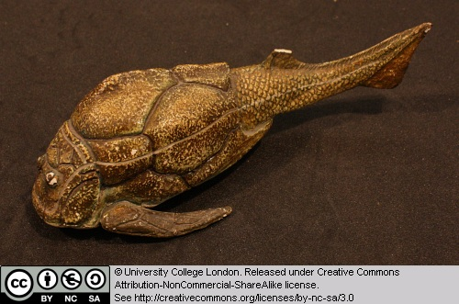
Figure 65 Above: Model of Bothriolepis seen from the left.

Identify the following features:
- The head-shield and its junction with the trunk.
- The lower jaw and mouth.
- The prominent eyes (this is characteristic of the placoderm subgroup known as Antiarchs).
- The pectoral fins.

What other fins can you identify?

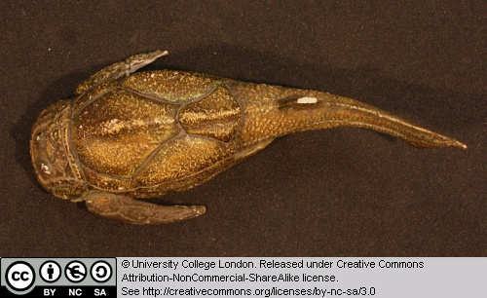
Figure 66 Above: Model of Bothriolepis seen from above.

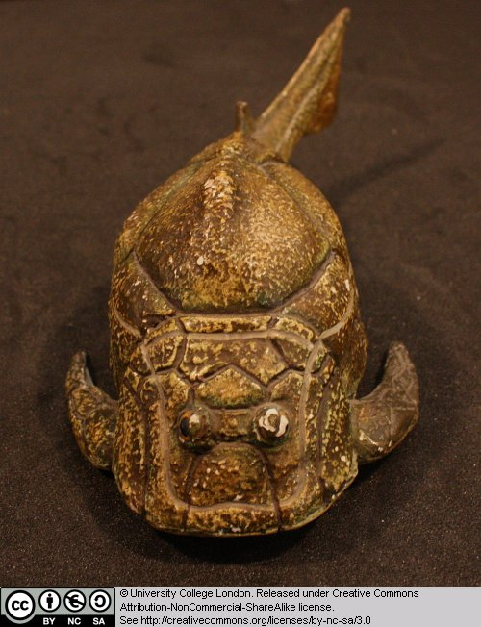
Figure 67 Above: Model of Bothriolepis seen from the front.

2.7 Cladoselache

Cladoselache is a shark from the Late Devonian of North America. This shark reached about 1 metre in length and probably fed on small fish.

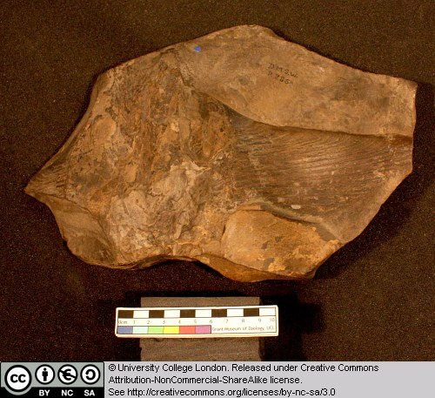
Figure 68 Above: Pectoral fin of Cladoselache.

Note the structure of this pectoral fin

2.8 Megalodon

Megalodon is a large shark from the Tertiary (see also Carcharodon). This specimen is a large triangular tooth. Note the shiny enamel, and the fine serrations.

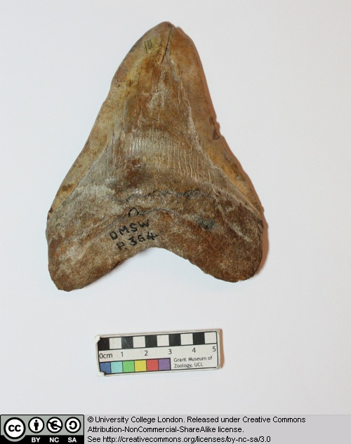
Figure 69 Above: Tooth of Megalodon.

2.9 Carcharodon angustidens

Carcharodon is a shark genus that includes the Great White shark. Some species, during the Tertiary, grew to gigantic sizes, though the evidence for this is mainly based on the discovery of large teeth. Do large teeth necessarily mean that this animal was a major predator of other large-bodied animals?

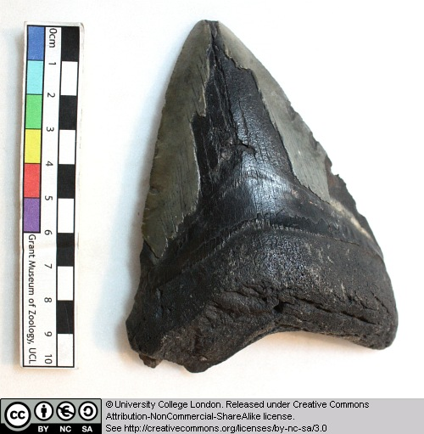
Figure 70 Above: Tooth of Carcharodon.

Note the shiny enamel and fine serrations.

2.10 Myliobatis

Myliobatis is a genus of ray that first appeared in the Late Cretaceous. It includes extant species such as the Eagle Ray, from the east Atlantic and around Britain. The Eagle ray can grow up to 1.8 m long. It feeds on molluscs and crustaceans from the sea floor.

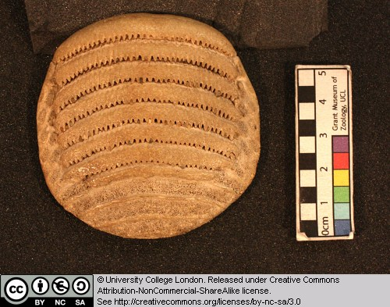
Figure 71 Above: Tooth plate of Myliobatis seen from below (the front of the plate is to the top).
This specimen is one of the crushing tooth-plates with a rasp-like surface.

2.11 Orodus (pavement tooth shark)

This is a member of the Holocephali (rat-fish), a third group of cartilaginous fish. Orodus comes from the Lower Carboniferous and therefore represents a very early member of this rat-fish radiation.

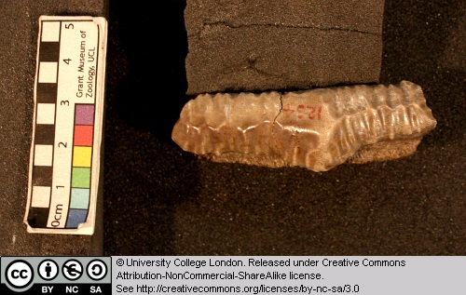
Figure 72 Above: Single tooth of Orodus seen from the side.

This specimen is a tooth.

2.12 Rhinoptera

Rhinoptera is an extinct ray that lived between the Late Cretaceous and Pliocene. It has been found in Europe, Africa, North and South America.

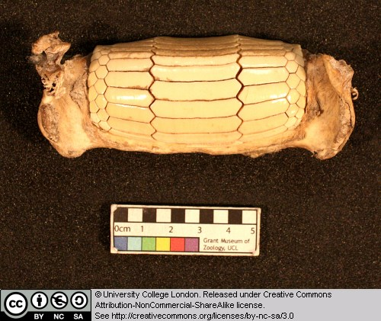
Figure 73 Above: Tooth battery of Rhinopters seen from below.

This specimen is a crushing tooth battery.

2.13 Palaeoniscus

Early members of the ray-finned fish radiation (i.e. those present during the late Palaeozoic) are sometimes referred to collectively as ‘palaeoniscids’. It is from somewhere within this early assemblage that we believe the ancestors of more advanced forms (sturgeons, gars, the Bowfin and ultimately the teleost fish) arose.

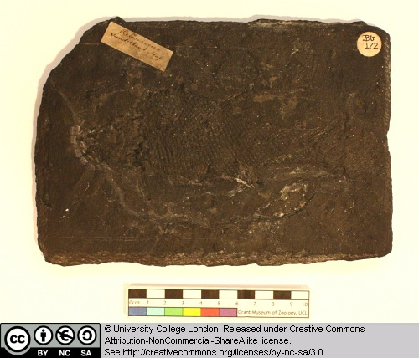
Figure 74 Above: Cast of a fossil of the fish Palaeoniscus, the head is to the left.

Palaeoniscus comes from the Late Permain of Germany. Note the major fins and head structures etc. and the presence of the primitive heterocercal tail.

2.14 Sturgeon

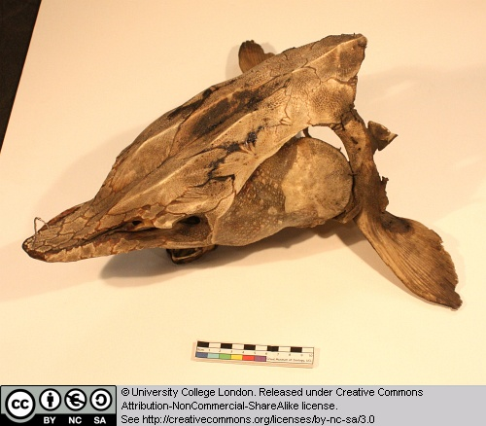
Figure 75 Above: Head of a sturgeon, seen from above left.

This mass of elements represent parts of the skeleton and armour of an extant sturgeon. Try to identify some of these elements.

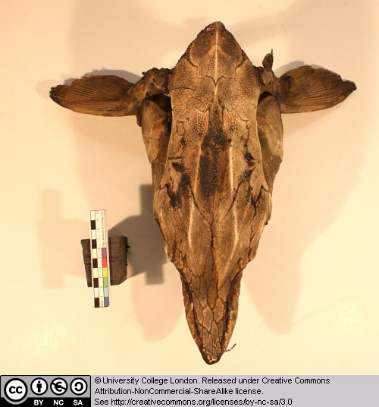
Figure 76 Above: Head of a sturgeon, seen from above.

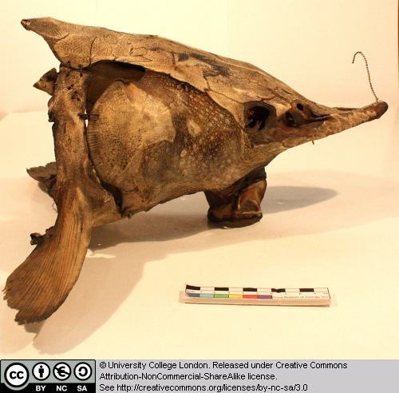
Figure 77 Above: Head of a sturgeon, seen from the left.

2.15 Lepidotes minor

Lepidotes is a ray-finned fish from the Jurassic. It is relatively advanced compared to the palaeoniscid-like forms, but retains several plesiomorphic features with regard to teleosts. Note the scale pattern and other major features such as fins, operculum, head structures and so on.

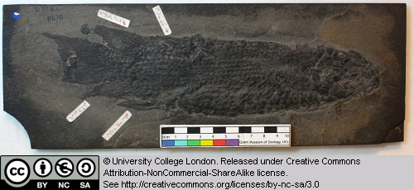
Figure 78 Above: Fossil of the fish Lepidotes, seen on the left side (the head is to the right).

2.16 Scombrocolupea

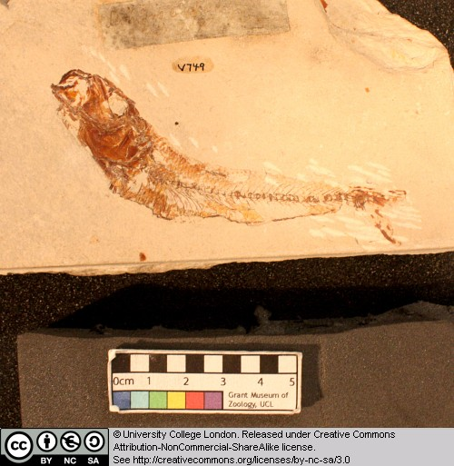
Figure 79 Above: Fossil of the fish Scombrocolupea, seen from the left.

This ray-finned fish belongs to the same group of teleosts as the perch, sailfish, tuna and mackerel.

2.17 Clupea

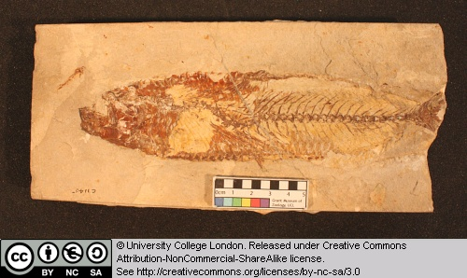
Figure 80 Above: Fossil of the fish Clupea, seen from the left.

Clupeiformes is the order of Ray-finned fish that includes herrings, anchovies and sardines. They tend to be fairly small open water or coastal fish, that feed on plankton, small fish and crustaceans.

2.18 Other taxa

The skate Raja batis, the fossil fish Lepidotes minor and the modern bowfin Amia were all featured in Chapter 1.

Glossary

A

akinetic
In anatomy, this refers to a low level of flexibility in a structure due to a lack of moveable joints.

amniote
Those vertebrates with an amniotic egg. The extant clades are Testudines (turtles), Diapsida (lepidosaurians, crocodilians, and birds), and Synapsida (mammals).

anapsid
Skull possessing no temporal fenestrae (NB. an- = without).
Amniotes with this skull condition form a paraphyletic group including the Parareptilia (turtles and their extinct relatives), the extinct common ancestor of all amniotes, and basal eureptiles (the extinct precursors of diapsids).
Note that the Testudines (turtles and relatives) have modified the anapsid condition through a reduction (emargination) of the posterior region of the skull.

Apatite
Calcium phosphate: the crystalline component of bone.

apomorphy
A derived or specialised character.

Appendicular skeleton
The endoskeletal element of the fins or limbs of a vertebrate, and their associated girdles (pectoral or pelvic).

Axial skeleton
All parts of the vertebrate endoskeleton except the limbs or fins and their associated girdles. That is, the cranium, visceral skeleton, notochord, vertebrae, and ribs.

B

Basal
Of, relating to, located at, or forming a base.

Bicuspid
A tooth bearing two cusps.

C

Calcified cartilage
Cartilage strengthened with a scattering of apatite crystals (calcium phosphate), as seen in Chondrichthians.

Cartilage
A tough, elastic, fibrous connective tissue composed of collagen fibres. Used as skeletal tissue in vertebrates, it is non-mineralised and is often the developmental precursor of bone.

Clade
A phylogenetic lineage comprising a common ancestor and all its descendant species.
Note that the difference between a taxon and a clade is that a clade must include all descendant species from a common ancestor, whereas a taxon need not.

cladistic
Relating to the branching sequences of phylogeny.

cladogram
A branching tree-like diagram representing the phylogenetic relationships (evolutionary history) of a lineage.

cloaca
The common opening for the reproductive, urinary, and digestive tracts, seen in all vertebrates except therian mammals (marsupials and placental mammals).

The term comes from the Latin for sewer.

Cursorial
Adapted for running.

Cusp
The biting point of a tooth.

D

Dentary
The anterior bone of the lower jaw which bears the teeth. It forms the whole of the lower jaw in mammals.

Dentine
A bone-like substance, lacking cell bodies and consisting mainly of calcium phosphate (apatite) in a fibrous matrix.

Dermal bone
A type of bone forming within the dermis - the deep layer of vertebrate skin cells below the surface layer, the epidermis.

diapsid
Skull possessing both an upper and a lower temporal fenestra (NB. di- = two).
Amniotes with this skull condition form the monophyletic clade Diapsida, which includes the lepidosaurs (lizards, snakes, and tuatara), archosaurs (crocodilians, dinosaurs, and birds), and their other extinct relatives.
Note that some diapsids, such as lizards, have lost the temporal bar separating the fenestrae to form one large window. Others, such as the Aves (birds), have merged both fenestrae with the orbit.

E

Enamel
The crystalline material covering the crown of a tooth, or certain scales.

Endopterygota
A clade of insects charachterised by their undergoing complete metamorphosis (i.e. holometabolous).
See Insect Diversity WebBook for the clades within (from Neuroptera down).

Epidermal
Pertaining to, or originating from, the epidermis - the surface layer of skin cells in vertebrates

euryapsid
Skull possessing an upper temporal fenestra only.
However, animals with this skull condition do not represent an important amniote lineage, as they are likely to be a polyphyletic group, originating a least twice within the Diapsida. Euryapsids include the plesiosaurs and ichthyosaurs - Mesozoic marine reptiles.

extant
Not extinct.

F

fossorial
Specialised for burrowing.

furcula
The fused clavicle bones of a bird, also known as the wishbone.

H

Hemimetabolous
Refers to a type of insect development that is categorised by three distinct, progressive life stages: egg, nymph, imago (adult). Changes are gradual, with no pupal stage.
Some hemimetabolous insects include grasshoppers, cicadas, cockroaches, termites, earwigs, and dragonflies.
Also termed incomplete metamorphosis.

Holometabolous
Refers to a type of insect development that is categorised by four distinct, progressive life stages: embryo, larva, pupa, imago (adult).
Seen exlusively in the Endopterygota, which includes beetles, butterflies, wasps, bees, ants, and others.
Also termed complete metamorphosis.

Horny
Consisting of horn - a tough material composed mainly of keratin.

I

ilium
In tetrapods, the dorsal section of the pelvis, which articulates with one or more sacral vertebrae.

K

Kinetic
In anatomy, referring to a high level of flexibility afforded by numerous moveable joints.

L

Lymph heart
Muscular dilation in a lymph vessel, which pumps lymph (fluid containing white blood cells called lymphocytes important in immune response) around the body of some lungfishes, amphibians and reptiles.

M

Metacone
In mammals, the metacone is the distobuccal (rear-most and cheek side) cusp of an upper molar tooth.

monophyletic
Having a single evolutionary origin. A taxon is monophyletic if it contains all the descendants of a common ancestor.

For example, mammals are a monophyletic group, as all species descended from the first known mammal are considered mammals.

See paraphyletic and polyphyletic for alternative terms.

Myrmecophagy
Feeding behaviour categorised by an exclusive (or near exclusive) diet of ants ant termites.

O

Orbit
The bony socket of the eye.

Osteosclerosis
An increase in the density of bone.

P

Pachyostosis
A thickening of the bone, often associated with a reduction in the volume of marrow tissue contained within.

Paracone
In mammals, the paracone is the mesiobuccal (front-most and cheek side) cusp of an upper molar tooth.

Paraphyletic
A taxon including a common ancestor and some but not all of its descendants.
For example, the class Reptilia is paraphyletic, as it does not include birds, who are considered a separate class: Aves. However, birds evolved from theropod dinosaurs, and are therefore reptiles themselves. Similarly, all tetrapods are, evolutionarily speaking, lobe-finned fish.
Importantly, reptiles can be made monophyletic through the addition of birds to the taxon.
See monophyletic and polyphyletic for alternative terms.

Pectoral girdle
In vertebrates, the skeletal structure that provides support for the fore limbs or fins.

Pelvic girdle
In vertebrates, the skeletal structure that provides support for the hind limbs or fins, which also fuses with the sacral vertebrae.

phylogeny
The evolutionary history of organismal lineages as they develop through time.

plesiomorphy
An ancestral character.

polyphyletic
Referring to a group that does not contain the common ancestor of all the taxa within. Therefore, this is not a true taxonomic group, but is often a term used to categorise organisms with a similar ecology, such as insectivorious mammals, or marine mammals.
It is also used when the evolutionary origin of a group, such as snakes, is unsure, and characteristic species within may have originated separately.

Protocone
In mammals, the protocone is the mesiolingual cusp of an upper molar tooth.

Pulp cavity
The space within a tooth, or a dentine scale, occupied by blood vessels and nerves.

S

symplesiomorphy
A character that is shared between groups but was inherited from an ancestor prior to the last common ancestor.
These are characters that - at the level at which they are referred to as symplesiomorphies - are not used to form cladistic groupings, or clades.

synapomorphy
A derived or specialised character that is shared between two or more groups, and was inherited from the common ancestor in which it originated.
These are the characters that morphological systematists use to support the existence of particular clades, forming the basis of the field of cladistics.

synapsid
Skull possessing a lower temporal fenestra only.
Amniotes with this skull condition form the monophyletic clade Synapsida, which includes the mammals and their extinct ancestors, the non-mammalian reptile-like synapsids.
Note that in the Mammalia, the lower temporal fenestra has merged with the orbit.

T

taxon
A group of organisms sharing a common ancestry.
Note that the difference between a taxon and a clade is that a clade must include all descendant species from a common ancestor, whereas a taxon need not.
Pl. taxa.

temporal fenestra
An opening in the temporal region of the skull seen in amniotes, providing a flat edge for the attachment of strong lower jaw closing muscles to the skull.
Amniotes show four skull types, based on the position and number of these temporal fenestrae, two of which define two major lineages of the amniotes. The skull types and associated groups are as follows:
1) Synapsid - Skull possessing a lower temporal fenestra only. Amniotes with this skull condition form the monophyletic clade Synapsida, which includes the mammals and their extinct ancestors, the mammal-like reptiles. Note that in the Mammalia, the lower temporal fenestra has merged with the orbit.
2) Diapsid - Skull possessing both an upper and a lower temporal fenestra (NB. di- = two). Amniotes with this skull condition form the monophyletic clade Diapsida, which includes the lepidosaurs (lizards, snakes, and tuatara), archosaurs (crocodilians, dinosaurs, and birds), and their other extinct relatives. Note that some groups within the Diapsida, such as lizards, have lost the temporal bar separating the fenestrae to form one large window. Others, such as the Aves (birds), have merged both fenestrae with the orbit.
3) Anapsid - Skull possessing no temporal fenestrae (NB. an- = without). Amniotes with this skull condition form a paraphyletic group including the Parareptilia (turtles and their extinct relatives), the extinct common ancestor of all amniotes, and basal eureptiles (the extinct precursors of diapsids). Note that the Testudines (turtles and relatives) have modified the anapsid condition through a reduction (emargination) of the posteriorregion of the skull.
4) Euryapsid - Skull possessing an upper temporal fenestra only. However, animals with this skull condition do not represent an importantamniote lineage, as they are likely to be a polyphyletic group, originating a least twice within the Diapsida. Euryapsids include the plesiosaurs and ichthyosaurs - Mesozoic marine reptiles.

V

vertebrae
From anterior to posterior:
Cervical vertebrae: Facilitate the mobility of the head. The first two, the atlas and the axis are highly specialised, the former articulating with the occipital region of the skull.
Thoracic vertebrae: Articulate with the ribs that fuse with the sternum.
Lumbar vertebrae: Generally larger, with small ribs not attached to the sternum, which support the posterior musculature.
Sacral vertebrae: Fused to the pelvic girdle, allowing the transfer of force from the appendicular skeleton (limbs) during locomotion.
Caudal vertebrae: Small and less specialised, forming the tail.

Vertebrate anatomical directions and axes
The image below illustrates the terms used for anatomical directions and axes in vertebrates.
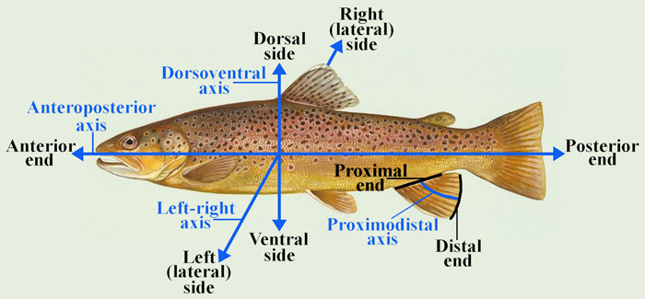

Vestigial
Occurring as a structure that, once functional (whether during development or in earlier evolutionary forms), is now reduced or degenerate. An example is the vestigial pelvic girdle seen in many snakes, including the boas and pythons, which bears no function.

Z

Zygapophysis
Articular process of a vertebra that articulates with the corresponding process of an adjacent vertebra.
Plural = zygapophyses

