Vertebrate Palaeontology and Evolution study pack

This resource is designed to familiarise you with the structure, diversity and evolutionary history of vertebrates through analysing images of specimens held at UCL’s Grant Museum of Zoology. It contains seven chapters: an introduction to vertebrate diversity, Fishes, the fish-tetrapod transition, Amphibians and Amniotes, Lepidosaurs and Chelonians, Archosaurs, and Birds and flight. All images have accompanying text, including information about the specimen plus hints about what to look for and the questions to consider when analysing the images. Please note that this resource does not look at mammals in detail – instead, this fascinating group are given a more thorough treatment in another Object Based Learning for Higher Education (OBL4HE) resource entitled ‘Vertebrate Diversity’ and the Virtual Educational Resource for the Biosciences (VERB) resource ‘Eutherians’.

- Verb Diversity: https://open-education-repository.ucl.ac.uk/id/eprint/204
- Eutherians (VERB): https://open-education-repository.ucl.ac.uk/id/eprint/210

Scalebars are provided throughout (except for models). Please note that there are two different scale bars used, one with 1cm divisions and one with 0.5cm divisions.

Multiple images of specimens are provided to try to illustrate the various anatomical features. However, please note that the limitations of photography (especially for specimens in cases or bottles) means that some distortion may occur or parts may be concealed or generally hard to determine.

To download this resource in its entirety, see the resource's collection page: https://open-education-repository.ucl.ac.uk/195/

Disclaimer: 'Vertebrate Palaeontology and Evolution' was originally designed by UCL staff as an internal teaching resource. The subsequent release of 'Vertebrate Palaeontology and Evolution' as an OER means that any changes to the product received relative to the original content may not reflect the desires of UCL teaching staff, or the original quality of the resource.

CC BY-NC-SA 4.0 International Licence: 'Vertebrate Palaeontology and Evolution' has been released as an open educational resource (OER) on a Creative Commons 'Attribution Non-commercial Share Alike' license. This means that once downloaded, content can be modified and improved to complement a particular course. This requires, however, that improvements are recycled back into the OER community, and full attribution is made to UCL. All content present at the time of download must be accordingly credited and, in turn, novel content must be appropriately licensed. For more information, please refer to the license deed by visiting: https://creativecommons.org/licenses/by-nc-sa/4.0/legalcode

Chapter 1: Vertebrate Structure

This chapter will introduce you to the structure and diversity of various vertebrates.

Contents
Chapter 1: Vertebrate Structure 2
1.1 Dipturus batis 5
1.2 Lepidotes minor 7
1.3 Amia 9
1.4 Bufo 13
1.5 Chelys frimbriata (Matamata) 17
1.6 Dimetrodon 25
1.7 Varanus niloticus (a monitor lizard) 27
1.8 Crocodylus 31
1.9 Alligator mississippiensis 34
1.10 Compsognathus longiceps 36
1.11 Parrot 37
1.12 Oceanodroma leuchorrhoa (petrel) 41
1.13 Hipparion brachypus 46
1.14 Palaeotherium sp. 49
Glossary 51

1.1 Dipturus batis

This belonged to a skate. Skates are found in the east Atlantic, Arctic ocean and Mediterranean. They can reach lengths of 2.4 metres. They live at depths of between 30 and 600 metres, and typically feed on fish, crabs, lobsters and octopuses. This specimen is the jaw and tooth battery.

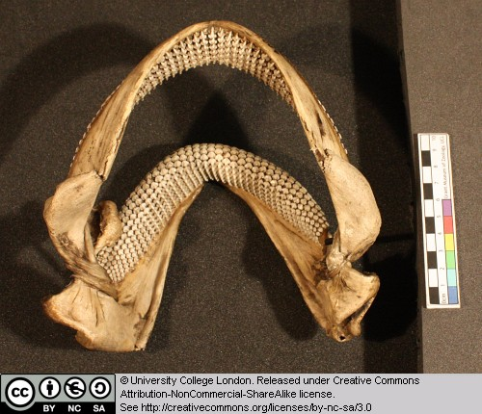
Figure 1 Above: Dipturus jaws seen from above and behind.

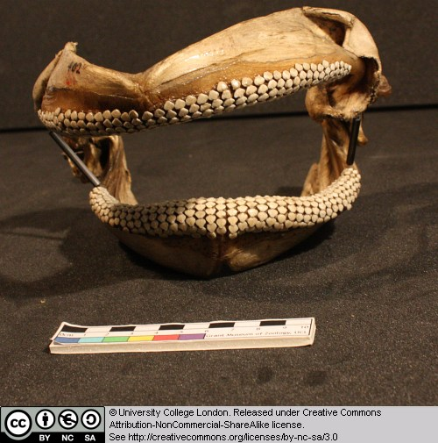
Figure 2 Above: Dipturus jaws seen from the front.

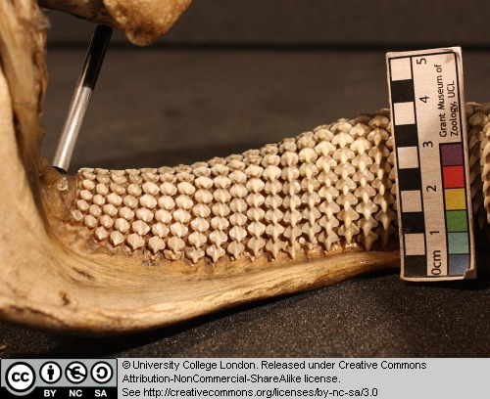
Figure 3 Above: Close-up of teeth in the lower jaw, seen from behind.

Note that, unlike ourselves, the upper jaw is not firmly fused to the braincase (not present here) of the sharks and rays.

Can you work out which parts are the palatopterygoquadrate and which represent Meckel’s cartilage? [hint – the palatopterygoquadrate is often described as ‘hatchet’-shaped].

1.2 Lepidotes minor

Lepidotes is a ray-finned fish from the Jurassic.

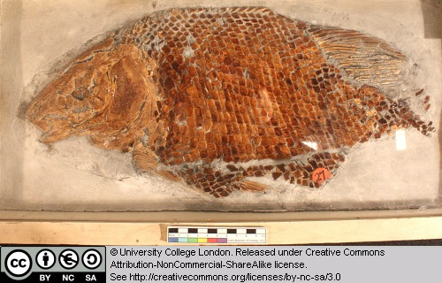
Figure 4 Above :Whole fossil specimen of Lepidotes.

Try to identify the various fins and the operculum (gill shield).

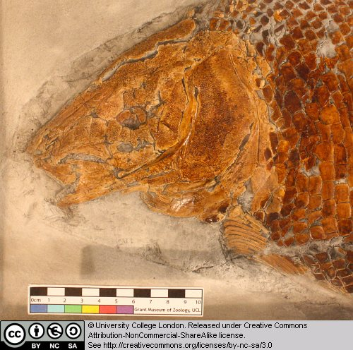
Figure 5 Above: Close-up of the head of Lepidotes fossil.

1.3 Amia

Amia (the bowfin) represents a group of ray-finned fish that are closely related to, but lie just outside of, the teleost radiation. Teleosts have a tendency to reduce the amount of sheet-like dermal bone covering their skulls – this has enabled them to modify their jaw mechanisms. Amia retains much of the primitive dermal bone.

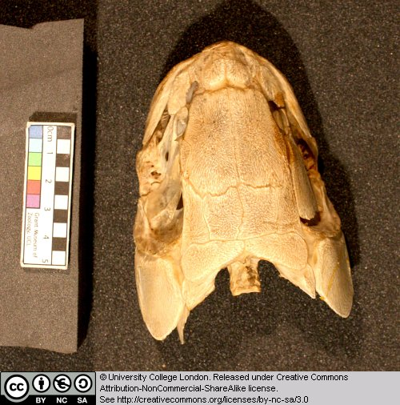
Figure 6 Above: Head of Amia as seen from above.

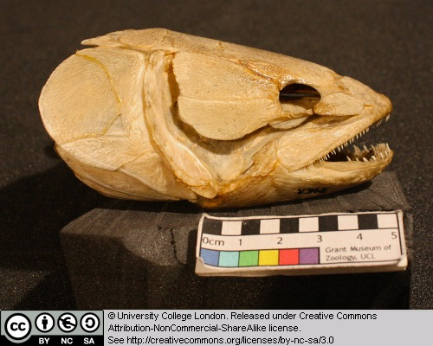
Figure 7 Above: Head of Amia as seen from the right.

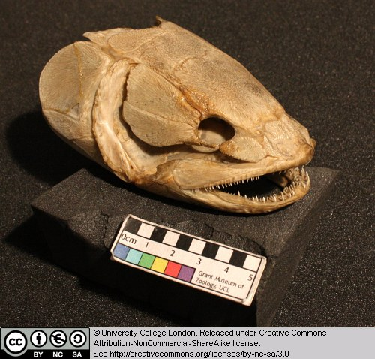
Figure 8 Above: Head of Amia as seen from the front right.

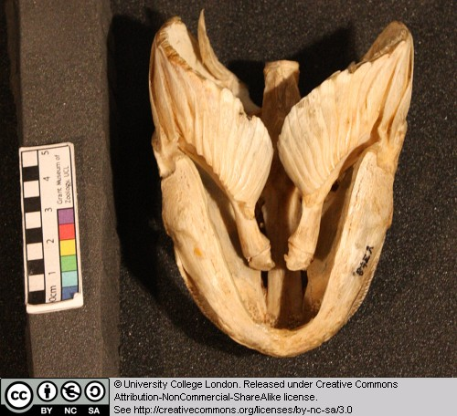
Figure 9 Above: Head of Amia as seen from below (the front if to the bottom of the picture).

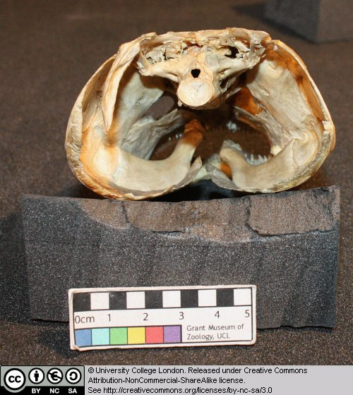
Figure 10 Above: Head of Amia as seen from behind.

Try to identify the dermal jaw bones (the premaxilla, maxilla and dentary) that possess teeth. Identify the eye socket (the orbit). Is a bony opercular plate (gill cover) present?

1.4 Bufo

This is the skeleton of a large extant toad.

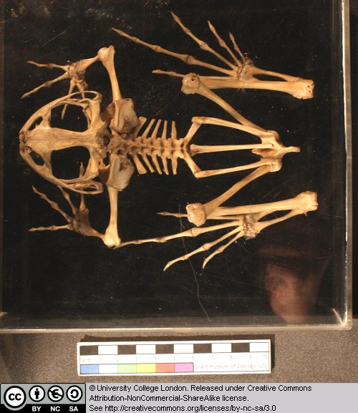
Figure 11 Above: Skeleton of Bufo, seen from above.

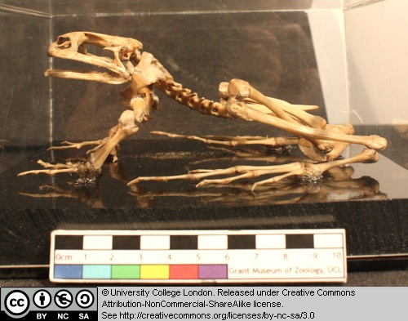
Figure 12 Above: Skeleton of Bufo, seen from the left.

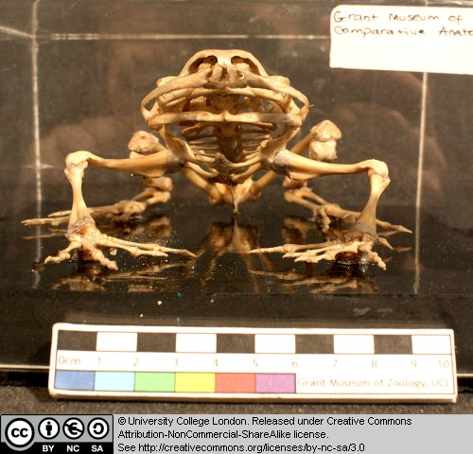
Figure 13 Above: Skeleton of Bufo, seen from the front.

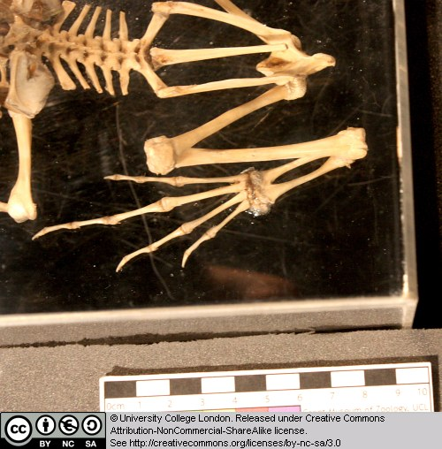
Figure 14 Above: Close-up of the pelvic region of Bufo, seen from above.

Note that the dorsal (trunk) vertebrae lack ribs. Identify the shoulder girdle, fore limb, pelvic girdle and hind limb elements as far as you can.

1.5 Chelys frimbriata (Matamata)

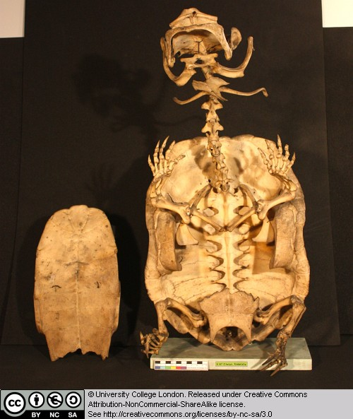
Figure 15 Above: Skeleton of Chelys, seen from below. The plastron (chest plate) has been removed and lies to the side.

The matamata is a pleurodiran turtle. This means that it is a member of the turtle group that bend their necks sideways in order to retract the head inside the shell. However, the length of the neck in the matamata must make it difficult or impossible for this animal to hide its head in this way. The matamata is an aquatic predator. It has a lure on the tip of its snout that tempts small fish to come close to its mouth. The wide mouth is then opened rapidly and the fish is pulled into it by the inflow of water. Clues to this lifestyle can be seen in the skeleton – but this can wait until a later chapter.

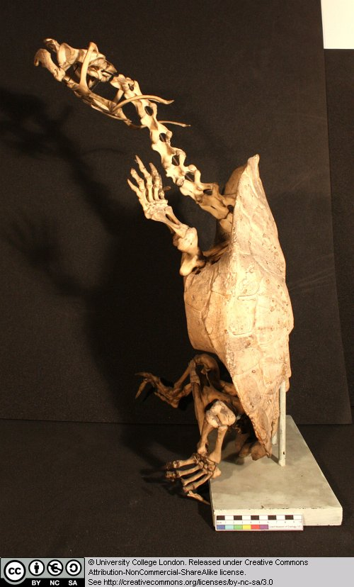
Figure 16 Above: Skeleton of Chelys, seen from the left.

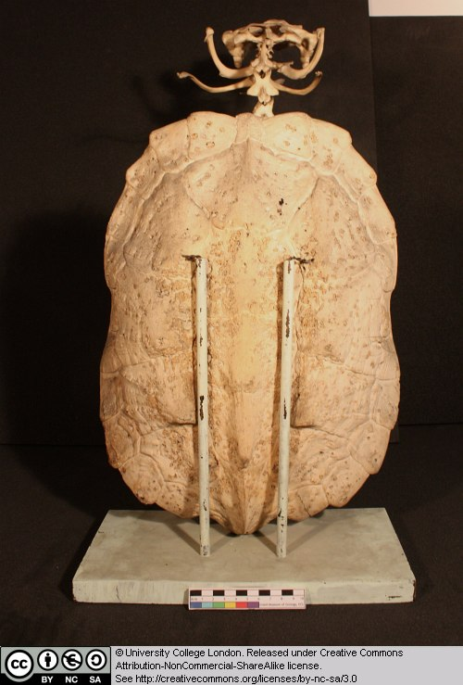
Figure 17 Above: Skeleton of Chelys, seen from behind.

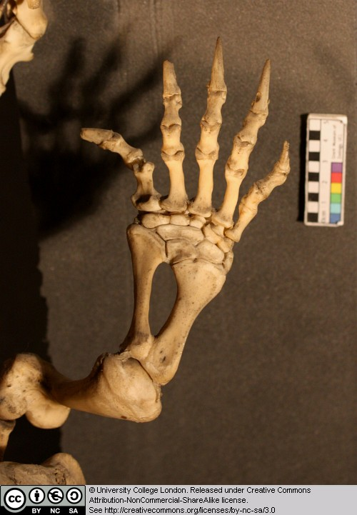
Figure 18 Above: Close-up of the forelimb of Chelys seen from above.

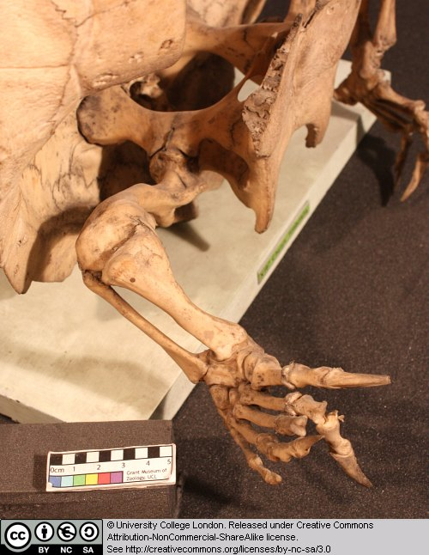
Figure 19 Above: Close-up of the hindlimb of Chelys seen from above and to the side.

Examine the limb structure and try to identify humerus, ulna, radius, manual (hand) phalanges, femur, tibia, fibula and pedal (hind foot) phalanges. Note also the ridges and projections on the neck vertebrae. Examine the armoured shell (both the dorsal carapace and the ventral plastron).

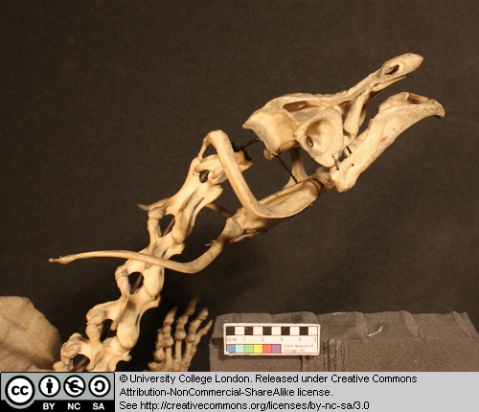
Figure 20 Above: Close-up of the skull of Chelys seen from the side

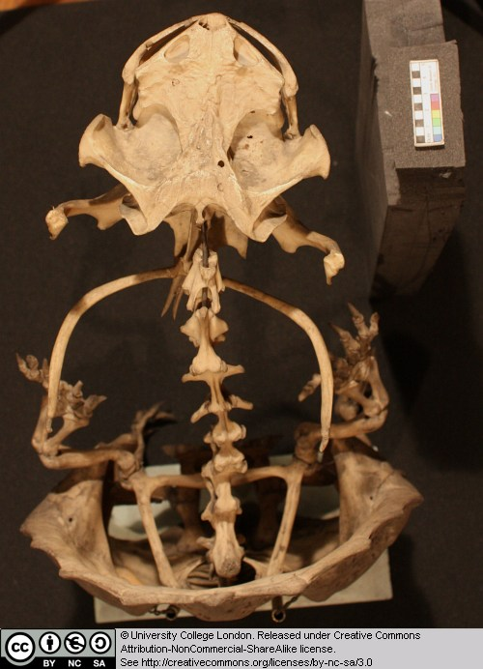
Figure 21 Above: Close-up of the skull of Chelys seen from above.

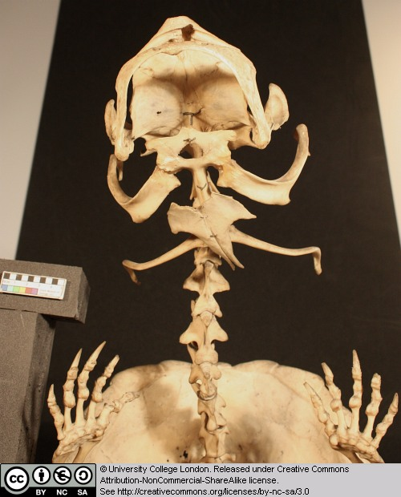
Figure 22 Above: Close-up of the forelimb of Chelys seen from below.

Identify the nasal openings and eye sockets in the skull.

More on the matamata (including a number of images of a live animal) can be seen here.

1.6 Dimetrodon

This box contains vertebrae from Dimetrodon – a famous sail-backed predator from the Permian (we’ll meet it again later in the course). Here several vertebrae are shown in left lateral, anterior and dorsal views.

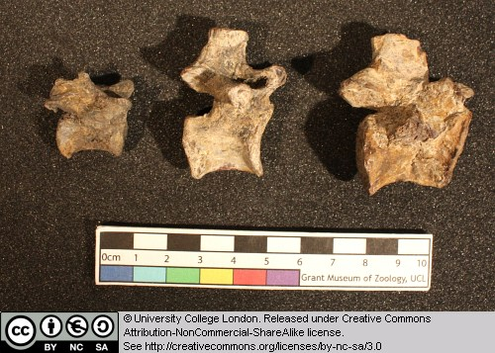
Figure 23 Above: Vertebrae of Dimetrodon, seen from the left (the front is to the right).

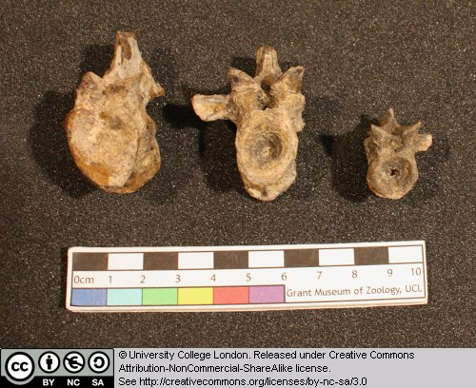
Figure 24 Above: Vertebrae of Dimetrodon, seen from the front.

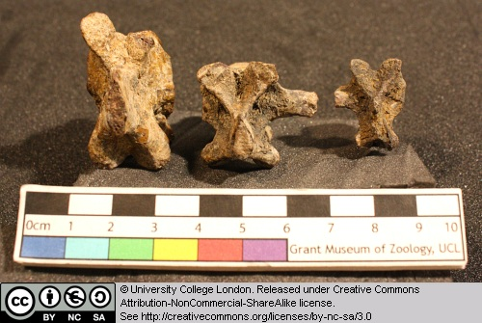
Figure 25 Above: Vertebrae of Dimetrodon, seen from above (the front is to the top).

This provides a good opportunity to learn some of the basic features of amniote vertebrae. Identify the following features: centrum, neural arch, spinal canal, neural spine, transverse processes (attachment points for the ribs).

1.7 Varanus niloticus (a monitor lizard)

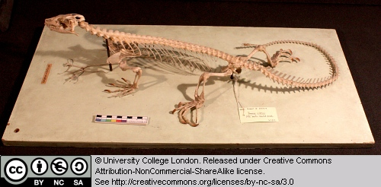
Figure 26 Above: Skeleton of Varanus, seen from the left.

This is the skeleton of a varanid lizard from Africa. Varanids are highly derived lizards that may be closely related to the gigantic extinct marine mosasaurs of the Mesozoic, and modern snakes.

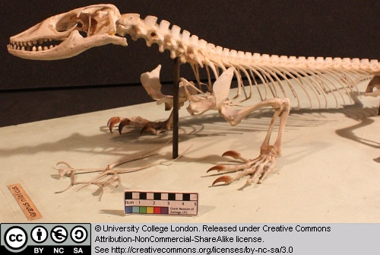
Figure 27 Above: Front half of the skeleton of Varanus, seen from the left.

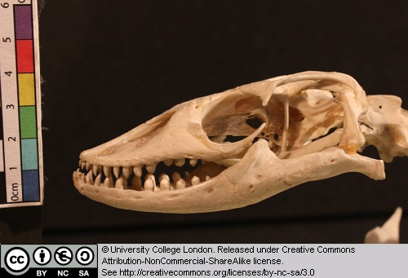
Figure 28 Above: Skull of Varanus, seen from the left.

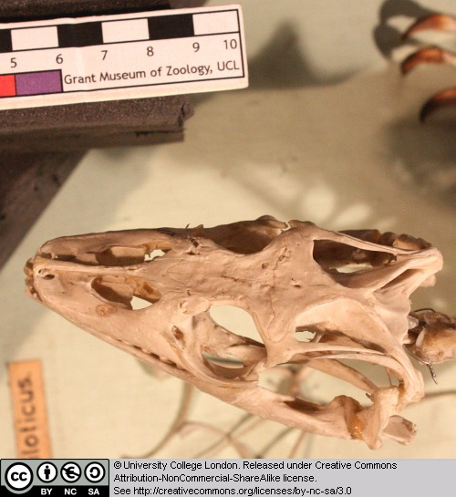
Figure 29 Above: Skeleton of Varanus, seen from the above.

Can you identify the eye sockets and nasal openings?

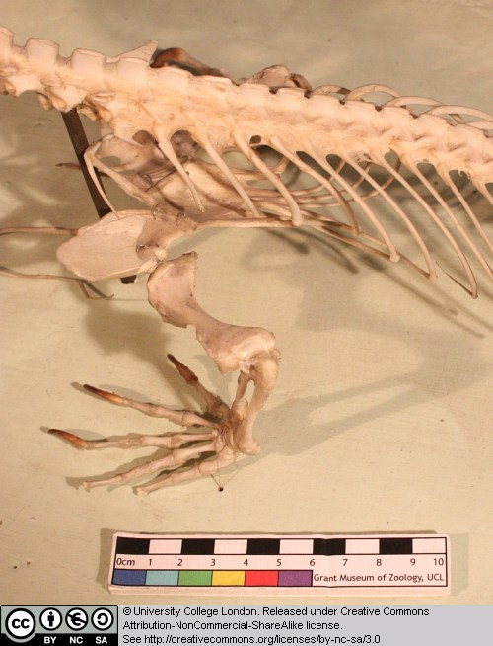
Figure 30 Above: Spine and forelimb of Varanus, seen from above and left.

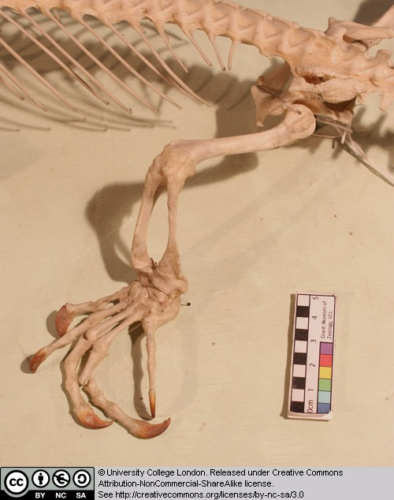
Figure 31 Above: Hindlimb of Varanus, seen from the left.

Note the sprawling limb posture (the limbs extend out to the sides, rather than being held vertically beneath the body, as in ourselves).

1.8 Crocodylus

This is the skull of an extant crocodile.

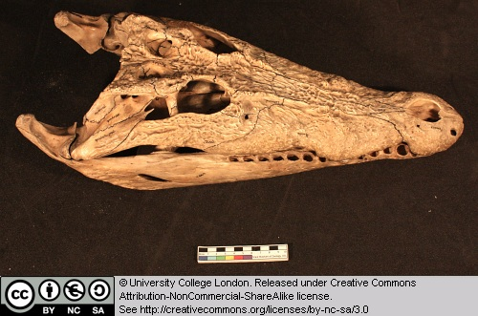
Figure 32 Above: Skull of Crocodylus, seen from above and to the left.

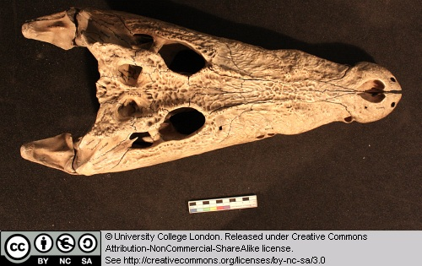
Figure 33 Above: Skull of Crocodylus, seen from above.

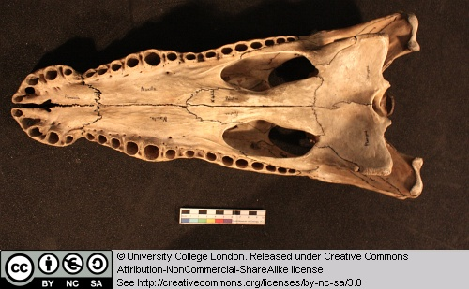
Figure 34 Above: Skull of Crocodylus, seen from below.

Identify the nasal openings and eye sockets. Identify the three tooth bearing bones – premaxilla, maxilla and dentary.

Can you find the rounded ‘occipital condyle’ at the back of the skull where it would have articulated with the first neck vertebra? Just above this is the ‘foramen magnum’ – the opening where the spinal cord enters the skull and joins the brain.

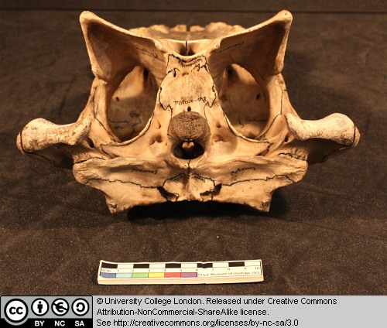
Figure 35 Above: Skull of Crocodylus, seen from behind (the skull roof is below and palate uppermost).

We will be revisiting crocodiles again and in more detail in a later practical.

1.9 Alligator mississippiensis

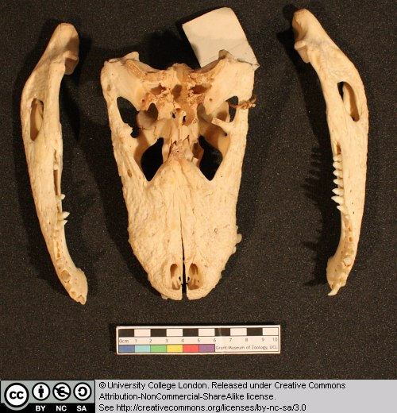
Figure 36 Above: Skull of Alligator, seen from above and with the lower jaws to the side.

This is the skull (and jaws) of the extant alligator

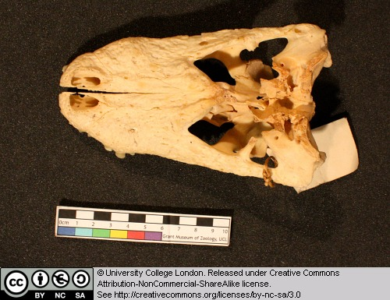
Figure 37 Above: Skull of Alligator seen from above.

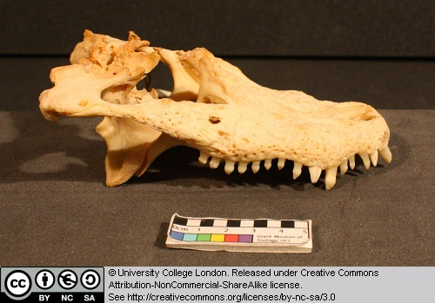
Figure 38 Above: Skull of Alligator seen from the right.

Identify the nasal openings and eye sockets. Identify the three tooth bearing bones – premaxilla, maxilla and dentary. Can you find the rounded ‘occipital condyle’ at the back of the skull where it would have articulated with the first neck vertebra? Just above this is the ‘foramen magnum’ – the opening where the spinal cord enters the skull and joins the brain. In the image below the skull is inverted and lies on its dorsal surface, with the palate uppermost.

Figure 39 Above: Skull of Alligator seen from behind (the skull roof is at the bottom and the palate is uppermost).

1.10 Compsognathus longiceps

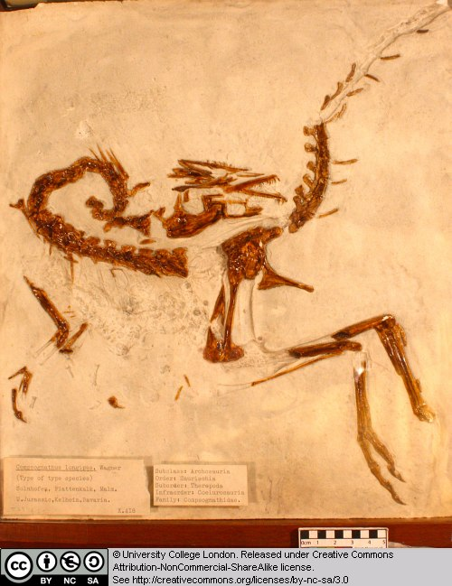
Figure 40 Above: Cast of Compsognathus, preserved with the left side uppermost.

This is a cast of a small theropod dinosaur from the Late Jurassic of Germany.

Try to identify as many of the elements as you can.

1.11 Parrot

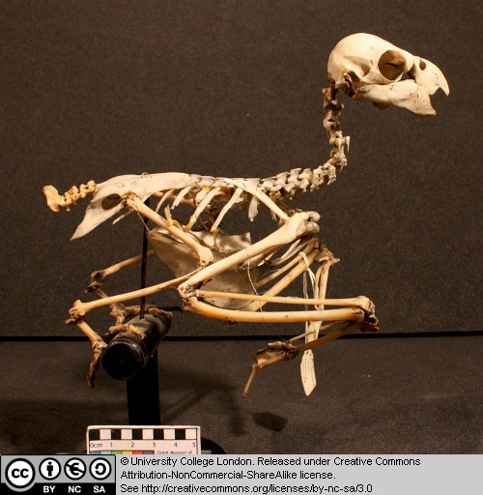
Figure 41 Above: Skeleton of a parrot seen from the right.

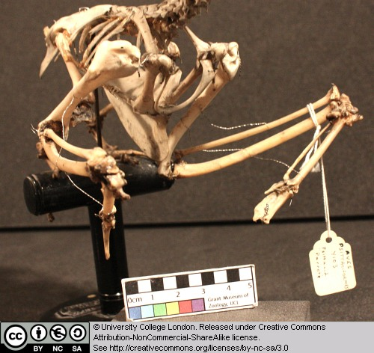
Figure 42 Above: Chest area of a parrot seen from the front right.

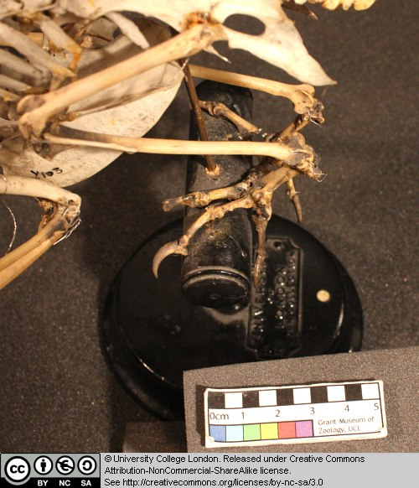
Figure 43 Above: Hindlimb of a parrot seen from above and to the left.

Bird skeletons are delicate. Try to identify the following features:

The rib cage and sternum (breast bone area) where the major flight muscles attach.

The form of the wing bones (try to identify the humerus, ulna and radius, and fused finger bones).

The short femur.

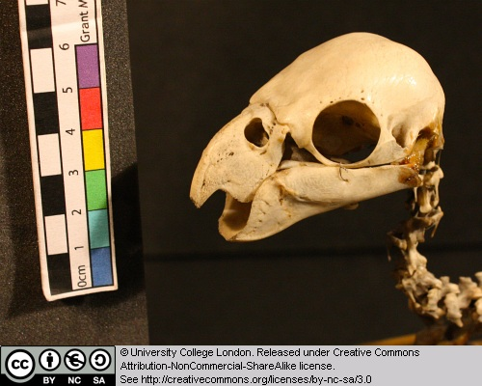
Figure 44 Above: Skull of a parrot seen from the left.

Can you detect a hinge-like region between the beak and posterior portion of the skull?

1.12 Oceanodroma leuchorrhoa (petrel)

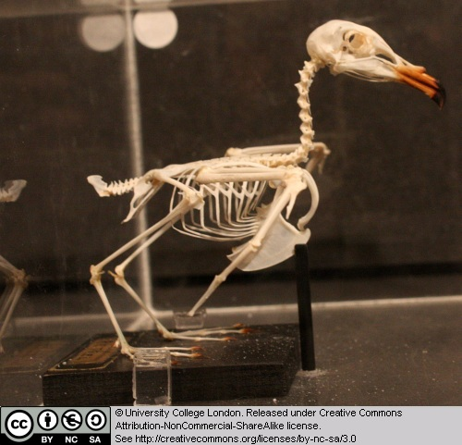
Figure 45 Above: Skeleton of Oceanodroma seen from the right.

This is the skeleton of a sea bird found around the coasts of western and northern Europe.

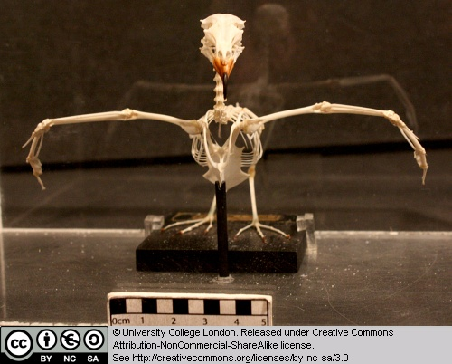
Figure 46 Above: Skeleton of Oceanodroma seen from the front.

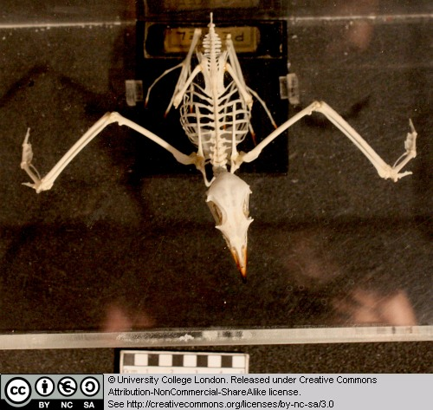
Figure 47 Above: Skeleton of Oceanodroma seen from above.

Examine the following features:

The rib cage and sternum (breast bone area) where the major flight muscles attach.

The form of the wing bones (try to identify the humerus, ulna and radius, and fused finger bones).

The short femur.

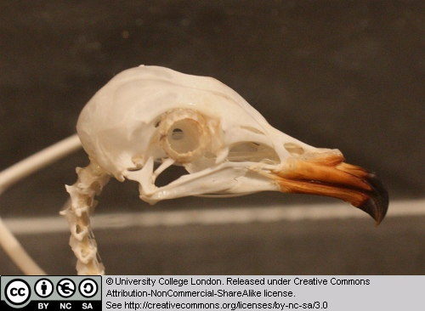
Figure 48 Above: Skull of Oceanodroma seen from the right.

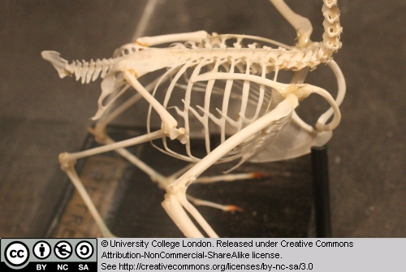
Figure 49 Above: Body of Oceanodroma seen from above right.

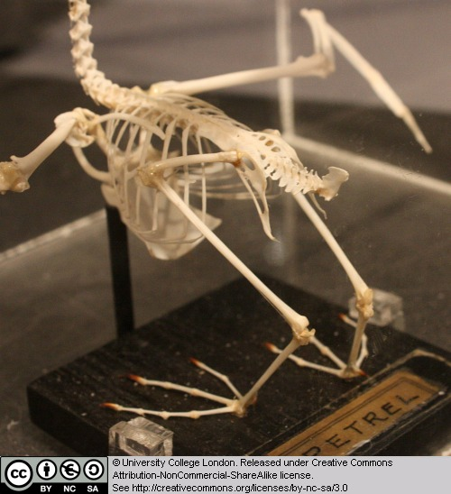
Figure 50 Above: Posterior part of the keleton of Oceanodroma seen from above left.

1.13 Hipparion brachypus

Although we do not look at mammals in detail in this course, we have included a couple of specimens here because we are looking at the diversity of vertebrates.

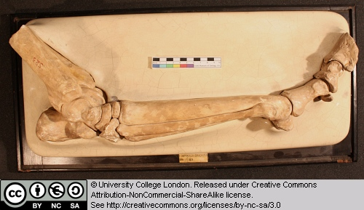
Figure 51 Above: Cast of hindlimb of Hipparion seen from the right.

This is a cast of the pes (hind foot) and distal end of the tibia of an equid (horse family). Note the reduction of the pedal digits, and the stout column-like nature of the limb bones.

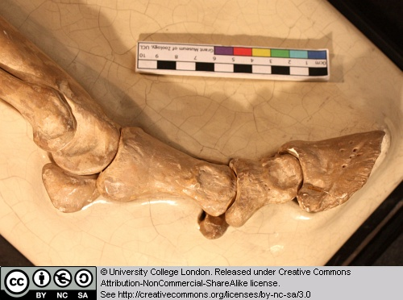
Figure 52 Above: Close-up of the foot of Hipparion seen from the right.

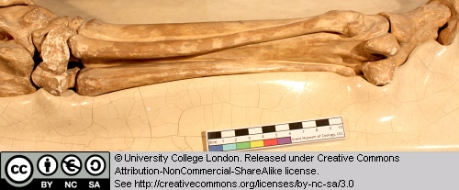
Figure 53 Above: Close-up of the metatarsals of Hipparion seen from the right.

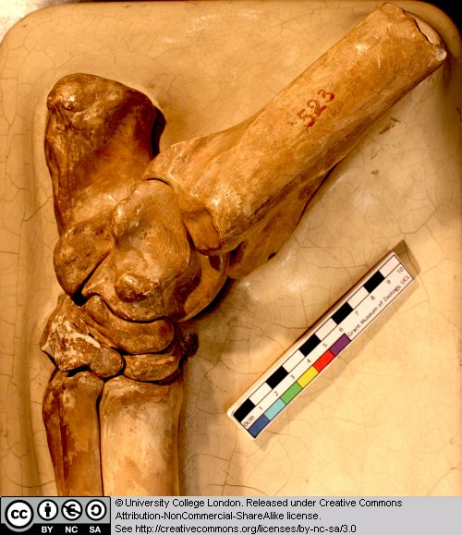
Figure 54 Above: Close-up of ankle joint of Hipparion seen from the right.

1.14 Palaeotherium sp.

Although we do not look at mammals in detail in this course, we have included a couple of specimens here because we are looking at the diversity of vertebrates. This is the skull of an equid (horse) from the middle Miocene of North America.

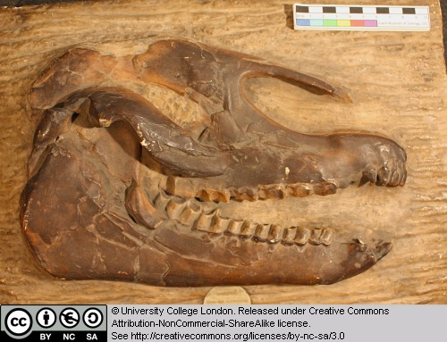
Figure 55 Above: Cast of the skull of Palaeotherium seen from the right.

Try to identify the main openings in the skull, such as the eye and external nostril. Note the cusps on the teeth and the arrangement of the teeth in the jaws. Compare these teeth with those in a crocodile. Mammals typically have complex teeth for grinding/slicing their food.

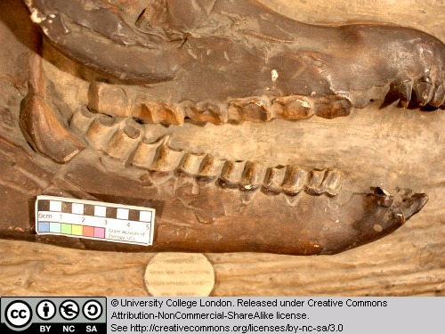
Figure 56 Above: Close-up of the teeth of Palaeotherium seen from the right.

Glossary

A

akinetic
In anatomy, this refers to a low level of flexibility in a structure due to a lack of moveable joints.

amniote
Those vertebrates with an amniotic egg. The extant clades are Testudines (turtles), Diapsida (lepidosaurians, crocodilians, and birds), and Synapsida (mammals).

anapsid
Skull possessing no temporal fenestrae (NB. an- = without).
Amniotes with this skull condition form a paraphyletic group including the Parareptilia (turtles and their extinct relatives), the extinct common ancestor of all amniotes, and basal eureptiles (the extinct precursors of diapsids).
Note that the Testudines (turtles and relatives) have modified the anapsid condition through a reduction (emargination) of the posterior region of the skull.

Apatite
Calcium phosphate: the crystalline component of bone.

apomorphy
A derived or specialised character.

Appendicular skeleton
The endoskeletal element of the fins or limbs of a vertebrate, and their associated girdles (pectoral or pelvic).

Axial skeleton
All parts of the vertebrate endoskeleton except the limbs or fins and their associated girdles. That is, the cranium, visceral skeleton, notochord, vertebrae, and ribs.

B

Basal
Of, relating to, located at, or forming a base.

Bicuspid
A tooth bearing two cusps.

C

Calcified cartilage
Cartilage strengthened with a scattering of apatite crystals (calcium phosphate), as seen in Chondrichthians.

Cartilage
A tough, elastic, fibrous connective tissue composed of collagen fibres. Used as skeletal tissue in vertebrates, it is non-mineralised and is often the developmental precursor of bone.

Clade
A phylogenetic lineage comprising a common ancestor and all its descendant species.
Note that the difference between a taxon and a clade is that a clade must include all descendant species from a common ancestor, whereas a taxon need not.

cladistic
Relating to the branching sequences of phylogeny.

cladogram
A branching tree-like diagram representing the phylogenetic relationships (evolutionary history) of a lineage.

cloaca
The common opening for the reproductive, urinary, and digestive tracts, seen in all vertebrates except therian mammals (marsupials and placental mammals).

The term comes from the Latin for sewer.

Cursorial
Adapted for running.

Cusp
The biting point of a tooth.

D

Dentary
The anterior bone of the lower jaw which bears the teeth. It forms the whole of the lower jaw in mammals.

Dentine
A bone-like substance, lacking cell bodies and consisting mainly of calcium phosphate (apatite) in a fibrous matrix.

Dermal bone
A type of bone forming within the dermis - the deep layer of vertebrate skin cells below the surface layer, the epidermis.

diapsid
Skull possessing both an upper and a lower temporal fenestra (NB. di- = two).
Amniotes with this skull condition form the monophyletic clade Diapsida, which includes the lepidosaurs (lizards, snakes, and tuatara), archosaurs (crocodilians, dinosaurs, and birds), and their other extinct relatives.
Note that some diapsids, such as lizards, have lost the temporal bar separating the fenestrae to form one large window. Others, such as the Aves (birds), have merged both fenestrae with the orbit.

E

Enamel
The crystalline material covering the crown of a tooth, or certain scales.

Endopterygota
A clade of insects charachterised by their undergoing complete metamorphosis (i.e. holometabolous).
See Insect Diversity WebBook for the clades within (from Neuroptera down).

Epidermal
Pertaining to, or originating from, the epidermis - the surface layer of skin cells in vertebrates

euryapsid
Skull possessing an upper temporal fenestra only.
However, animals with this skull condition do not represent an important amniote lineage, as they are likely to be a polyphyletic group, originating a least twice within the Diapsida. Euryapsids include the plesiosaurs and ichthyosaurs - Mesozoic marine reptiles.

extant
Not extinct.

F

fossorial
Specialised for burrowing.

furcula
The fused clavicle bones of a bird, also known as the wishbone.

H

Hemimetabolous
Refers to a type of insect development that is categorised by three distinct, progressive life stages: egg, nymph, imago (adult). Changes are gradual, with no pupal stage.
Some hemimetabolous insects include grasshoppers, cicadas, cockroaches, termites, earwigs, and dragonflies.
Also termed incomplete metamorphosis.

Holometabolous
Refers to a type of insect development that is categorised by four distinct, progressive life stages: embryo, larva, pupa, imago (adult).
Seen exlusively in the Endopterygota, which includes beetles, butterflies, wasps, bees, ants, and others.
Also termed complete metamorphosis.

Horny
Consisting of horn - a tough material composed mainly of keratin.

I

ilium
In tetrapods, the dorsal section of the pelvis, which articulates with one or more sacral vertebrae.

K

Kinetic
In anatomy, referring to a high level of flexibility afforded by numerous moveable joints.

L

Lymph heart
Muscular dilation in a lymph vessel, which pumps lymph (fluid containing white blood cells called lymphocytes important in immune response) around the body of some lungfishes, amphibians and reptiles.

M

Metacone
In mammals, the metacone is the distobuccal (rear-most and cheek side) cusp of an upper molar tooth.

monophyletic
Having a single evolutionary origin. A taxon is monophyletic if it contains all the descendants of a common ancestor.

For example, mammals are a monophyletic group, as all species descended from the first known mammal are considered mammals.

See paraphyletic and polyphyletic for alternative terms.

Myrmecophagy
Feeding behaviour categorised by an exclusive (or near exclusive) diet of ants ant termites.

O

Orbit
The bony socket of the eye.

Osteosclerosis
An increase in the density of bone.

P

Pachyostosis
A thickening of the bone, often associated with a reduction in the volume of marrow tissue contained within.

Paracone
In mammals, the paracone is the mesiobuccal (front-most and cheek side) cusp of an upper molar tooth.

Paraphyletic
A taxon including a common ancestor and some but not all of its descendants.
For example, the class Reptilia is paraphyletic, as it does not include birds, who are considered a separate class: Aves. However, birds evolved from theropod dinosaurs, and are therefore reptiles themselves. Similarly, all tetrapods are, evolutionarily speaking, lobe-finned fish.
Importantly, reptiles can be made monophyletic through the addition of birds to the taxon.
See monophyletic and polyphyletic for alternative terms.

Pectoral girdle
In vertebrates, the skeletal structure that provides support for the fore limbs or fins.

Pelvic girdle
In vertebrates, the skeletal structure that provides support for the hind limbs or fins, which also fuses with the sacral vertebrae.

phylogeny
The evolutionary history of organismal lineages as they develop through time.

plesiomorphy
An ancestral character.

polyphyletic
Referring to a group that does not contain the common ancestor of all the taxa within. Therefore, this is not a true taxonomic group, but is often a term used to categorise organisms with a similar ecology, such as insectivorious mammals, or marine mammals.
It is also used when the evolutionary origin of a group, such as snakes, is unsure, and characteristic species within may have originated separately.

Protocone
In mammals, the protocone is the mesiolingual cusp of an upper molar tooth.

Pulp cavity
The space within a tooth, or a dentine scale, occupied by blood vessels and nerves.

S

symplesiomorphy
A character that is shared between groups but was inherited from an ancestor prior to the last common ancestor.
These are characters that - at the level at which they are referred to as symplesiomorphies - are not used to form cladistic groupings, or clades.

synapomorphy
A derived or specialised character that is shared between two or more groups, and was inherited from the common ancestor in which it originated.
These are the characters that morphological systematists use to support the existence of particular clades, forming the basis of the field of cladistics.

synapsid
Skull possessing a lower temporal fenestra only.
Amniotes with this skull condition form the monophyletic clade Synapsida, which includes the mammals and their extinct ancestors, the non-mammalian reptile-like synapsids.
Note that in the Mammalia, the lower temporal fenestra has merged with the orbit.

T

taxon
A group of organisms sharing a common ancestry.
Note that the difference between a taxon and a clade is that a clade must include all descendant species from a common ancestor, whereas a taxon need not.
Pl. taxa.

temporal fenestra
An opening in the temporal region of the skull seen in amniotes, providing a flat edge for the attachment of strong lower jaw closing muscles to the skull.
Amniotes show four skull types, based on the position and number of these temporal fenestrae, two of which define two major lineages of the amniotes. The skull types and associated groups are as follows:
1) Synapsid - Skull possessing a lower temporal fenestra only. Amniotes with this skull condition form the monophyletic clade Synapsida, which includes the mammals and their extinct ancestors, the mammal-like reptiles. Note that in the Mammalia, the lower temporal fenestra has merged with the orbit.
2) Diapsid - Skull possessing both an upper and a lower temporal fenestra (NB. di- = two). Amniotes with this skull condition form the monophyletic clade Diapsida, which includes the lepidosaurs (lizards, snakes, and tuatara), archosaurs (crocodilians, dinosaurs, and birds), and their other extinct relatives. Note that some groups within the Diapsida, such as lizards, have lost the temporal bar separating the fenestrae to form one large window. Others, such as the Aves (birds), have merged both fenestrae with the orbit.
3) Anapsid - Skull possessing no temporal fenestrae (NB. an- = without). Amniotes with this skull condition form a paraphyletic group including the Parareptilia (turtles and their extinct relatives), the extinct common ancestor of all amniotes, and basal eureptiles (the extinct precursors of diapsids). Note that the Testudines (turtles and relatives) have modified the anapsid condition through a reduction (emargination) of the posteriorregion of the skull.
4) Euryapsid - Skull possessing an upper temporal fenestra only. However, animals with this skull condition do not represent an importantamniote lineage, as they are likely to be a polyphyletic group, originating a least twice within the Diapsida. Euryapsids include the plesiosaurs and ichthyosaurs - Mesozoic marine reptiles.

V

vertebrae
From anterior to posterior:
Cervical vertebrae: Facilitate the mobility of the head. The first two, the atlas and the axis are highly specialised, the former articulating with the occipital region of the skull.
Thoracic vertebrae: Articulate with the ribs that fuse with the sternum.
Lumbar vertebrae: Generally larger, with small ribs not attached to the sternum, which support the posterior musculature.
Sacral vertebrae: Fused to the pelvic girdle, allowing the transfer of force from the appendicular skeleton (limbs) during locomotion.
Caudal vertebrae: Small and less specialised, forming the tail.

Vertebrate anatomical directions and axes
The image below illustrates the terms used for anatomical directions and axes in vertebrates.
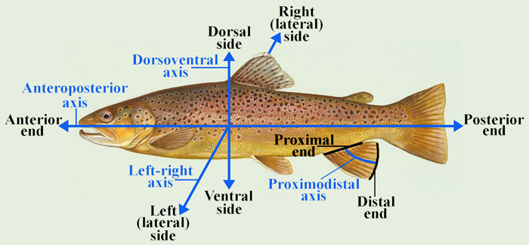

Vestigial
Occurring as a structure that, once functional (whether during development or in earlier evolutionary forms), is now reduced or degenerate. An example is the vestigial pelvic girdle seen in many snakes, including the boas and pythons, which bears no function.

Z

Zygapophysis
Articular process of a vertebra that articulates with the corresponding process of an adjacent vertebra.
Plural = zygapophyses

